Installation guide for R, RStudio, and packages

# Install R

1. Download the R installer

* Newest version can be installed via the official R website <https://cran.r-project.org/>

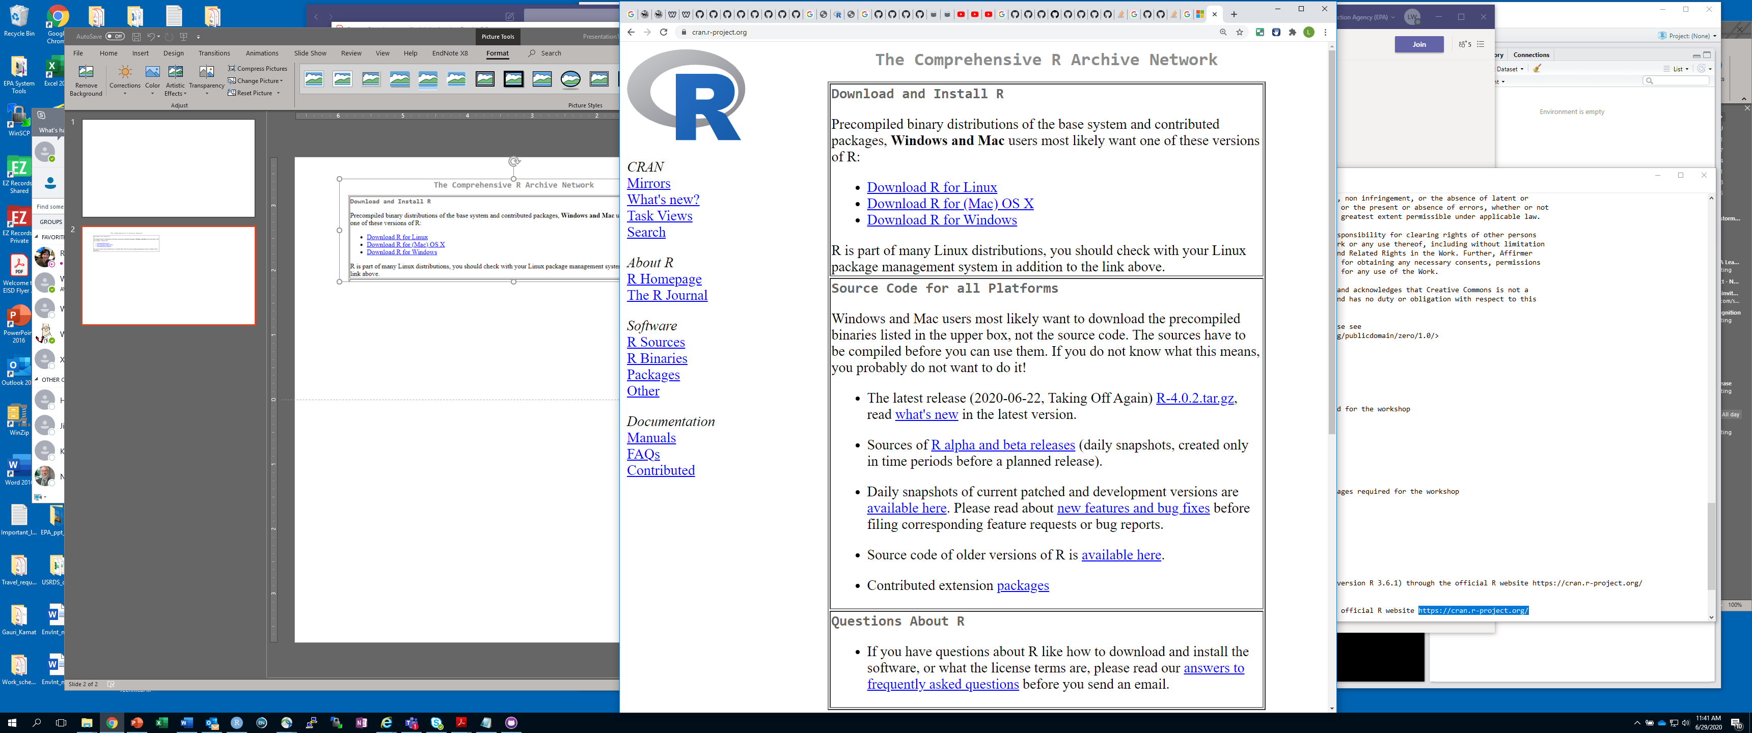

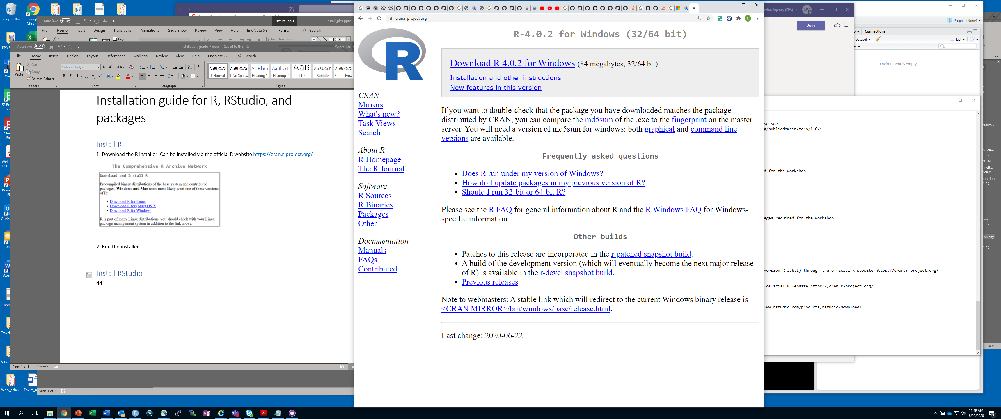

* Previous versions can be installed from <https://cran.r-project.org/bin/windows/base/old/>

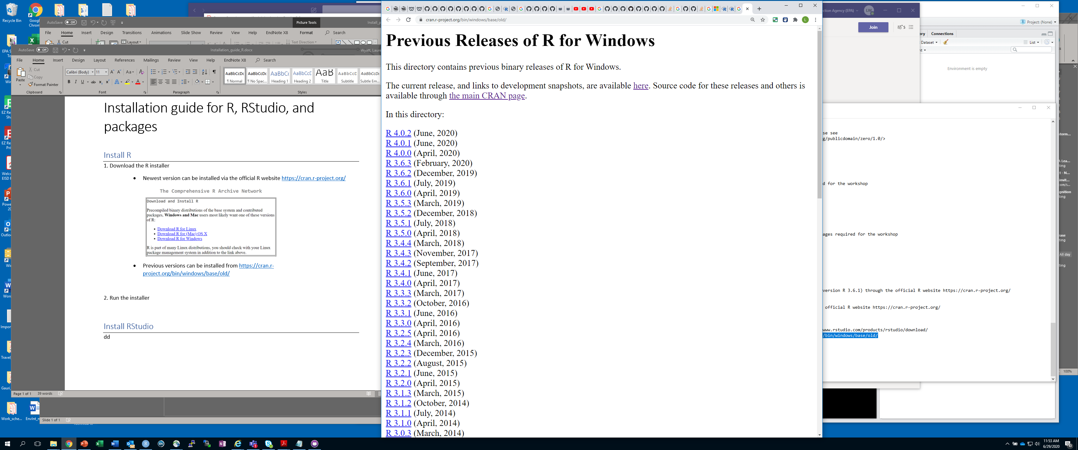

2. Run the installer and follow prompts

# Install RStudio

1. Have R installed before installing R Studio

2. Download RStudio: <https://www.rstudio.com/products/rstudio/download/>

3. Run the installer and follow prompts

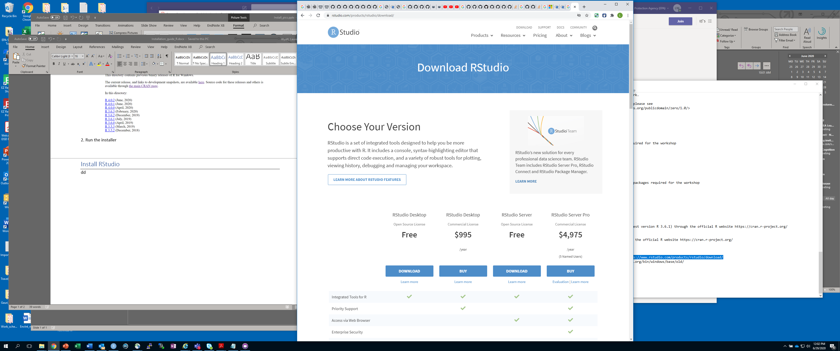

d