HypAR - Hyperspectral imaging using Augmented Reality

**Vacation Scholarship Final Report**

Casey Rogers, Curtin University/CSIRO Data61

Co-supervisors: Ulrich Engelke (Data61), Jens Klump (Mineral Resources)

Kensington, WA

Contents

1 Abstract 3

2 Introduction 3

3 Method

4 System Design 4

4.1 Demonstrator Choice 4

4.2 System Overview 4

4.3 User Interface 8

5 Implementation Process 9

5.1 Gathering Data 9

5.2 Data Processing 9

5.3 Creating the Overlay 11

6 Issues

6.1 HoloLens Limitations 13

7 Hardware and Software 13

8 Testing

8.1 Occlusion and Clutter 14

8.2 User Input 15

8.3 User Gaze 15

9 Discussion 15

10 Future Development 16

11 References 17

12 Appendix 17

# Abstract

Hyperspectral imagery is a key enabler for scientific discoveries in the geosciences. Being able to do this in a real time environment would be a game changer by enabling accelerated discovery of geological phenomena. This project addresses this important issue by developing an immersive analytics framework for hyperspectral data using augmented reality (AR). The framework defines the user interface design with meaningful visual representation and interaction of hyperspectral data using the state of the art HoloLens.

# Introduction

A real world issue that geologists face is understanding mineral compositions from rock samples. For example, in order to understand the mineral composition of an open mine face, face mapping is used. Face mapping involves hyperspectral imaging, gathering the spectrum of each pixel in the image of a certain range. The human eye sees colour of the visible light spectrum, spectral imaging divides the spectrum into multiple bands. Hyperspectral imagery provides opportunities to extract more detailed information than from other traditional methods. In many cases geologists cannot get in direct contact with a mine face. Mineral maps promote discoveries by seeing patterns and associations in mineral maps. Hyperspectral remote sensing is positioned to be the core technology for geospatial research, exploration and monitoring.

This project is aimed at using AR to demonstrate real world interaction with hyperspectral data. The definition of AR is the merging of real and virtual worlds1. This way the HoloLens can produce an environment where visualisations exist in real time. It can be a tedious process to interpret hyperspectral data, whereas the HypAR project allows for the fast and easy viewing of data such as graphs, textual information and most importantly the immediate hyperspectral overlay on top of the surface. In this report we discuss the design, implementation and final application in detail.

# Method

The method of design for HypAR is user-centred, focusing on the requirements and user experiences of geoscientists. The design is based on the understandings of the tasks, environment and practices of geoscientists. We take into consideration the current practice of face mapping mine faces. A way of accelerating the face mapping process would be a real time analytic framework. Identifying the need for an AR analytic framework will specify the requirements and design solutions for HypAR. The reason AR was chosen was due to the capability of a real time overlay of hyperspectral images. These images allow us to visualise spatial distributions and associations. AR is a powerful method of displaying visuals on top of the real world, similarly to a hyperspectral camera.

Iterative user testing was a key method of understanding the goals of geoscientists when they are identifying a mineral’s composition. Geoscientists determine mineral composition from the electromagnetic spectrum, both visible and infrared. In order for HypAR to be successful it needed to be able to visualise the outer bounds of the visible spectrum using predetermined RGB values.

# System Design

## Demonstrator Choice

In early discussions, the choice of demonstrators were: an online mineral library, or the Daedalus Wing. The online mineral library did not allow for the full capability of AR to be met, therefore the Daedalus Wing was chosen as the demonstrator. It is located in the Kensington ARCC building, level 4 hallway. The Daedalus Wing is an art piece by Sarah Dowling, containing rocks of economic importance: from diamonds, emeralds and gold; to iron ore, nickel and coal. The Daedalus wing contains many unique minerals, which are of interest to geoscientists. The Daedalus wing is also easily accessible and scannable for data and is all contained in one piece (Figure 1). Compared to an online mineral library which you cannot come in physical contact with. The Wing contains a wide variety of minerals with different spectral values and makes it a suitable demonstrator.

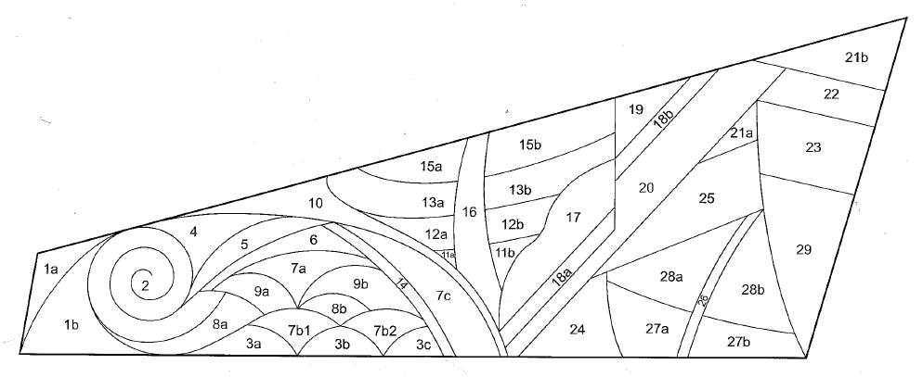

Figure 1: Daedalus Wing Illustration and Architecture from flyer.

## System Overview

In the initial stages of the project, only a brief flow diagram was drawn up. In the first demonstration, only a graph and text were present to the user. After feedback, more immersive features needed to be added. In the second demonstration, spatial sound, and more detailed information were present. The flow diagram (Figure 2) is a result of several iterations including discussions with end users, which leads back to user centred design. The tutorial is a new feature added to HypAR, tailored for new users to greatly improve the learning curve of the application. Use cases were discussed in detail, further contributing to the addition of voice commands.

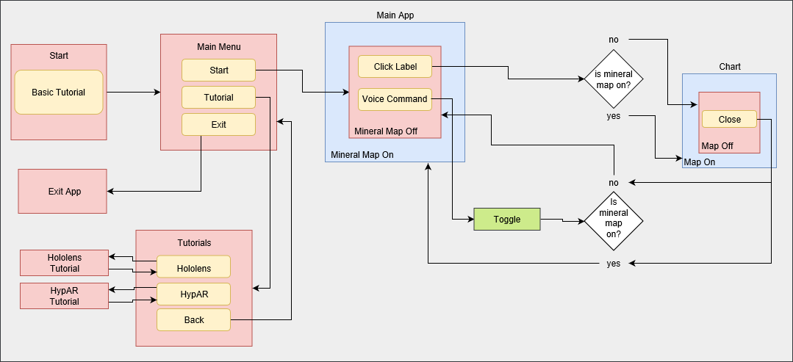

Figure 2: Final flow diagram of HypAR application.

HypAR initially presents the user with a menu, where a tutorial is optional. The user can then choose if they would like to view the HoloLens tutorial, explaining the basics of the HoloLens (Figure 3.1, 3.2, 3.3). The second tutorial is HypAR specific. This tutorial gives the user a step by step guide for HypAR, including all voice commands.

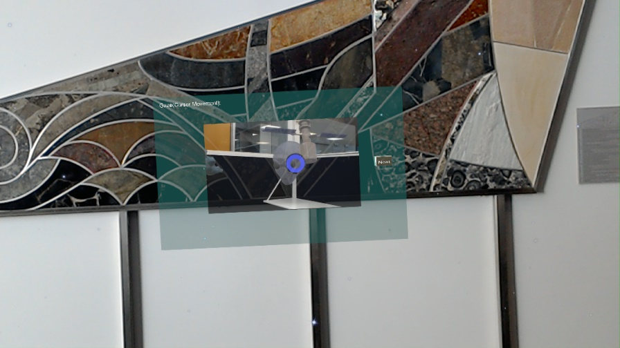

Figure 3.1: Gaze tutorial with video and voice explanation.

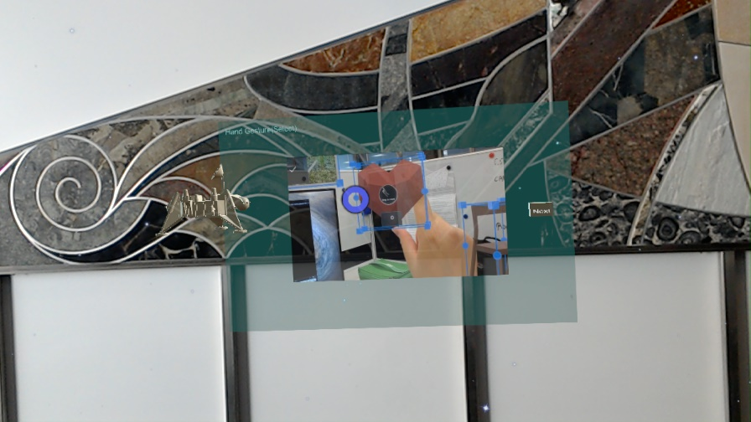

Figure 3.2: Gesture tutorial with voice over. Hologram included in scene to practice gesture.

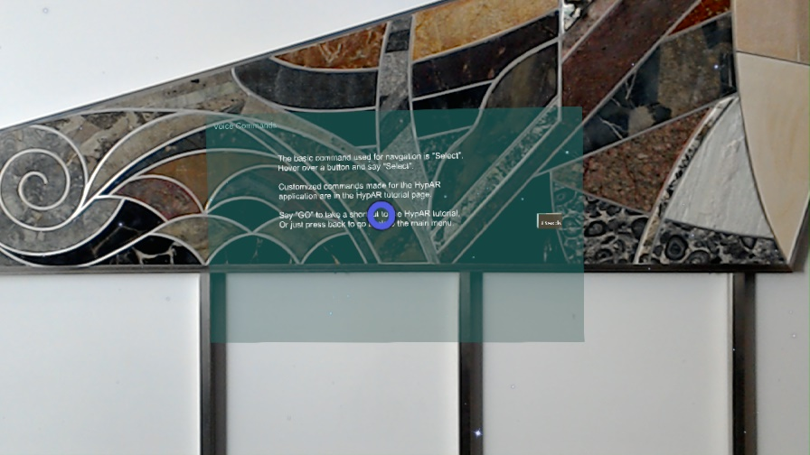

Figure 3.3: Voice command tutorial showing all commands the user can say.

Experienced and inexperienced HoloLens users are able to start the application immediately. The user needs to be standing directly in front of the Daedalus Wing (at a distance of at least 2 metres) for the application to recognise it. Once recognised, labelled buttons appear on top of points of interest. The user is then able activate them upon selection, once activated a number of visualizations appear (Figure 4):

* Line graph of hyperspectral data(reflectance/wavelength)
* Simplified name of mineral segment
* Textual information from Daedalus Wing flyer
  + Full name/nickname of segment
  + Mineral/Chemical content
  + Location excavated
  + Age/Period which was formed

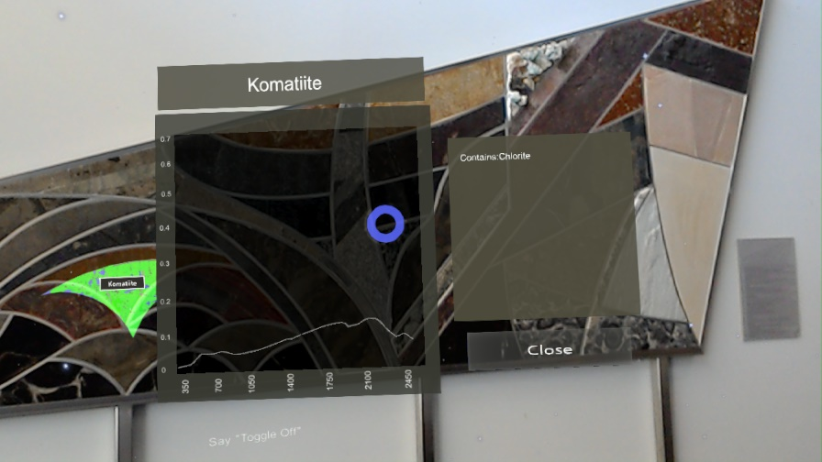

Figure 4: Data chart of Komatiite.

The overlay is not present when starting HypAR, however can be toggled on and off. If the overlay is “On,” the spectral image will be present upon selection. The overlay is able to be toggled on and off at any time during the use of HypAR using voice command.

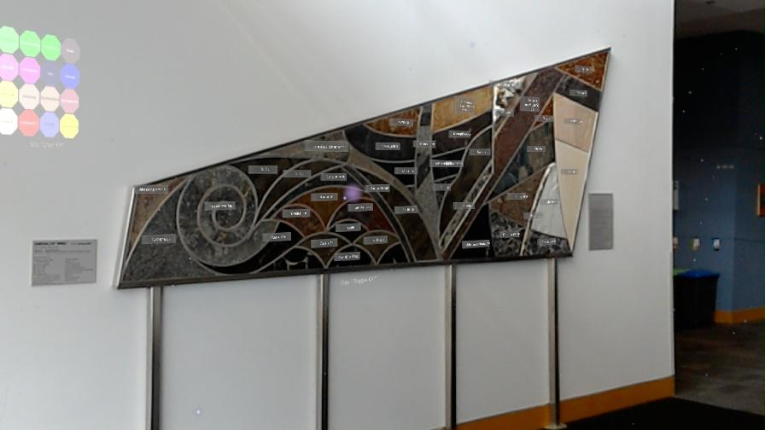

Figure 5: HypAR mineral overlay toggled off.

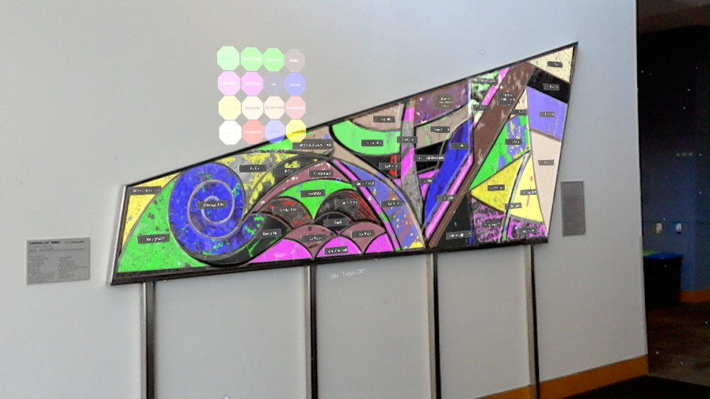

Figure 6: HypAR mineral overlay toggled on.

## User Interface

The design of the user interface was to be minimal and understandable, however it is to output maximum visual information of the Daedalus wing. The main solution was to visualize as much data to the user without cluttering their view. The HoloLens only provides a limited field of view for virtual objects, meaning less clutter is better for an efficient design. By default, information is presented directly into the user view. The user is able to manipulate the view of this information by hand dragging it. The reason for this is to allow the user to be completely in control of their virtual environment. In a real world example, the user is present in front of a mine face. Potential incidents can be caused by virtual objects blocking the user view of real objects. The Hyperspectral overlay represents the mineral composition of each segment of the Daedalus Wing. Implementing voice commands is essential for de-cluttering view, additionally if the user has no hands free they can toggle the face map at any time. The user can view spectral data, as well as see the RGB mineral values.

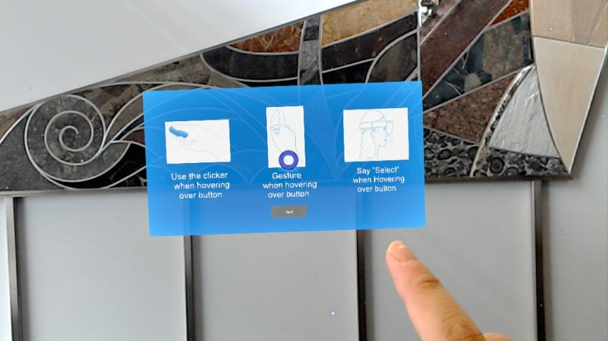

Figure 7: Initial tutorial screen

# Implementation Process

## Gathering Data

Before Implementation, photos of the Daedalus Wing needed to be taken. From these images, 10 points are marked. The points represent the areas where it will be scanned. The machine used to take these scans is the Spectral Evolution oreXpress field spectrometer

From each point I was able to gather its reflectance values over wavelength. These values are used to implement the spectral graph. The spectrometer also gave the mineralogy of each point, assisting in the development of the hyperspectral overlay.

## Data Processing

HypAR was created using Unity which uses C# language and Visual Studio builds the application to be deployable on the HoloLens. Vuforia was used to apply the overlay onto the Daedalus Wing. Vuforia allows for the close interaction between virtual objects and the real world. Vuforia recognises the Daedalus Wing, which is saved in a database. The database is then loaded into Unity for the overlay to be placed on top of it. This is how the overlay looks “on top” of the Daedalus Wing. During the whole development process, HoloLens specific features were added to the application. Microsoft Holographic Academy essentials are included in HypAR such as Gaze, Gesture, Voice and Tag-along. HoloToolkit is an essential extension for Unity provided by Microsoft. HoloToolkit scripts and materials contributed to HypAR buttons, voice commands and spatial sound.

The scanner produced 2 different CSV files, spectra and mineralogy. Using a C# script₄, the spectra CSV file was read, and the reflectance plotted over the wavelength. Wavelength ranges from 350 to 2500. Each point on the Daedalus Wing produces a graph, therefor 10 graphs per segment.

|  |  |  |  |  |
| --- | --- | --- | --- | --- |
| Wavelength | 1a_01 | 1a_02 | 1a_03 | 1a_04 |
| 350 | 0.136046 | 0.219545 | 0.126438 | 0.052421 |
| 351 | 0.136077 | 0.219478 | 0.129258 | 0.055475 |

Table 1: Small sample of spectra data collected. Shows 4 scans made on segment 1a of Daedalus Wing.

The graph is plotted against a graph container, with an x (wavelength) and y (reflectance) axis. All other textual information were found on the Daedalus wing flyer (Figure 8). Textual information such as: name, chemical composition, location and age were provided. I used Unity’s default text to speech asset to “voice over” the flyer information when the user selects a segment. The user can then listen to the audio, as well as read.

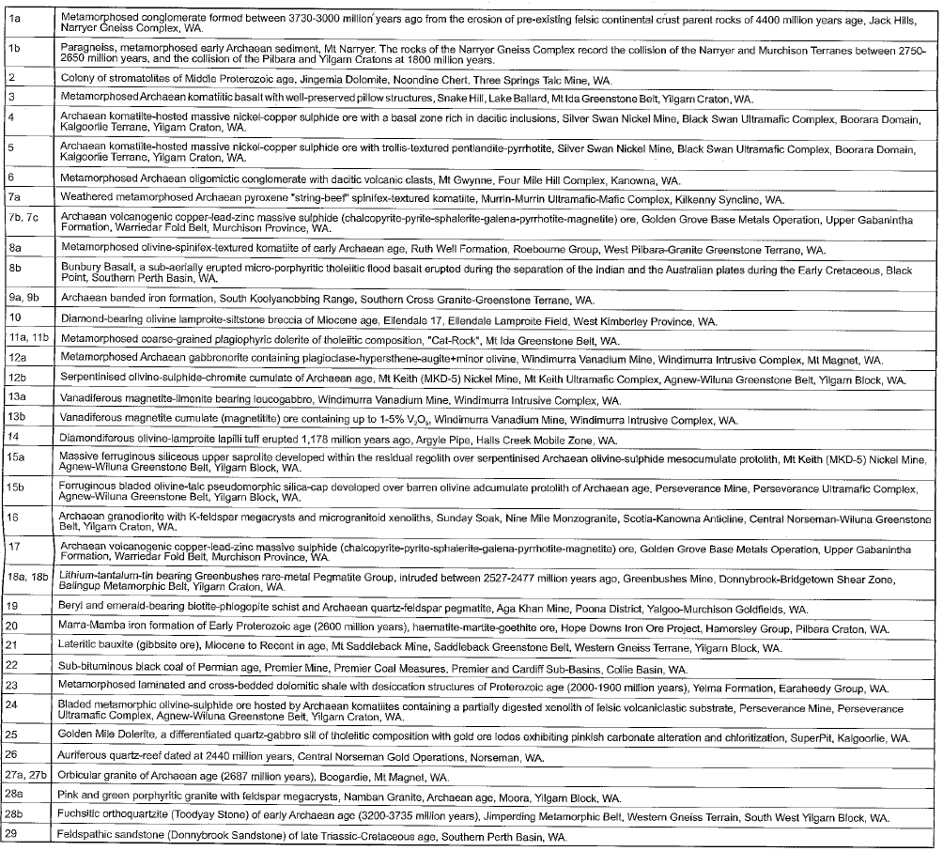

Figure 8: Daedalus Wing flyer containing all information for each segment

## Creating the Overlay

In order to map the mineralogy values on each point of the Daedalus wing I needed to turn the image into grayscale. The domain scientists obtained the scientific RGB values of each mineral in the mineralogy CSV file. Using Photoshop, the points were mapped to their specific RGB values producing a colour spectral overlay for the Daedalus Wing.

|  |  |  |
| --- | --- | --- |
| Sample | Mineral 1 | Mineral 2 |
| 1a_01 | Muscovite | NULL |
| 1a_02 | Muscovite | NULL |
| 1a_03 | Muscovite | Magnesite |
| 1a_04 | Muscovite | NULL |

Table 2: Minerology sample from 1a segment, showing minerology of 4 scans.

|  |  |  |  |
| --- | --- | --- | --- |
| Name | B | G | R |
| Muscovite | 128 | 256 | 255 |
| Magnesite | 255 | 0 | 0 |

Table 3: Class colour chart for Muscovite and Magnesite.

The mineral overlay mimics the output which a hyperspectral camera may produce. Currently the overlay is not “real” since it was produced from static point measurements, and not from a real camera.

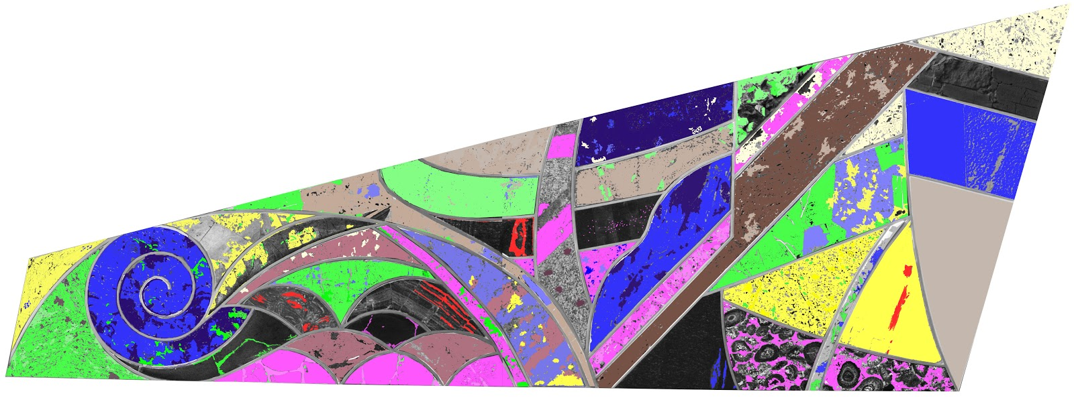

Figure 9: Final mineral overlay for the Daedalus Wing, made in Adobe Photoshop CC 2019.

# Issues

The original project abstract intended to use a hyperspectral camera to capture the overlay. Unfortunately, the hyperspectral camera was not available to us. As an alternative the hand held machines were used to gather point data on the Daedalus. The solution resulted in manually developing the mineral overlay in Photoshop (Figure 10). The goal of developing a manual mineral map is to mimic the look of real hyperspectral camera output (Figure 11).

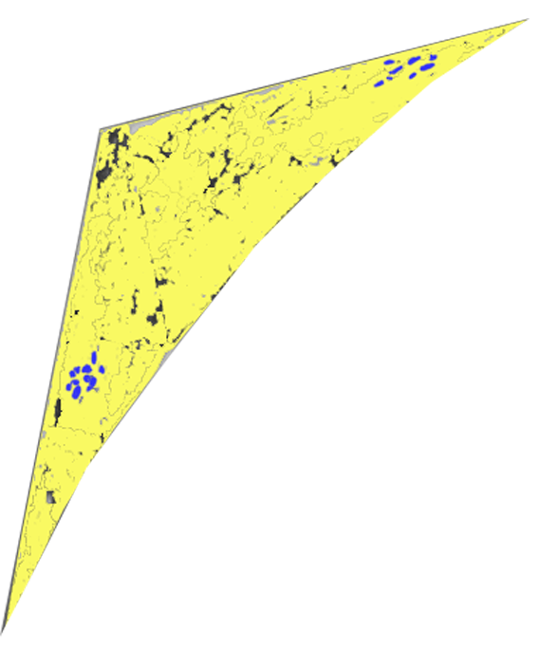

Figure 10: Segment 1a of Daedalus Wing with mineral map (made in Photoshop CC 2019).

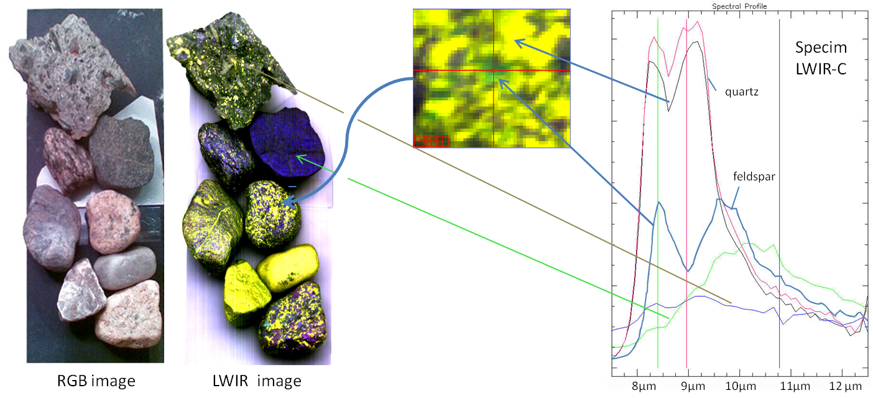

Figure 11: Example of hyperspectral camera output, with similar results to HypAR overlay₂

In order to test HypAR with full augmented reality features, it needed to be deployed onto the HoloLens. Vuforia is not supported by HoloLens emulator, as well as the Unity editor. In order to test HypAR, it must be built in Unity and then deployed in Visual Studio. The time taken to complete this task is much longer than testing a script. On average each test would take 3 minutes.

## HoloLens Limitations

Upon testing the graphs, I noticed that the HoloLens was struggling for frames per second. The spectral CSV file contains over two thousand data points. The HoloLens cannot handle large data sets such as the spectral data. My solution was to subsample the data points, only keeping the 30th data point. The final graph will be missing data points but the shape of the graph is not greatly impacted. The interest points are the spikes and troughs in the data set. These points determine minerals contained in that particular segment of the Daedalus Wing. As long as these interest points are not impacted, the graph can be viable.

Whilst testing the position of the UI elements, issues arise when the user is moving. The elements appear to be “shaking” during user movement, this is due to the HoloLens calculating the position relative to the Daedalus wing, since it is a fixed position. My solution was locking the elements in space when the Daedalus Wing is recognised, however this brought upon more issues. Even though the shaking was solved, the HoloLens does not fix the position based on rotation, only position. As the user walks on an angle to the Daedalus wing, the UI elements are locked on a frontal view. From these results I decided to keep the original approach, but additionally trying to optimize the HoloLens as much as possible to prevent shaking.

# Hardware and Software

The HoloLens is equipped with customised processors and is powerful in terms of spatial recognition and human tracking. The HoloLens has many cameras and microphones. Microsoft provides extensive documentation and tutorials for how to develop for the HoloLens (<https://docs.microsoft.com/en-au/windows/mixed-reality/academy>).

HoloLens 2017₃:

* 2GB RAM
* 64GB flash storage
* 32-bit Intel processor
* Microsoft Holographic Processing Unit(HPU)
* Built in Windows 10, Wi-Fi, Bluetooth connectivity
* Clicker accessory for the HoloLens 2017

The development software which is recommended by Microsoft for HoloLens is Unity 2017.4.x, with the addition of Microsoft HoloToolkit₃.

* Unity 2017.4.19
* Visual Studio 15.9.4
* Microsoft HoloToolkit 2017.4.3.0
* Vuforia 6.2.10
* Adobe Photoshop CC 2019

# Testing

The purpose of user testing throughout the system design is to gain feedback from users concerning their experience with HypAR. Testing with a range of different users challenges the validity of data and the efficiency of the user interface. In addition to ongoing feedback from geoscientists who were involved in the iterative system design, we received user feedback from approximately 10 domain scientists who walked past when we regularly tested the system at the Daedalus Wing. Each user wore the HoloLens for a varying amount of time to use HypAR and they were encouraged to ask any questions they may have or provide feedback on the usability of the system. While this was not an organised user study it provided us with invaluable input towards the system design for HypAR.

## Occlusion and Clutter

In the first demonstration for HypAR, occlusion was found between objects. This user test was done with myself and 3 other users. The purpose of this test was to visualise the placement of objects and the menu. We found that there were too many menu screens present. As the user moved their head, these objects followed the user’s field of view, this caused the clashing of objects. We realised that we needed to simplify the design to prevent clutter and occlusion.

## User Input

Approximately 10 users, which are inexperienced with the HoloLens were asked to use the Gesture command to interact with buttons. Most users struggled with this command and were not able to use HypAR to its full ability. In early development, the Gesture command was the only mode of input. After user testing, voice commands and the clicker (Figure 12) were added as user input.

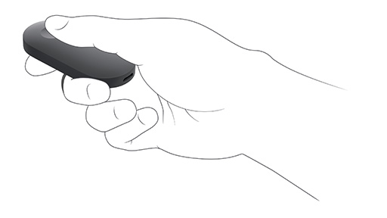

Fig 12. HoloLens Clicker which works like a button click

## User Gaze

One user raised attention to the size of the cursor used for gaze navigation. This user was not able to see the cursor and therefore was not able to select buttons. The buttons during user testing were not intractable, meaning no feedback is given to the user if they are gazing over it. This made it difficult for users to recognise if they are gazing over a button. My solution was to increase the size of the cursor, as well as make all buttons change colour when gazed over, and audio feedback when clicked.

# Discussion

The design of HypAR is tailored for geoscientists, and we cater for both novice and experienced HoloLens users by implementing a tutorial. HypAR is designed to give a user experience which is satisfying and easily understandable. The user can be immersed in spatial sounds, visualisations and intractable objects in a virtual world. Users who are not geoscientists can also find this application educational. Users learn the importance of the spectral bands, and how these bands represent the minerals which cannot be seen by the human eye.

In terms of data validity, most are accurate. The only inaccurate aspect to HypAR is the overlay. The placement of colour values were done manually based on the greyscale image of the Daedalus Wing. I am not an expert in geology, and I placed my trust in the mineralogy data given to me. Manual development of the overlay also meant that RGB values are not “pixel perfect,” and there are imperfections in colour placement. I tried however to make it as accurate as possible. Some of the data sets in the mineralogy CSV were empty. I needed to ask domain scientists about the contents of the mineral, as well as make an intuitive decision of where to place these colours.

Overall, HypAR is able to demonstrate various types of data visualisation using spectral data. Its function is to display data graphs, mineral mapping on a surface and local information about the Daedalus Wing. HypAR is successful in implementation in terms of displaying sufficient amounts of data. HypAR is a demonstrator for the capabilities of augmented reality in geoscience for representing mineral data. This data is invaluable and indispensable for geoscientists when determining the mineral composition of rocks contained on sites.

# Future Development

For further development, a hyperspectral camera would be ideal for use in HypAR. As stated in issues, a hyperspectral camera was not available to implement with the current version of HypAR. The camera is much more accurate, and much less processing would be needed. With a camera, there are more opportunities for machine learning and testing on a real mine face. This version of HypAR is a demonstrator for the capabilities of AR for visualising data, not in real time. HypAR also has the capability of expanding the types of data it has. At the moment it holds hyperspectral data, however if developed further it can hold more information to display. For example: data from different bands of the spectrum.

Diggers waste tons of coal each day due to not knowing the full content of each sample they dig up. With the further development of HypAR, they would be able to see the mineral content of each sample to make informed decisions of what is waste, and what is valuable.

The user can have a camera attached to them, as well as the HoloLens. This way the user can see a live stream of the camera output, whilst processing in real time. The user can then visualise processed data in the moment, rather than manually develop graphs. The HoloLens is a hands free device and HypAR is implemented for voice commands, meaning the user has the ability to multitask. Collaboration of multiple HoloLenses₇ will be a game changer by allowing multiple scientists to view mineral compositions at any one time. Opinions and discoveries can be shared between users, even from across the world.

# References

1. Shippert, Peg (2004). Why use Hyperspectral Imagery? *Photogrammetric Engineering and Remote Sensing 70(4), 377-380.* Available at: <https://www.researchgate.net/publication/241258216_Why_Use_Hyperspectral_Imagery>
2. wikimedia.org (2019) *File:HSI LWIR stones.png*. By Aappo, CC BY-SA 3.0 Available at: <https://commons.wikimedia.org/w/index.php?curid=17686740>
3. Microsoft.com (2019) *Windows Mixed Reality documentation*. Available at: <https://docs.microsoft.com/en-au/windows/mixed-reality/>
4. YouTube (2019). *Unity Tutorial – Create a Graph*. Available at: <https://www.youtube.com/watch?v=CmU5-v-v1Qo&t=344s>
5. C. Laukamp et al. / Ore Geology Reviews 73 (2016). *Proximal and remote spectroscopic characterisation of regolith in the Albany–Fraser Orogen (Western Australia)*. Available at: <https://www.sciencedirect.com/science/article/pii/S0169136815300974?via%3Dihub>
6. Usability.gov (2019). *User-Centred Design Basics*. Available at: <https://www.usability.gov/what-and-why/user-centered-design.html>
7. Nguyen, Huyen, Peter Marendy, and Ulrich Engelke. "Collaborative framework design for immersive analytics." In *Big Data Visual Analytics (BDVA), 2016*, pp. 1-8. IEEE, 2016.

# Appendix

How to deploy application from Unity to the HoloLens. (Unity version 2017.4.18f1)

1. Go to File
2. Go to Build Settings
3. Select Build

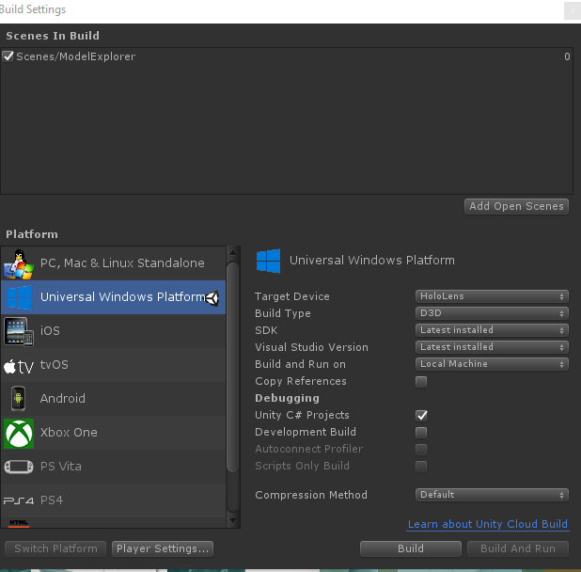

1. Select the “App” folder (contains the visual studio solution)
2. Open the Solution (If HypAR.sln doesn’t work, use ModelExplorer.sln)

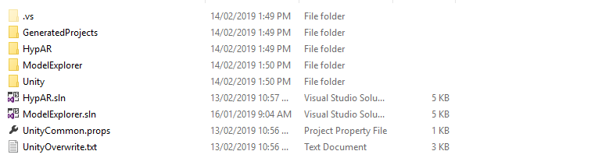

1. In Visual Studio, go to Debug/Start Without Debugging
2. If there is an error to connect to IP address ***.***.***, then go to the HoloLens and check the IP address
3. In Visual Studio, go to Project/HypAR Properties/Debug
   1. Put the new IP address in
4. Follow step 6 again

|  |  |  |
| --- | --- | --- |
| CONTACT US  t 1300 363 400  +61 3 9545 2176  e csiroenquiries@csiro.au  w www.data61.csiro.au  we do the extraordinary every day  We innovate for tomorrow and help improve today – for our customers,  all Australians and the world.  WE IMAGINE WE COLLABORATE WE INNOVATE |  | For further information  Ulrich Engelke Senior Research Scientist  e Ulrich.Engelke@csiro.au  w www.data61.csiro.au  Jens Klump Team Leader CSIRO  e Jens.Klump@csiro.au  w www.csiro.au/en/Research/MRF  Casey Rogers Summer Vacation Student  e Casey.Rogers@csiro.au |
|  |  |  |