Cayde Brummer

Abstract

Screenshots of the API calls performed by the backend application.

APDS7311

API Calls

Table of Contents

Sign Up 2

Login 3

Create Post 4

Show all posts 5

Delete a post 6

API CALLS

# Sign Up

The user will sign in, creating a user in the database.

# 

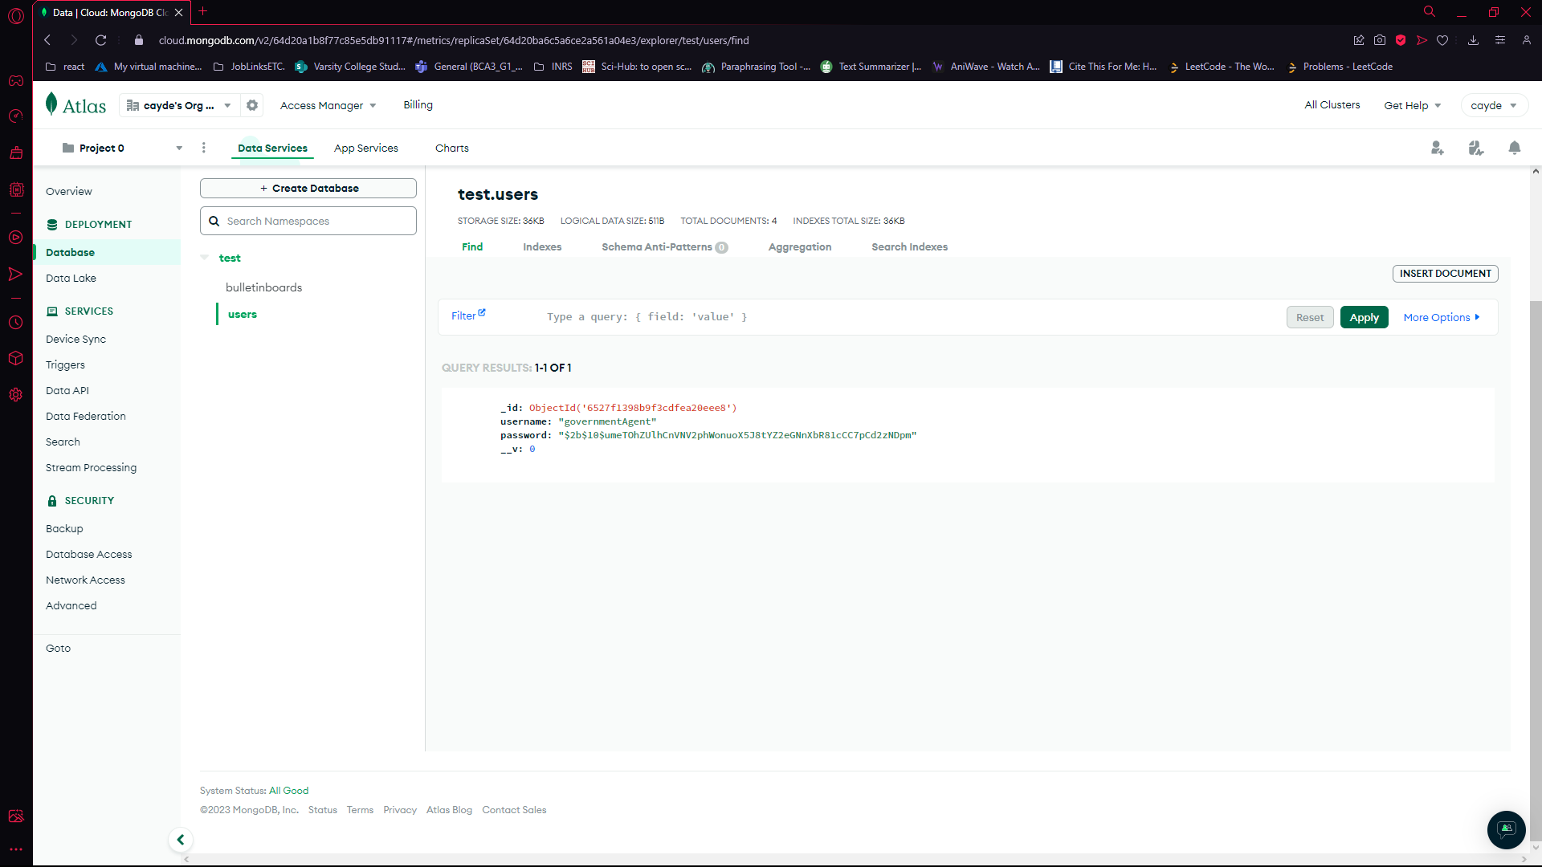

# Login

The user will log in, and a jws token will be assigned to them, giving them the functionality to create and delete bulletinBoard items. It will only last for one hour before the token expires.

# 

# Create Post

The user is verified with their token, and then they can post.

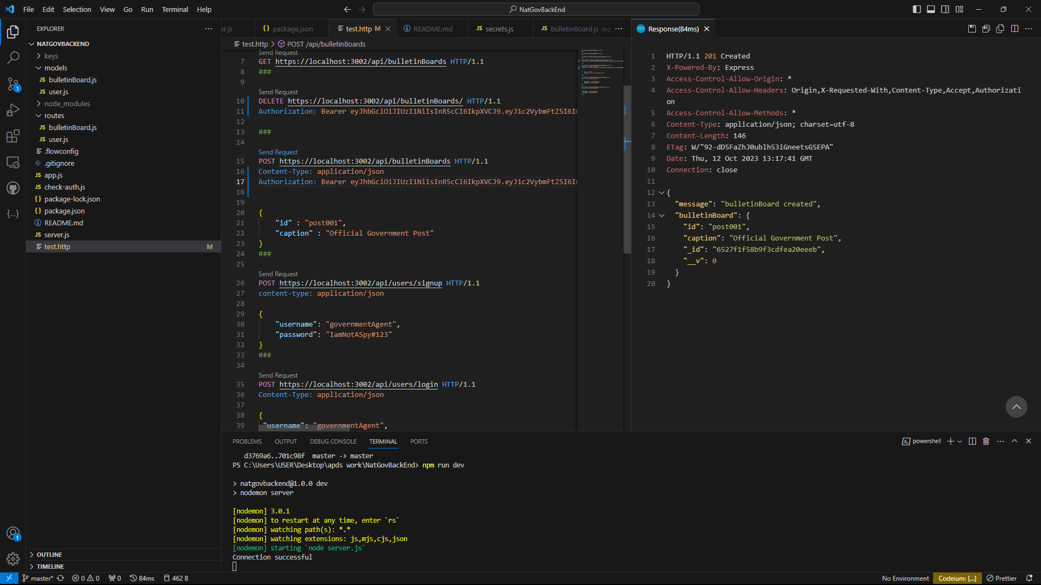

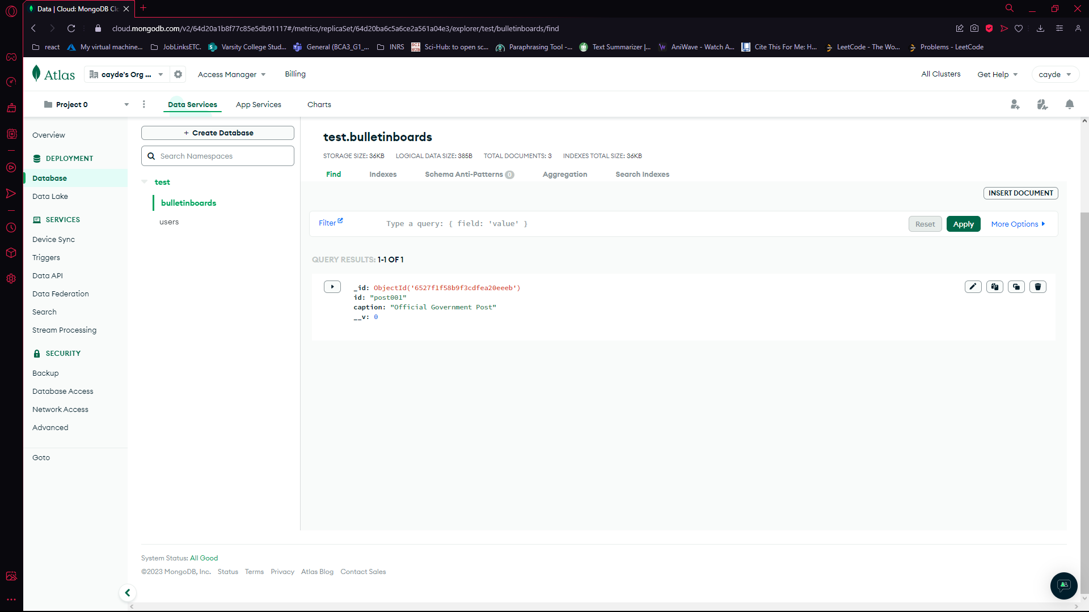

# Show all posts

I have created some extra posts to show that more than one post is being fetched.

# 

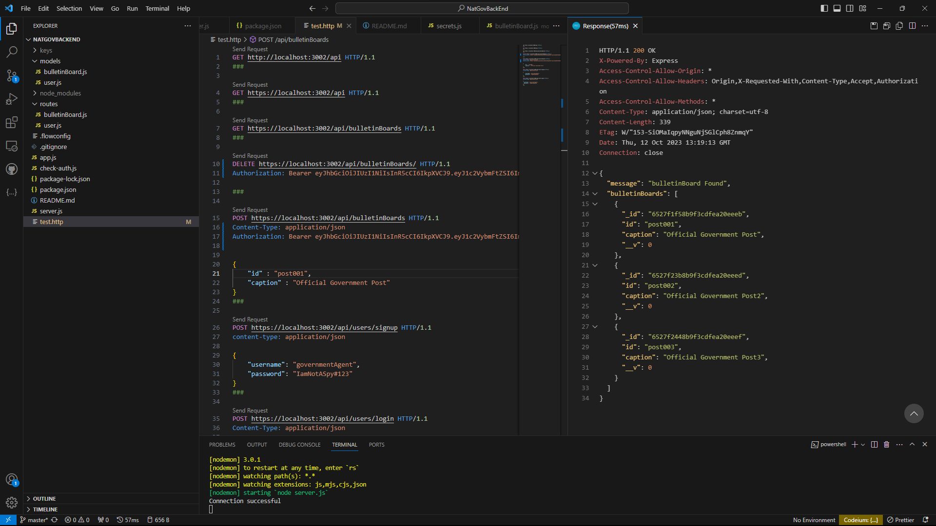

# Delete a post

The user is verified with their token, and then they can delete a post.

