Contents
Software Specification Requirements for Digit Span Task 2
1. Software Perspective 2
2. Software Functions 2
3. User Characteristics 2
4. Constraints 3
5. Assumptions / Dependencies 3
6. Specific Requirements 3
6.1 User Interface 3
6.2 Hardware Interface 3
7. Functional Requirements 3
7.1 Trial Generation 3
7.2 Age Based Timing 3
7.3 Response Handling 4
7.4 Audio-Based Presentation 4
7.5 Results Display 4
8. Non-Functional Requirements 5
8.1 Performance Requirements 5
8.2 System Qualities 5
9. Data Management 5
10. Appendices 5
Appendix A: Age Timing Presets 5
Appendix B: Data Output Format 6

https://www.psychopy.org/download.html
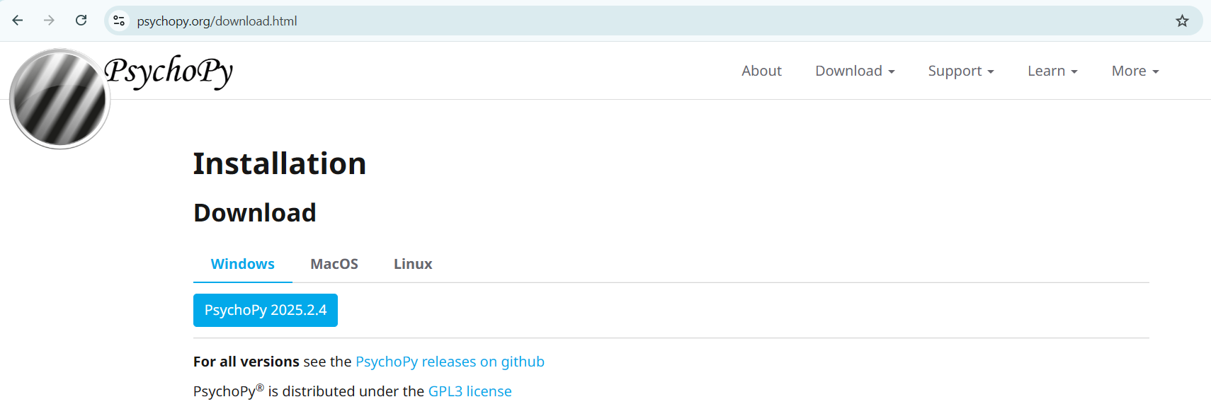

Software Specification Requirements for Digit Span Task

1. Software Perspective
1.1 The system is a single PsychoPy script.
1.2 It can be distributed as source or packaged using PsychoPy’s build tools.

2. Software Functions
2.1 It should collect participant metadata like Participant ID, Name, Age Group, Gender.
2.2 It should generate digit sequences for each trial with constraints “0-9, no immediate repeats).
2.3 It should present digits one at a time with configured display and “Interstimulus Intervals” timing.
2.4 Collect typed numeric responses with edit controls (backspace, enter).
2.5 Score accuracy and compute response Reaction Time.
2.6 Log trial data to a timestamped “CSV” file and “auto-save after each trial”.

3. User Characteristics
3.1 Primary user: researcher or experimenter.
3.2 Secondary user: participant “children to older adults”.

4. Constraints
4.1 Use only PsychoPy native modules like “visual, event, core, gui, data” plus Python standard library.
4.2 PsychoPy v2023.x compatibility and cross-platform support.
4.3 No external dependencies.

5. Assumptions / Dependencies
5.1 Assumes a working keyboard and display.
5.2 Timing accuracy depends on hardware and Operating System scheduling.
5.3 PsychoPy provides guidance on millisecond-level precision and practical limits.

6. Specific Requirements

6.1 User Interface
6.1.1 System should provide instructions, ready, stimulus, response, end screen and all what is needed.

6.2 Hardware Interface
6.2.1 System should support standard monitors and keyboards.
6.2.2 Numeric keypad input should be accepted when available.

7. Functional Requirements

7.1 Trial Generation
7.1.1 The system should run a default protocol of 10 trials with length [2,2,3,3,4,4,4,5,5,5], this should be able to be adjusted when a specific sequence is needed.
7.1.2 System should generate random digit sequences using digits 0-9.
7.1.3 The system should prevent immediate repeated digits within a sequence when enabled.
7.1.4 The system should allow full screen operation by configuration, can also be configured within the code as needed, by adjusting the “width and height”.
7.1.5 The system should show a ready screen before each trial.
7.1.6 During a test, the system should save the numbers exactly in the order the person types them. Do not rearrange or change the order in any way.

7.2 Age Based Timing
7.2.1 The system should provide 6 age group timing presets.
7.2.2 The system should display 1 digit per second.
7.2.3 The system should record timing used per trial in output.
7.2.4 The system should allow manual timing by editing AGE_PRESETS.
7.2.5 The system should implement “Interstimulus Interval” as a blank interval between digits.
7.2.6 System should provide longer response windows for children/older adults/clinical for usability.

7.3 Response Handling
7.3.1 The system should accept numeric input from keyboard and number row.
7.3.2 The system should support backspace or delete editing, like if a participant enters wrong digit during trails.
7.3.3 The system should submit on Enter or Return.
7.3.4 The system should treat empty responses as incorrect and log them.
7.3.5 The system should record reaction time from response screen on set to submission.
7.3.6 The system should allow exiting the session when pressed the “X” key on the keyboard.
7.3.7 The system should display entered digits in real-time on the response screen as they are typed by the participant.
7.3.8 Displayed digits should update immediately with each keypress and backspace operation.

7.4 Audio-Based Presentation
7.4.1 The system should support an audio-based digit span task using pre-recorded .wav files for digits 0–9.
7.4.2 The system should present digits sequentially by playing the corresponding audio file while maintaining the same order and timing constraints as visual presentation.
7.4.3 The system should apply the “Interstimulus Interval” as a silent gap between audio digit presentations.
7.4.4 The system should record whether audio presentation was enabled for each trial in the output data.

7.5 Results Display
7.5.1 The system should show immediate feedback like correct or incorrect after each trial before continuing.
7.5.2 The system should calculate and display the participant's final score for example "X out of Y correct") at the end of all trials.
7.5.3 The score display should appear before the end screen showing data save location.

8. Non-Functional Requirements

8.1 Performance Requirements
8.1.1 The timing of Digits or sounds in the test must be very precise, to match brain research standards.
8.1.2 This must be checked for accuracy.
8.1.3 Reaction times should be measured the instant something appears on the screen.

8.2 System Qualities
8.2.1 Reliability: Auto-saves after every question and handles unexpected exits smoothly.
8.2.2 Availability: Works completely offline after PsychoPy is installed.
8.2.3 Security: Only saves the data needed for the study, so no extra personal info.
8.2.4 Portability: Runs on Windows, macOS, and Linux using PsychoPy 2023.x.

9. Data Management
9.1 Each test session gets a uniquely named data file with the date and time in its name.
9.2 The file should contain all the required information columns.
9.3 Data is saved automatically after every question, so no progress is lost if the test stops early.
9.4 Every answer gets a timestamp.
9.5 All data files are saved together in a special "Data" folder.
9.6 The system will never accidentally overwrite an old file, so each file name is unique.
9.7 It should record whether the person ran out of time on a question.
9.8 It should record which age group setting was used for the test.
9.9 Save numbers exactly as it is, so the system should peep numbers as typed for instance "0123" stays "0123".
9.10 At the end, the system shows where the data file was saved.

10. Appendices

Appendix A: Age Timing Presets
Age Group | Display | Interstimulus Intervals | Responses
Children (6-8) | 1.0 | 1.0 | 30
Children (9-12) | 0.9 | 0.8 | 25
Adolescents (13-17) | 0.8 | 0.7 | 20
Adults (18-65) | 0.7 | 0.7 | 15
Older Adults (65+) | 1.0 | 1.0 | 25
Clinical | 1.2 | 1.2 | 30

Column | Meaning | Example (Adults: 0.7, 0.7, 15)
Display | How long each number stays on screen (seconds) | 0.7 seconds: Each digit like "5" is shown for 0.7 seconds, then disappears.
Interstimulus Intervals (ISI) | How long the blank/empty gap is between digits (seconds) | 0.7 seconds: After a digit disappears, there's 0.7 seconds of blank screen before the next digit appears.
Responses | How long the participant has to type their answer after all digits are shown (seconds) | 15 seconds: After the last digit, they have 15 seconds to type and submit their answer.

These above Presets are just estimates, real life values must be researched for accuracy, later after getting the values the above can be changed.

Appendix B: Data Output Format
CSV file columns: Timestamp, ParticipantID, AgeGroup, Trial, SequenceLength, PresentedDigits, Response, Accuracy, RT, TimedOut, TimingUsed.

