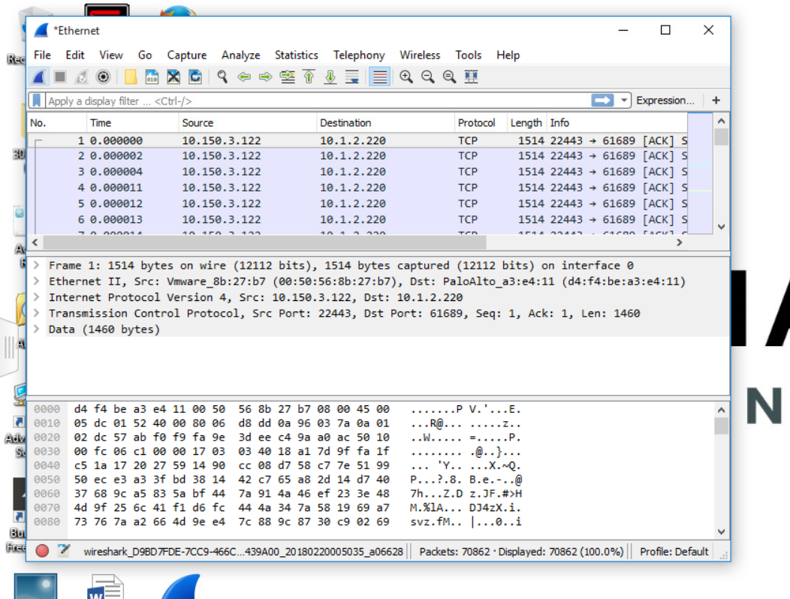

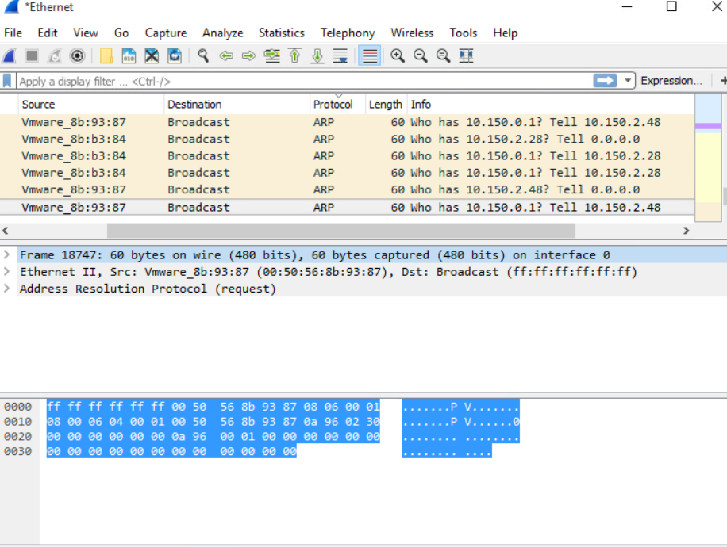



The protocol I analyzed is ARP.  
The Packet is asking who has 10.140.0.1? And if someone does own It the protocol tells 10.150.2.48. This is used when someone wants to create there own router connection. If no one holds 10.150.0.1, then a user could take ownership of the land.

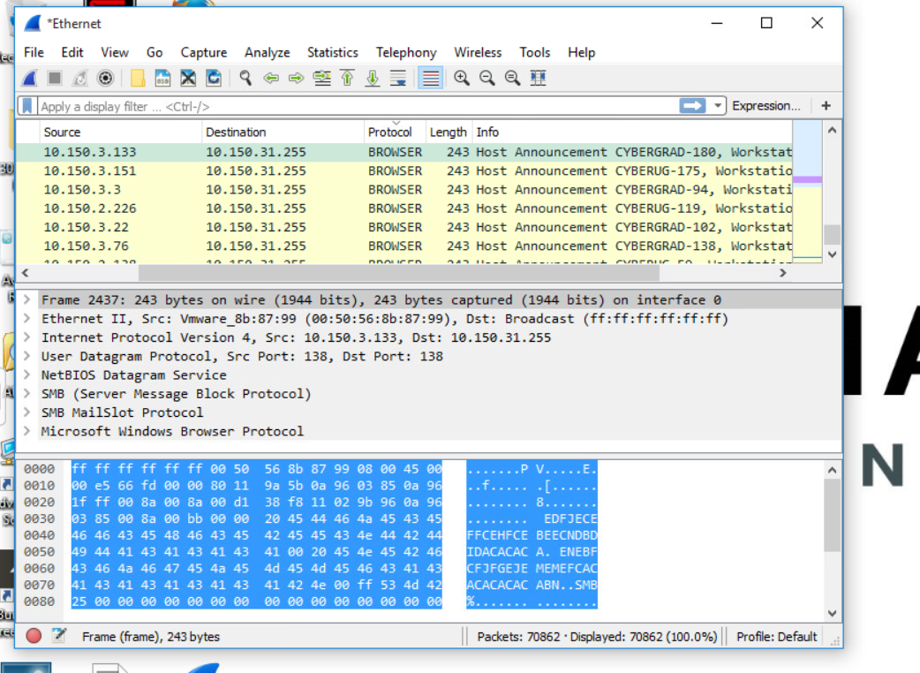

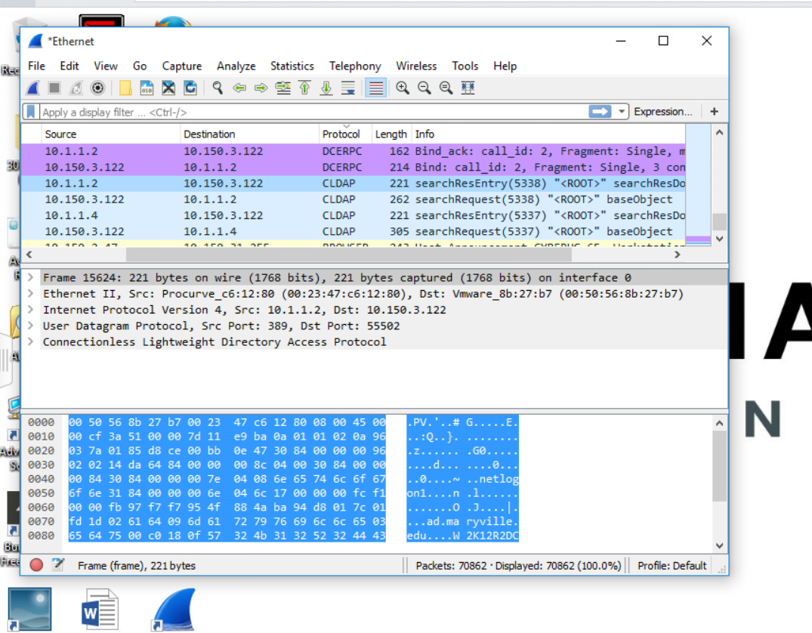

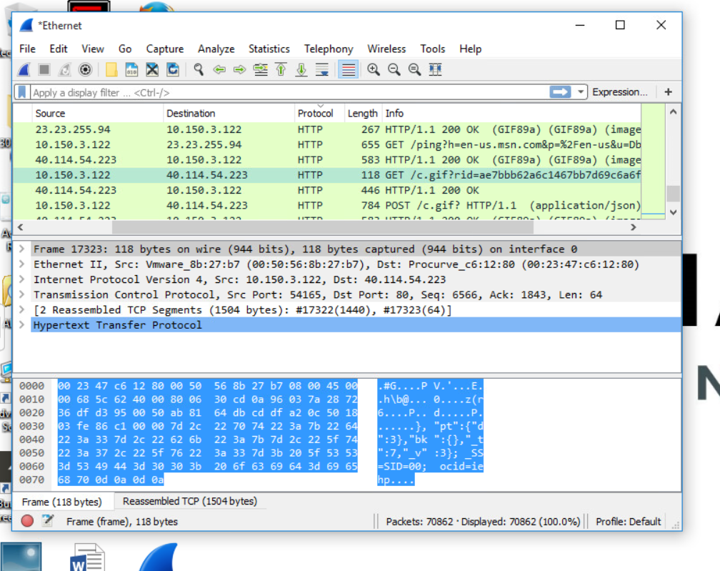

HTTP is the protocol to exchange or transfer hypertext.  
HTTP session source port was 54217 and it sent a get message to establish a connection between the client and the server.

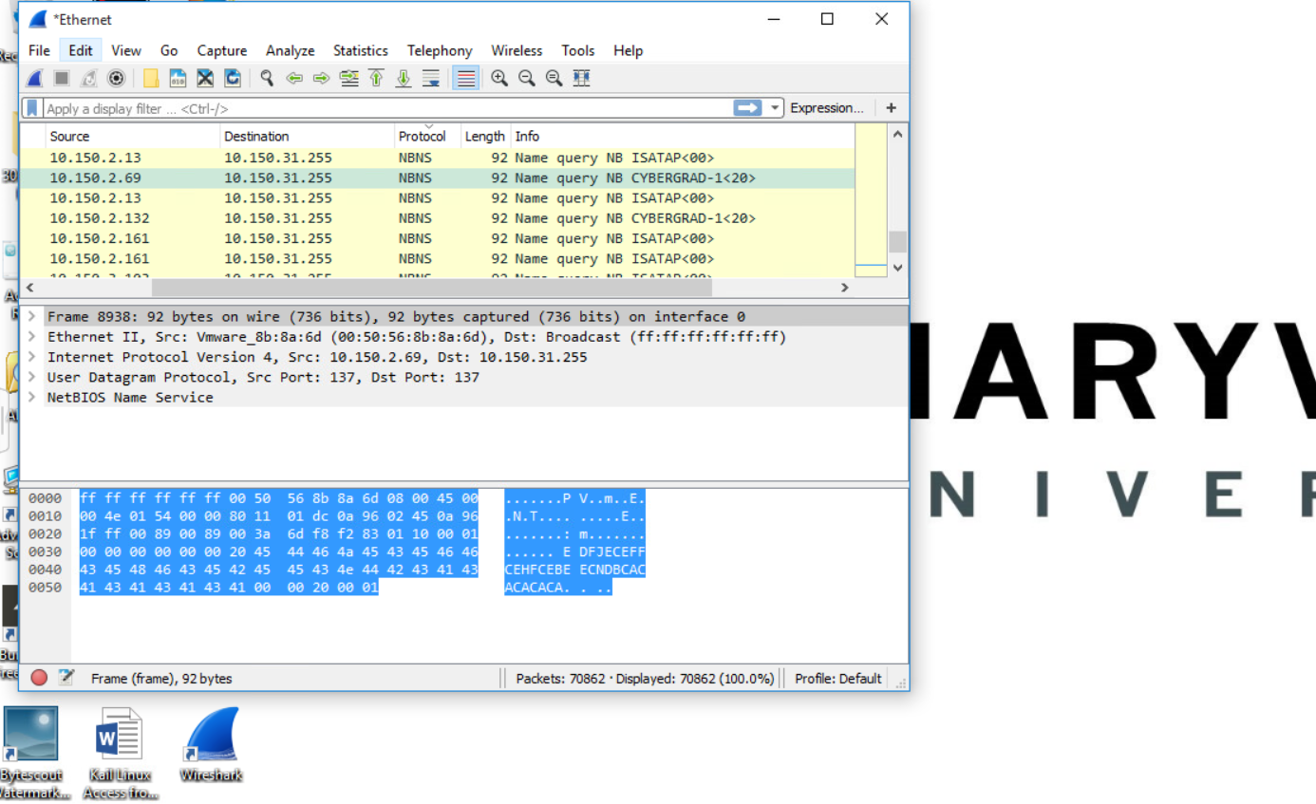

NBNS stands for The NetBIOS Name Service. This protocol translates names to IP addresses. The packet shows 92 Name quarry NB CYBERGRAD-1<20>. The NBNS makes a name query request to establish communication between a Windows computer and a NetBIOS computer. The NAME QUERY REQUEST message includes the name of the computer that initiated the connection which is why the Packet says CYBERGRAD.The user datagram protocol source port and restating port are both 137.