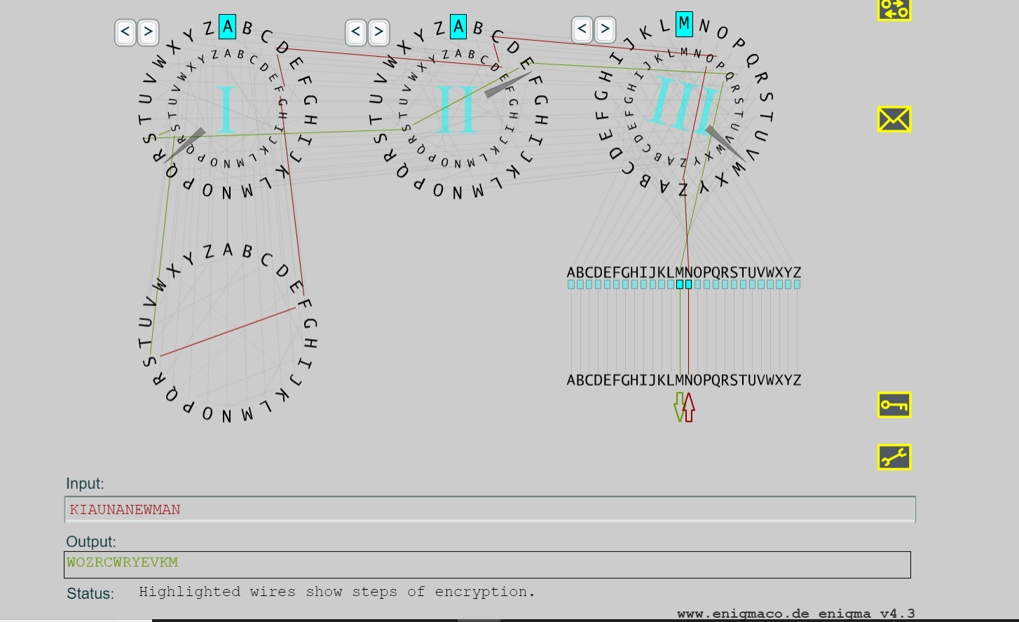

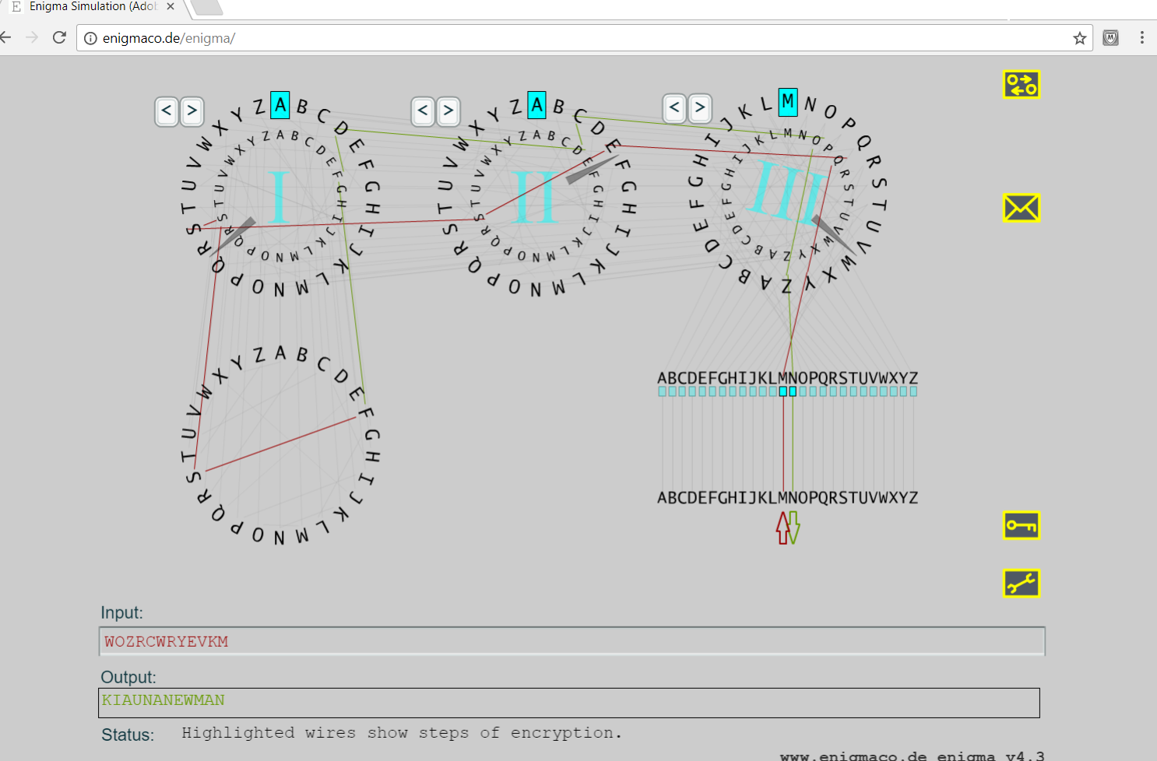

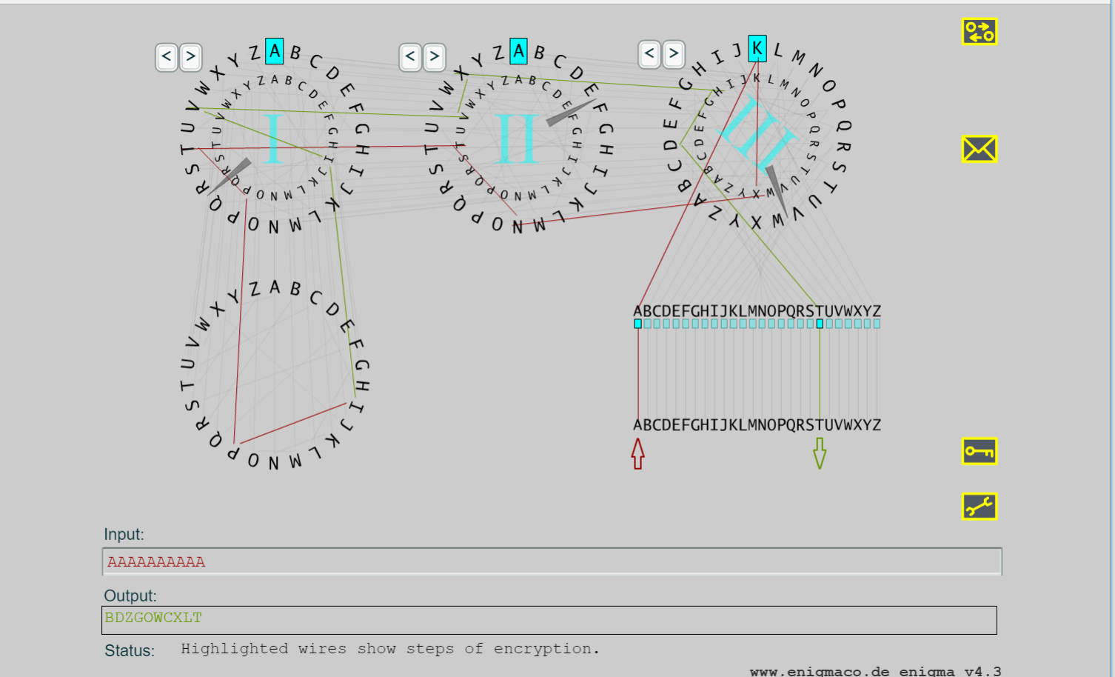

Write a paragraph discussing a type of encryption that you use on a regular basis on your phone/computer. Are there any security issue that concern you with your use of this encryption?

I use two encryption methods on my cell phone. The primary method is fingerprinting and the secondary method is a passcode. My phone uses my finger print to verify my identity. This prevents an unauthorized user from trying to hack into my cell phone. I’m concerned about the passcode encryption because it’s not as secure as the fingerprint.