12.1

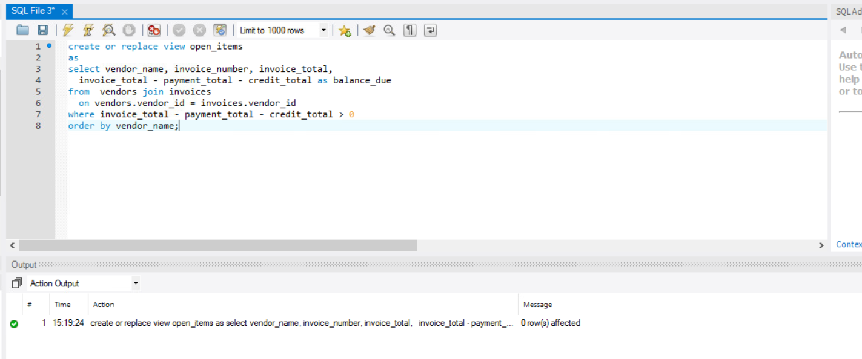

12.2

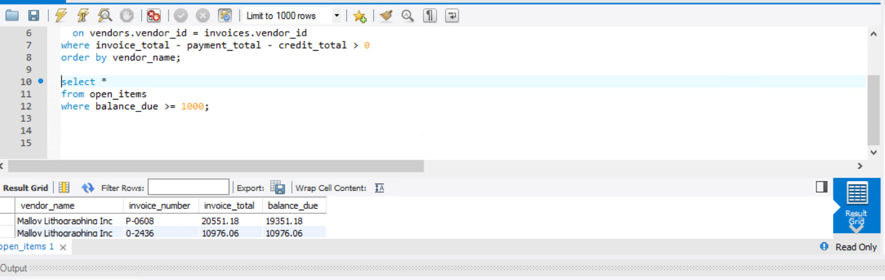

12.3

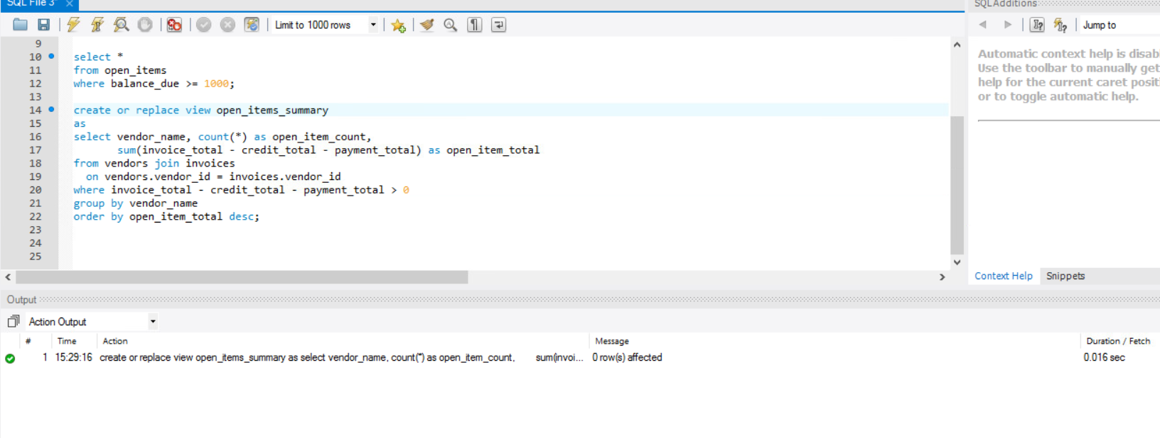

12.4

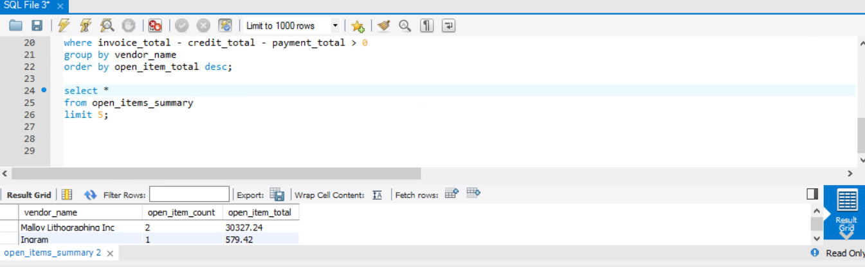

12.5

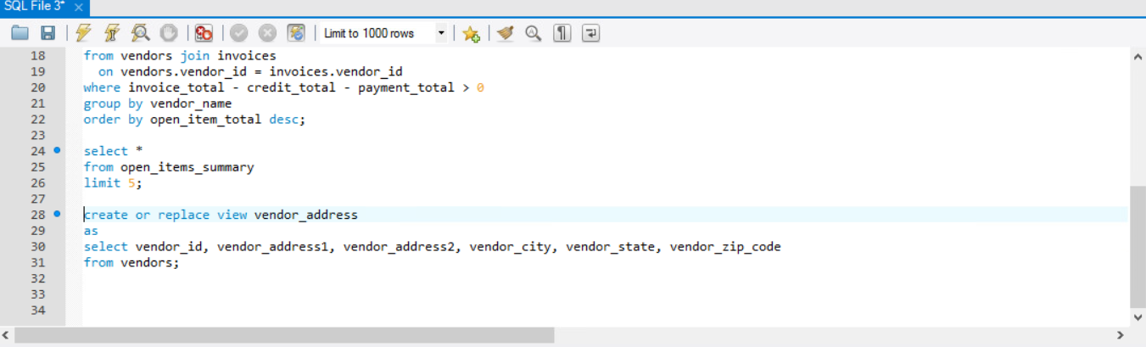

12.6

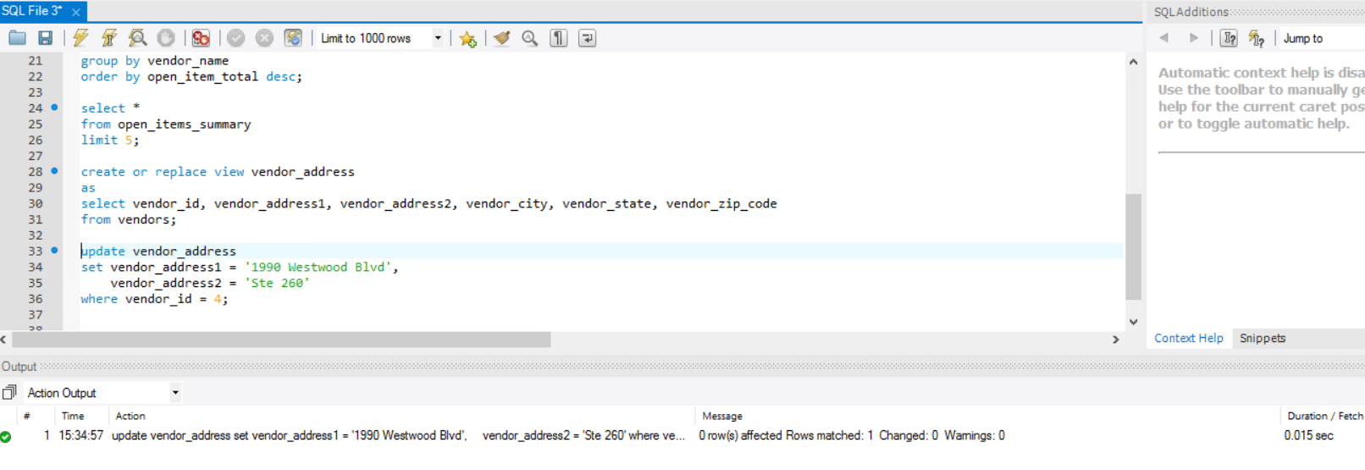

13.1

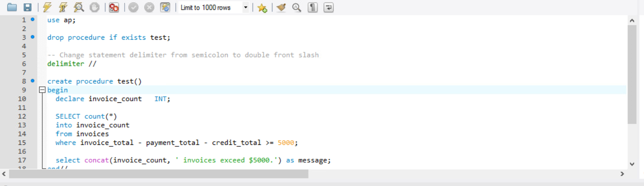

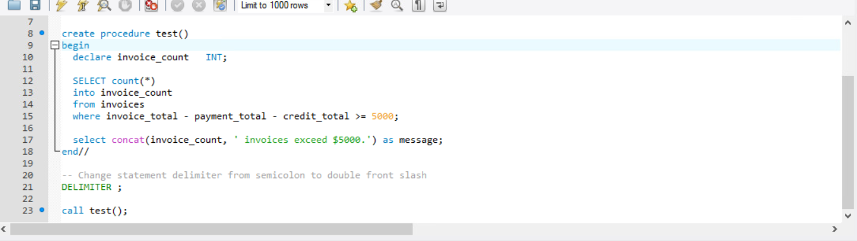

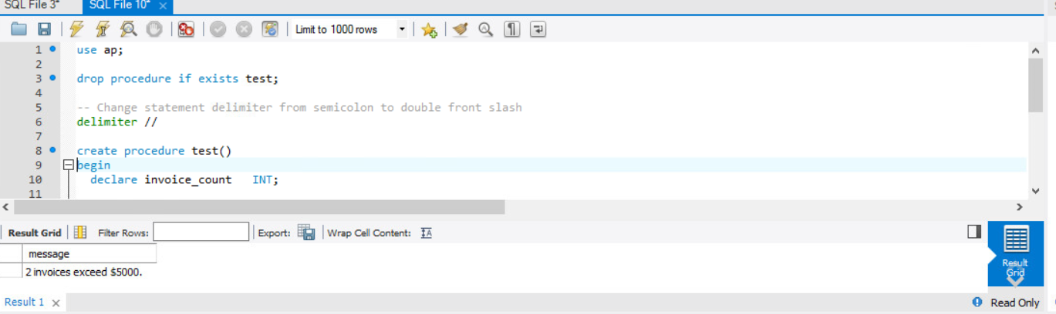

13.2

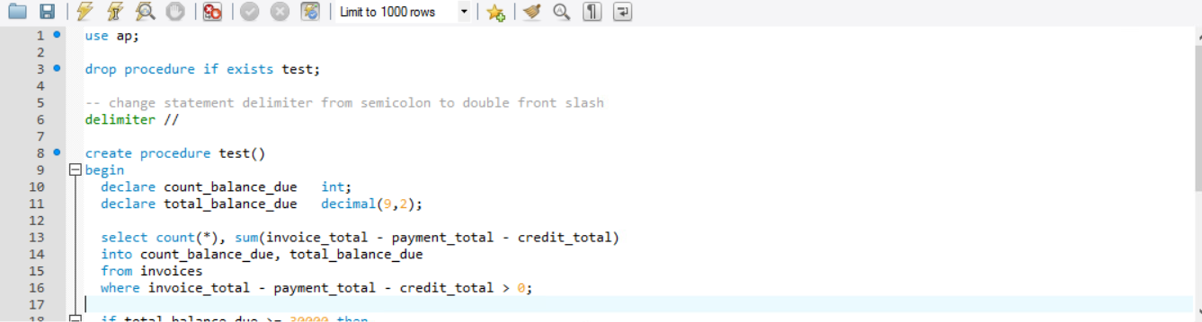

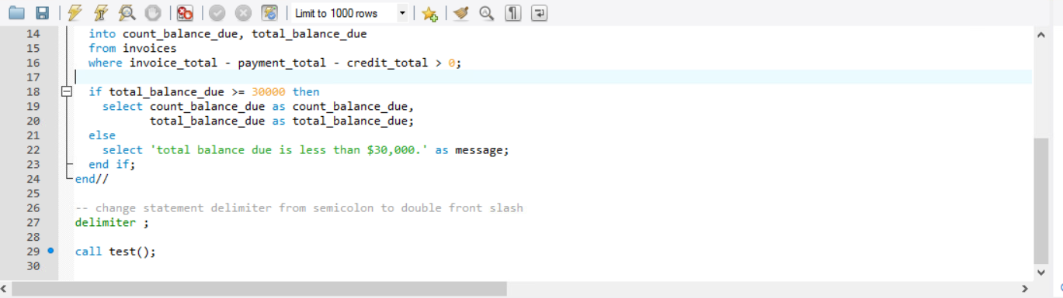

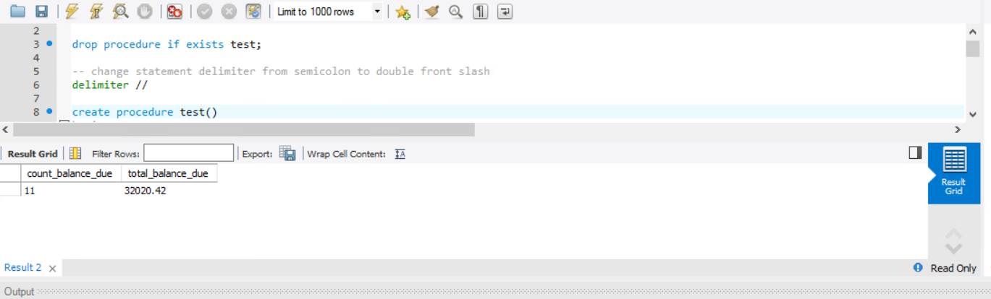

13.3

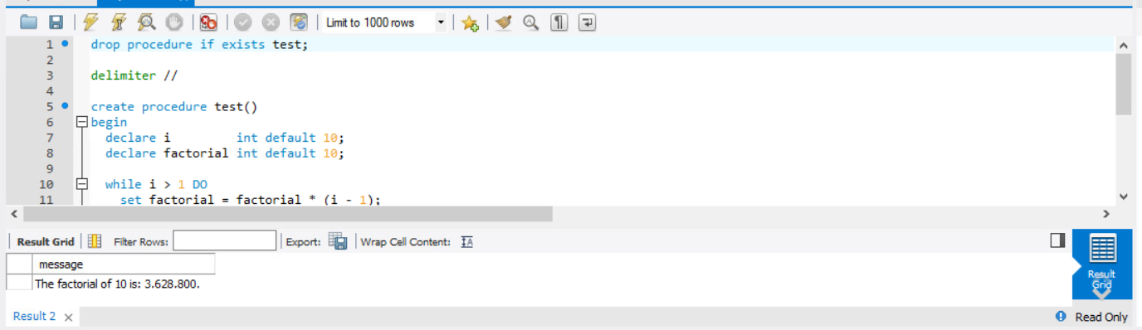

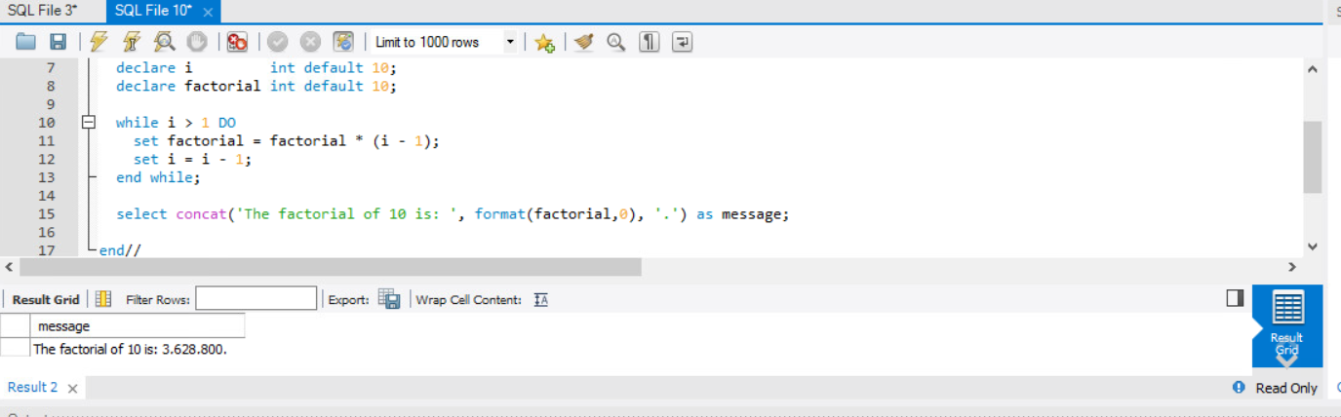

13.3





13.4

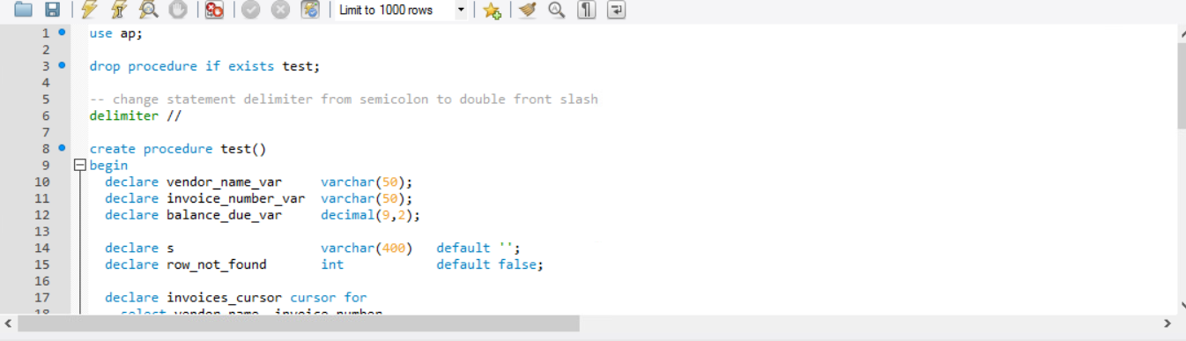

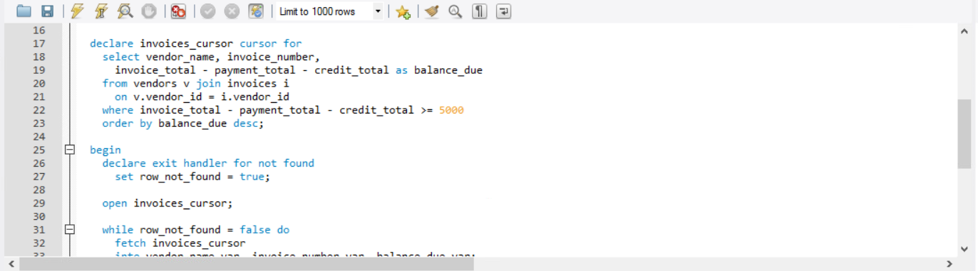

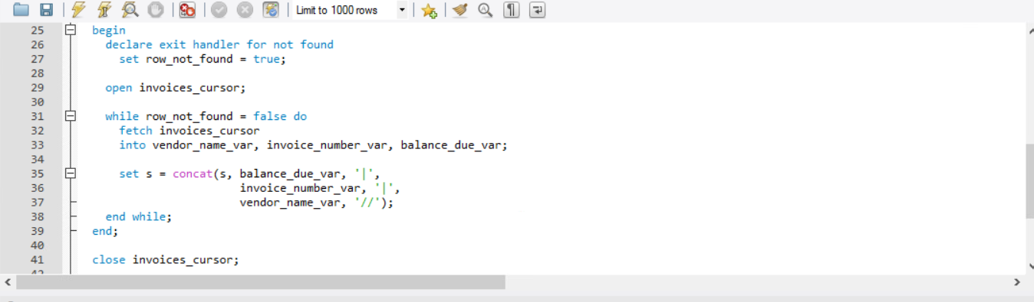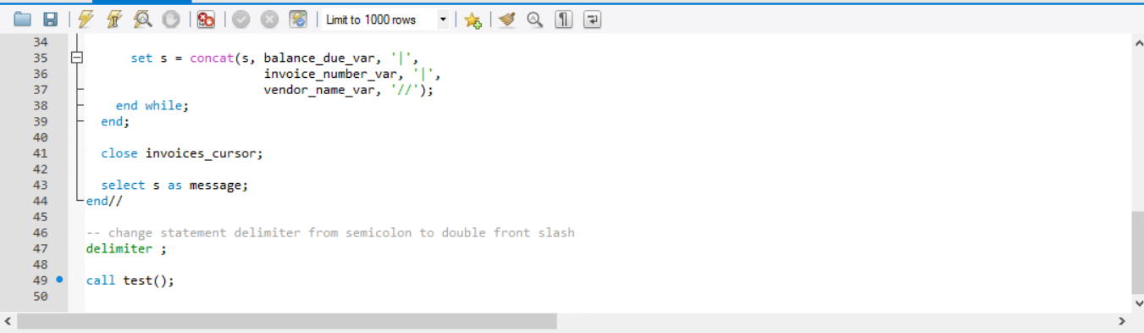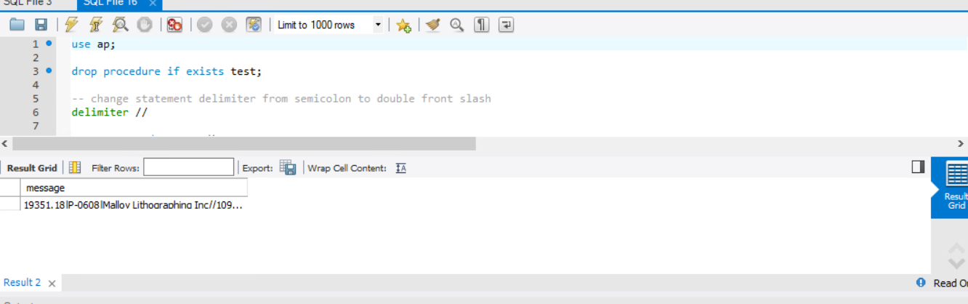

13.5

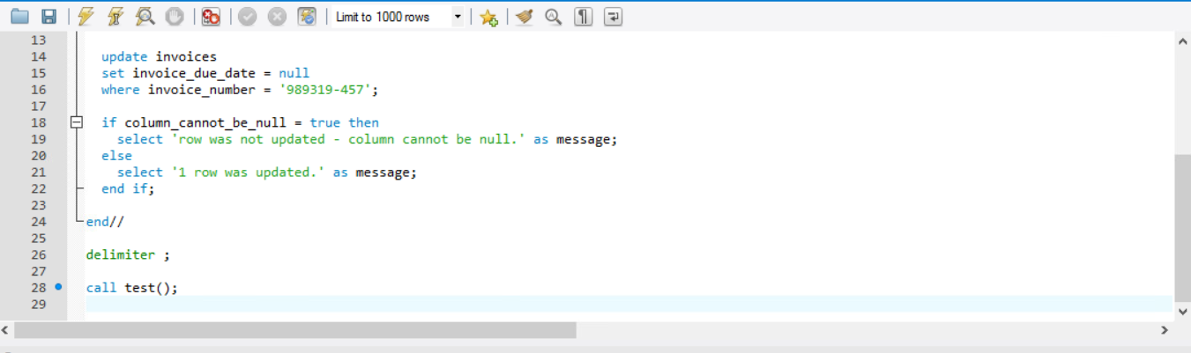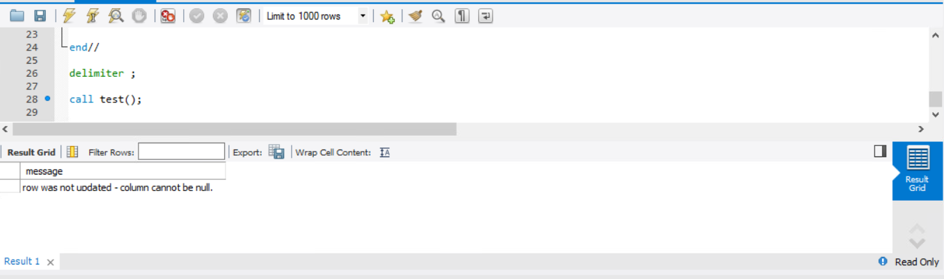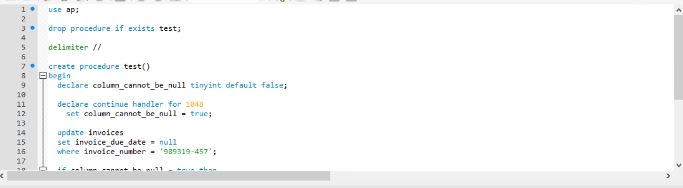

13.6

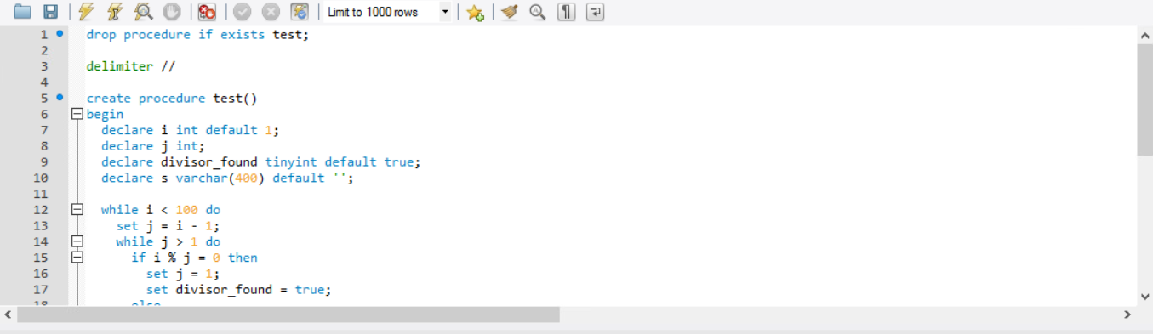

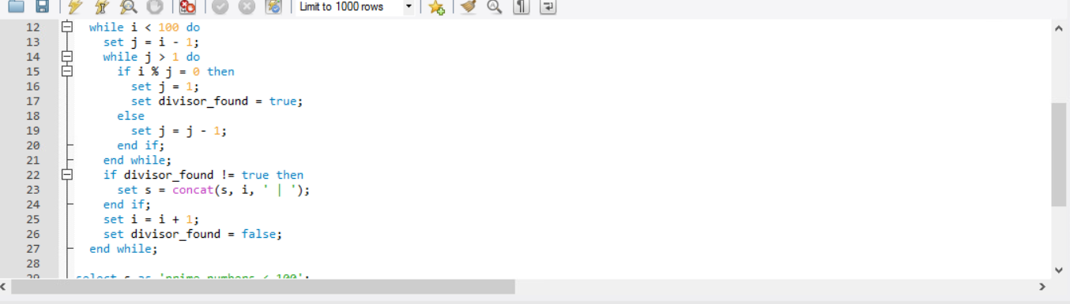

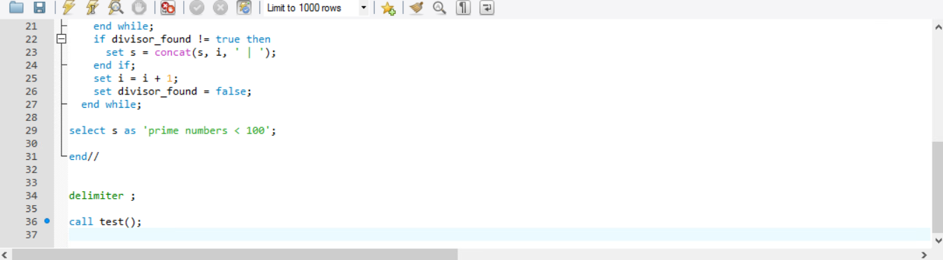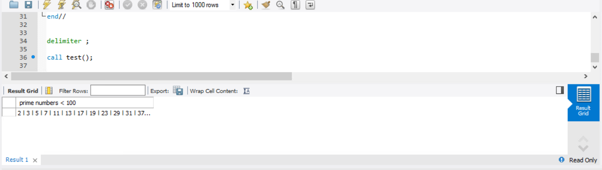

13.7

