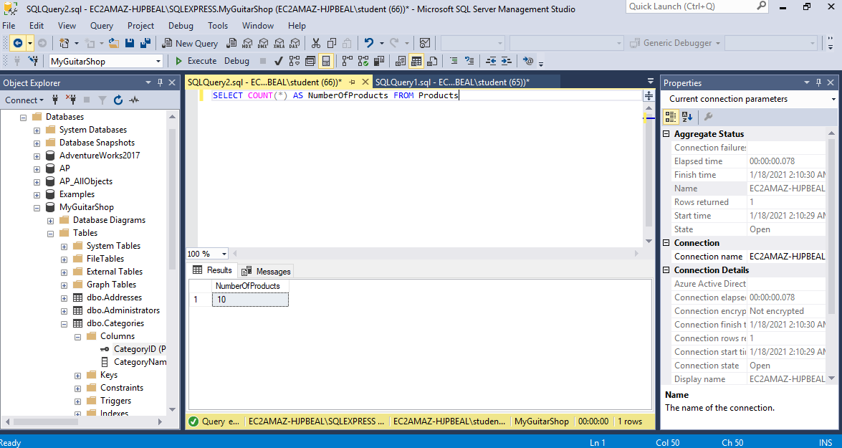

I did not encounter any difficulties while working on this assignment.