**汇报人：张常乐 学号：15S158746 班级：Electronic and Information Engineering**

**Programme list：**

1. Histogram_Equalization.m
2. Noise_Remove.m
3. Gaussian_Highpass_Filtering.m

**Programme introduction：**

1. 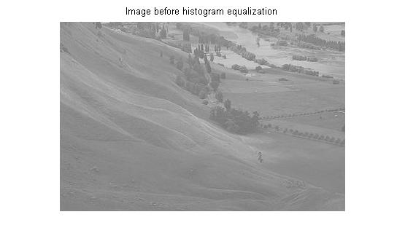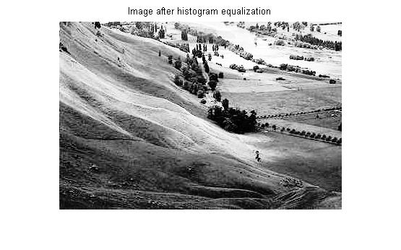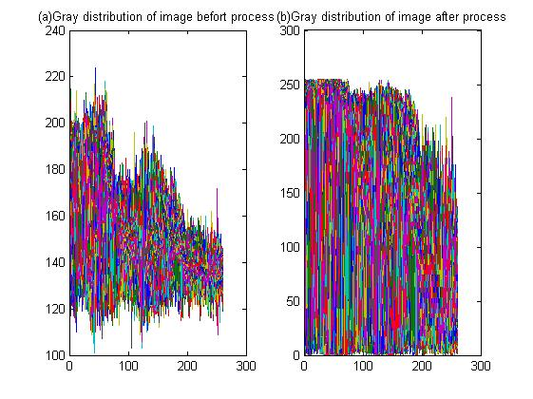First of all, we processed the original image and obtained its gray level histogarm (GLH), by the GLH, we can obseved that region of lower gray level dominated this image which indicates a somber tinge with low contrast ratio. To solve this problem and make an enhancement for the image, histogram equalization was applied. Histogram equalization algorithm calculated each frequnce and probability corresponding to different gray level and generated gray cumulative distribution with discrete integral function:

**Fig. 3**

**Fig. 2**

**Fig. 1**

$$S_{k}=\frac{L-1}{MN}\sum_{j=0}^{k-1}{n_{j}},k=0,1,2,…,L-1$$

With this distribution, a mapping relation which made the new gray level as 255*probabiility and get the nearest integer was formed to generate a homogeneous gray level distribution for this image. Final gray level distribution and processed image was shown in Fig 1(b) and Fig 3.

1. To process the salt and pepper noise in Fig 4, a median filter was applied. With a template of this,

1 1 1

1 1 1

1 1 1

Replaced the template center pixel with the median gray level in this templated. After swapping by the whole image, salt and pepper noise can be removed greatly. Meanwhile, in order to remove the boundary effect, image boundary was expanded by half length of this template. After proper clipping, final image can be obtained. Here, we should pay attention to those things as follows:

1. The dimension of suqare template must be odd, template with even width can casue lots of trouble when we are determining the template center.
2. Template size should be regarded to the size of salt and pepper noise, meanwhile, the larger template is, the heavier image fuzzy it may cause. In this project we can find 3*3 template is the best choice.
3. 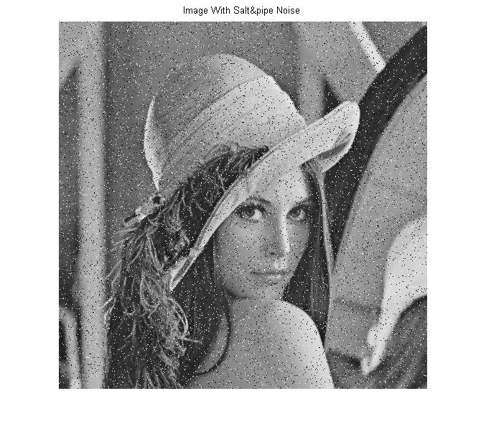For the median value calculation, MEDIAN and SORT function was banned in this project, thus, a algorithm of bubble sort was applied and as for the properity of Matlab software, processing of the FOR circulation is very slow which caused the slowly performance of this programme.
4. 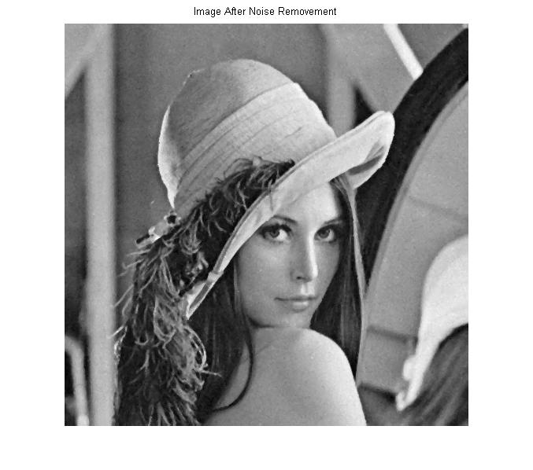As for the image sharpening of topic 3, a Gaussian High Pass Filter (GHPF) was applied. After the calculation of normalized spectrum distribution of Fig 6, space-frequency distribution can be generated. With the help of GHPF:

**Fig. 4**

$$H\left(u,v\right)=1-e^{-\frac{D^{2}\left(u,v\right)}{2{D_{0}}^{2}}}$$

A transfer function H (u, v) was used to processed image’s frequency map which is Y (u, v) generated by x (m, n) after fftshift and fft. After ifft of final frequency map, sharpened image Fig 7 can be obtained.

**Fig. 6**

**Fig. 7**

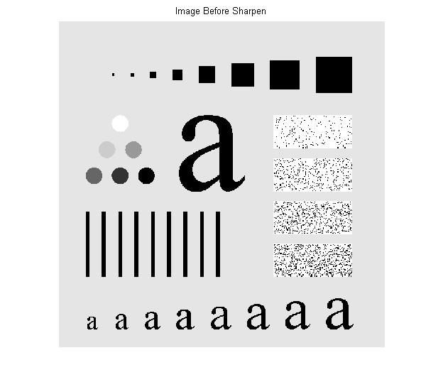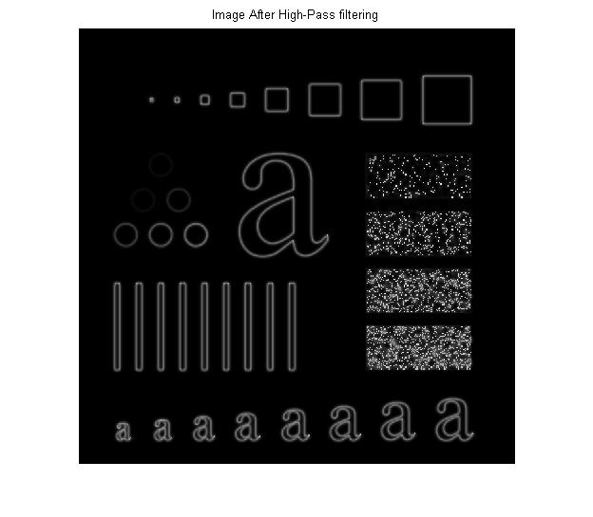

**Fig. 5**