**Code**

a=1000;%gravitational acceleration in cm

%The initial positions of

Sx1=100;%insect

Sy1=100;

Sx2=0;%droplet

Sy2=0;

Vx1=0;%speed of insect in x-axis,fix

Vy1=0;%speed of insect in y-axis,variable

Vx2=500*sqrt(2);%speed of droplet in x-axis,fix

Vy2=500*sqrt(2);%speed of roplet in y-axis, variable

dt= 0.001; %rate of change of time

min=sqrt(((Sx1-Sx2)^2)+((Sy1-Sy2)^2)); %initially set the mininum distance of they meet

for t=0:dt:0.2;

%change the speed in every 'dt's

Vy1= Vy1-a*dt;

Vy2= Vy2-a*dt;

%as the speed is changed,the positions is changed correspondingly

Sy1= Sy1+Vy1*dt;

Sy2= Sy2+Vy2*dt;

%Sx1 will not change because of Vx1=0

Sx2= Sx2+Vx2*dt;%Sx2 will change constantly

axis([0, 120, 0, 120]);

plot(Sx1,Sy1,'k:*');

plot(Sx2,Sy2,'b:diamond');

hold on

dist=sqrt(((Sx1-Sx2)^2)+((Sy1-Sy2)^2));

if dist<min %to find the minimum distance of two points

min=dist;

fprintf('The minimum distance of they meet is %fcm\n.',min);

fprintf('The time of they meet is %fth s\n.',t)

end

if Sy2>Sy1 %since the droplet will nor over the insect as it hit the insect

break;

end

end

**图表**

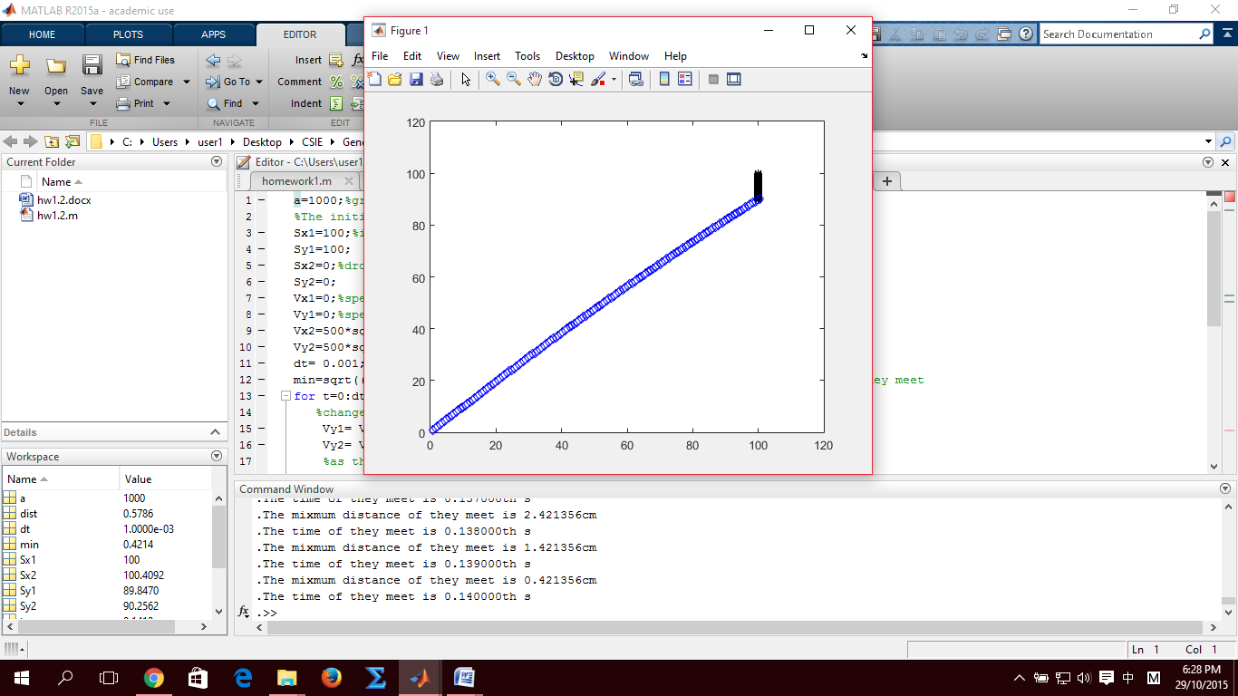

**计算最短距离或交接点时的时间：t**

**判定甲虫与**

**水珠之最短距离或交接点：**

**dist<min**

**初位置：**

**（甲虫）**

**Sx1, Sy1**

**（水珠）**

**Sx2,Sy2**

**初速度：**

**（甲虫）**

**Vx1, Vy1**

**（水珠）**

**Vx2,Vy2**

**重力**

**加速度：**

**a=1000**

**(in cm)**

**时间**

**间隔：**

**dt**

**甲虫与水珠之最近距离：min**

**Input**

**For loop 呼叫**

**Output**

**以积分计算时间间隔之**

**速度的位移的改变**

**Plot 绘图**

**流程图**