**Code**

**(Part 1)**

k=1; %spring constant

L0=10; %original length of spring

m=0.1; %mass of block

Vo=0; %initial velocity of block

X=2; %extension of spring

Ep=0.5*k*X.^2; %elastic potential energy

Ek=0; %kinetic energy

dt=0.002; %the fixed time interval

for t=0:dt:2;

a=-k*X/m;

Vo= Vo+a*dt; %velocity changes in every 'dt's

X= X+Vo*dt; %displacement changes with corresponding to velocity

L=L0+X; %length changes with corresponding to displacement

Ep=0.5*k*X.^2; %elastic potential energy changes with corresponding to displacement

Ek=0.5*m*Vo.^2; %kinetic energy changes with corresponding to velocity

Et=Ep+Ek; %total energy is equal to the addition of elastic potential energy and kinetic energy

subplot(2,2,1); %draw the extension-time graph

plot(t,X,'g:*');

xlabel('Time(s)');

ylabel('Extension(m)');

title('Extension-Time graph')

hold on;

grid on;

subplot(2,2,2); %draw the length-velocity graph

plot(Vo,L,'k:diamond');

xlabel('Velocity(m/s)');

ylabel('Length(m)');

title('Length-Velocity graph')

hold on;

grid on;

subplot(2,2,3); %draw the length-elastic potential energy graph

plot(Ep,L,'r:X');

xlabel('elastic potential energy(J)');

ylabel('Length(m)');

title('Length-Elastic potential energy graph')

hold on;

grid on;

subplot(2,2,4); %draw the total energy-length graph

plot(L,Et,'m:O');

xlabel('Length(m)');

ylabel('Total Energy(J)');

title('Total energy-Length graph')

axis([0,15,0,5]);

hold on;

grid on;

end;

**(Part 2)**

%The sub-question of giving the information of friction is 0.1N

k1=1; %spring constant

L01=10; %original length of spring

m1=0.1; %mass of block

Vo1=0; %initial velocity of block

X1=2; %extension of spring

Ep1=0.5*k1*X1.^2; %elastic potential energy

Ek1=0; %kinetic energy

dt1=0.002; %the fixed time interval

Ff1=0.1; %the friction given by the question

af1=Ff1/m1;%the acceleration caused by friction

for t1=0:dt1:10;

a1=-k1*X1/m1;

if Vo1<0 %when the block moves to left, there are decceleration

af1=-Ff1/m1;

end

if Vo1>0 %when the block moves to right, there are acceleration

af1=Ff1/m1;

end

Vo1= Vo1+(a1-af1)*dt1%velocity changes in every 'dt's with respect to 2acceleration(Elastic&Friction)

X1= X1+Vo1*dt1; %displacement changes with corresponding to velocity

L1=L01+X1; %length changes with corresponding to displacement

Ep1=0.5*k1*X1.^2; %elastic potential energy changes with corresponding to displacement

Ek1=0.5*m1*Vo1.^2; %kinetic energy changes with corresponding to velocity

Et1=Ep1+Ek1; %total energy is equal to the addition of elastic potential energy and kinetic energy

subplot(4,2,1); %draw the extension-time graph

plot(t1,X1,'g:*');

xlabel('Time(s)');

ylabel('Extension(m)');

title('Extension-Time graph(f=0.1N)')

hold on;

grid on;

subplot(4,2,2); %draw the length-velocity graph

plot(Vo1,L1,'k:diamond');

xlabel('Velocity(m/s)');

ylabel('Length(m)');

title('Length-Velocity graph(f=0.1N)')

hold on;

grid on;

subplot(4,2,3); %draw the length-elastic potential energy graph

plot(Ep1,L1,'r:X');

xlabel('Elastic potential energy(J)');

ylabel('Length(m)');

title('Length-Elastic potential energy graph(f=0.1N)')

hold on;

grid on;

subplot(4,2,4); %draw the total energy-length graph

plot(L1,Et1,'m:O');

xlabel('Length(m)');

ylabel('Total Energy(J)');

title('Total energy-Length graph(f=0.1N)')

axis([0,15,0,5]);

hold on;

grid on;

end;

%The sub-question of giving the information of friction is 0.5N

k2=1; %spring constant

L02=10; %original length of spring

m2=0.1; %mass of block

Vo2=0; %initial velocity of block

X2=2; %extension of spring

Ep2=0.5*k2*X2.^2; %elastic potential energy

Ek2=0; %kinetic energy

dt2=0.002; %the fixed time interval

Ff2=0.5; %the friction given by the question

af2=Ff1/m2; %the acceleration caused by friction

for t2=0:dt2:10;

a2=-k2*X2/m2;

if Vo2<0 %when the block moves to left, there are decceleration

af2=-Ff2/m2;

end

if Vo2>0 %when the block moves to right, there are acceleration

af2=Ff2/m2;

end

Vo2= Vo2+(a2-af2)*dt2%velocity changes in every 'dt's with respect to 2acceleration(Elastic&Friction)

X2= X2+Vo2*dt2; %displacement changes with corresponding to velocity

L2=L02+X2; %length changes with corresponding to displacement

Ep2=0.5*k2*X2.^2; %elastic potential energy changes with corresponding to displacement

Ek2=0.5*m2*Vo2.^2; %kinetic energy changes with corresponding to velocity

Et2=Ep2+Ek2; %total energy is equal to the addition of elastic potential energy and kinetic energy

subplot(4,2,5); %draw the extension-time graph

plot(t2,X2,'g:*');

xlabel('Time(s)');

ylabel('Extension(m)');

title('Extension-Time graph(f=0.5N)')

hold on;

grid on;

subplot(4,2,6); %draw the length-velocity graph

plot(Vo2,L2,'k:diamond');

xlabel('Velocity(m/s)');

ylabel('Length(m)');

title('Length-Velocity graph(f=0.5N)')

hold on;

grid on;

subplot(4,2,7); %draw the length-elastic potential energy graph

plot(Ep2,L2,'r:X');

xlabel('Elastic potential energy(J)');

ylabel('Length(m)');

title('Length-Elastic potential energy graph(f=0.5N)')

hold on;

grid on;

subplot(4,2,8); %draw the total energy-length graph

plot(L2,Et2,'m:O');

xlabel('Length(m)');

ylabel('Total Energy(J)');

title('Total energy-Length graph(f=0.5N)')

axis([0,15,0,5]);

hold on;

grid on;

end;

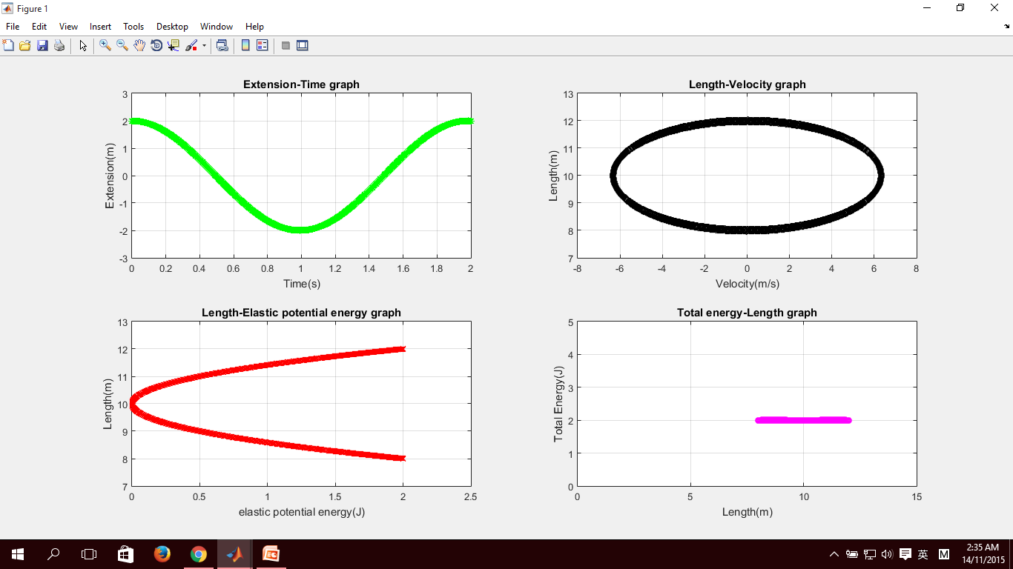

The first question with no friction

**Graph**

The sub-question with frictional force 0.1N and 0.5N

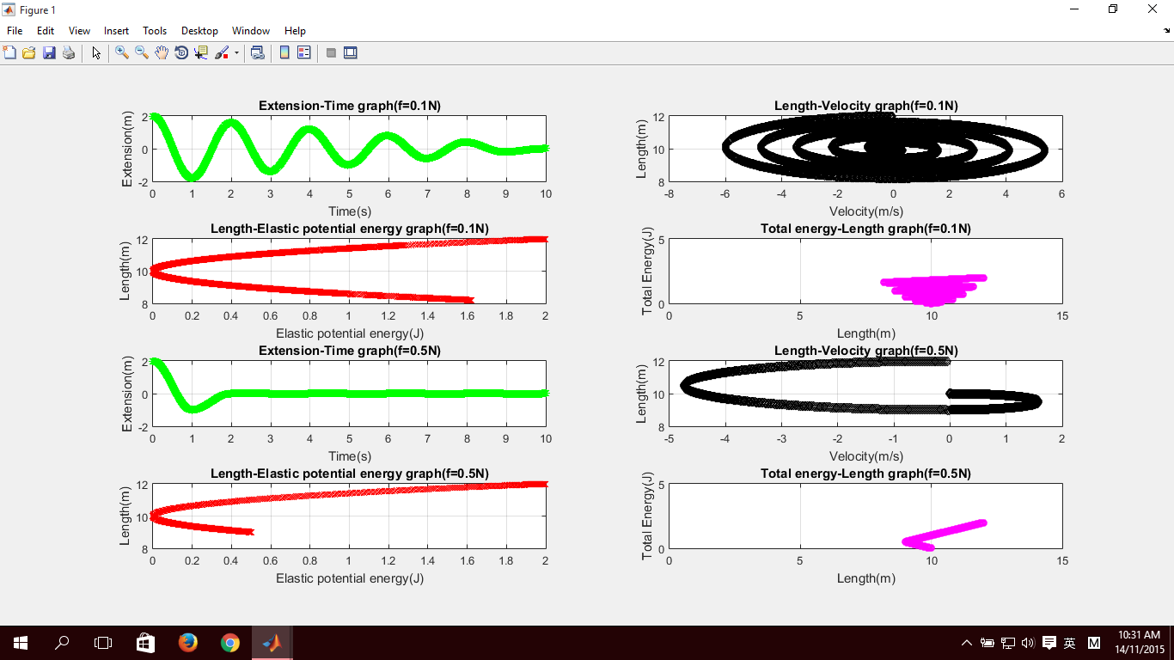

**Flow Chart**

Spring Constant, k

Original length, L0;

Extension of spring, X

Mass, m

Velocity, Vo

Elastic potential energy, Ep;

Kinetic energy, Ek;

Input

Friction, Ff1 & Ff2

For loop

Determination:

Got Friction?

Output

Ff1

Ff2

Determination:

t<10?

Calculating by integration

Plot Graph

**Yes**

**Yes**

**No**

**No**