**Code**

%the part of doing the Q1-1&Q1-2

%finding the square wave and triangle wave with sampling rate of 100Hz

x1=0;

yelement=1;

ytriangle=1;

for t=1:1:1000

if sin(x1*pi*0.01)>=0 %the part of sine wave from 0 to pi

ysquare=yelement*1;

ytriangle=ytriangle-0.02; %0.02 is the gradient

end

if sin(x1*pi*0.01)<0 %the part of sine wave from pi to 2pi

ysquare=yelement*-1;

ytriangle=ytriangle+0.02;

end

Xarray(t)=x1;

Y1array(t)=ysquare; %array to store the data of square wave

Y2array(t)=ytriangle; %array to store the data of triangle wave

x1=x1+1;

end

subplot(2,3,1);

plot(Xarray,Y1array),grid on,hold on

title('方波')

axis([0 1000 -2 2]);

subplot(2,3,2);

plot(Xarray,Y2array),grid on,hold on

title('三角波')

axis([0 1000 -2 2]);

%the part of doing the Q2&Q3

%finding the square wave from first to firth order

%the initial definition is used

Po=1;

syms x2;

syms x3;

syms n;

%the initial definition of fourier series of square wave

a0=2./Po*int(1*cos(2*pi*0*x2./Po),x2,0,1./2)+2./Po*int(-1*cos(2*pi*0*x2./Po),1./2,1);

a(n)=2./Po*int(1*cos(2*pi*n*x2./Po),x2,0,1./2)+2./Po*int(-1*cos(2*pi*n*x2./Po),1./2,1);

b(n)=2./Po*int(1*sin(2*pi*n*x2./Po),x2,0,1./2)+2./Po*int(-1*sin(2*pi*n*x2./Po),1./2,1);

x2=0:0.01:2;

%the initial definition of fourier series of triangle wave

A0=2./Po*int((-4*x3+1).*cos(2*pi*0*x3./Po),x3,0,1./2)+2./Po.*int((4*x3-3)*cos(2*pi*0*x3./Po),1./2,1);

A(n)=2./Po*int((-4*x3+1).*cos(2*pi*n*x3./Po),x3,0,1./2)+2./Po.*int((4*x3-3)*cos(2*pi*n*x3./Po),1./2,1);

B(n)=2./Po*int((-4*x3+1).*sin(2*pi*n*x3./Po),x3,0,1./2)+2./Po.*int((4*x3-3)*sin(2*pi*n*x3./Po),1./2,1);

x3=0:0.01:2;

Y2=0;

Y3=0;

for n=1:1:5 %from first to firth-order

if rem(n,2)==1 %since all even harmonies are 0, only the odd numbers will did the work

Y2=Y2+a(n)*cos(2*pi*n*x2./Po)+b(n)*sin(2*pi*n*x2./Po);

Y3=Y3+A(n)*cos(2*pi*n*x3./Po)+B(n)*sin(2*pi*n*x3./Po);

end

Ysquarewave2=a0./2+Y2;

subplot(2,3,3);

plot(x2,Ysquarewave2),grid on,hold on;

title('方波1到5阶的傅里叶展开结果)

subplot(2,3,4);

Ysquarewave3=A0./2+Y3;

plot(x3,Ysquarewave3),grid on,hold on;

title('三角波1到5阶的傅里叶展开结果')

end

%the part of doing the Q4

%finding the Fourier expansion results by using the basic definition

clear all;

syms x4;

FFF=0;

ddd=0;

x4=0:0.001:5;

N=5;

hold on;

for n=1:1:N

FFF=FFF+(2./((n.*pi).^2)).*(((-1).^n)-1).*cos(n.*pi.*(x4+1))-(2./(n.*pi)).*((-1).^n).*sin(n.*pi.*(x4+1));

lll=-1./2+FFF;

hold on;

subplot(2,3,5);

plot(x4,lll);,grid on,hold on;

title('Q4: 1到5阶的傅里叶展开结果')

end

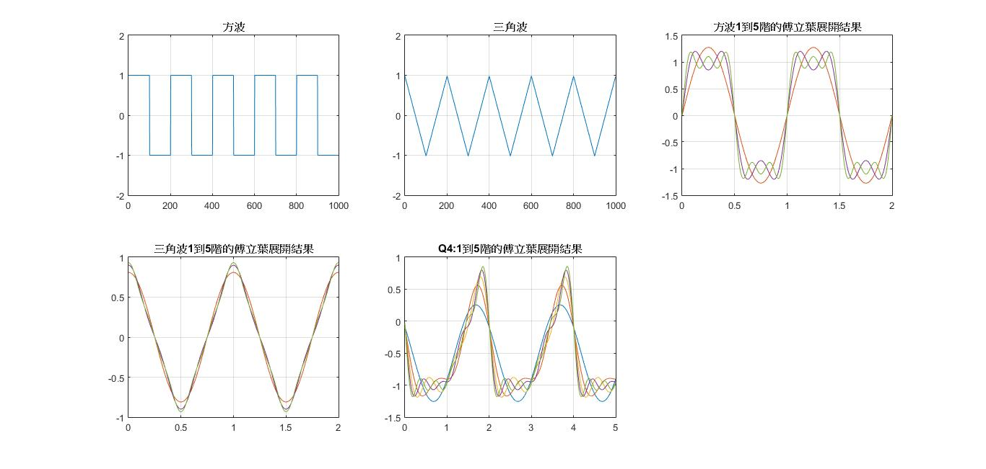**Graph**

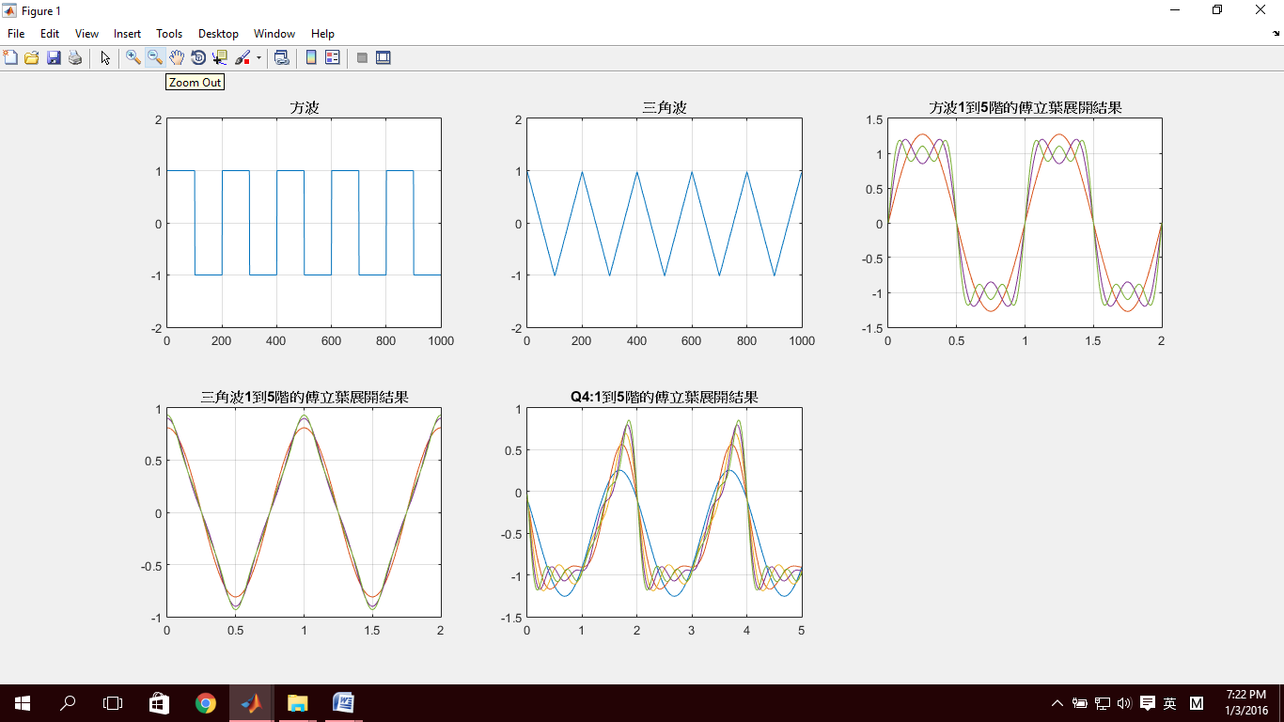









**Flow Chart**

**Yes**

**No**

**Plot Graph**

**Data**

**Determine whether under condition?**

**Calculating**

**&**

**Storing data**

**For loop**

**Input**

**Condition**