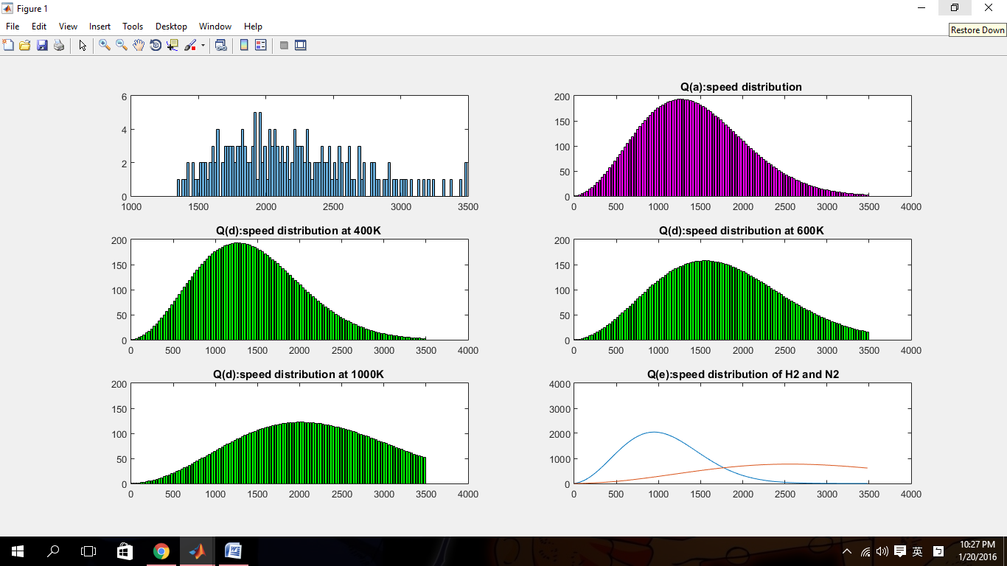**Graph**

**Flow Chart**

**Yes**

**For loop**

**No**

**Determine whether under condition?**

**Plot Graph**

**Data**

**Calculating**

**&**

**Storing data**

**Input**

**Condition**