Name: Cayon Liow Keei Yann

Student ID number: F74045018

Question 1:

1. The methods I used is Finite Riemman Sum and the Basic definition of differentiation.
2. The program can be used to solve the specific integration and differentiation just by changing to equation needed and also the range of the equation included and needed to be calculated.
3. Answer:

The upper figure is the v-t plot of (a) and the lower figure is the F-t plot of (b)

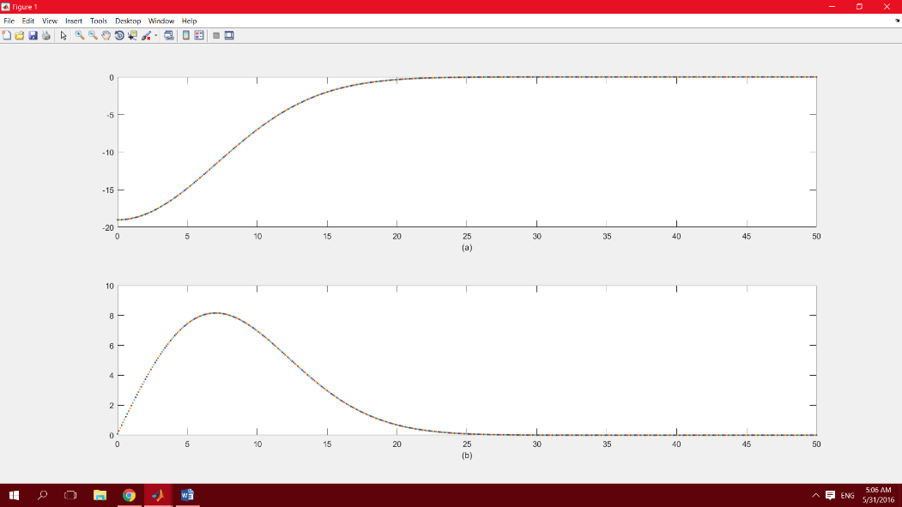h=0.1;

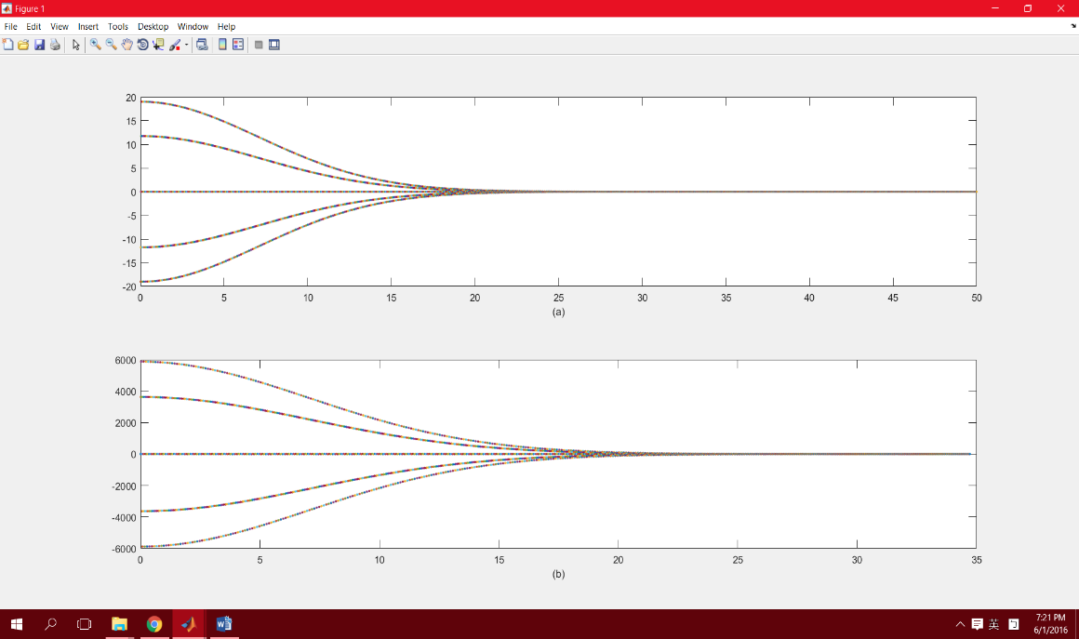h=0.01;

h=0.001;

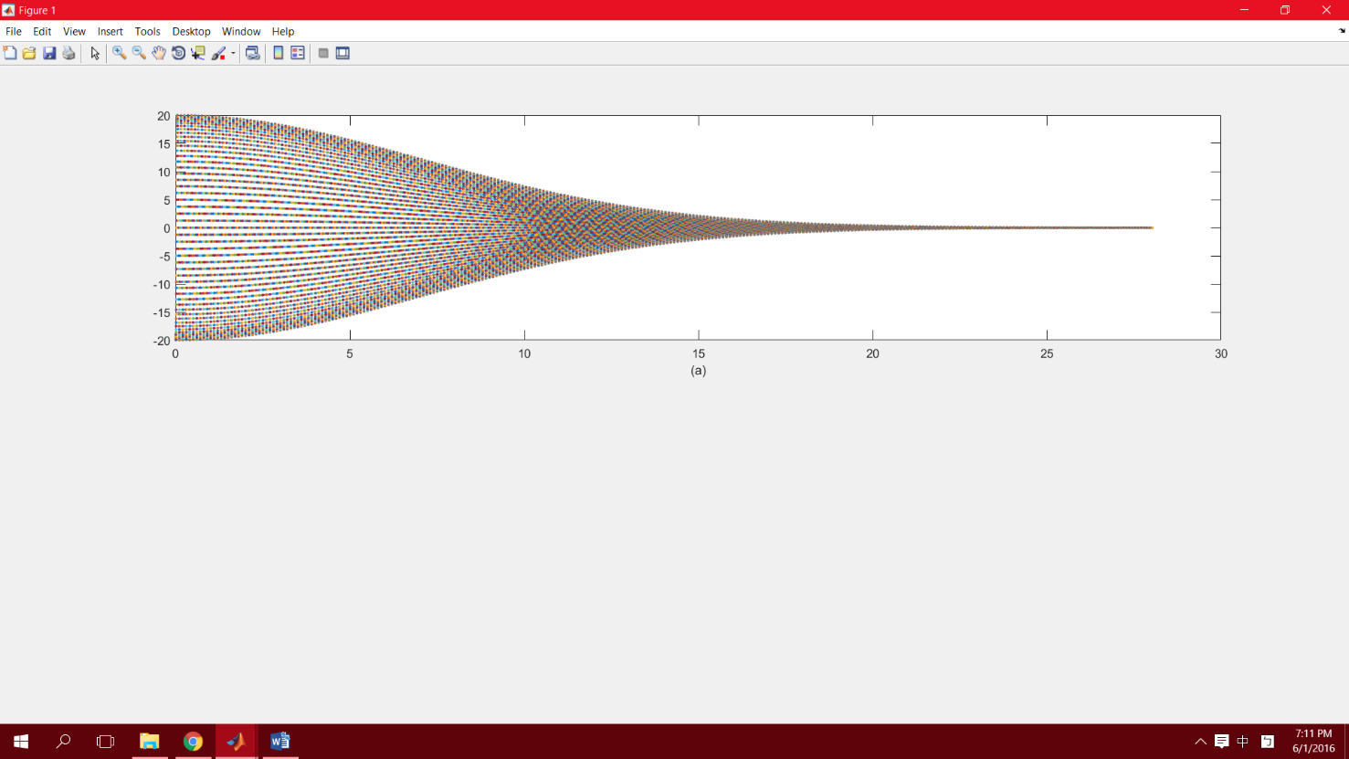

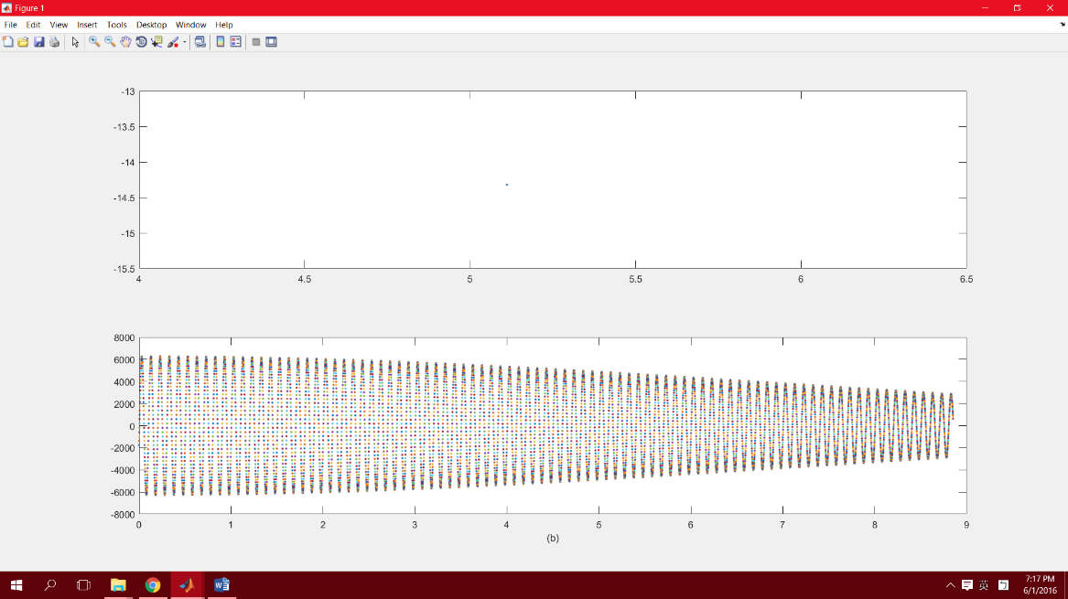

(c) F(8) = -1015.673879N

(d) x(10) = -6.18248626e-02 m

(e) The total travel length from t=0 to 10 is 9.51105067e+01 m

Step:

1. 1. Plot the given equation of v(t) with t is substituted from 0 to 50 with the interval of 0.1.
2. 1. Differentiate the given equation of v(t)

2. Multiply the equation with m=5

3. plot the F(t)

1. 1. Using the modified equation of (b)

2. Substitute the number of 8 into t

3. Calculate the result

1. 1. Integrate the initially given equation of v(t) into x(t)

2. Accumulate the result with a for loop

1. 1. Steps in (d) are repeated.

2. Modulus is added to every result in order to get the positive result

3. sum it up from t=0 to t=10

Question 2:

1. The method I used is Finite Riemman Sum.
2. The program can be used to solve the specific integration just by changing to equation needed and also the range of the equation included and needed to be calculated.
3. Answer: (i) 7.85398213e-01

(ii) 2.15651569e+00

(iii) 3.21793566e-01

The method I used is Finite Riemman Sum and its main concept is the approximation of definite integral from the range of x to x+h is almost equal to the multiplication of f(x) and h.

Step:

set the interval of h be 0.0000001.

let the initial range of number be a and the final range of number be b.

A for loop is used to accumulate the result of substituting the x from b to a with the interval of h.

The way I justify the precision of the answer should be included is considering the calculating system of the program which can represent the exact 8 decimal places of floating point.

Therefore, I show the answer with 8 decimal places.

Question 3:

1. The method I used is Monte Carlo Integration.
2. The program can be used to solve the specific integration just by changing to equation needed. The range of the number randomly generated and the times of the random number that needed to be generated have to be set again according to the equation given.
3. Answer:

A total of 1000000 random points are used and the volume of the ellipsoid is 25.161264.

Step:

Set the number of times of generating the random number be 1000000

Set the range of the 3 variables, x, y and z, in the 3-dimension graph respectively.

A for loop is used to count whether the random numbers is in the graph, which means the result is equal or less than 1, and also regenerate the 3 random variables after 1 time of calculation is done.

The way I justify the precision of the answer should be included is considering the calculating system of the program which can represent the exact 8 decimal places of floating point.

Therefore, I show the answer with 8 decimal places.

In addition, I compare the answer by calculating repeatedly to make sure the accuracy.

Question 4:

1. The method I used is Integration.
2. The program can be used to solve the specific integration just by changing to equation needed. The centre of the square cube and the edge of the square cube can be changed.
3. Answer:

(1) The total flux is 1.129464e+11(Volt.m)

(2) The total flux is 1.129402e+11(Volt.m)

(3) The total flux is 1.129405e+11(Volt.m)

Step:

Let Q=1, k=8.897\*10^9

Find out the length of edge of the cube

The radius of the cube is calculated and is being divided to calculate the angle.

For loop is used to calculate and accumulate the result of the formula