Name: Cayon Liow Keei Yann

Student ID number: F74045018

Question 1:

1. The methods I used is Euler’s formula and applying the information given by the Textbook
2. Step: 1.dt=0.001

2.for loop and the variable t are used calculate the value of x(t) and store in array

3.plot the x(t)

(3) the directions of right and upward are stated to be positive

Answer: (a) $m\frac{d^{2}x}{dt^{2}}+v\frac{dx}{dt}+kx=0$

(b)

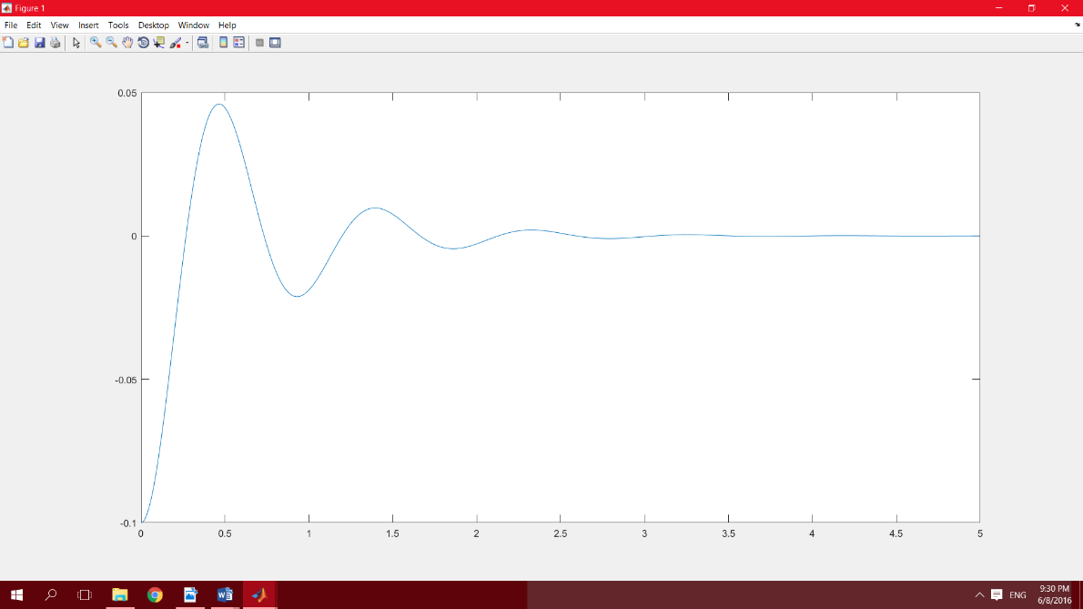

(c) the oscillation frequency of the system is 0.9300

Question 2:

1. The methods I used is Euler’s formula
2. Step: (b) 1. dt=0.0001

2. differentiate the equation by Euler’s method

3.plot the graph

(c) 1. dt=0.0001

2. differentiate the equation by Euler’s method

3. every 100times E will change according to the graph given

4. plot the graph

(d) 1. dt=0.0001

2. differentiate the equation by Euler’s method

3. gradient will change according to the graph given

4. plot the graph

(3) the directions of right and upward are stated to be positive

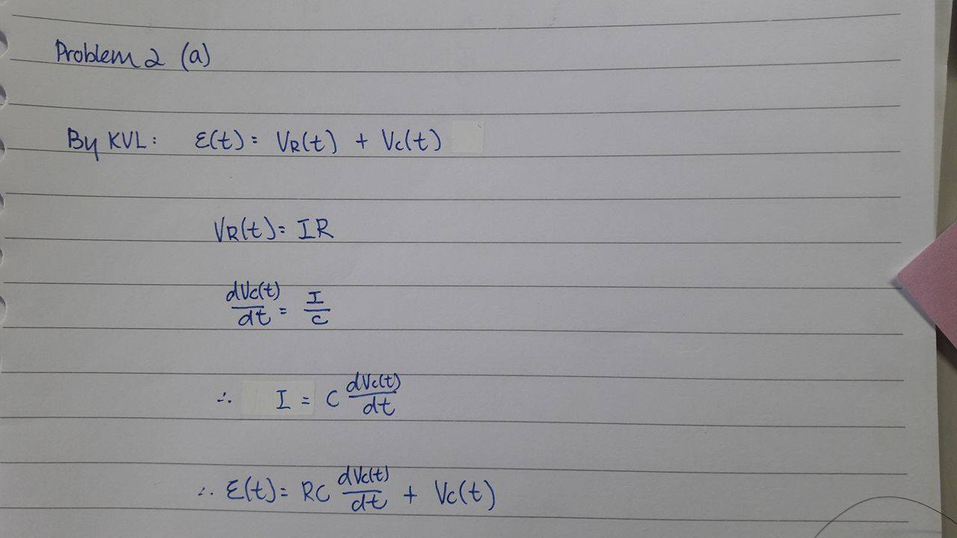Answer: (a)

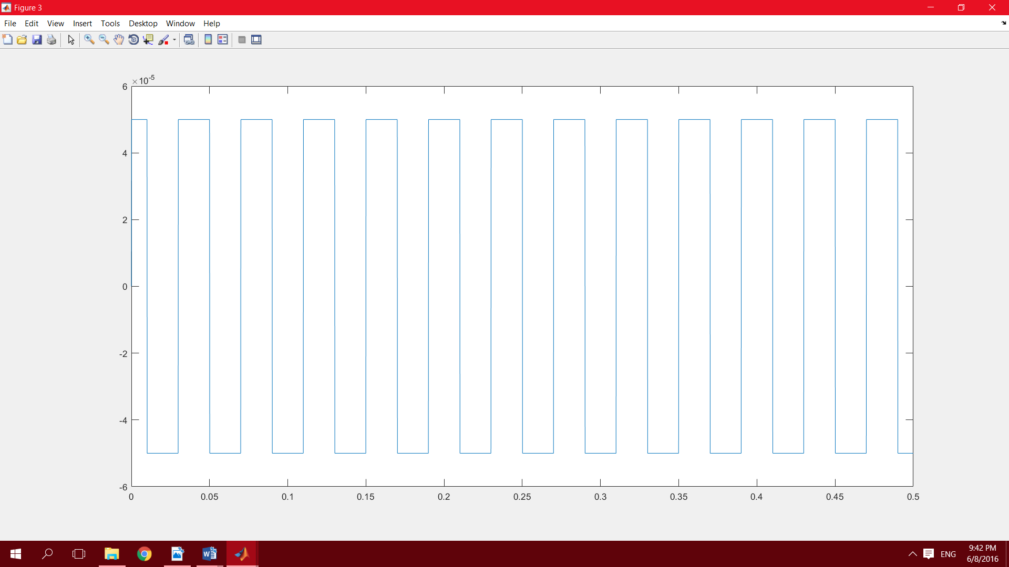

(b)

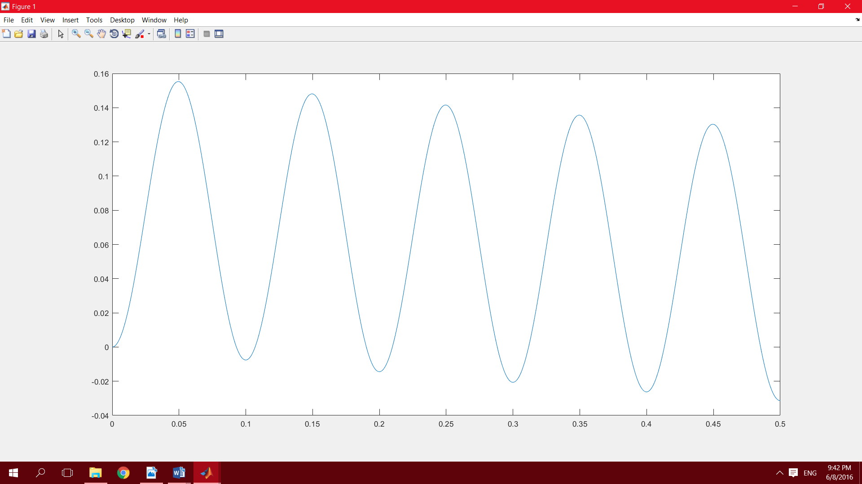

(c)

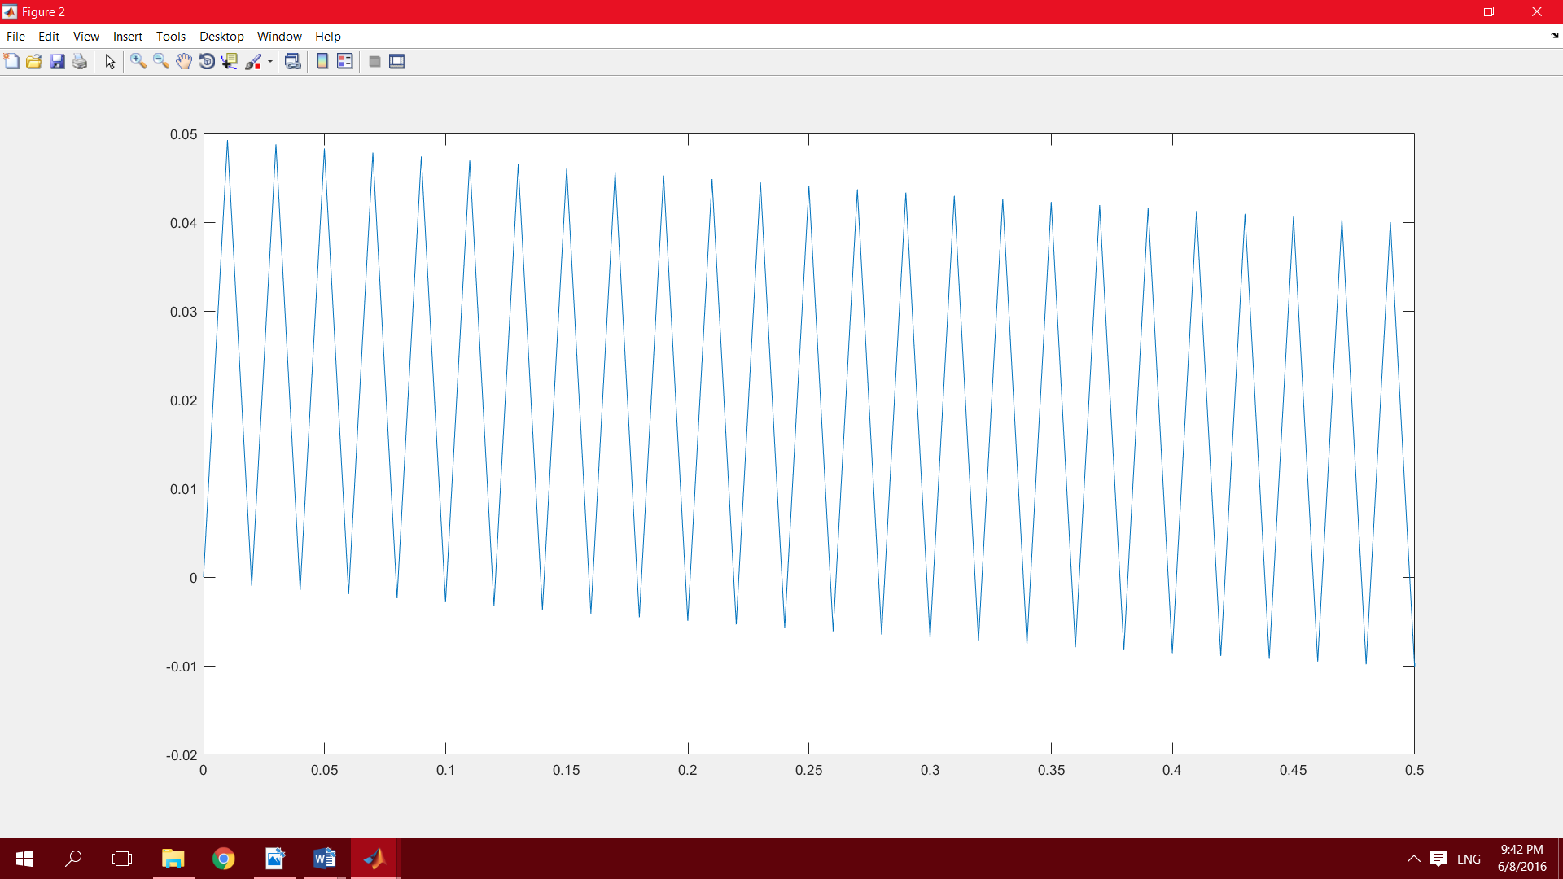

(d)



Question 3:

1. The methods I used is Euler’s formula
2. Step: 1.dt=0.001

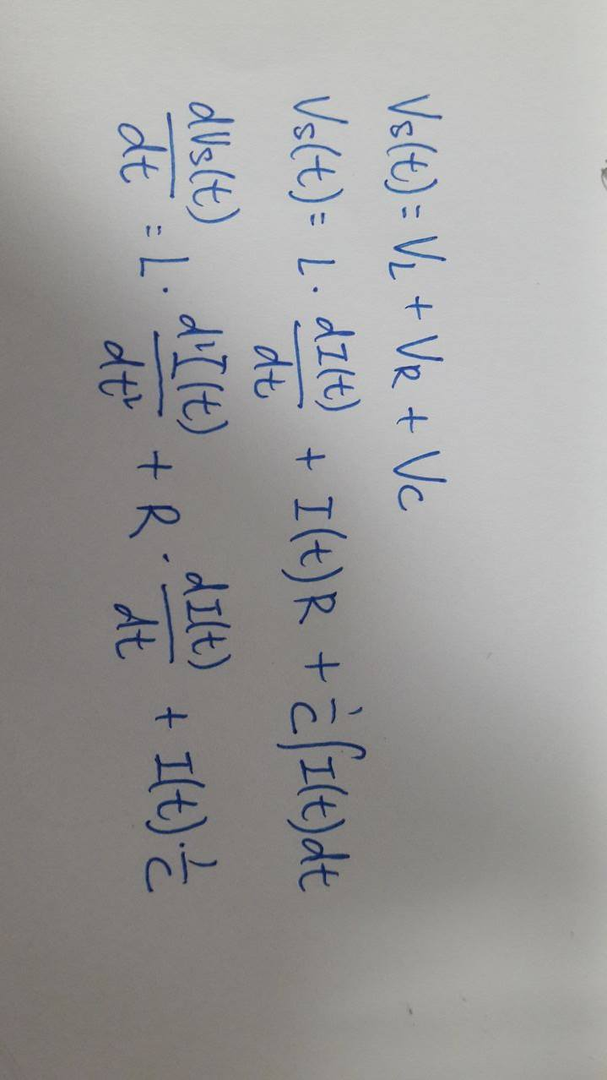2.for loop and the variable t are used calculate the value of x(t) and store in array

3. differentiate the equation by Euler’s method

4. plot the graph

(3) the directions of right and upward are stated to be positive

Answer: (a)

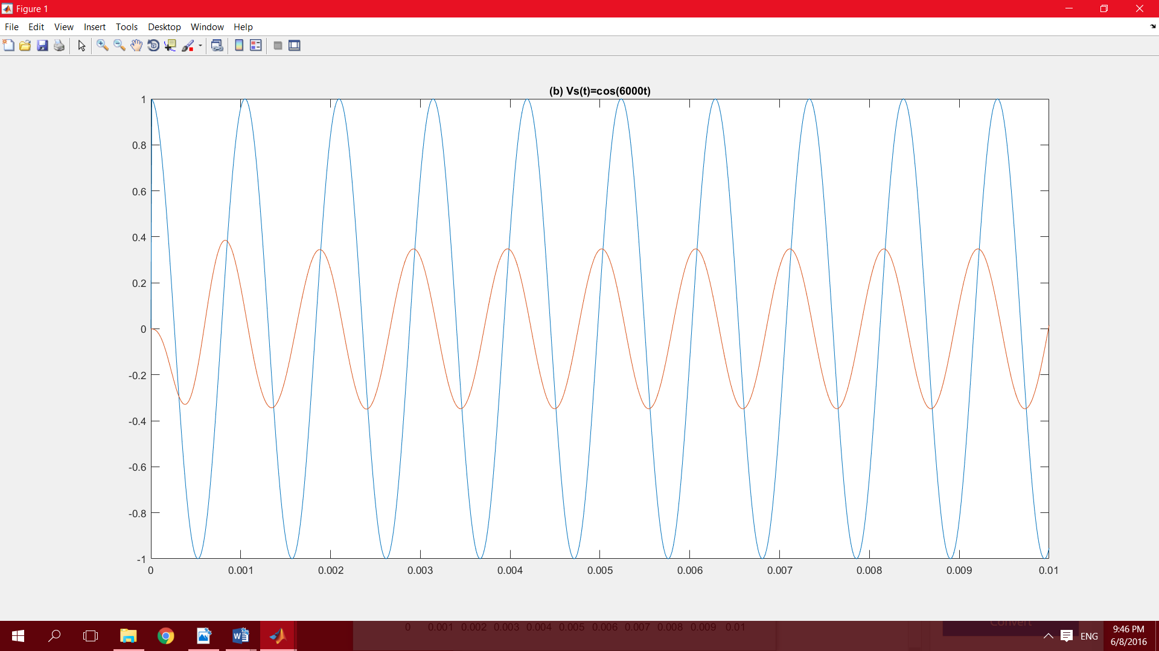 (b)

(c)

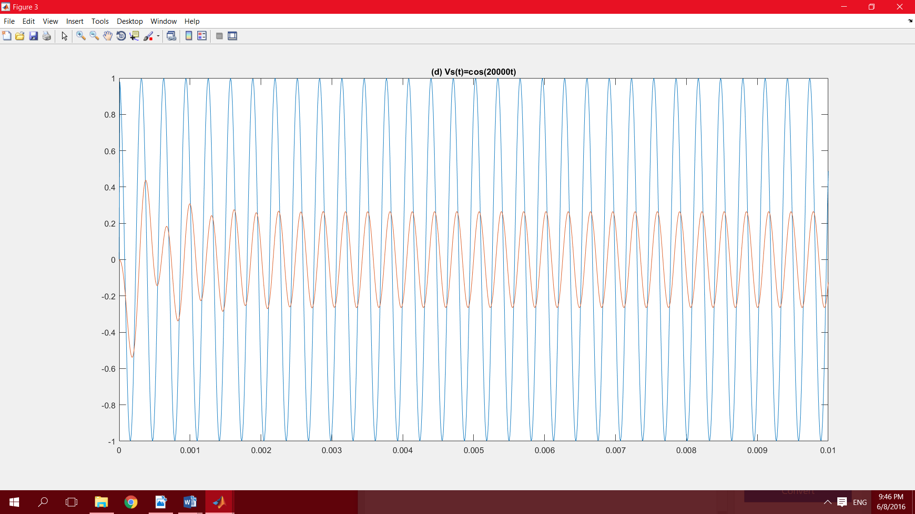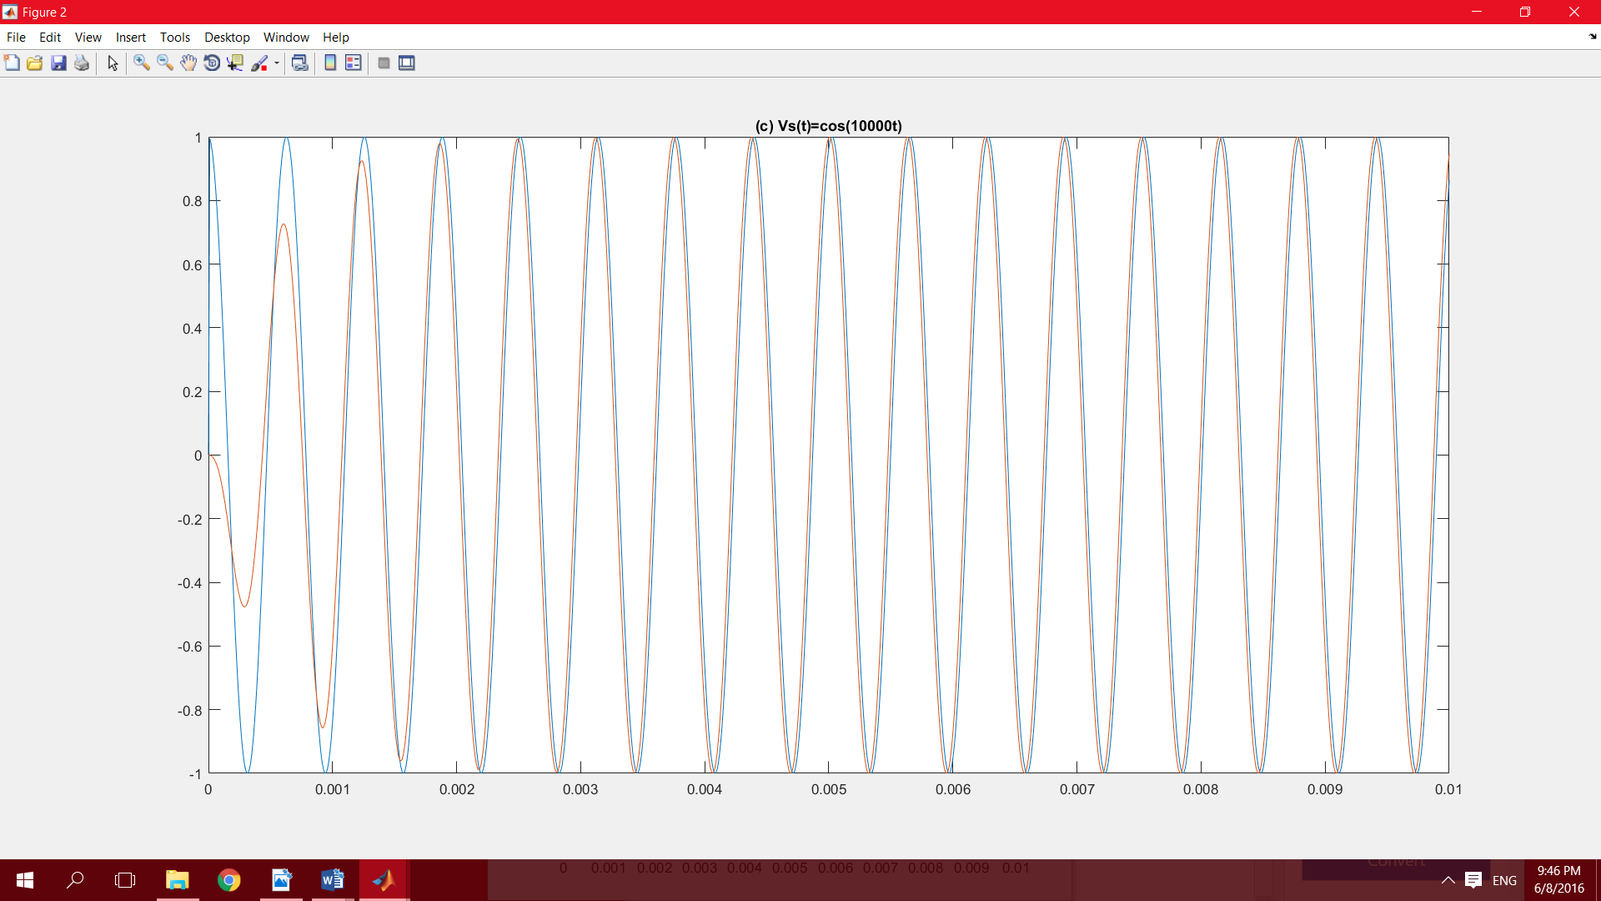

(d)