Name: Cayon Liow Keei Yann

Student ID: F74045018

Question 1

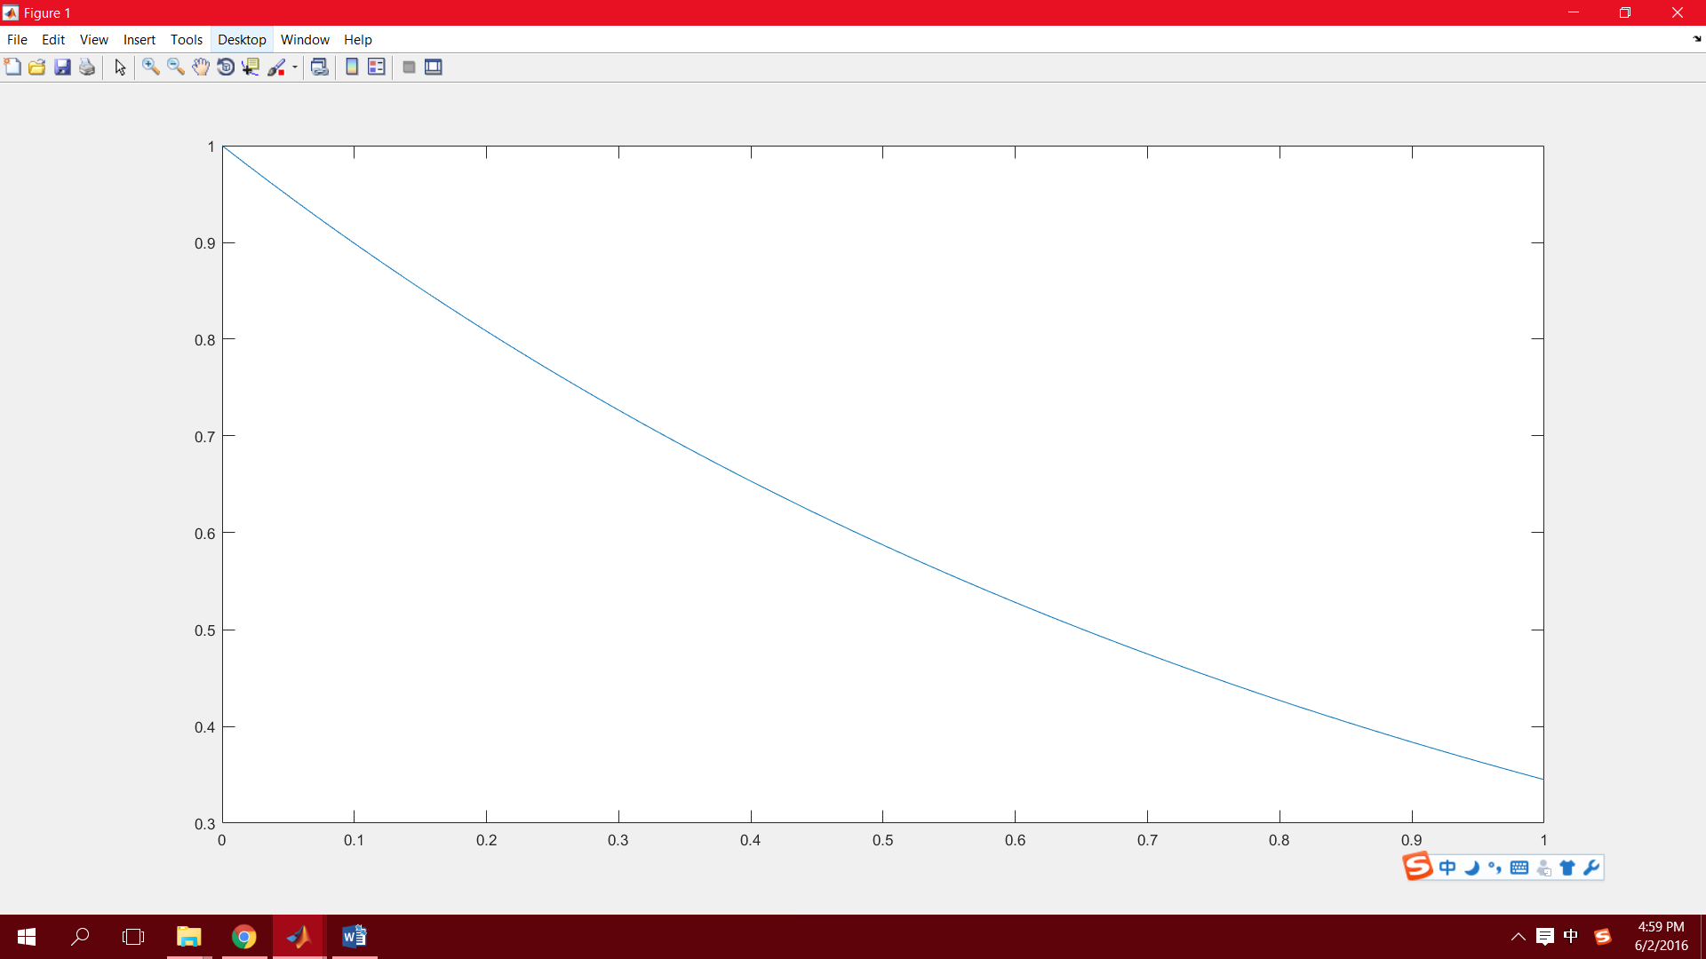

1. The method used is Euler Method。
2. the capacitor’s voltage at t = 0.3 sec is 0.727418

step size: dt=0.010000 voltage at t = 0.3 sec is 0.733327

dt=0.001000 voltage at t = 0.3 sec is 0.727418

1. time=2.165000

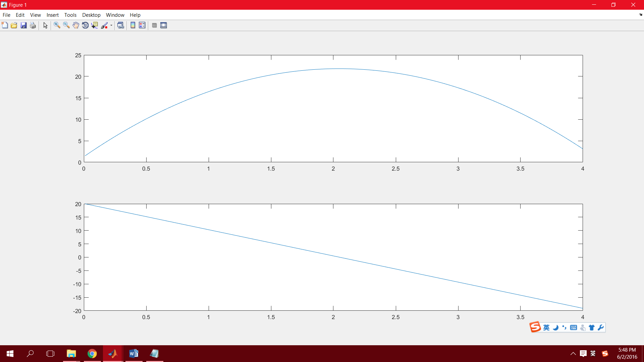Question 2

Dt=0.01;

y(4) = 3.09600000

y'(4) = -19.10200000

Question 3

1. The method used is Euler Method

Step size=0.01

