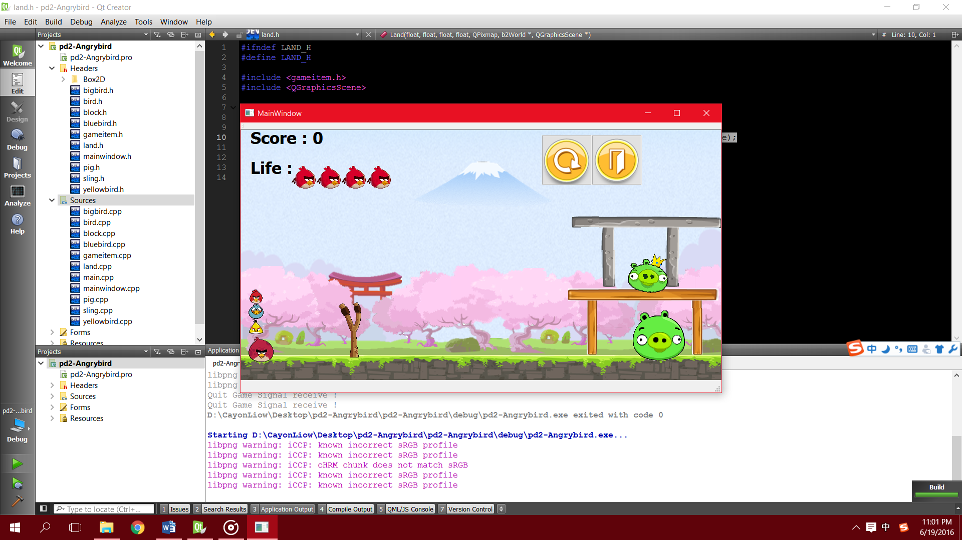

* There is the environment of the game.
* There are two pigs(enemy) and 4 birds.
* You are given 4 chances to attack the pigs.
* You have to click the mouse to place the bird to the sling and then you can press and pull the bird to attack the pigs.
* The concept of projection is involved in the game.
* The score will be added by 100 if 1 of the pigs is attacked.
* You are win if you had attacked all the pigs with 4 chances.
* Finally you can choose to restart to quit the game.

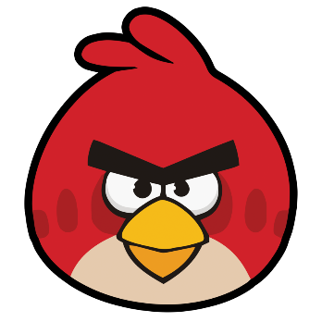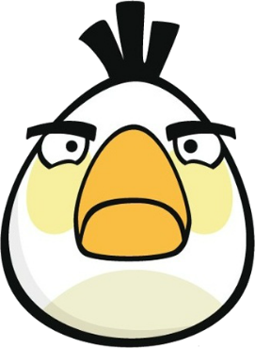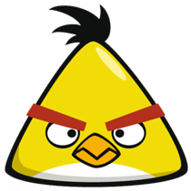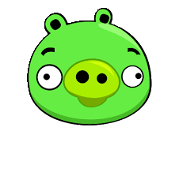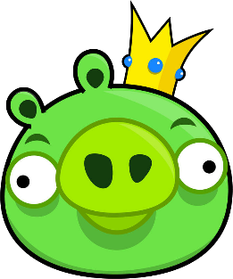

，

**MainWindow**

+Land(x: float, y: float, w: float, h: float, timer: QTimer *, pixmap: QPixmap, world: b2World *, scene: QGraphicsScene *);

**Land**

+ Yellowbird (x: float, y: float, radius: float, timer: QTimer *, pixmap: QPixmap, world: b2World *, scene: QGraphicsScene *);

+SpecialSkill(): virtual void

+bodydef: b2BodyDef

**Yellowbird**

+bodydef: b2BodyDef +fixturedef: b2FixtureDef

+bodyshape: b2CircleShape +radius: int

+Bird(x: float, y: float, radius: float, timer: QTimer *, pixmap: QPixmap, world: b2World *, scene: QGraphicsScene *);

+set_linear_velocity(velocity: b2Vec2): void

+set_type_of_body(check: bool): void

+SpecialSkill(): virtual void

**Bird**

**Bigbird**

+bodydef: b2BodyDef +radius: int

+fixturedef: b2FixtureDef +bodyshape: b2CircleShape

+ Bigbird (x: float, y: float, radius: float, timer: QTimer *, pixmap: QPixmap, world: b2World *, scene: QGraphicsScene *);

+SpecialSkill(): virtual void

+set_linear_velocity(velocity: 2Vec2): void

+ Bluebird (x: float, y: float, radius: float, timer: QTimer *, pixmap: QPixmap, world: b2World *, scene: QGraphicsScene *);

+SpecialSkill(): virtual void

+bodydef: b2BodyDef +radius: int

**Bluebird**

+Pig(x: float, y: float, radius: float, timer: QTimer *, pixmap: QPixmap, world: b2World *, scene: QGraphicsScene *);

+bodydef: b2BodyDef

**Pig**

+ Sling (x: float, y: float, w: float, h: float, timer: QTimer *, pixmap: QPixmap, world: b2World *, scene: QGraphicsScene *);

+bodyBox: b2PolygonShape

**Sling**

+Block(x: float, y: float, width: float, height: float, timer: QTimer *, pixmap: QPixmap, world: b2World *, scene: QGraphicsScene *);

**Block**

+GameItem(b2World *world);

+~GameItem();

+setGlobalSize(worldsize: QSizeF, windowsize :QSizeF): static void

+<<slots>> paint(): void

public slots:

void paint();

**GameItem**

+g_body: b2Body * +g_pixmap: QGraphicsPixmapItem +g_size;QSizeF

+g_world;b2World * +g_windowsize: static QSizeF +g_worldsize: static QSizeF

+<<explicit>> MainWindow(QWidget *parent = 0): void

+eventFilter(QObject *, QEvent *event): bool

+showEvent(QShowEvent *): void

+closeEvent(QCloseEvent *): void

+SetUpOBJ(): voidSetUpVRB(): void

+Situation(): void

+~MainWindow();

+<<slots>> tick(): void

+<<slots>> RestartGame(): void

+<<slots>> QUITSLOT(): void

+<<signals>> quit_game(): void

-ui: Ui::MainWindow * -no_mouse_click: int

--world: b2World *; -score: int

-itemList: QList <GameItem *>; -count: int

-scene: QGraphicsScene *; -mx3: int

-timer: QTimer; -my3: int

-Main: QGraphicsPixmapItem *; -fuck: int

-End: QGraphicsPixmapItem *; -suck: int

-LifeRemainder[4]:QGraphicsPixmapItem * -dx1: int

-Music: QMediaPlayer *; -dy1: int

-QiQi: QSound * -dx2: int

-ZiZi: -QSound * -dy2: int

-Mimi: QSound * -no_deleted: int

-FiFi: QSound * -whetherD1: bool

-Restart: QPushButton * -whetherD2: bool

-Exit: QPushButton * -click_ed: bool

-ShowingScore: QLabel * -g: bool

-ShowingLife: QLabel * -checkscore: bool

-birdstay[4]: Bird * -blockblock[6]: Block *

-pigpig[2]: Pig * -slingsling: Sling *