**CHAPTER 1**

**INTRODUCTION**

1. **Introduction**

In the fast-paced fashion and convenience world, the online shopping has attracted people. Amid this digital revolution, Online Shoe Store comes forth like a knight in shining armor to promote style and comfort while offering tailored seamless shopping experience for all shoe lovers.

Online Shoe Store was formed out of love for shoes and desire for quality. We put together an extensive collection that combines trendy styles with lasting comfort. The selection we made is best suited for any event or taste from latest urban sneakers to stylish formal men’s shoes and even tough outdoor boots.

Thus, at Online Shoe Store, our focus is not just on fashion but customer happiness as well. Our internet site consists of an easy-to-use interface; one can effortlessly browse through different pairs of shoes as well as buy them then afterwards easily go back to it. This feature allows you to see everything about the product including its specification, size chart in order to choose the right pair from home.

Apart from our wide-ranging selection, we are proud of our exceptional customer care service. Throughout your entire shopping process, right from first inquiry to timely doorstep deliveries, we have a team of committed professionals who are ready to help you anytime.

1. Top of Form
2. Bottom of Form
   1. **Problem Background**

Operating an online shoe shop presents several challenges that require efficient solutions to maintain smooth business operations and high customer satisfaction. Accurate inventory management is critical to avoid overstocking and understocking, while logistics and shipping complexities demand timely and cost-effective solutions to prevent delays and errors. Ensuring a seamless customer experience through accurate product information and a user-friendly mobile interface is essential, as is securing online transactions to protect consumer data. Effective marketing strategies, a strong social media presence, and the use of data analytics can drive sales and customer loyalty. Lastly, staying ahead of market trends through innovation, such as AI-driven product recommendations, is vital for competitiveness. A robust management system integrating these aspects is key to thriving in the online shoe retail industry.

1. Top of Form
2. Bottom of Form

**1.2 Problem statement**

One major problem this online shoe shop management system aims to address is the inefficiency and complexity of running an e-commerce shoe retailer. Key issues include disconnected processes, where the absence of a centralized management system forces shoe store owners to rely on multiple independent tools and spreadsheets for inventory management, order processing, customer relationship management, and reporting. This lack of integration leads to increased manual effort and a higher likelihood of errors. Inventory issues are also a significant concern, as continuously monitoring stock levels, reordering, and fulfilling orders can be highly time-consuming and error-prone, resulting in stock-outs or over-selling, which negatively impact customer experiences.

Additionally, limited visibility and insights pose a problem, as many shoe store owners lack proper data analytics to make informed business decisions. Without advanced reporting, they struggle to understand customer behavior, optimize product pricing, and plan for future demand. A suboptimal customer experience further exacerbates the situation, as the absence of a customer-centric system can lead to disjointed and inconsistent shopping experiences, affecting product discovery, order tracking, returns, and personalized recommendations, thereby reducing customer satisfaction and loyalty. Operational inefficiencies, driven by manual and isolated processes, create bottlenecks, delay fulfillment, and increase administrative burdens, limiting the business's ability to scale and respond swiftly to market changes.

* 1. **Objectives of the project**

The primary objectives of online shoe store management system are:

* **Inventory Management:** To efficiently track, stock levels manage restocking needs and ensure that the availability of products matches customer demand. An accurate inventory minimizes losses and keeps the business running smoothly.
* **Order Processing:** To streamline the order processing workflow, from the initial customer order through to final delivery. This includes generating invoices packing orders and coordinating with shipping carriers to ensure timely delivery to customers.
* **Customer Relationship Management:** To maintain customer satisfaction by providing an excellent shopping experience, which includes easy navigation of the website a secure payment gateway and responsive customer support. Effective CRM tools can aide in building a loyal customer base.
* **Financial Management:** To handle all financial transactions including tracking sales managing returns and processing refunds. Accurate financial records ensure that business decisions are based on reliable data. This helps in assessing the business performance.
* **Reporting and Analytics:** To provide detailed reports and analytics on various aspects of the business. Gathering data on customer behavior, sales trends and inventory status. This information is critical for strategic planning and decision-making.
* **Integration with Other Systems:** To ensure seamless integration with other business systems such as supplier databases and logistics platforms. This fosters a cohesive operation. Reducing the risk of errors and delays in the supply chain management.
* **Scalability:** To design the system to accommodate business growth. Whether expanding product lines or entering new markets. Scalability ensures the infrastructure can handle increased demand without compromising performance.
* **Legal Compliance:** To adhere to relevant laws and regulations regarding e-commerce data protection and consumer rights. Compliance is not negotiable. It prevents legal issues and upholds the company’s reputation.
  1. **Scope of the Project**

The scope of the project is to build an online shoe store, 'Carwo Kabo store' in Hargeisa, Somaliland.

* 1. **Procedure/Methodology**

For the development of the online shoe store management system, we will use the Waterfall model, which is simple to understand and ensures each phase is fully completed before the next phase begins. The phases include:

* + Requirements Analysis
  + System Design
  + Implementation
  + Integration and Testing
  + Deployment
  + Maintenance
  1. **Expected Outcome**

Based on the literature review expected outcomes of effective online shoe store management system include:

**Enhanced User Experience:** An online shoe store must offer easy navigation, clear product descriptions and user-friendly interfaces. Simplifies shopping process. Encourages repeat customers and builds brand loyalty.

**Improved Inventory Management System:** Streamlines inventory tracking. Reduces instances of stock outs and overstocking. Ensures real-time data synchronization between physical stores and online platform.

**Increased Sales and Revenue**: Allows for targeted marketing efforts using customer data. Efficient management results in higher conversion rates. Could potentially increase average order value and rate of returning customers.

**Better Customer Communication**: Enables real-time customer support through various channels like live chat and email. Immediate resolution of queries. Fosters customer satisfaction and trust in the brand.

**Efficient Order Processing:** Facilitates faster order processing. Reduces manual errors. Ensures timely delivery. Contributes to overall customer delight and positive reviews.

**Advanced Analytics and Reporting:** Online management system must offer detailed analytics. Helps in understanding customer behavior. Aids in making data-driven business decisions. Essential for long-term strategy formulation.

**Cost Reduction:** By automating various administrative tasks reduces operational costs. Frees up resources for more strategic objectives. Contributes to an overall increase in business efficiency.

**Global Reach:** Effective system allows expansion beyond local markets. Facilitates transactions in different currencies. Ensures compliance with international e-commerce regulations. Essential for business growth.

# **CHAPTER 2**

# **LITERATURE REVIEW**

**1.0 Introduction**

In the rapidly evolving landscape of online retail, the implementation of efficient and customer-centric management systems is paramount to success. This chapter delves into a comprehensive literature review, analysing existing systems and technologies within the domain of online shoe store management. By critically evaluating current platforms and technologies, this review sets the stage for understanding the challenges and opportunities in the field. Additionally, it juxtaposes these existing solutions with the proposed online shoe store management system, highlighting its innovative features and strategic alignment with organizational objectives. Through this analysis, the chapter aims to provide a nuanced perspective on the evolution of e-commerce platforms and the role of tailored management systems in driving operational excellence and customer satisfaction.

**1.1 Definitions**

Certainly! Here are the definitions for the selected key terms related to an online shoe store, including

**E-commerce Platform:** Imagine a virtual shoe store! This is the platform where customers browse shoes, add them to their cart, and pay. It's like the online storefront with all the bells and whistles.

**Inventory Management:** Keeping track of all the shoes in stock, like a shoe counter's backroom. It involves making sure there are enough shoes (not running out) and not having too many clogging up the shelves (wasting space).

**Shopping Cart:** Just like a physical shopping cart, this holds the shoes a customer wants to buy online. They can add, remove, and review their selections before heading to checkout.

**Logistics and Shipping:** This is getting the shoes from the online store to the customer's doorstep. It involves packaging the shoes, working with delivery companies, and making sure they arrive safely and on time.

**1.2 Theoretical reviews**

Recent advancements in augmented reality (AR) technology have revolutionized the online shoe shopping experience, as highlighted by Wang et al. [1]. Virtual try-on capabilities now allow customers to visualize how shoes will look on their feet before making a purchase, effectively reducing the traditional barrier of fit concerns in online shopping [2]. This innovation not only enhances customer satisfaction by providing a more immersive and personalized shopping experience but also holds the potential to significantly increase online shoe sales. By addressing one of the major drawbacks of online shopping—uncertainty about fit—AR-based virtual try-on systems empower consumers to make more informed purchasing decisions, ultimately driving higher conversion rates.

Moreover, personalized recommendation systems, as elucidated by Huang et al. [3], play a pivotal role in optimizing the online shoe shopping journey. These systems leverage machine learning algorithms to analyze user preferences and past behavior, offering tailored product suggestions that align with individual tastes. By curating a personalized shopping experience, retailers can foster deeper engagement with customers, leading to improved satisfaction and loyalty. Concurrently, the influence of online reviews, as discussed by Manchanda et al. [4], cannot be overstated. These reviews serve as a critical form of social proof, influencing consumer decisions by providing insights into product quality, fit, and overall satisfaction. Positive reviews not only bolster consumer confidence but also contribute to higher sales volumes as potential buyers trust the experiences shared by fellow shoppers.

**1.3 Empirical reviews**

Here are some existing projects and platforms specifically designed for managing online shoe stores:

**Foot Locker**: Foot Locker is a well-known retailer specializing in athletic shoes and apparel. They have a comprehensive online store management system that includes product catalog management, inventory tracking, order processing, and integration with various payment gateways and shipping providers.

**Zappos**: Zappos is an online shoe and clothing retailer known for its extensive selection of shoes. Their online store management system includes features such as product categorization, customer reviews, order management, and integration with multiple payment options and shipping methods.

**DSW (Designer Shoe Warehouse)**: DSW operates both physical stores and an online platform dedicated to selling shoes. Their online shoe store management system includes functionalities like inventory management across multiple locations, personalized recommendations based on customer preferences, and seamless checkout processes.

**Nike**: Nike, a global leader in athletic footwear and apparel, operates a robust online store management system. This system includes features such as product customization options (Nike ID), real-time inventory tracking, and order fulfillment integration with Nike retail stores, and personalized customer experiences based on Nike membership data.

**Adidas**: Adidas, another major player in the athletic footwear industry, offers an online store management system that caters specifically to shoes. Their platform includes features such as product launches, limited edition releases, integrated marketing campaigns, and seamless checkout processes with various payment options.

These projects demonstrate how major shoe retailers manage their online operations, displaying various features and functionalities tailored to the specific needs of selling shoes online. Each system emphasizes aspects such as inventory management, customer engagement, secure payment processing, and integration with logistics partners to provide a seamless shopping experience for customers.

# **CHAPTER 3**

# **ANALYSIS**

This chapter documents the analysis of the Online Shoes Store Management System to be implemented. An analysis of the requirements is provided, listing both functional and non-functional requirements. Functional requirements cover system functionality expected by users, while non-functional requirements address reliability, portability, and response and processing times with detailed justification.

**3.1 Existing System Description**

he existing system for managing an online shoes store involves several manual and semi-automated processes that lack integration and efficiency. Inventory management, order processing, customer management, and reporting are handled through disparate systems, resulting in inefficiencies and increased potential for errors. The current setup includes a basic e-commerce platform with limited functionality, where inventory updates, order tracking, and customer interactions are often managed manually or through basic spreadsheets.

Key Challenges of the Existing System:

**Manual Inventory Updates**: Frequent errors and delays due to manual updates.

**Order Processing Delays**: Inefficient order processing leading to customer dissatisfaction.

**Poor Integration**: Lack of integration between different modules such as inventory, sales, and customer management.

**Limited Reporting**: Inadequate reporting tools to analyze sales trends and customer behavior.

**3.2 Requirements Specifications of the To-Be System**

The to-be system aims to address the shortcomings of the existing system by implementing a fully integrated, automated online shoes store management system. This new system will streamline operations, enhance customer experience, and provide robust analytical tools for better decision-making.

**3.2.1 Functional Requirements**

* **Inventory Management**: Automated tracking and updating of inventory levels.
* **Order Management**: Efficient order processing from placement to delivery.
* **Customer Management**: Comprehensive customer profiles and interaction history.
* **Product Listings**: Dynamic and SEO-optimized product listings.
* **Payment Processing**: Secure and diverse payment options.
* **Reporting and Analytics**: Advanced reporting tools for sales, inventory, and customer behavior analysis.
* **Notification System**: Automated notifications for orders, deliveries, and promotional offers.
* **User Authentication and Authorization**: Secure login and role-based access control.

**3.2.2 Non-Functional Requirements**

The non-functional requirements outline the characteristics that the system must possess to be effective and user-friendly.

* + - **Performance**: The system should handle high traffic and large volumes of transactions efficiently.
    - **Reliability**: High availability with minimal downtime.
    - **Scalability**: Ability to scale up with the growth of the business.
    - **Security**: Strong security measures to protect customer data and transactions.
    - **Usability**: User-friendly interface for both customers and administrators.
    - **Compliance**: Adherence to relevant legal and regulatory standards.

**3.2.3 Hardware Requirements**

|  |  |
| --- | --- |
| Hardware | Minimum System requirement |
| **Processor** | 2.4 GHz processor speed |
| **Memory** | 256 MB RAM (512 MB Recommended) |
| **Disk Space** | 80 GB (including 20 GB for the database management system) |
| **D**isplay**** | 1024 x 768 high color (64-bit recommended) |

**3.2.3 Hardware Requirements**

|  |  |
| --- | --- |
| Software | Minimum System requirement |
| **Operating System** | Windows 10 or later, macOS, Linux |
| **Database** | MySQL |
| **Programming Languages** | PHP |
| Web Server | XAMPP(APACHE) |
| **Web Browser** | Firefox, Chrome, or Edge |

**3.3 Data Flow Diagrams (DFD)**

Online Store DFD shows data flow between customers, owner and core functions like listings, orders, and transactions

**3.3.1 Use Case Diagrams**

**3.3.1.1 Context Diagram**

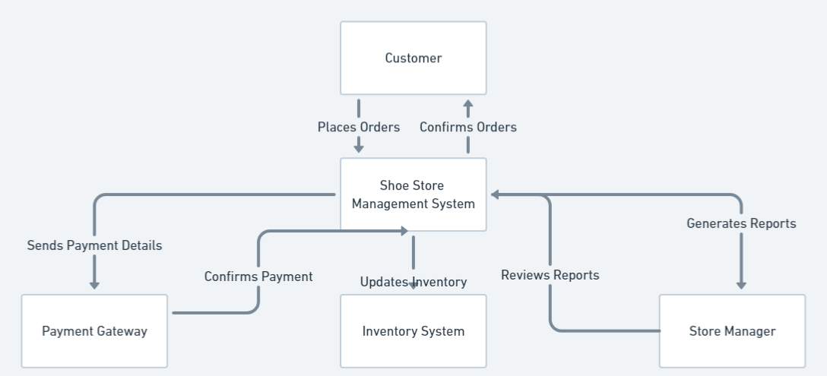

**3.3.1.2 Level-0 Diagram**

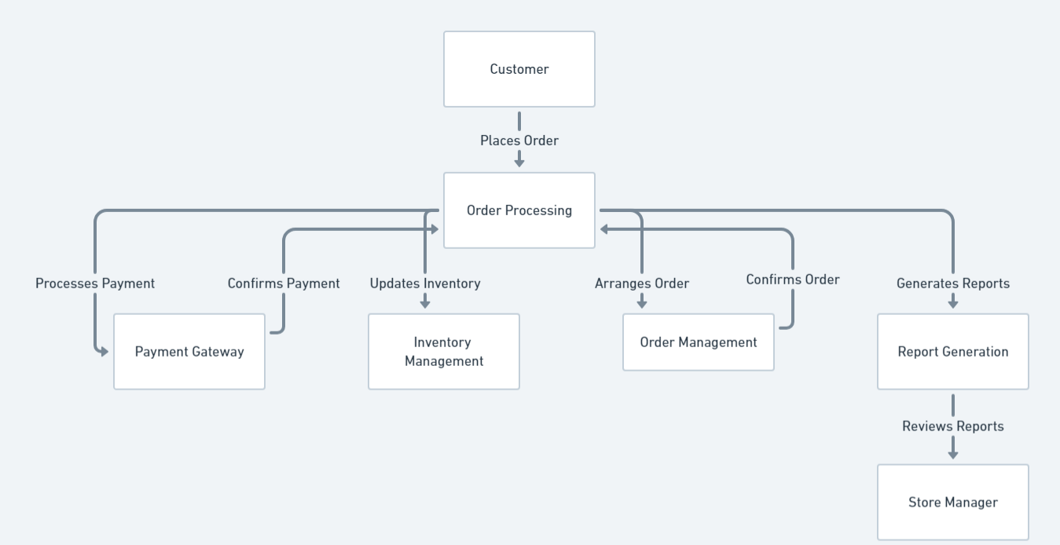

**3.3.1.3 Level-1 Diagram**

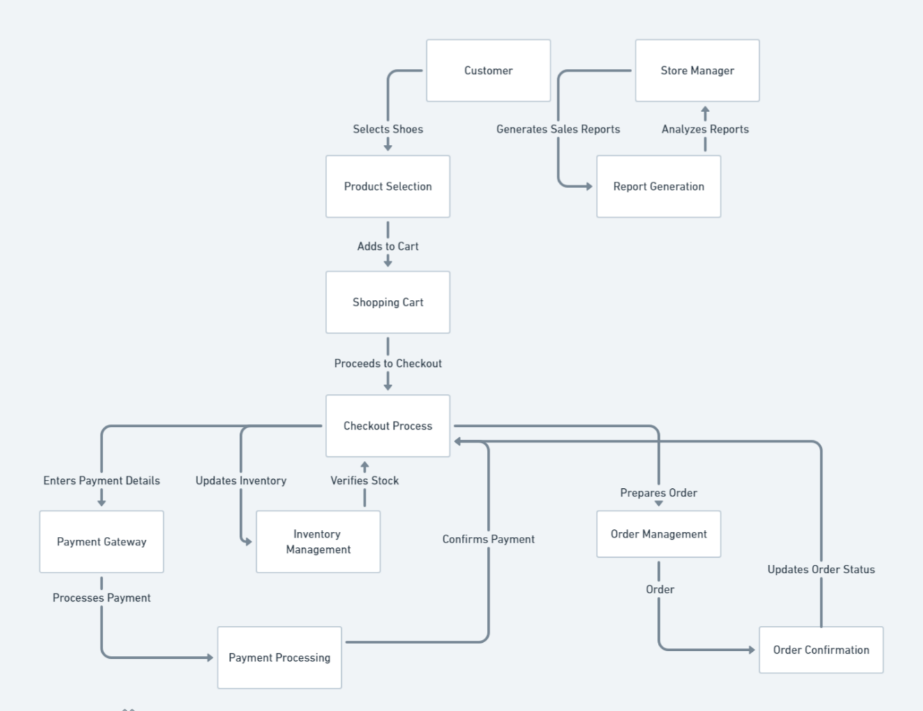

**3.3.2 Use Case Diagrams**

Use case diagrams will illustrate the interactions between users (actors) and the system.

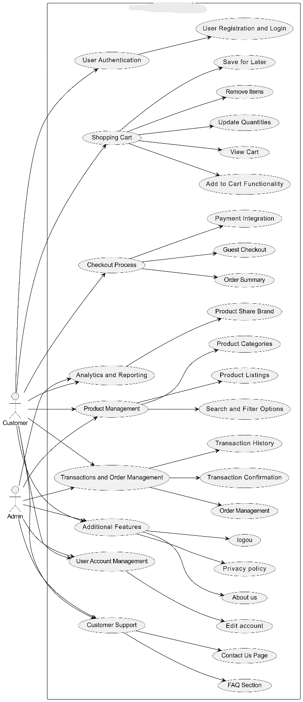

**3.3.2.1 Use Case Descriptions**

Here are the descriptions for each use case in the Online Shoes Store

|  |  |
| --- | --- |
| User Authentication | Allows users to create an account and log in to the system to access personalized features and maintain their purchase history. |
| Product Management | Display detailed information about each product including product name, high-quality images, size and color options and Pricing |
| Product Categories | Organize products into categories for easier browsing: basketball, football, running |
| ****Search and Filter Options****: | Enable users to find products based on specific criteria: by size, by color, by price range and by brand |
| Shopping Cart | Allow users to add selected products to their shopping cart. Provide users with a summary of items in their cart. Let users adjust the quantity of items in their cart. Allow users to remove unwanted items from their cart. Enable users to save items for future purchase. |
| Checkout Process | Allow users to complete purchases without creating an account. Integrate with payment gateways to facilitate secure transactions. Provide a detailed summary of the order before finalizing the purchase. |
| User Account Management | Allow users to update their personal information and account settings. |
| Customer Support | Provide users with a means to contact customer support for inquiries or issues. Offer answers to common questions to assist users. |
| Analytics and Reporting | Analyze and report on the distribution of products by brand. |
| Transactions and Order Management | Easily view and manage all your current orders. Access your complete transaction history, including detailed records of each transaction. you can confirm or cancel transactions, view and manage current transactions, and receive real-time transaction status updates. |
| Additional Features | Provide information about the company. Detail the company's policies on user data and privacy. Allow users to securely log out of their accounts |

**3.3.2 Activity Diagrams**

**Inventory Managements Activity**

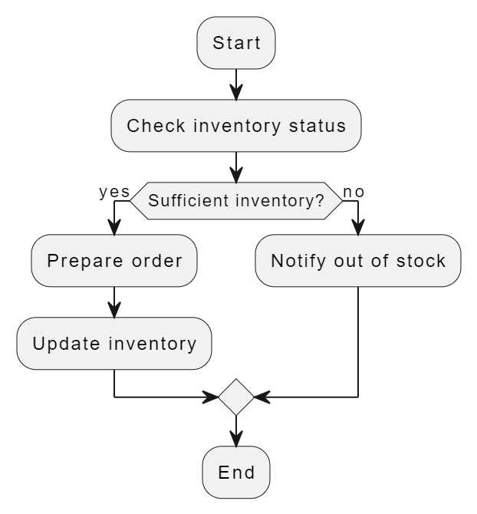

**Order Shoes Activity**

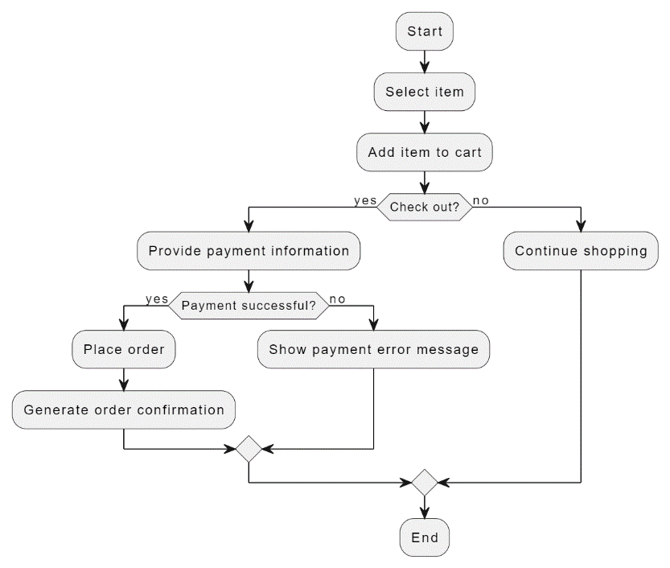

**3.3.3 Sequence Diagrams**

**Customer Places Order**

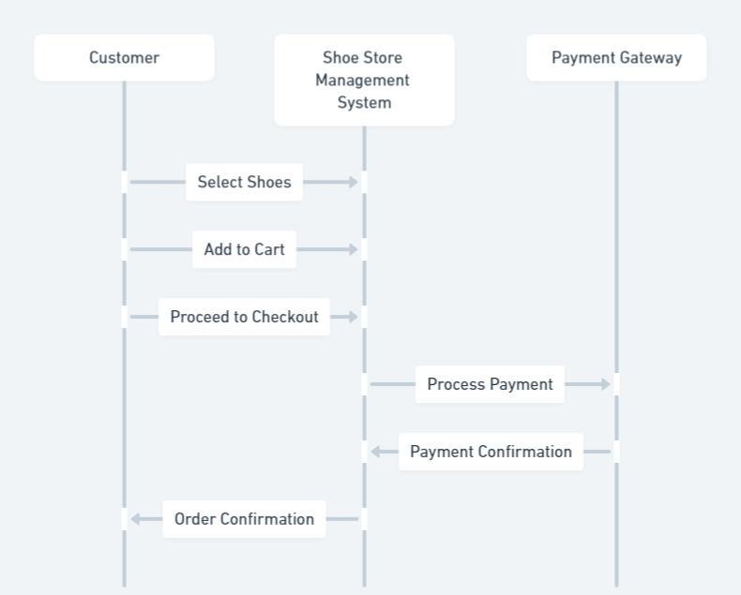

**Payment Processing**

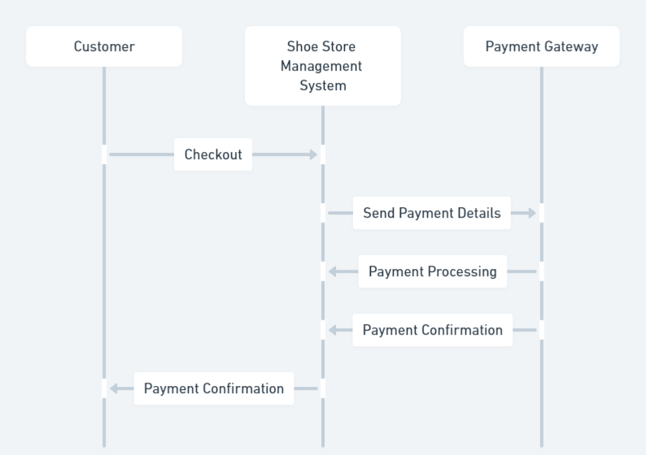

**3.3.4 Object modeling of the to-be system (Class Diagram)**

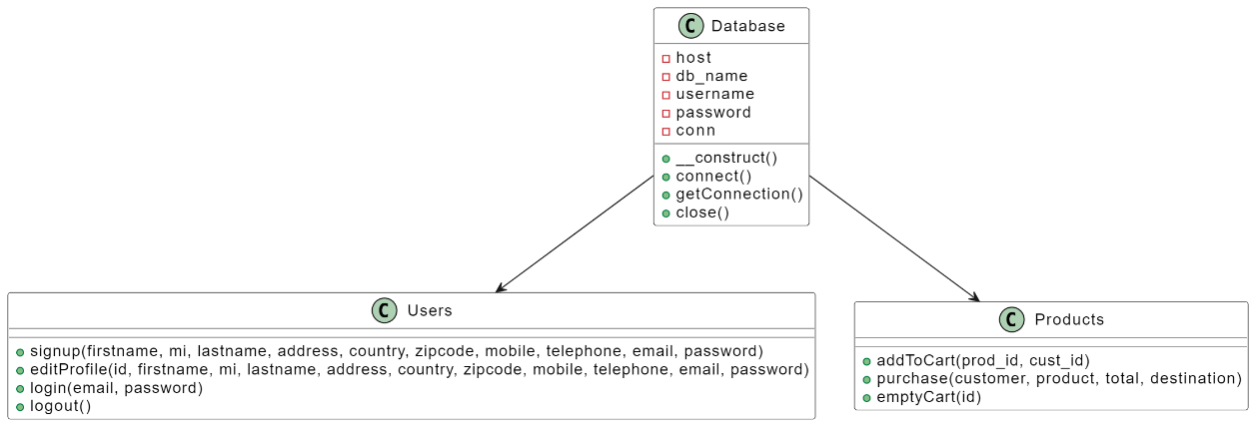

**3.3.5 Data modeling of the to-be system (Conceptual Data Modeling using ERD)**

**Customer and Transaction**: One-to-Many

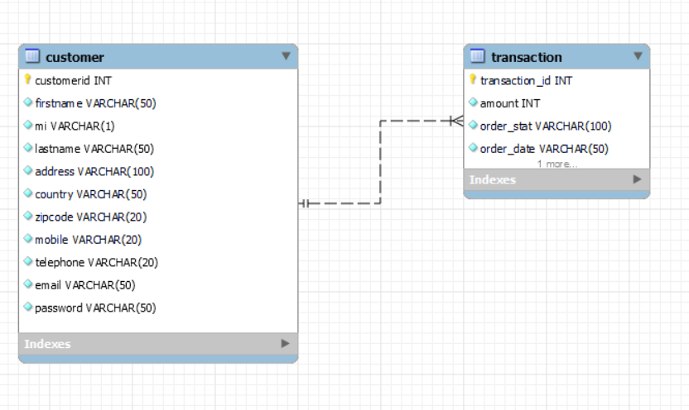

**Customer and Contact**: One-to-Many

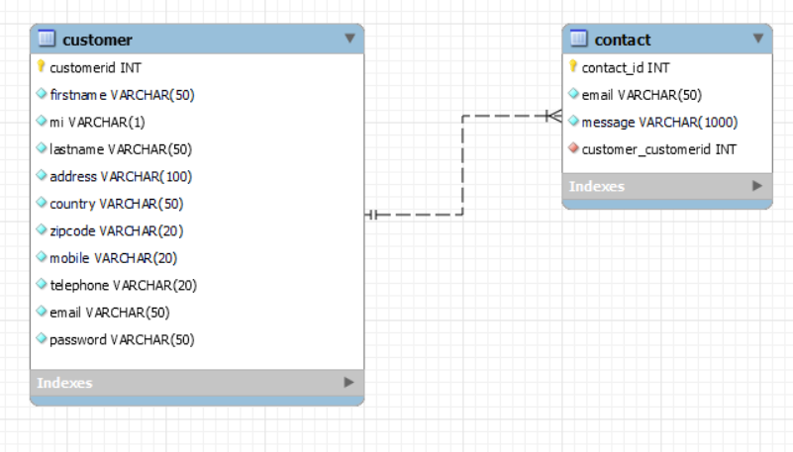

**Product and Stock**: One-to-One

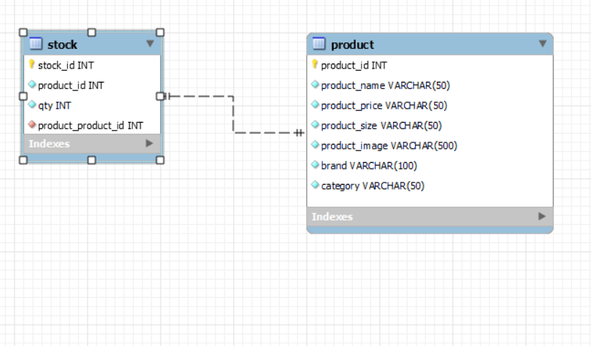

**Transaction and Transaction Detail**: One-to-Many

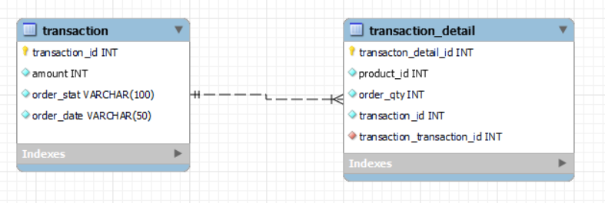

**REFERENCE**

[1] Y. Wang et al., "A Survey on Augmented Reality for E-Commerce," IEEE Transactions on Industrial Informatics, vol. 16, no. 6, pp. 4152-4165, Jun. 2020.

[2] M. S. Krishnamoorthy, "Critical factors influencing online shoe purchase decision: A conceptual framework," Journal of Retailing and Consumer Services, vol. 41, pp. 75-83, 2018.

[3] J. Huang et al., "A Deep Learning Based Recommendation System for Online Shopping," in Proceedings of the 2018 IEEE International Conference on Data Mining (ICDM), pp. 1108-1113, 2018.

[4] P. K. Manchanda, E. J. Newman, and D. G. Chandler, "Identifying the Link Between Online Reviews and Sales: An Exploration of Sentiment in Hotel Reviews," Journal of Marketing Research, vol. 45, no. 1, pp. 70-79, Feb. 2008.