COMP3010

Assignment 4

Chaz Lambrechtsen

45426317

Table of Contents

2 Problem A 2

2.1 Flow Network 2

2.2 Question 1 2

2.3 Question 2 2

3 Problem B 2

3.1 Flow Network 2

3.2 Question 1 2

4 Problem C 2

4.1 Flow Network 2

4.2 Question 1 3

4.3 Question 2 3

5 Problem D 3

5.1 Flow Network 3

5.2 Question 1 3

6 Problem E 3

6.1 Flow Network 3

6.2 Question 1 3

6.3 Question 2 3

6.4 Question 3 3

# Problem A

## Flow Network

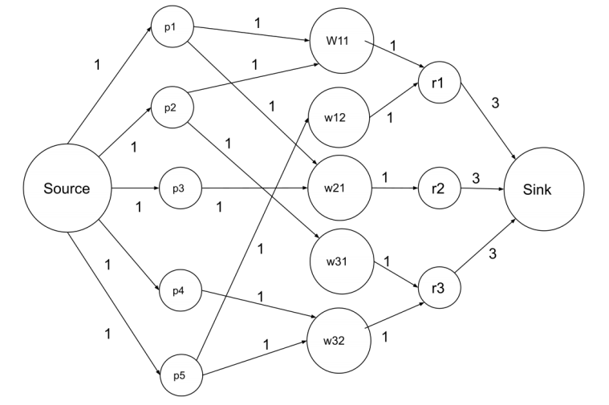

## Question 1

## Question 2

# Problem B

## Flow Network

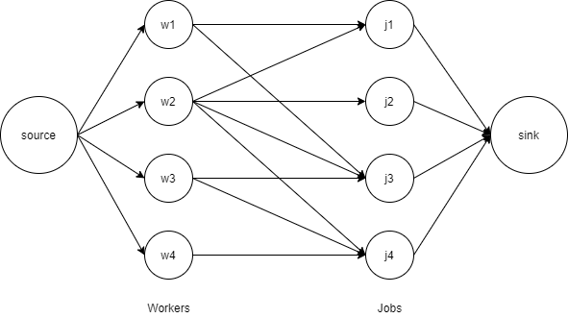

## Question 1

Yes, it is possible to use the greedy approach to solve the job assignment problem, however it is not the most optimal solution.

Solving via reduction to maximum flow:

For example, using Ford-Fulkerson (Greedy Algorithm), all residual capacities and flows are 0-1; flow corresponds to edges in a matching F.

Residual Graph RG simplifies to:

If (w, j) ∉ F, then (w, j) is in RG.

If (w, j) ∈ F, then (w, j) is in RG.

* Augmenting path simplifies to:
* Edge from s to an unmatched node w ∈ Workers,
* Alternating sequence of unmatched and matched edges,
* Edge from unmatched node j ∈ Jobs to sink.

# Problem C

## Flow Network

## Question 1

## Question 2

# Problem D

## Flow Network

## Question 1

# Problem E

## Flow Network

## Question 1

## Question 2

## Question 3