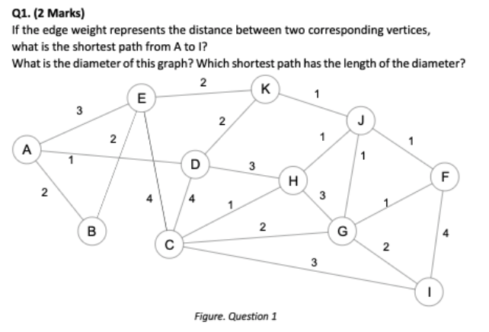

|  |  |
| --- | --- |
| A - D - H - G - I | 1 + 3 + 3 + 2 = 9 |
| A - D - H - J - G - I | 1 + 3 + 1 + 1 + 2 = 8 |
| A - D - K - J - G - I | 1 + 2 + 1 + 1 + 2 = 7 |
| A - E - K - J - F - I | 3 + 2 + 1 + 1 + 4 = 11 |
| A - E - K - J - G - I | 3 + 2 + 1 + 1 + 2 = 9 |
| A - E - C - I | 3 + 4 + 3 = 10 |

Shortest Path is ( A - D - K - J - G - I ) = 1 + 2 + 1 + 1 + 2 = 7

Diameter of the graph is 7

shortest path that has length of the diameter

|  |  |
| --- | --- |
| A - E - C | 3 + 4 = 7 |
| A - D - H - G | 1 + 3 + 3 = 7 |
| A - D - H - G | 1 + 4 + 2 = 7 |
| A - D - K - J - G - I | 1 + 2 + 1 + 1 + 2 = 7 |

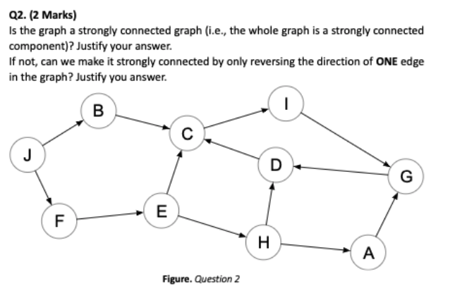

The whole graph IS NOT strongly connected - as not every pair of nodes can reach each other, ie: Out(J) <> In(J), and, Out(E)<> In(E)

No - by reversing the direction of only ONE edge in the graph - this will NOT make the whole graph strongly connected. Multiple edges would need to be reversed in direction (up to 3 edges).

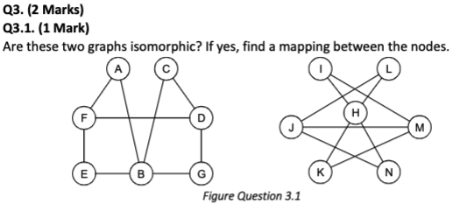

Yes these 2 graphs are isomorphic

|  |  |  |
| --- | --- | --- |
| B | H | 4 degrees |
| A | I | 2 |
| F | M | 3 |
| D | J | 3 |
| E | K | 2 |
| G | N | 2 |
| C | L | 2 |

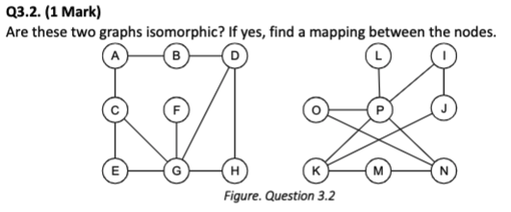

|  |  |  |
| --- | --- | --- |
| F | L | 1 degree |
| G | P | 5 |

No graphs are NOT isomorphic

Node F has 1 degree, so maps to L,

G is 5 degrees and maps to P,

However graph 2 nodes K and N are 3 degrees

But in graph 1, only ONE node has 3 degrees

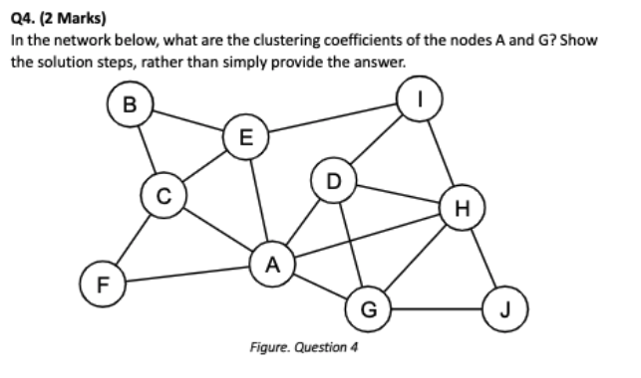

Clustering coefficient is the probability that two randomly chosen friends of node A are friends with each other.

n = number of friends of node

m = number of friends pairs of node which are also friends with each other

for node A: m = 6 friends, n = 5 friend pairs with each other

for node G: m = 4 friends, n = 4 friend pairs with each other

|  |  |
| --- | --- |
| C(A) = m / ( n * (n - 1)) / 2 )  = 6 / ( 5 * ( 5 - 1 )) / 2 )  = 6 / ( 20/2 )  = 6 / 10  = 3 / 5  = 0.6 | C(G) = m / ( n * (n - 1)) / 2 )  = 4 / ( 4 * ( 4 - 1 )) / 2 )  = 4 / ( 12/2 )  = 4 / 6  = 1 / 3  = 0.33 |

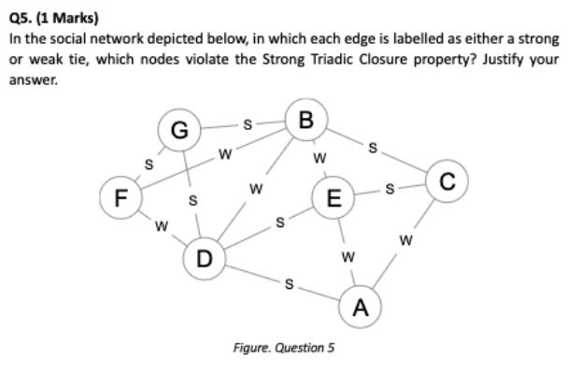

Strong triadic closure = two strong ties imply a third edge

Nodes B, D, F as all 3 nodes have a weak tie only

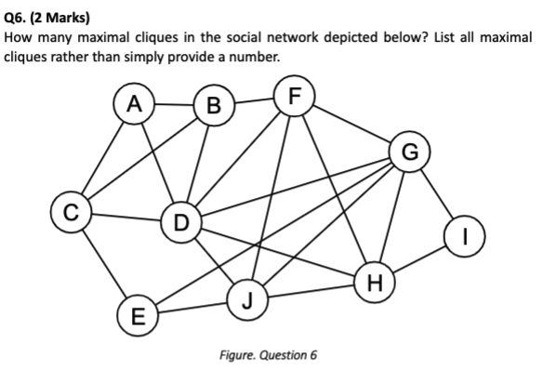

Clique definition: everybody in the group knows everybody else

6 maximal cliques include:

( C, E ) = 2

( B, F, D ) k = 3

( E, G, J ) k = 3

( G, H, I ) k = 3

( A, B, C, D ) k = 4

( D, F, G, H, J ) k = 5

­­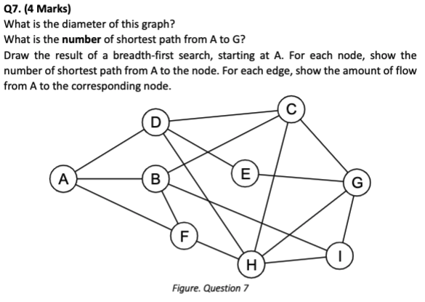

Diameter = 3

The longest, shortest, path is A - G = 3

There are 6 paths that match the shortest paths

A - D - C - G

A - D - E - G

A - D - H - G

A - B - C - G

A - B - I - G

A - F - H - G