Tyler Patton, Shae Bolt
Dr. Yin
CS 5402 – Machine Learning
12/7/2016
Autonomous Navigation Using Neural Networks
Introduction
To finish our Introduction to Machine learning we are tasked with applying our knowledge gained to a problem of our choosing. This is to showcase our knowledge gained from the course and express our creativity and passion for the subject by implementing our own work. For this task our group decided to assist the Missouri S&T Robotics design team in achieving autonomous navigation of the IGVC Competition Robot. The MS&T Robotics team produced a robot built from scratch yearly. This robot is placed on a course outlined in white lines and littered with obstacles. From a starting point it must navigate through the course on without human interaction to a specified end point. Many challenges are posed for the IGVC competition: building the robot, making it run, equipping it with necessary tools, and giving it the ability to solve the courses. The point of our project is to hone in on one specific challenge associated with the robot: autonomous navigation.
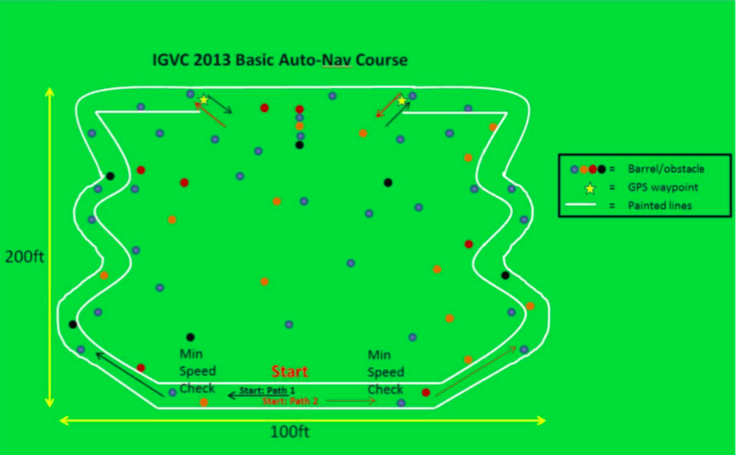

Resources
Missouri S&T Robotics Team:
The team is the basis for our project and both of us have worked with them in the past. Our interaction with them will be more notable if our work is successful enough to be integrated with the robot to be used in IGVC.
TensorFlow Machine Learning Library
To implement our neural network design we are using Google’s open source library TensorFlow. This will allow us to more easily construct, manipulate and visualize a neural network.
Ros Gmapping
This resource provides for us a probability map. The probability map will take the area visible to the robot and convert it into probabilities of whether or not there is an object obstructing the robots path. This will come into play in the integration phase with the Robotics team.
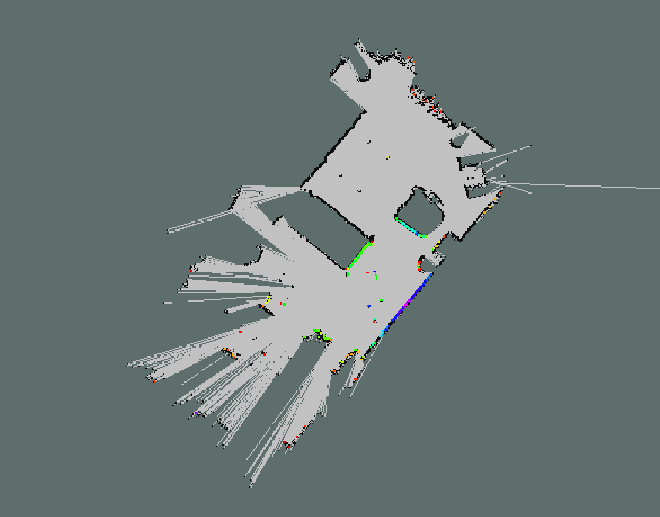
Example of a probability map produced from Gmapping

Algorithm
Generating Maps
We need to simulate the course maps that the robot will be placed in, as we do not have access to a variety of quality maps that are easily utilized by our path finding. To solve this we have generated several maps resembling the one below. First we draw a map on draw.io, then we run it through a python script which converts the image to a series of 1’s and 0’s. Then we manually clean the image so that all open space is available to all other open space and the dimensions are 50x50.
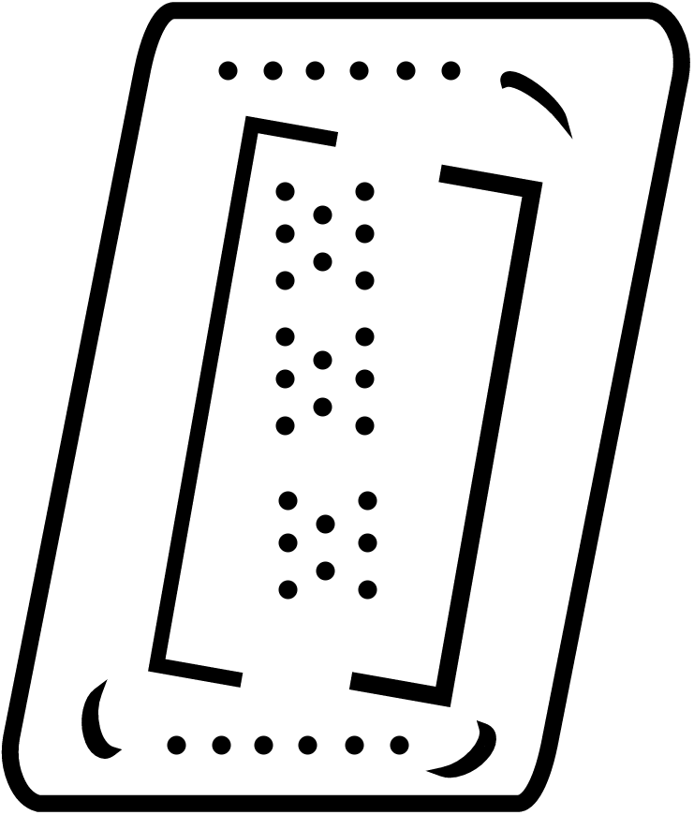
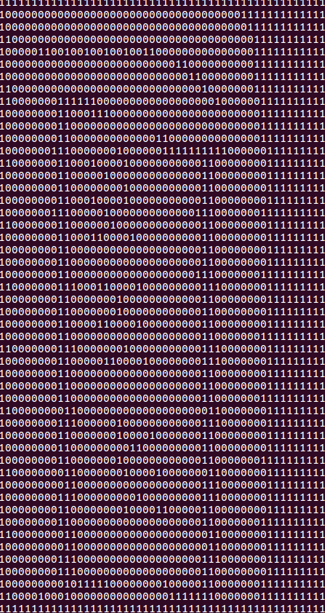

Floyd-Warshall All Pairs Shortest Path
One vital part of our project is the use of path finding for training. We have implemented Floyd-Warshalls to run on the grid maps we have produced. Given a starting point and ending point we are given a path. At each point along that path we will determine what the next direction of Floyd-Warshall’s produces and train it with the next direction our neural network produces.
Subgraph
The robot has a limited vision range in the real world so we have simulated subgraphs in our maps. We feed the map, the robots starting position and the dimensions of the subgraph (the robots vision radius) to the script. These subgraphs are then used to perform ray casts.
Ray Casts
Ray casts are vectors at specified angles 360 degrees around the robot. Our initial expriemnt is run with angle 2pi/16 for 16 rays. A ray cast returns the distance to the closest object along that vector of sight. If the vector does not hit an object by the end of the robots vision radius the distance is inf. This collection of ray casts will be a part of the input to our neural network.
Neural Network
The neural network takes as inputs the (x,y) position of the robot and the (x,y) position of the goal, and the distances from ray casts 1→N. As output it returns a direction vector that will move the robot for a specified distance before processing the next set of ray casts. This sequence is run until the goal is reached. The neural network uses a softmax regression model, using gradient descent as an optimization method during back propogation. These tools are defined and utilized through Tensorflow.

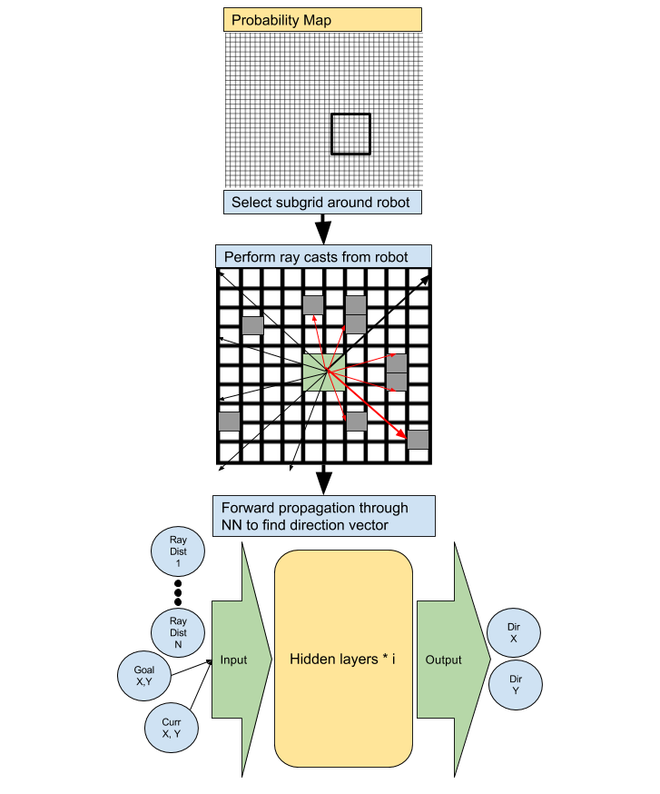
Ray casting and neural network concept image

Results
Test set = 100 data
Training set = 100 data
We ran different iterations of gradient descent to test different levels of accuracy.
Step Size | 0.01 | 0.001 | .5
10 Iteration Accuracy | 50% | 0% | 50%
100 Iteration Accuracy | 50% | 0% | 50%

These results define how often our neural network predicted the correct direction along the path compared to Floyd-Warshall. What we have found is that if Gradient Descent hits enough iterations or with a high enough learning rate we reach a 50% accuracy, else we have 0%. These results seem strange and we have a couple of predictions on why we are seeing this behavior.
1. Our subgraph dimension for these tests is 9x9, so our neural network does not have as much information available to it as Floyd-Warshall does. This would be an obvious contribution to a less efficient path as the ‘robot’ will be progressing using the information available to it.
2. There is an algorithmic flaw in our code. TensorFlow is a new tool to us and we are trying to make as much use of the features available to us as possible. To remedy this we need to familiarize ourself with TensorFlow more, use different models (softmax, etc), or build our a neural network from scratch.

Observations
cost 174943.0
cost 1.10479e+14
cost 1.12911e+11
cost 3.99014e+16
cost 2562.46
cost 2.1641
cost 2.15306
cost 2.14204
cost 2.13103
cost 2.12004
Through running our neural network we processed the cost which was attempted to be minimized over the runs. This was accomplished through gradient descent, so this result was more promising that we did reduce cost. We viewed this as an error function similar to cross-entropy, but we performed reduce-mean. Considering this we more firmly believe that we have an algorithmic error as our gradient descent seems to make progress although our results do not reflect this.
Neural Network Visualized
This is the neural network constructed by TensorFlow and visualized through Tensorboard. We ended up with 2 hidden layers. With more tuning of the logs produced from running the training Tensorboard will allow us control over visualization of the data and scalars as they are propagated through the training. In future experiments we would need to more closely follow these scalars so we could tune what model and optimizations our neural network are performing. Although with achieving an output and a solidly designed network we are happy with the project as a stepping stone into future work.

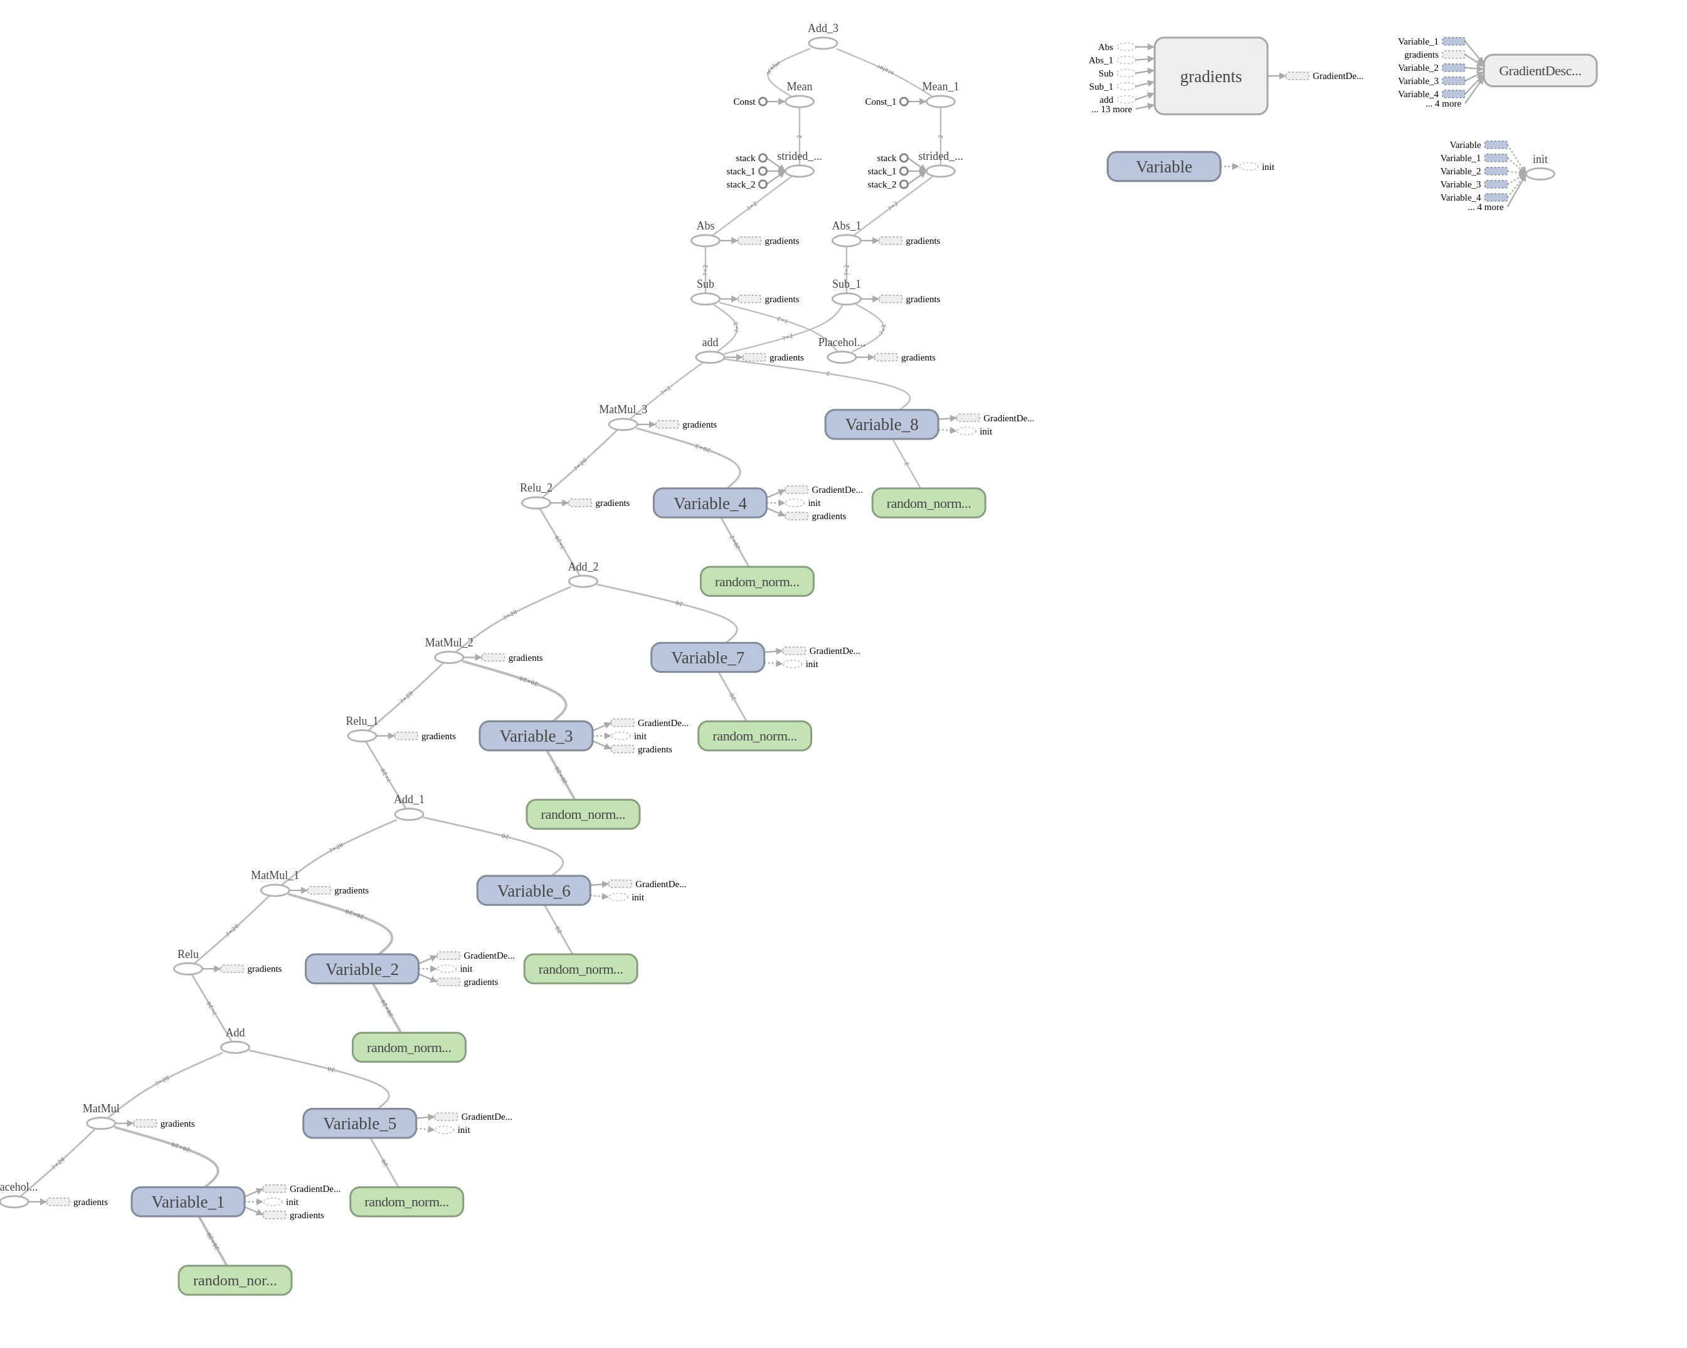

Future Work
Our project was a success in utilization of tools and procedures, but the results are not quite up to our standards for pushing this project into production with the Robotics team. In future iterations of this project we would need to more closely monitor what model would be necessary to best fit the needs of this project. Softmax regression was easily implemented through Tensorflow but in the future would need to be scrutinized in a validation step to prove it is effective for this project. TensorFlow is a very powerful tool and may have been too ambitious for our relatively small neural network. It would have been viable to build a neural network with a single hidden layer by hand for our implementation. Now for our push into integration with the Robotics team. This project will hopefully be seen as an approach possible for their competition Robot. Apart from the neural network we successfully implemented data extraction from graphs with ray tracing to provide effective and tunable features. These scripts we produced would need to be fitted to Gmapping probability maps but the concept is tested here. In summary our future work will consist of fine tuning, validation and integration. We had successful pieces but questionable results. In all, the project is a step towards success.
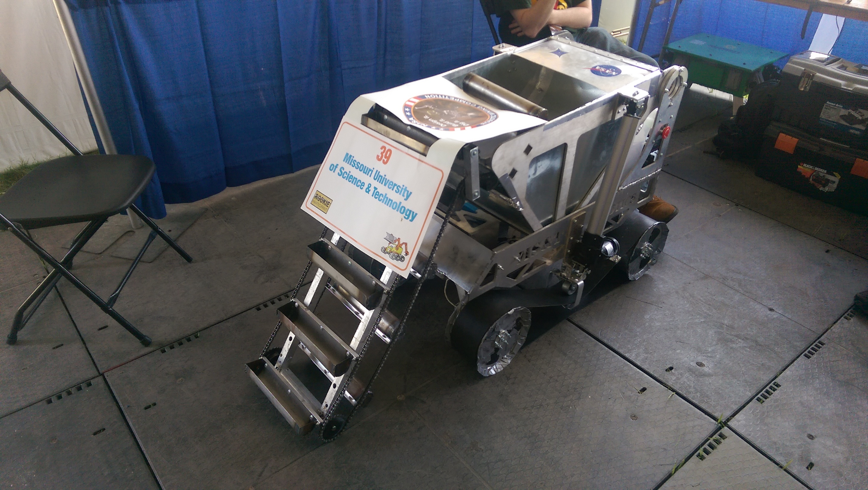
2014 IGVC Competition robot from MST Robotics Facebook

