Kung Neonair
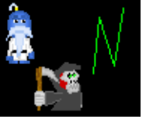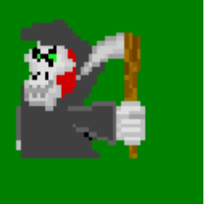
About Kung Neonair

Kung Neonair is a platform game about a GrimReeper who works at a Chinese Restaurant named Neonair(Lol! The Restaurant’s name isn’t Neonair, the GrimReeper’s is). He is obviously Neonair’s(the game making group) biggest star(so to speak. Others have their opinions).

Enough said.

Plot

One day when Neonair is happily making Chinese food at Ching’s Chinese Restaurant( That’s the name of the restaurant), evil lawyers come in and declare that they’re going to destroy the restaurant.
Why? Because Neonair burnt their food last time(it’s the evil lawyer’s fault. They ordered extra crispy and Neonair warned them about it).
The only way that Neonair can save Ching’s restaurant is to make the evil lawyers an ULTIMATE CHINESE FOOD PLATTER.
But first, he must get the ingredients from a whole lot of different worlds filled with various puzzles, enemies, characters, ect. You must guide Neonair to get the ingredients and then defeat the evil lawyers! Prepare for a fun challenge.

Controls
Enter = confirm
arrow keys = move, select
shift = jump
ctrl = attack/aimer on

comments

Send any comments to Mytochi@aol.com

copyright stuff

Neonair©2002

all characters, the story , and graphics(except music) are copyrighted.

That means (obviously) that only Neonair can use them unless given special permission from Neonair.

