1. **Explain the steps required to create and deploy Ubuntu operating system using virtual box.**

S1:- Download the Windows Virtual Box

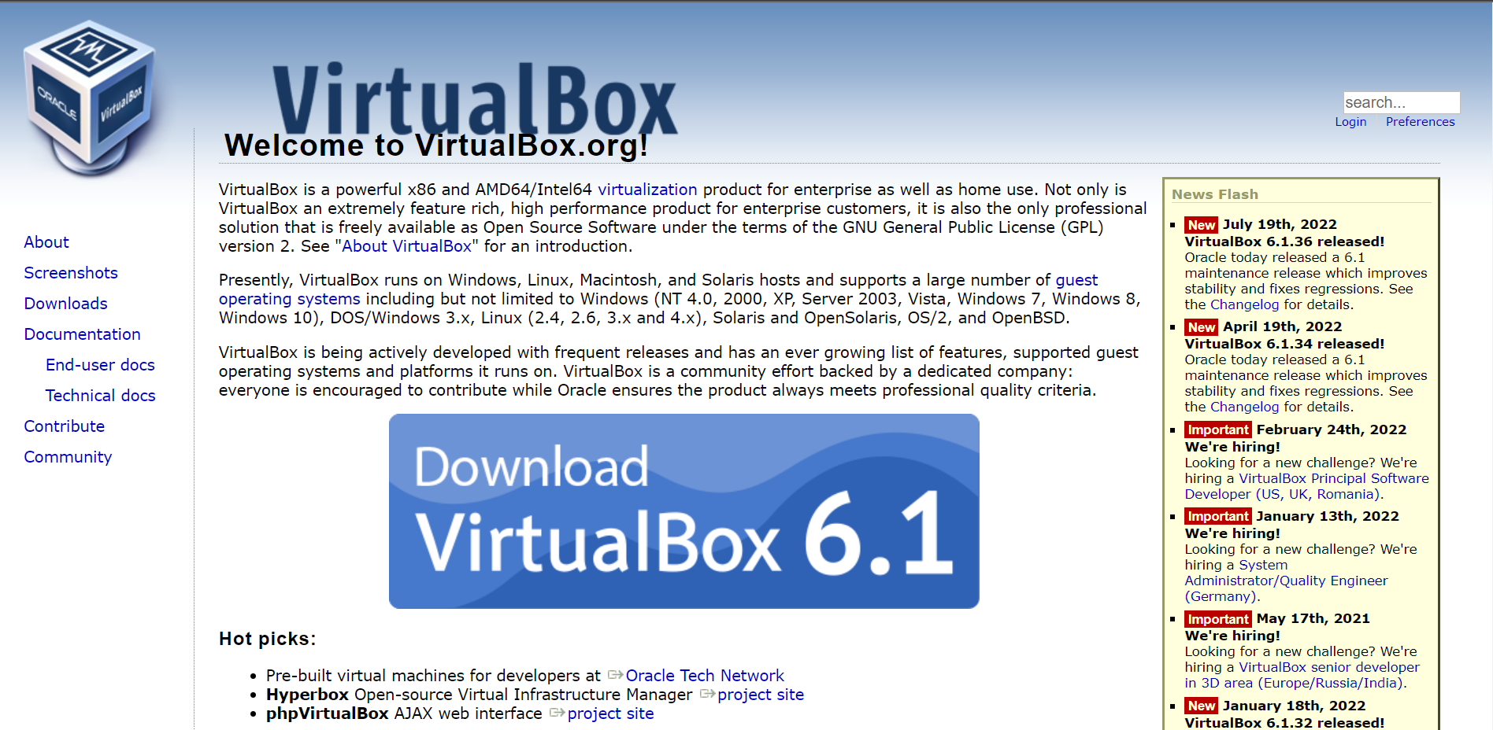

S2:- Download Ubuntu latest version ie 22.04LTS (long term support)

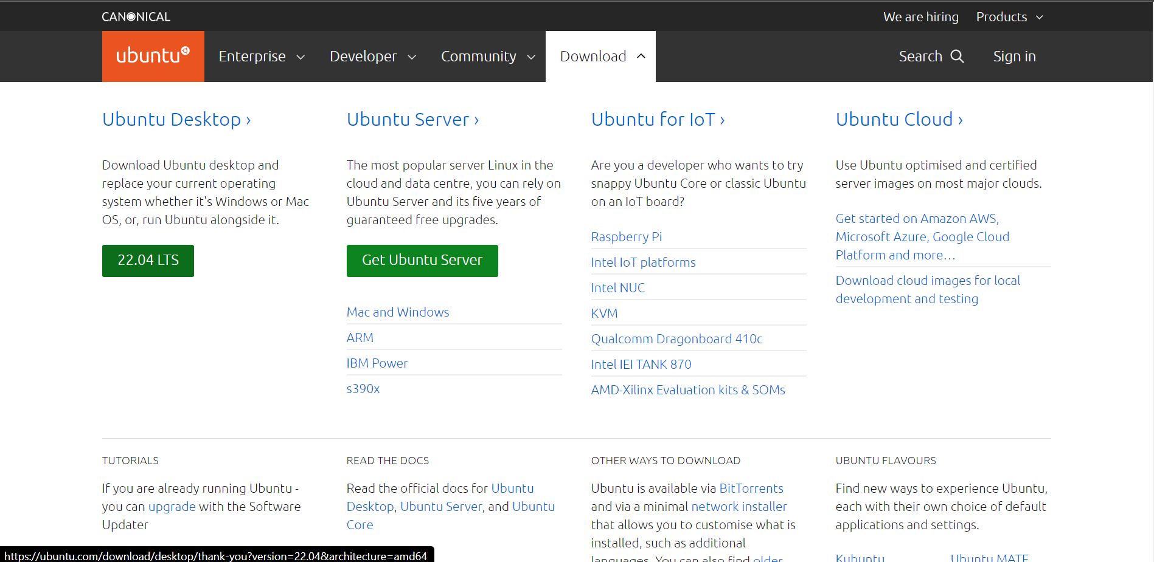

S3:- Once the Virtual Box is downloaded it look like this with empty OS.

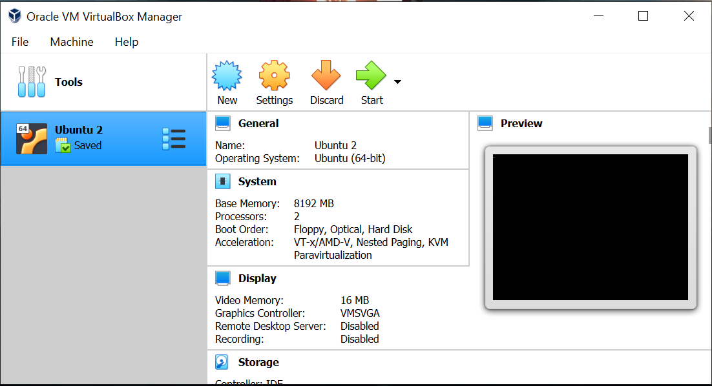

S4:- Once the Virtual Box is downloaded click on New option to create new OS in that.

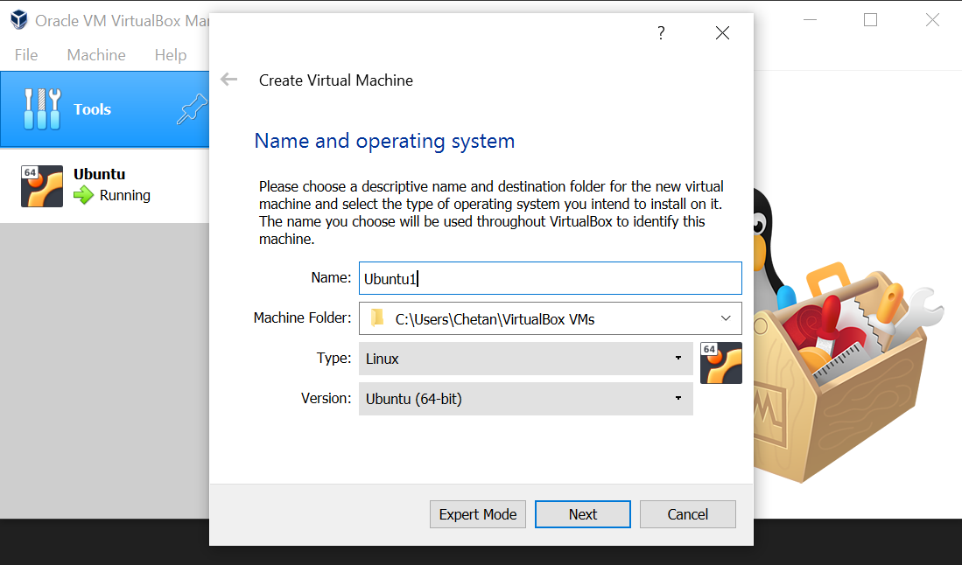

After clicking on new, Name the OS which u want and select the machine folder where your Virtual Box VM’s need to be stored and then select the type of OS and version depending on your PC.

S5:- After the click on next and there select the memory size and adjust according to you.

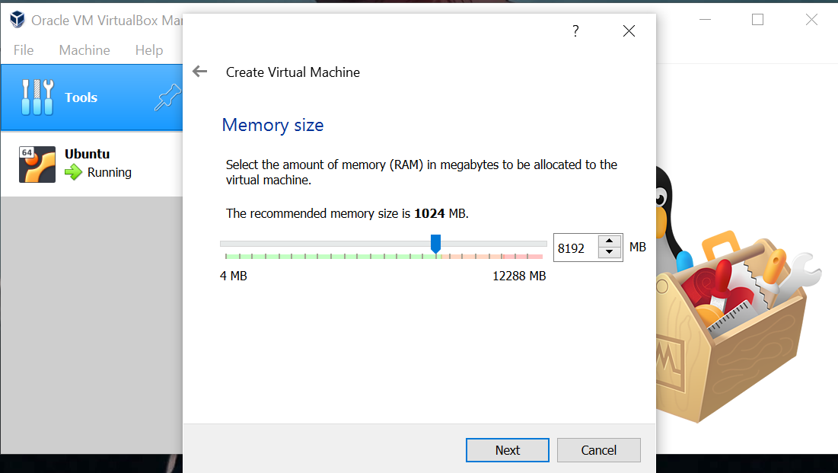

S6:- Click on next and keep the Hard disk file type as default, click on next.

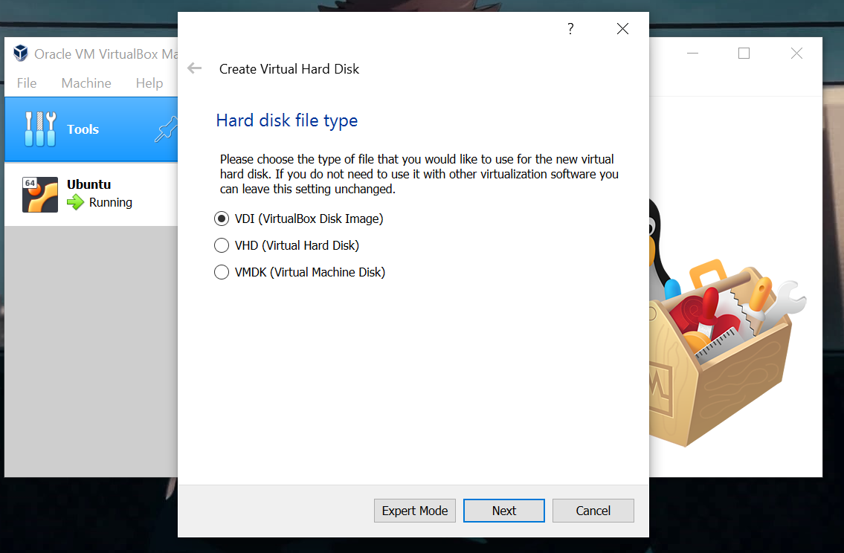

S7:- Keep the remaining things as default, like storage on physical hard disk as dynamically allocation after clicking on next it will ask file location and size keep that as default the click on create.

S8:- After clicking on create it will create a Virtual machine.

S9:- Now the Ubuntu OS is created now click on that OS and go to setting to provide a Ubuntu ISO file, go to storage >> Click on Controller: IDE >> Click on disk icon >> Select the Ubuntu iso from the download folder after that click on OK.

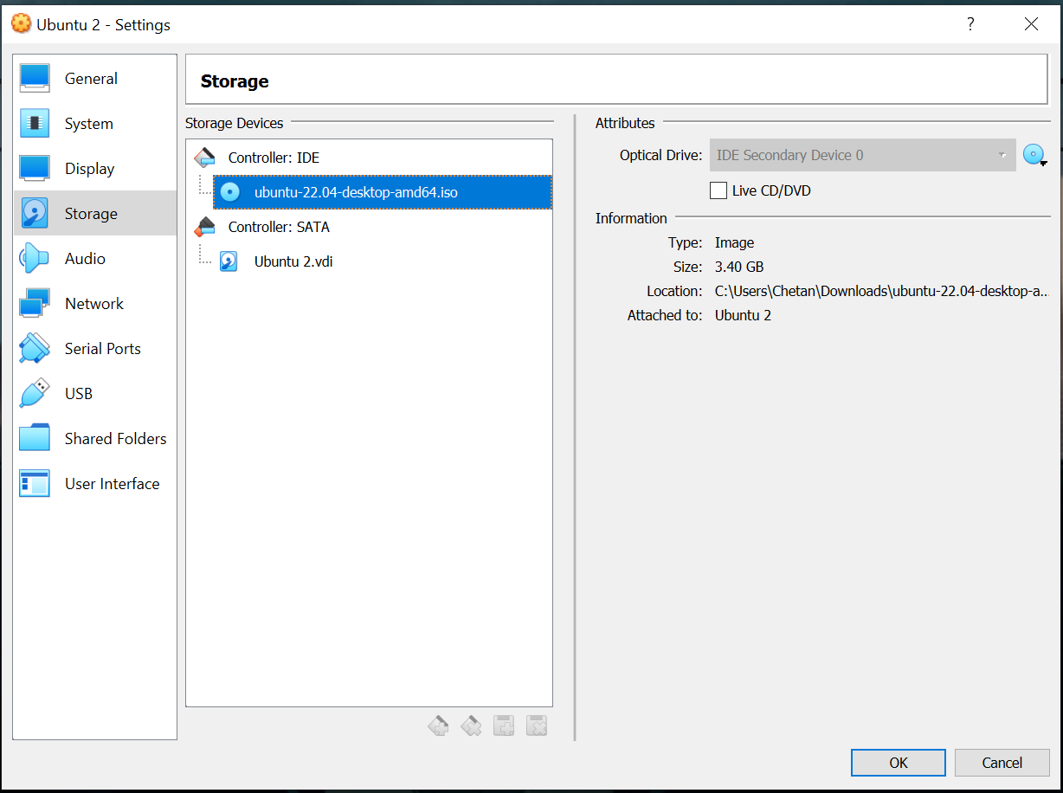

S10:- Now click on start, on the terminal it will ask to select the options, select try and install Ubuntu option the press enter.

S11:- After that it ask on the 1st window select the language the click on install ubuntu option and rest of the option keep as default and keep on clicking on continue option until it ask you to select the region option/where are you?

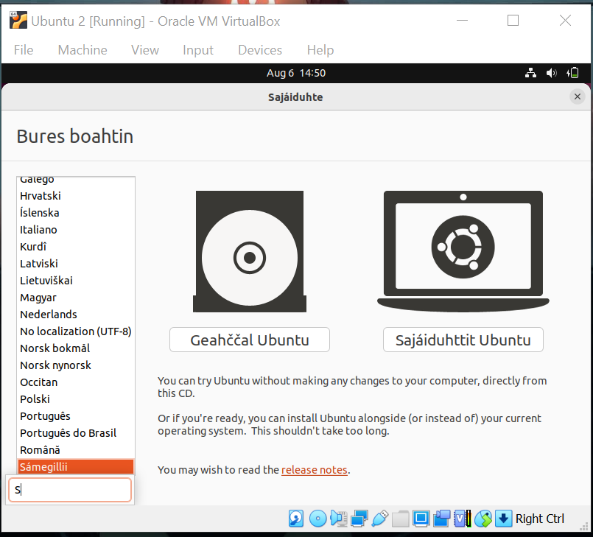

S12:- Select the region where you are from and continue the process.

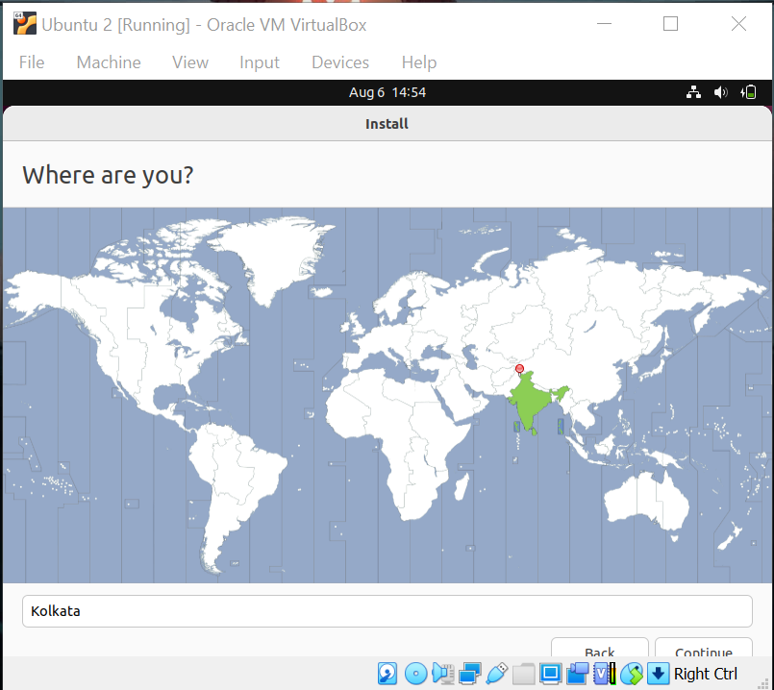

S13:- Here provide your information according to you and click on continue.

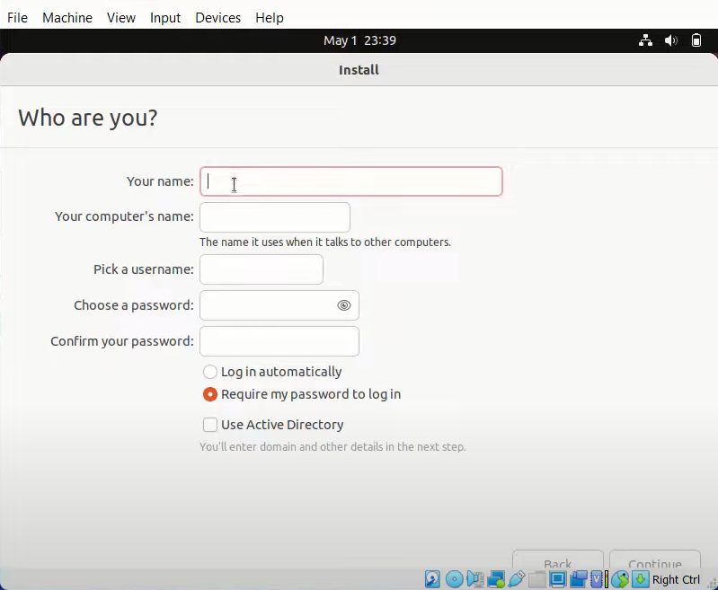

S14:- Now the installation of the Ubuntu starts.

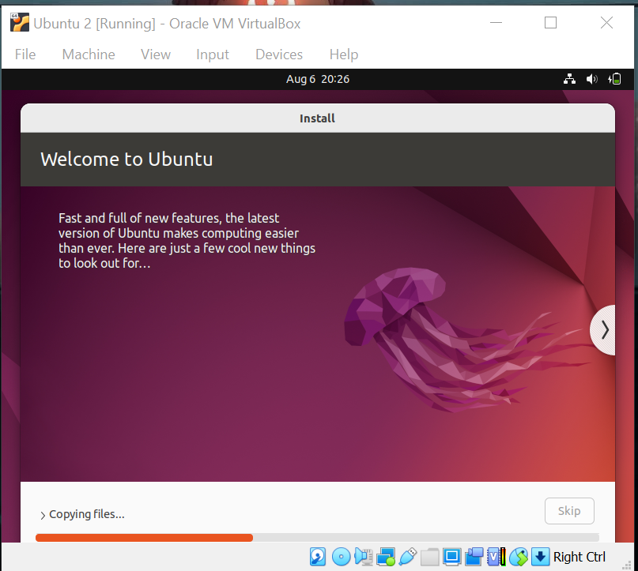

S15:- After installation it will ask your to restart after that your Ubuntu OS is ready.

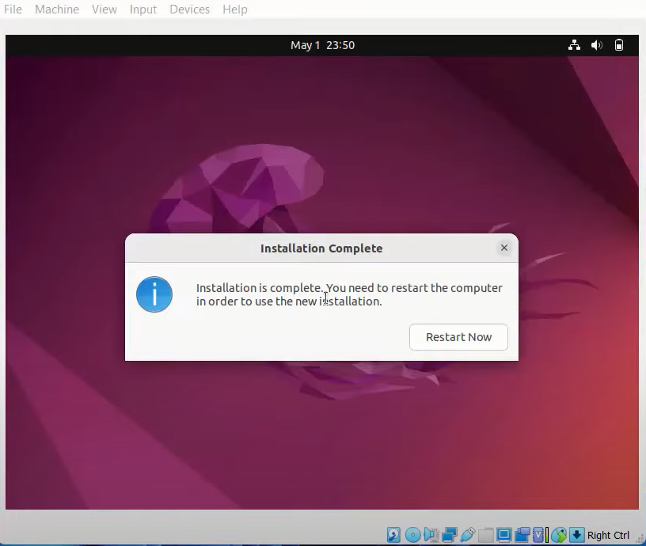

1. **Write the steps to install Centos using VMware and display a php program.**

S1:- Download VMware latest version.

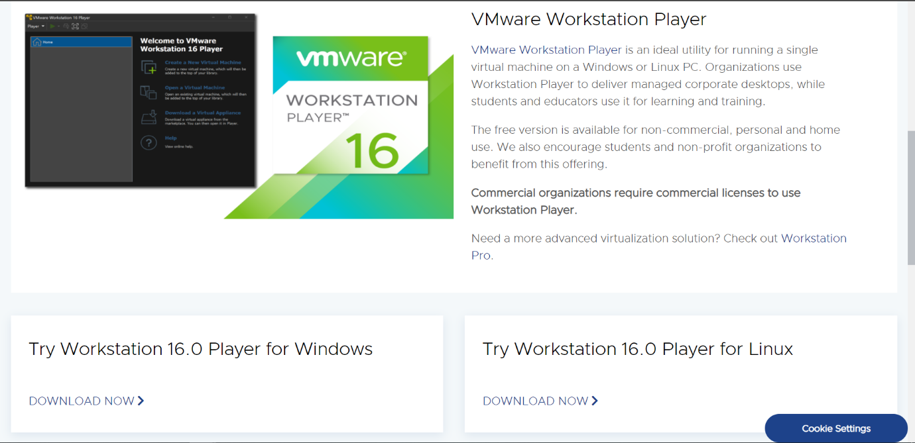

S2:- Download the Centos dvd1.iso file.

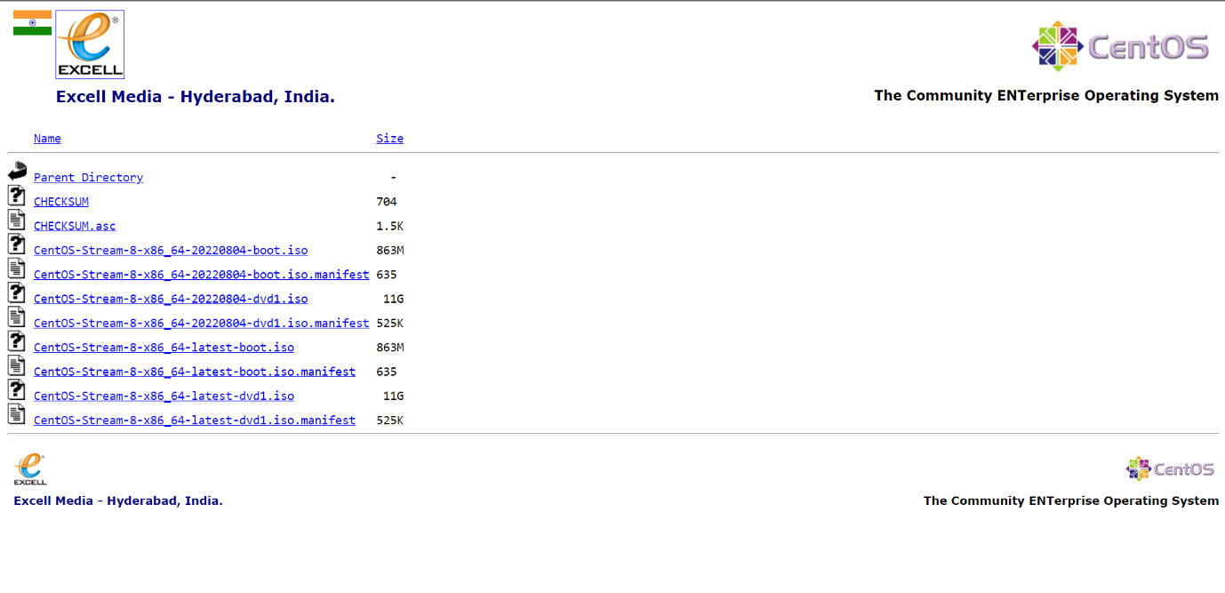

S3:- Install the VMware.

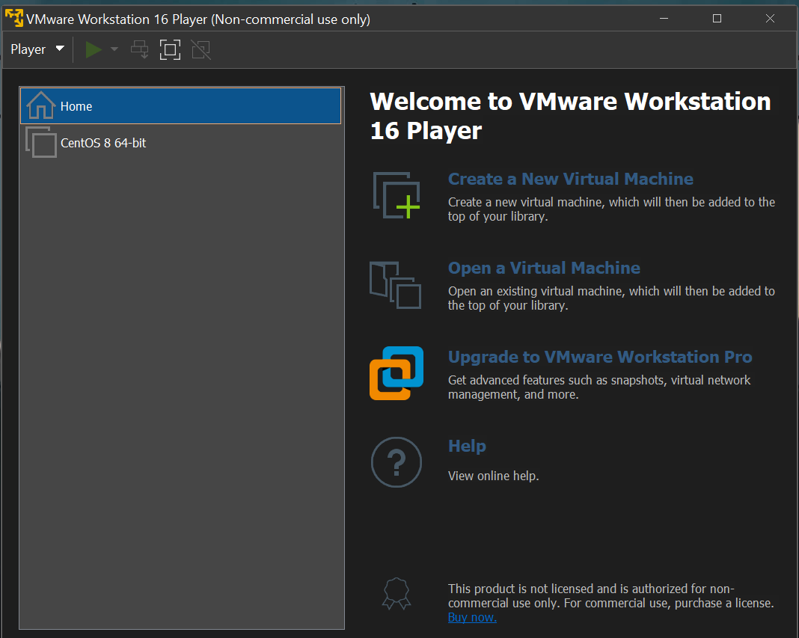

S4:- Click on create a new virtual machine and select option ‘I will install the operating system later’ or if you have downloaded the Centos iso file select ‘Installer disc image file’ the click on next option.

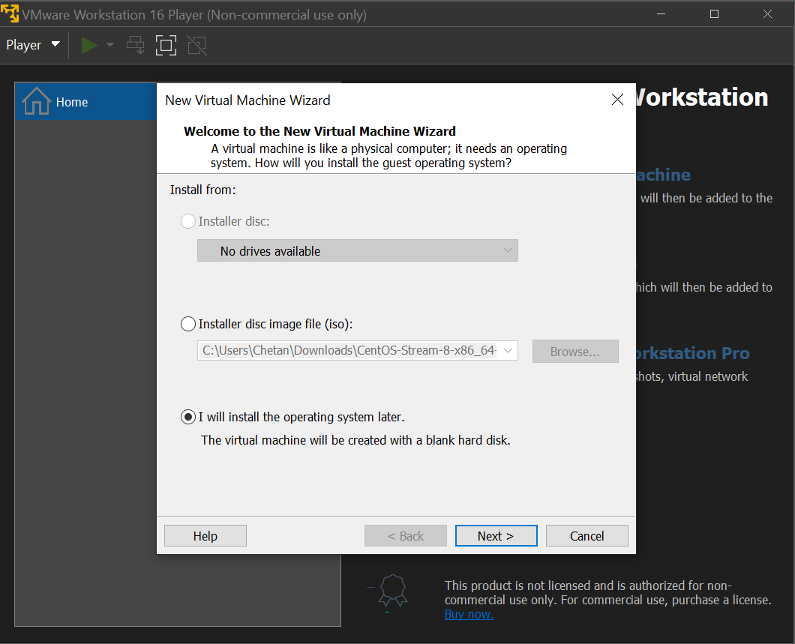

S5:- Now select Linux as Centos is Linux operating system and select the version as CentOS 8 64-bit then click on next.

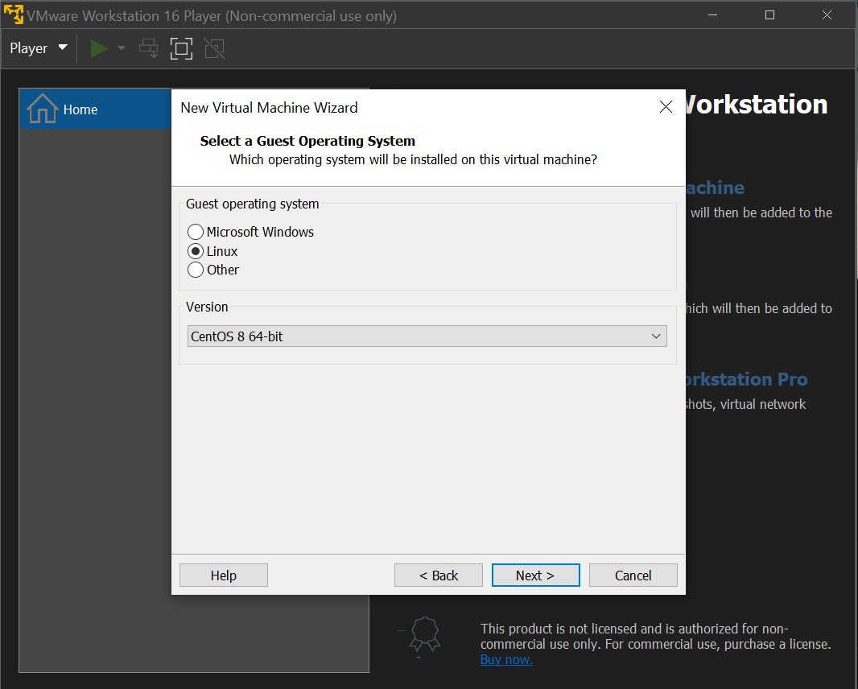

S6:- Select the disk size as u wish the select Store virtual disk as a single file so that it wont split the disk to multiple files, click on next.

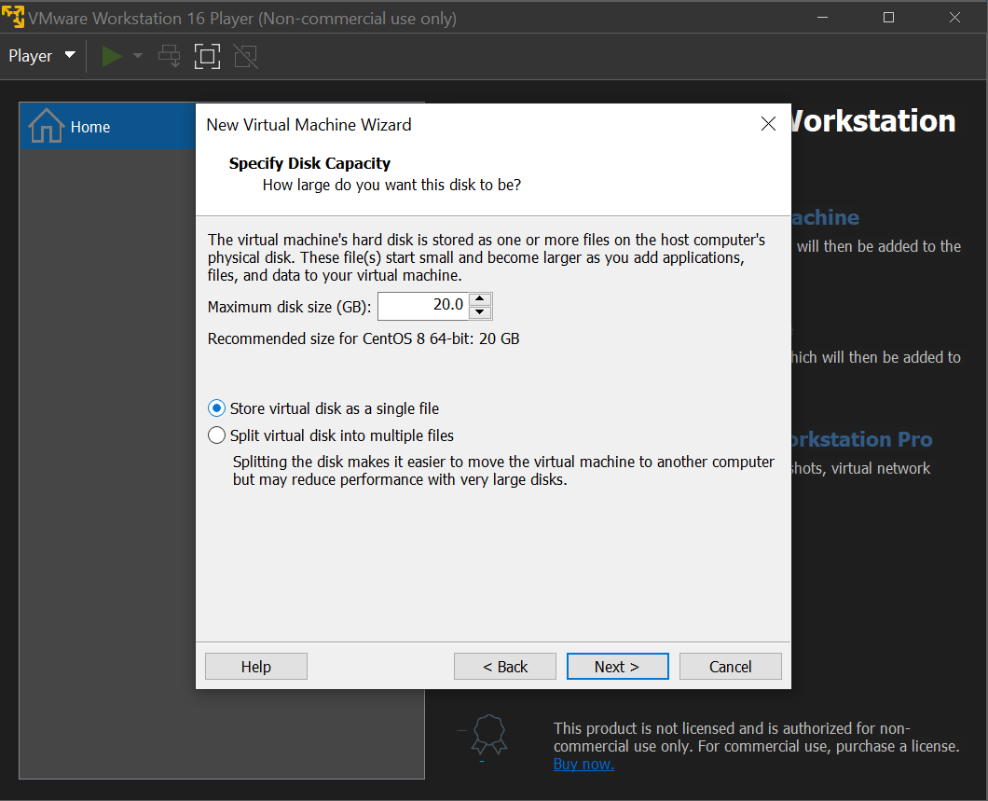

S7:- Now if u want to Customize Hardware click on that option or else click on Finish.

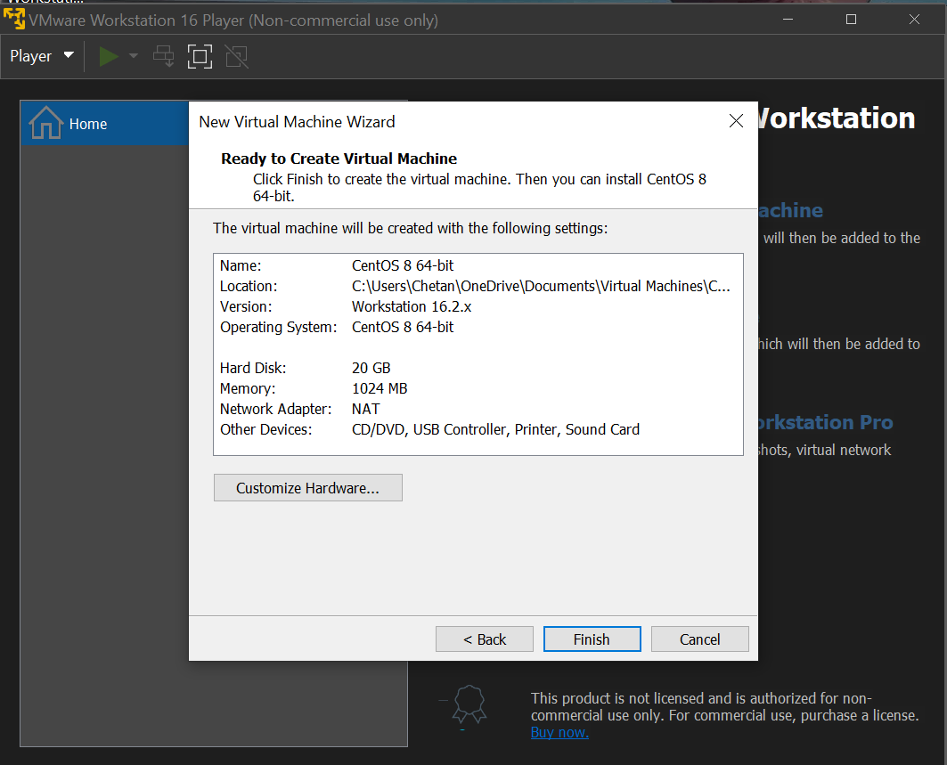

S8:- Click on Customize Hardware.

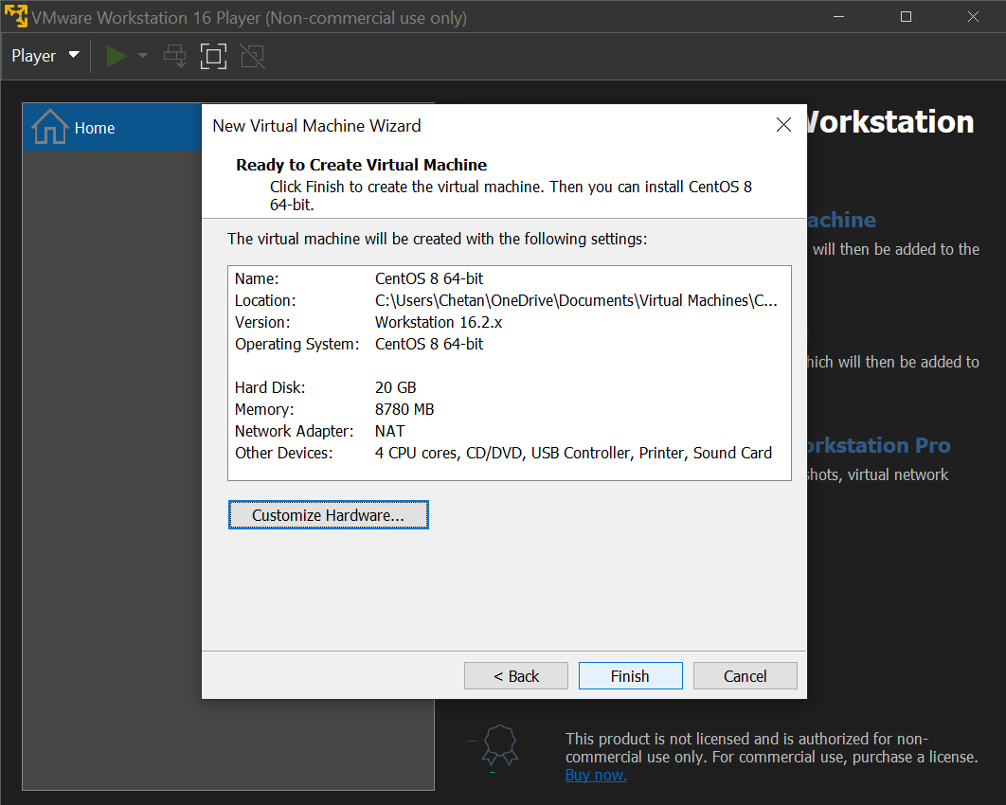

S9:- When you click in Customize Hardware select New CD/DVD option there select ‘Use ISO image file’ to select the downloaded CentOS iso file to that, the click on close.

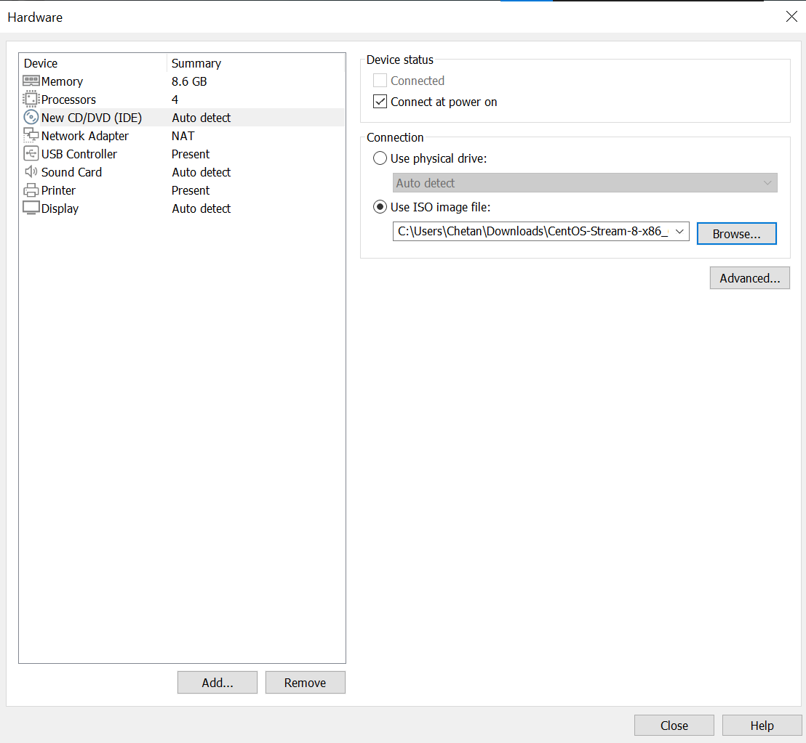

S10:- Now New CentOS Virtual machine is created.

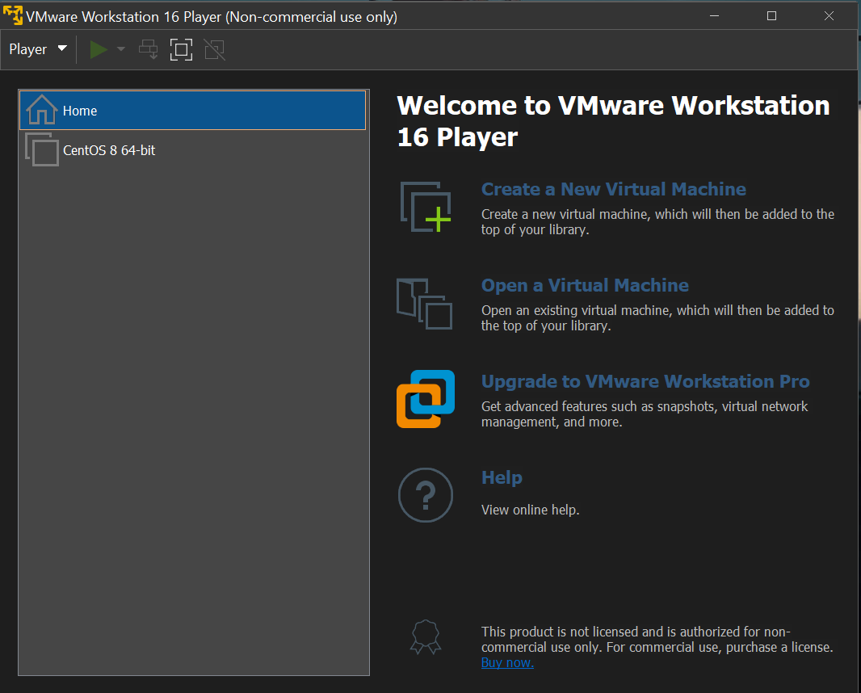

S11:- Click on Play Virtual Machine and the CentOS operating system starts wait for it to boot automatically.

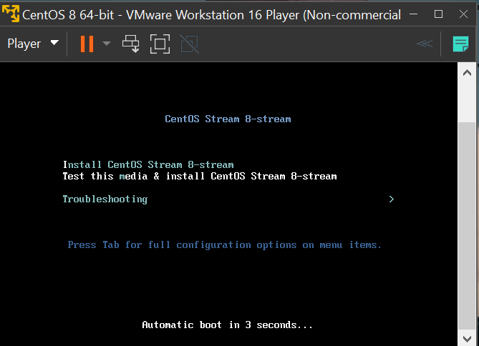

S12:- After that it will automatically process the things and download its required files to start.

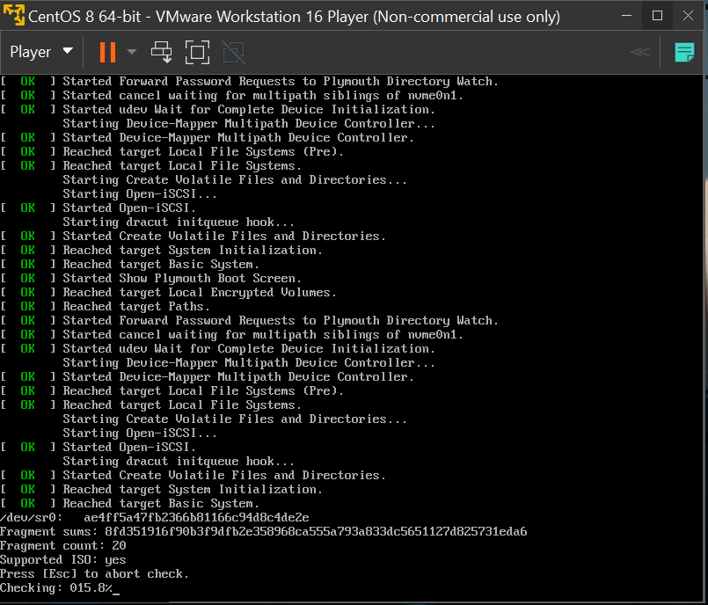

S13:- After all the process CentOS ask you to select the language and the click on continue.

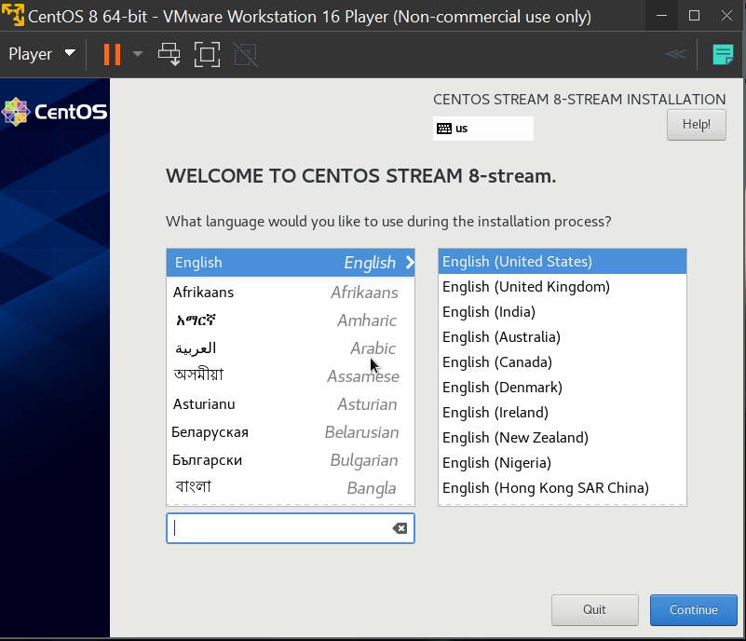

S14:- Keep the Installation Destination as default as 20Gb and click on Done.

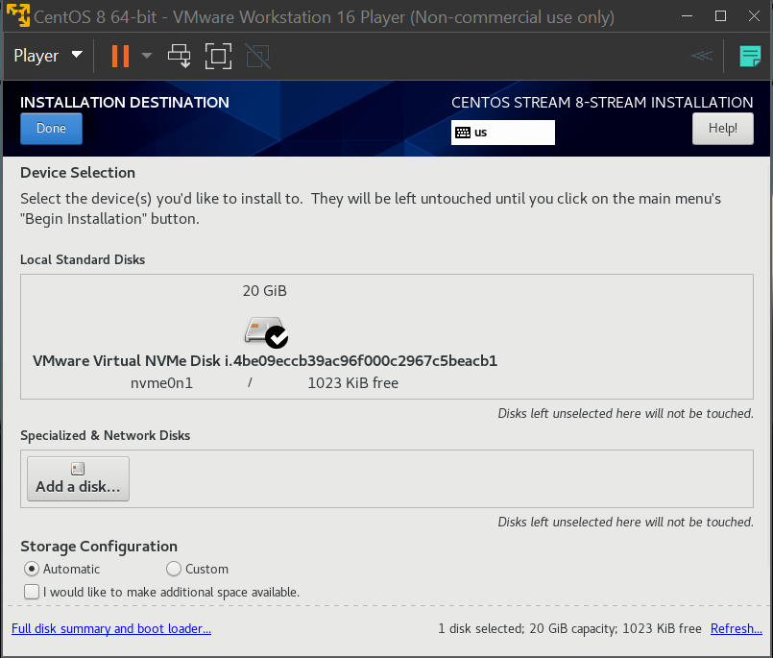

S15:- It will ask your to set ‘Root Password’ and to create ‘User Creation’.

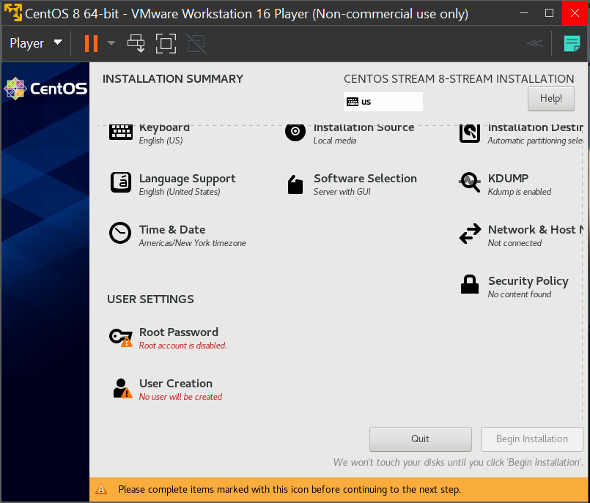

S16:- Click on User Creation and set your Name and set password then click on done and continue.

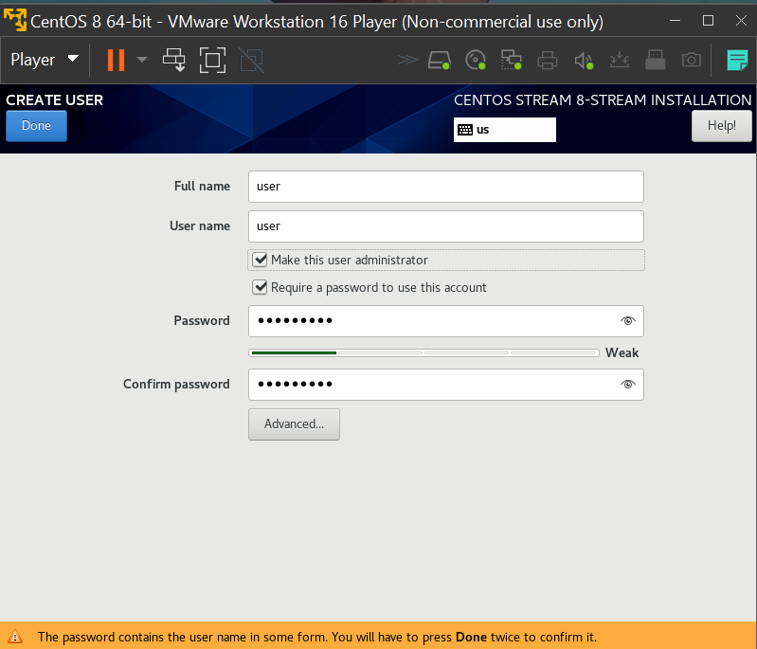

S17:- Installation starts.

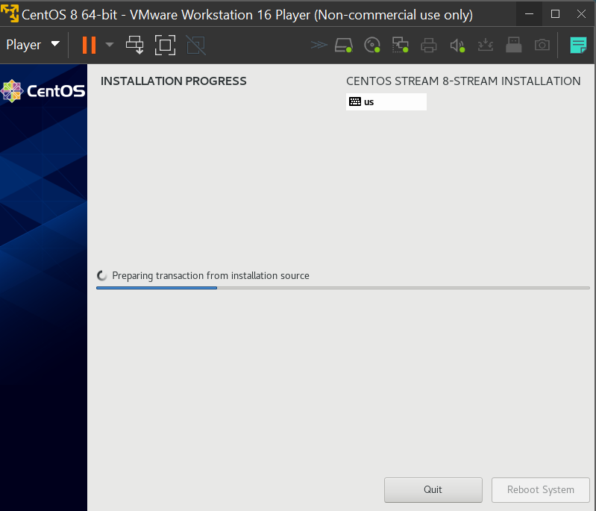

S18:- After installation CentOS Operating system it ask you to give user password to get into it.

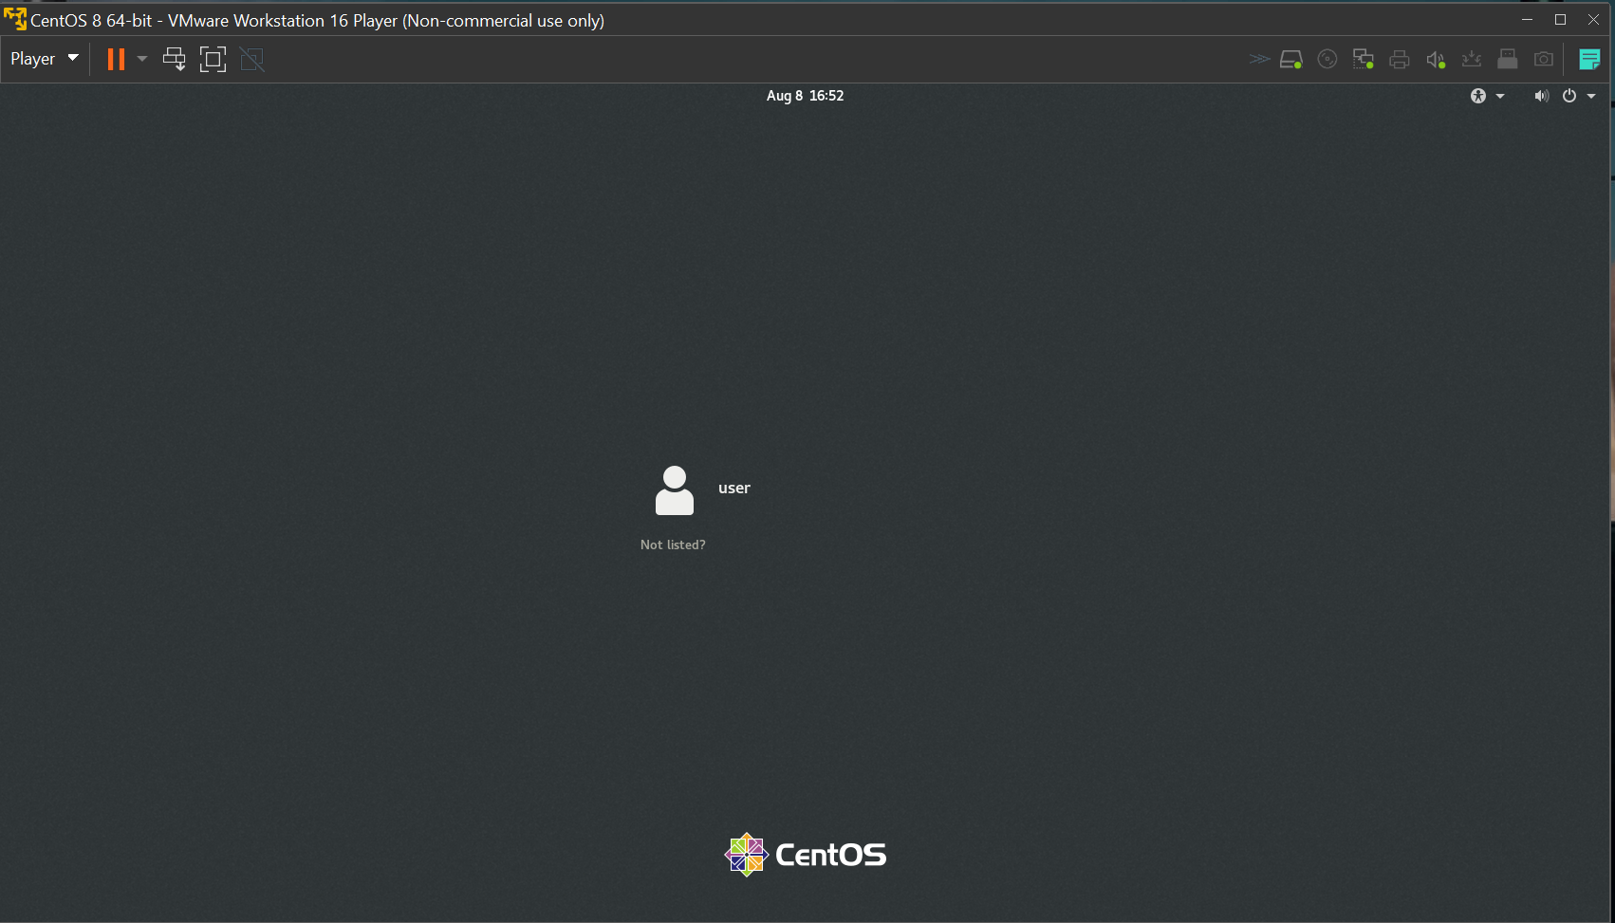

S19:- It asks to set language and keep all default settings and click on done and its ready to use.

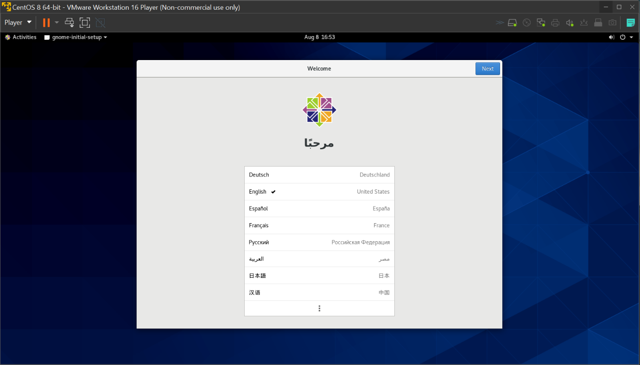

**1) Write a Python program to identify the occurance of vowels in given string**

string=input("Enter string : ")

vowels=0

for i in string:

if(i=='a' or i=='e' or i=='i' or i=='o' or i=='u' or i=='A' or i=='E' or i=='I' or i=='O' or i=='U'):

vowels=vowels+1

print(i)

print("Number of vowels are : ",vowels)

**2)Write a Python program to write to file and read the content of the file**

Writing into file

file = open('sample.txt', 'w')

val = input("Enter your value: ")

file.write(val)

file.close()

Reading the file content

file1 = open("sample.txt","r")

print("Read Operation : ")

print(file1.readlines())

print()

file1.close()

**3) Write a java program to compute Age from given date of birth**

import java.time.LocalDate;

import java.time.Period;

import java.util.Scanner;

public class AgeCalculatorExample1

{

public static void main(String args[])

{

System.out.print("Enter date of birth in YYYY-MM-DD format: ");

Scanner sc = new Scanner(System.in);

String input = sc.nextLine();

sc.close();

LocalDate dob = LocalDate.parse(input);

System.out.println("You are " + calculateAge(dob)+" years old.");

}

public static int calculateAge(LocalDate dob)

{

LocalDate curDate = LocalDate.now();

if ((dob != null) && (curDate != null))

{

return Period.between(dob, curDate).getYears();

}

else

{

return 0;

}

}

}

**4) Simple Php program to run in Linux Mint**

>>sample.php

<?php

echo "Hello world!"

?>

**Pushing the assignment into github**

Chetan@DESKTOP-F18S4EI MINGW64 ~

$ cd c

bash: cd: c: No such file or directory

Chetan@DESKTOP-F18S4EI MINGW64 ~

$ cd c:

Chetan@DESKTOP-F18S4EI MINGW64 /c

$ cd github

Chetan@DESKTOP-F18S4EI MINGW64 /c/github

$ git config --global user.email "chetan.b9880989930@gmail.com"

Chetan@DESKTOP-F18S4EI MINGW64 /c/github

$ ssh-keygen -t ed25519 -C "chetan.b9880989930@gmail.com"

Generating public/private ed25519 key pair.

Enter file in which to save the key (/c/Users/Chetan/.ssh/id_ed25519):

/c/Users/Chetan/.ssh/id_ed25519 already exists.

Overwrite (y/n)? y

Enter passphrase (empty for no passphrase):

Enter same passphrase again:

Your identification has been saved in /c/Users/Chetan/.ssh/id_ed25519

Your public key has been saved in /c/Users/Chetan/.ssh/id_ed25519.pub

The key fingerprint is:

SHA256:2pI+uNJT3alvUoPnAHUqqJ/vr6bSijj38KzEKF0uBKM chetan.b9880989930@gmail.com

The key's randomart image is:

+--[ED25519 256]--+

| |

| . . |

|o . . o |

|.o . o . |

|E ... +So . |

| =.o .++ * |

|o *+.++ .* . |

|+o+=B.o.o o |

|ooo**B=+.+. |

+----[SHA256]-----+

Chetan@DESKTOP-F18S4EI MINGW64 /c/github

$ cat /c/Users/Chetan/.ssh/id_ed25519.pub

ssh-ed25519 AAAAC3NzaC1lZDI1NTE5AAAAIADGEd0pmpwrnAf297vUNh4xgPrXEcn0uJDxv+sKB7C0 chetan.b9880989930@gmail.com

Chetan@DESKTOP-F18S4EI MINGW64 /c/github

$ git clone git@github.com:Cb12300923/CC-Assignment.git

Cloning into 'CC-Assignment'...

remote: Enumerating objects: 3, done.

remote: Counting objects: 100% (3/3), done.

remote: Total 3 (delta 0), reused 0 (delta 0), pack-reused 0

Receiving objects: 100% (3/3), done.

Chetan@DESKTOP-F18S4EI MINGW64 /c/github

$ ls

CC-Assignment/

Chetan@DESKTOP-F18S4EI MINGW64 /c/github

$ cd CC-Assignment/

Chetan@DESKTOP-F18S4EI MINGW64 /c/github/CC-Assignment (main)

$ ls

README.md

Chetan@DESKTOP-F18S4EI MINGW64 /c/github/CC-Assignment (main)

$ ls

Cloud-Computing.docx README.md

Chetan@DESKTOP-F18S4EI MINGW64 /c/github/CC-Assignment (main)

$ git add Cloud-Computing.docx

Chetan@DESKTOP-F18S4EI MINGW64 /c/github/CC-Assignment (main)

$ git commit -m "Adding test file"

[main 8257dd2] Adding test file

1 file changed, 0 insertions(+), 0 deletions(-)

create mode 100644 Cloud-Computing.docx

Chetan@DESKTOP-F18S4EI MINGW64 /c/github/CC-Assignment (main)

$ git push origin main

Enumerating objects: 4, done.

Counting objects: 100% (4/4), done.

Delta compression using up to 4 threads

Compressing objects: 100% (3/3), done.

Writing objects: 100% (3/3), 3.82 MiB | 1.28 MiB/s, done.

Total 3 (delta 0), reused 0 (delta 0), pack-reused 0

To github.com:Cb12300923/CC-Assignment.git

722d0f0..8257dd2 main -> main

Chetan@DESKTOP-F18S4EI MINGW64 /c/github/CC-Assignment (main)

$