

Republic of the Philippines

Department of Education

Region IV - A CALABARZON

DIVISION OF ANTIPOLO CITY

District I-B

**BAGONG NAYON II NATIONAL HIGH SCHOOL**

***Lower San Isidro, Brgy. San Isidro Antipolo City***

**FIRST QUARTER EXAMINATION IN MATHEMATICS 8**

**SY 2024 – 2025**

**Directions**: Read and understand each item carefully. Write the letter of the correct answer on your answer sheet.

1. What is the greatest common monomial factor of $4ab +8abc$?
2. $4ab$ B. $4abc$ C. $8ab$ D. 8 $abc$
3. What is the equivalent factors of ${x^{2} – y}^{2}$?

A. $(x + y)(x +2y)$ C $. (x-y)(x - y$)

B. $(x – y)(x +y)$ D. $(x – y)(x – 2y)$

1. Which of the following factors gives a product of $x^{2}+8x+7?$

A. $\left(x+1\right)\left(x+8\right)$ B. $\left(x+7\right)\left(x+1\right)$ C. $\left(x-7\right)\left(x-1\right)$ D. $\left(x-8\right)\left(x-1\right)$

1. The area of a rectangular garden in Brgy. San Isidro is $(x^{2}-5x-24)$ square units. If its length is $(x+3$) unit, what is its width?

A. $x +2$ B. $x-2$ C. $x+8$ D $. x-8$

1. An expression that can be written in the form $\frac{P}{Q}$, where P and Q are polynomials and Q ≠ 0.

A. Integers B. Irrational C. Radical D. Rational Algebraic Expressions

1. Which of the following expressions is a rational algebraic expression?

A. $\frac{m}{ √3p}$ B**. $x^{-2}+y^{-3}$**  C. $\frac{a}{b}$ D. $\frac{8c¼}{7}$

1. Which one shows a rational algebraic expression in its simplest form?
2. $\frac{m}{-8m}$ B. $\frac{c+4}{7}$ C. $\frac{x^{5}}{x^{3}}$ D. $\frac{{5c}^{3}}{{15c}^{2}}$
3. Which is the simplified form of $\frac{x^{2}-9}{x+3}$?
4. $x+3$ B. $x^{2}-9$ C. $x-3$ D. $x-9$
5. What is the simplest form of rational algebraic expression $\frac{\text{4a +12b}}{\text{2}}$?

A. $2a + 4b$ B. $2a – 6b$ C. $2a + 6b$ D. $2a – 4b$

1. What would be the sum of the expression $\frac{2a}{2}$ and $\frac{3a}{2}?$

A. $\frac{5a}{2}$ B. $\frac{a}{2}$ C. $\frac{5a}{4}$ D. $\frac{a}{4}$

1. What is the product of $\frac{2x}{3} and \frac{9}{4y}?$

A. $\frac{3x}{2y}$ B. $\frac{x}{4y}$ C. $\frac{3x}{y}$ D. $\frac{x}{y}$

1. Mr. Lee Jung Suk can paint the wall in 5 hours. What part of the wall is painted in 3 hours?
2. $\frac{1}{5}$ B. $\frac{1}{3}$ C. $\frac{3}{5}$ D. $\frac{5}{3}$
3. At what quadrant is the point $(7,-2)$ located on the plane?
4. Quadrant I B. Quadrant II C. Quadrant III D. Quadrant IV
5. In the ordered pair ($3,-2),$ which is the y-coordinate?
6. $-3$ B. $-2$ C. 2 D. 3
7. Which of the following expressions illustrates linear equations in two variables?
8. $y= x +2$ B. $y = 8$ C. ${y=x}^{2}-7$ D. $y^{2}-8x=0$
9. In the equation $y = 3x-5,$ what is its y-intercept?
10. $- 5$ B. $-3$ C. $3$ D. $5$
11. What is the slope in the equation $y= 7x +9$?
12. $x$ B. y C. 7 D. 9
13. What is the slope between the points (4,3) and (6,7)?
14. $0$ B. 2 C. 3 D. 4

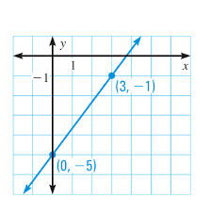

1. What is the slope of the line?
2. 4 B. 3 C. $\frac{4}{3}$ D. $-\frac{4}{3}$
3. What is the standard form of the linear equation $y = -8x +2$?
4. $y= 8x-2$ B. $8x+y = 2$ C. $y -2= -8x$ D. $y=-8x+2$
5. What is the slope-intercept form of the equation $x+y =10$?
6. $y = x + 10$ B. $y = x-10$ C $. y = -x+10$ D. $y = -x-10$
7. Which of the following is the graph of the linear equation whose points are (0, 1) and (2, 0)?

A. B. C. D.

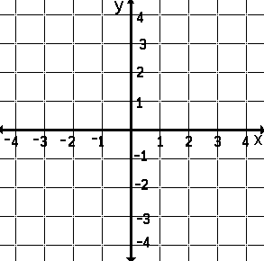   

1. Which of the following represents the graph of the equation **y = 2x – 2?**

A B. C. D.

1. If the graph shows a vertical line, what is its slope?
2. $-1$ B. 0 C. $1$ D. undefined
3. What is the equation of a line if the slope is **2** and y-intercept is **3**?

A. $y = 2x+3$ B. $y = 3x+2$ C. $y = 2x- 3$ D. $y = 3x-2$

1. What is the equation of the line given the points (3,10) and (1,2)?
2. $y = 2x-4$ B. $y = x-4$ C. $y = 4x – 2$ D. $y =x-2$
3. A tricycle passenger is charged P20.00 for the first ten kilometers and an additional of P3.00 per succeeding kilometers. What is the cost of a 25 kilometers ride?
4. Php 25.00 B. Php 45.00 C. Php 65.00 D. Php 85.00
5. Which of the following illustrates system of linear equations in two variables?

A. $x^{2}$ + 3y = 9 C. $3y = -6$

1 $1x + 4y = -3$ $11x = 21$

B. $12x + 3y = 8$ D. $2x = 7$

$11x – 4y = -9$ $x + 5y = 10$

1. Which of the following graph of system of linear equation in two variables is consistent and dependent?
2. B. C. D.

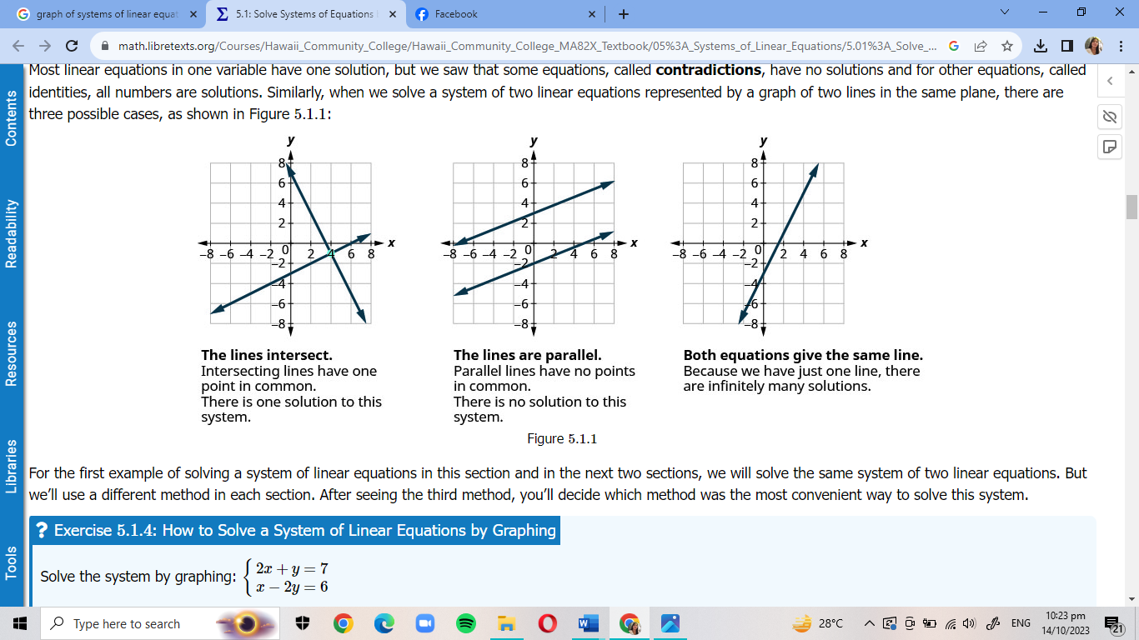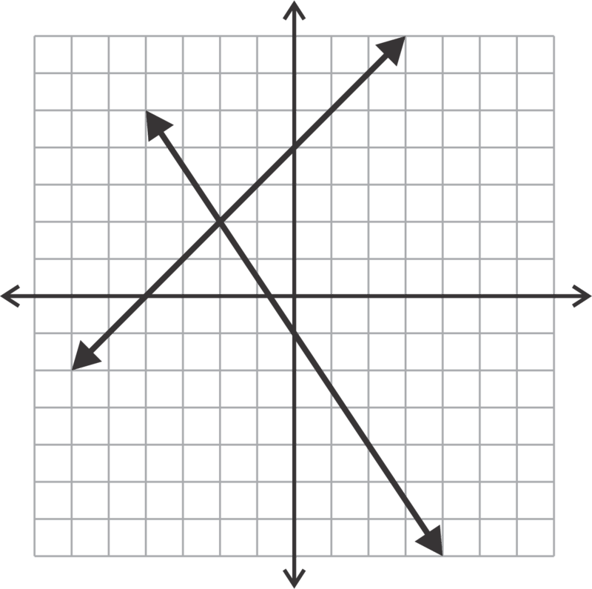

1. Which of the following equations is parallel to the equation 5x – y = 3?

A $. 5x + y = 10$ B. $10x – 2y = 10$ C. $5x + 2y = 10$ D. $5x - 25y = -5$

1. What are the factors of $4y^{2}+7y-2?$

A. ( $4y-1)(y+2)$ B. $(4y+1) (y-2)$ C. $(2y+1) (2y-1)$ D. $(2y-1)(2y+2)$

1. Forty-nine less than the square of a number equals zero. What is the number?
2. 6 B. 7 C. 8 D. 9
3. Which of the following expressions **DOES NOT** belong to the group?
4. $\frac{x}{y}$ B. $\frac{2x}{3y}$ C. $\frac{3x^{2}}{2y}$ D. $\frac{x^{-2}}{3y}$
5. Which rational expression is the same as $\frac{x^{2}+8x+16}{X+4}$?
6. $x - 4$ B $. x + 8$ C. $x+4$ D. $x -8$
7. When $\frac{2a}{a+b}$ is divided by $\frac{3b}{a+b},$ what would be its quotient?

A. $\frac{3b}{2a}$ B. $\frac{a+b}{a-b}$ C. $\frac{a}{b}$ D. $\frac{2a}{3b}$

1. What is the difference if $\frac{2x}{5x-2}$ is subtracted from $\frac{4x}{5x-2}?$
2. $\frac{4x}{5x-2}$ B. $\frac{2x}{5x-2}$ C. $\frac{6x}{5x-2}$ D. $\frac{6x}{10x-4}$
3. Reign can finish solving Sudoku puzzle in 20 minutes, while Ross can do the same in 30 minutes.

If they solve the puzzle together, how many minutes will it take them to finish?

A. 9 minutes B. 10 minutes C. 11 minutes D. 12 minutes

1. In the standard form of equation $3x + y = 8$, what is the slope?
2. -3 B. 1 C. 3 D. 8
3. What will be the graph of linear equation whose slope is $\frac{2}{3}$ and passes through (-2,-3)?
4. B. C. D.

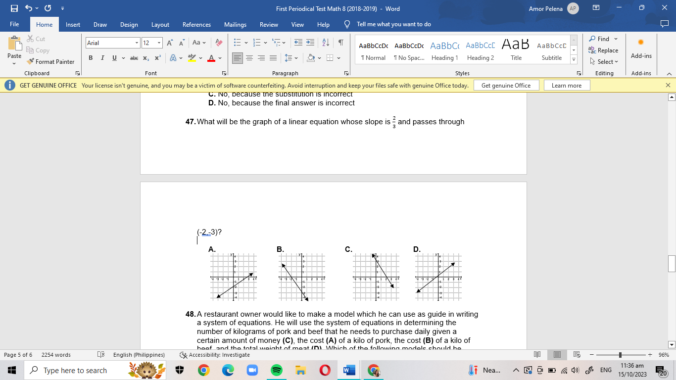

1. Which graph describes a positive slope and a y- intercept of 3?

A. The graph is increasing from left to right and intersect at point (3, 0)

B. The graph is increasing from left to right and intersect at point (0, 3)

C. The graph is decreasing from left to right and intersect at point (0, 3)

D. The graph is decreasing from left to right and intersect at point (3, 0)

1. Jen has Php 2,520 in her piggy bank and earns Php 500 for a whole day of wall painting. What is the equation in slope-intercept form for the total earnings (y) and the (x) number of days of painting?

A $. 500x – y = 2520$ C. $y = 2520x + 500$

B. $2520x + y = 500$ D. $y = 500x + 2520$

1. Amor is 23 years older than Ana. Six years ago, she was twice as old. What are their ages now?
2. 31 and 54 B. 30 and 53 C. 29 and 52 D. 28 and 51
3. Which of the following is ***NOT*** a system of linear equation in two variables?
4. $2x+3y=4$ B. $x=y+6$ C. $y=5x^{2}$ D. $y= -7x +1$

$x-2y=6$ $2x=5y+3$ $x=9y^{2}$ 4 $x=y-2$

1. 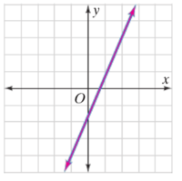 How many solutions does this system of linear equations have?

1. one solution
2. infinitely many solutions
3. no solution
4. two solutions
5. Which system of linear equations has **coinciding/overlapping** graphs?

A. $x – y = 5$ and $2x – 2y = 10$ C. $2x – 3y = 4$ and $5x – 10y = 12$

B $. 2x + y = 5$ and $3x – y = 9$ D. $2x + y = -6$ and $2x + y = 10$

1. The product of two consecutive even integers is 48. What are the integers?

A. 1 and 48 B. 2 and 24 C. 4 and 12 D. 6 and 8

1. Three years ago, Aki’s age is one-half of the age he will be in 6 years. How old is he now?

A. 12 years old B. 15 years old C. 18 years old D. 21 years old

1. Hanz was selling hotdogs for Php 12 each and sodas for Php 15 each. At the end of the night, he earned a total of Php 1,104. Let x represent the number of hotdogs sold and y represent the number of sodas sold. What is the equation of a line in standard form?

A. x + y = 1104 C. 12x + 15y = 1104

B. 12x – 15y = 1104 D. 17 (x + y) = 1104

1. Michael and Tom are brothers. Their combined age is 20, and Tom is 4 years older than Michael. What are Michael and Tom's ages**?**

A.8 and 12 B. 10 and 14 C. 4 and 16 D. 11 and 15

1. Which system of linear equations has graphs that intersect at a certain point?

A.Consistent and Dependent C. Consistent

B.Consistent and Independent D. Independent

**Prepared by: Checked by:**

AMOR A. PELENA MRS. SHEILA S. VELGADO

Mathematics 8 Teacher Chairman, Mathematics Department

**Approved by:**

MR. ESTEBAN B. CASAUAY

Principal IV

**First Quarter Examination in Mathematics 8**

**Answer Key**

|  |  |  |  |
| --- | --- | --- | --- |
| 1. | A | 26. | C |
| 2. | B | 27. | C |
| 3. | B | 28. | B |
| 4. | D | 29. | C |
| 5. | D | 30. | B |
| 6. | C | 31. | A |
| 7. | B | 32. | B |
| 8. | C | 33. | D |
| 9. | C | 34. | C |
| 10. | A | 35. | D |
| 11. | A | 36. | B |
| 12. | C | 37. | D |
| 13. | D | 38. | A |
| 14. | B | 39. | A |
| 15. | A | 40. | B |
| 16. | A | 41. | D |
| 17. | D | 42. | C |
| 18. | B | 43. | C |
| 19. | C | 44. | B |
| 20. | B | 45. | A |
| 21. | C | 46. | D |
| 22. | C | 47. | A |
| 23. | C | 48. | C |
| 24. | D | 49. | A |
| 25. | A | 50. | B |