Structural Limits of White Dwarfs and The Chandrasekhar Limit

**Introduction**

White Dwarfs are the end stage life structures for stars with masses ranging from 1 to 8 solar masses. The goal of this project is to investigate the structure and maximum possible mass for white dwarfs to sustain by electron degeneracy pressure. We will complete this by employing numerical integration methods on internal density structure equations of white dwarf stars.

**Part 1:**

In the first section we create 10 central densities in using logspace since this will provide values of multiple magnitudes rather than linspace which will create values of 5/6 orders of magnitude. of two functions are created. The first function is named “Equations8n9”. Within this function the arguments for the dimensionless radius and the dimensionless current state (array of [mass, density]) are entered. We then plug the density into equations (1) to find a dimensionless variable x, which we then use in equation (2) to find gamma.

$x=\sqrt[3]{ρ}$ (1) $γ=\frac{x^{2}}{3\sqrt{1+x^{2}}}$ (2)

These functions are then plugged into equations (3) and (4). Which are named equations 8 and 9 in the project description resulting in the function name. Equations (3) and (4) are then returned.

$\frac{dρ}{dr}=-\frac{mρ}{γr^{2}}$ (3)

$\frac{dm}{dr}=r^{2}ρ$ (4)

The second function is called “stateSolver”. In this function the arguments for the initial white dwarf core and the integration methods are passed. An initial state is created by making an array with the given central density and 0 which is the mass with radius 0. Then we use SciPy’s solve_ivp function passing the function, integration bounds, the initial state, the event at which integration can stop, and the method of integration. The function we passed was the Equations8n9 we created earlier. The integration bounds are the minimum radius which I set to ${10}^{-8}$ to which is miniscule compared to the radius of the sun and 1000 which is just a large number that should never be reached. The initial state is the initial state we created earlier in the function. The event at which integration can stop is when the density is equal to or less than 0. The method that will be passed is the method is passed when the function is called. The solution of this solve_ivp function is then returned.

**Question 2:**

We create a ‘for’ loop which will iterate through every value that was created by the logspace array. The ‘stateSolver’ function is called giving the current density and default integration method ‘RK45’. This will return an array for the 0 dimensional values of the mass (y[0]), density (y[1]), and radius (t[0]). These arrays are then converted in solar masses, cgs density units, and solar radii respectively. The radius is added to a plot as a function of the mass. When all the densities are iterated through, the plot is created with all the solutions. We are able to estimate a solution because the larger initial densities with and order magnitude of approximately 4-6 all seem to converge to similar points and cannot surpass a mass of approximately 1.43 solar masses (see fig. 1). The final values for the mass agree with the limit of approximately 1.46 solar masses that is stated within the Kippenhahn & Weigert (1990) paper.

Figure 1: The Mass-Radius relation for various initial densities. A vertical line was added at the Chandrasekhar mass limit to help visualize.

**Question 3:**

We saved values 3 for the initial central density and the solutions to the IVP of a white dwarf with an initial density. We create the same ‘for’ loop as in question 2 but we pass the ‘RK23’ integration method to the solve_ivp function. We then plot these solutions for the densities under the 3 respective solutions for the ‘RK45’ method. These solutions match almost identically to each other (see Fig 2.).

Figure 2: The Mass-Radius relation for 3 initial densities using both “RK23” and “RK45” integration methods. The “RK45” is dotted and lying on top. We can see that the lines agree very closely to another.

**Question 4:**

In this final section we imported data obtained from the Tremblay et al. (2017) paper that the *Gaia* satellite to investigate white dwarf masses and radii from binary systems. This data provides the mass of the white dwarf and its radius and their respective uncertainties. I plotted the observed stars onto the plot from question 2 (See fig 3.). The observed white dwarfs generally have a greater radius than at their respective mass than was calculated within question 2. Certain white dwarfs and their margin of error were not within the predicted mass-radius relation.

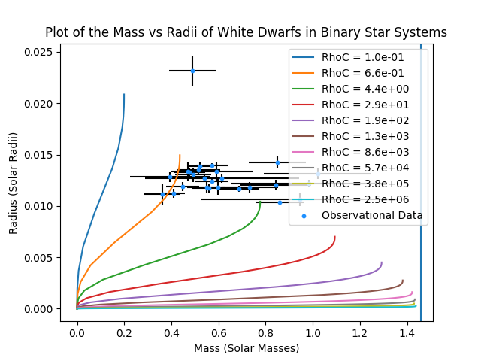

Figure 3: A plot of the mass-radius relation with observed white dwarf relation and their error bars. Many of the white dwarfs agree with the relation predicted.

Figure 3:

