Ridgedale College

New Perspectives Access 2019 | Module 1: SAM Project 1b



CREATING AND MODIFYING TABLES AND OTHER DATABASE OBJECTS

# GETTING STARTED

* Open the file **NP_AC19_1b_*FirstLastName*_1.accdb**, available for download from the SAM website.
* Save the file as **NP_AC19_1b_*FirstLastName*_2.accdb** by changing the “1” to a “2”.

If you do not see the .accdb file extension in the Save As dialog box, do not type it. The program will add the file extension for you automatically.

* Open the **_GradingInfoTable** table and ensure that your first and last name is displayed as the first record in the table. If the table does not contain your name, delete the file and download a new copy from the SAM website.
* PROJECT STEPS

1. You are a graduate teaching assistant for Ridgedale College, a private college in the Midwest. To help the college better manage their course scheduling, you have created an Access database and are working on the tables.   
     
   Create a new table in Datasheet View with the following options:
   1. Rename the *ID* field to **DeptID** and change the data type to **Short** **Text**.
   2. Change the field size of the *DeptID* field to **4**.
   3. Add a new field with the name **DeptName** and the **Short Text** data type. Save the table and use **Departments** as the table name.
2. With the *Departments* table still open in Datasheet View, add the seven records shown in Table 1. Save and close the *Departments* table.

* Table 1: New records for Departments Table

|  |  |
| --- | --- |
| *DeptID* | *DeptName* |
| **ACCT** | **Accounting** |
| **BUS** | **Business** |
| **CIS** | **Computer Science** |
| **ECON** | **Economics** |
| **ENGR** | **Engineering** |
| **MATH** | **Math** |
| **MKT** | **Marketing** |

1. Create a new table in Design View to store the teaching assistants at Ridgedale College as follows:
   1. Add a field with the name **TAID** and the **AutoNumber** data type.
   2. Make *TAID* the table's primary key. Save the table with the name **TeachingAssistants** but do not close it.
2. With the *TeachingAssistants* table still open in Design View, add a second and third field to the table with the field names **TAFirstName** and **TALastName**, each with the **Short Text** data type. Save the *TeachingAssistants* table and then close it.
3. Open the *Professors* table in Design View and use **ProfFirstName**as the new field name for the *FirstName* field and use **ProfLastName** as the new field name for the *LastName* field.
4. With the *Professors* table still open in Design View, change the data type property for the *ProfEMail* field from Short Text to **Hyperlink**.
5. With the *Professors* table still open in Design View, add a new field to the *Professors* table after the *ProfEMail* field. The field should be named **HireDate** and have the **Date/Time** data type. Save the *Professors* table but do not close it.
6. Switch the *Professors* table to Datasheet View, navigate to the 12th record (which has a *ProfID* field value of LRG for Lucas Garland), and **delete** the record.
7. With the *Professors* table still open in Datasheet View, navigate to the fifth record (which has a *ProfID* field value of CJZ for Carla Zimmerman) and edit the value for the *Salary* field, using **49000** as the new value. Close the *Professors* table.
8. Use the Form Wizard to create a form for the *Professors* table with the following options:
   1. Include all fields from the *Professors* table in the form.
   2. Select **Columnar** as the layout for the form. Save the form with the name **ProfessorEntry** as shown in Figure 1. Close the form.

* Figure 1: ProfessorEntry Form in Form View

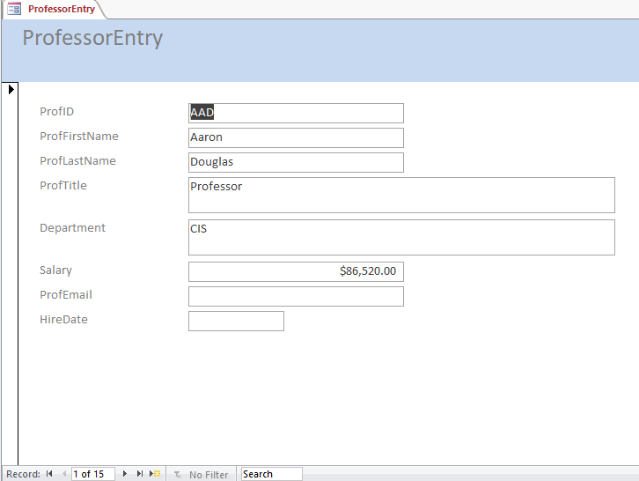

1. Use the Simple Query Wizard to create a query based on the *Classes* table with the following options:
   1. Include all fields from the *Classes* table in the query. Show detailed records. Save the query with the name **ClassListing** and then close the query.
2. Use the Report Wizard to create a report based on the *Classes* table with the following options:
   1. Include all of the fields from the *Classes* table in the report.
   2. Do not include any grouping fields.
   3. Sort the report by *ClassNo* in **ascending** order.
   4. Select **Tabular** as the layout of the report and **Portrait** as the orientation. Save the report with the name **Classes** and preview the report as shown in Figure 2.  Close the *Classes* report.

* Figure 2: Classes Report in Print Preview

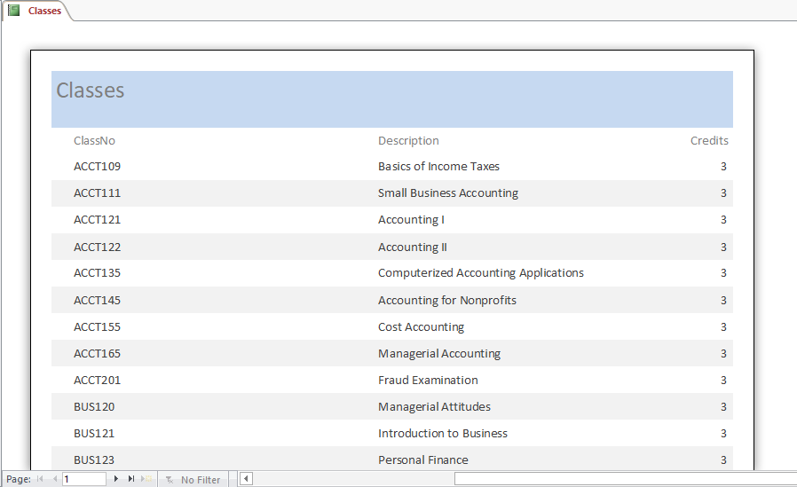

1. In the Navigation Pane, rename the *Sections* form. Use **SectionsByProfessor** as the new name of the form.

Save and close any open objects in your database. Compact and repair your database, close it, and then exit Access. Follow the directions on the SAM website to submit your completed project.