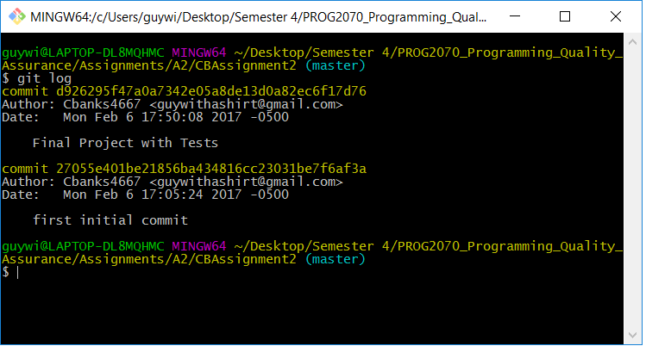

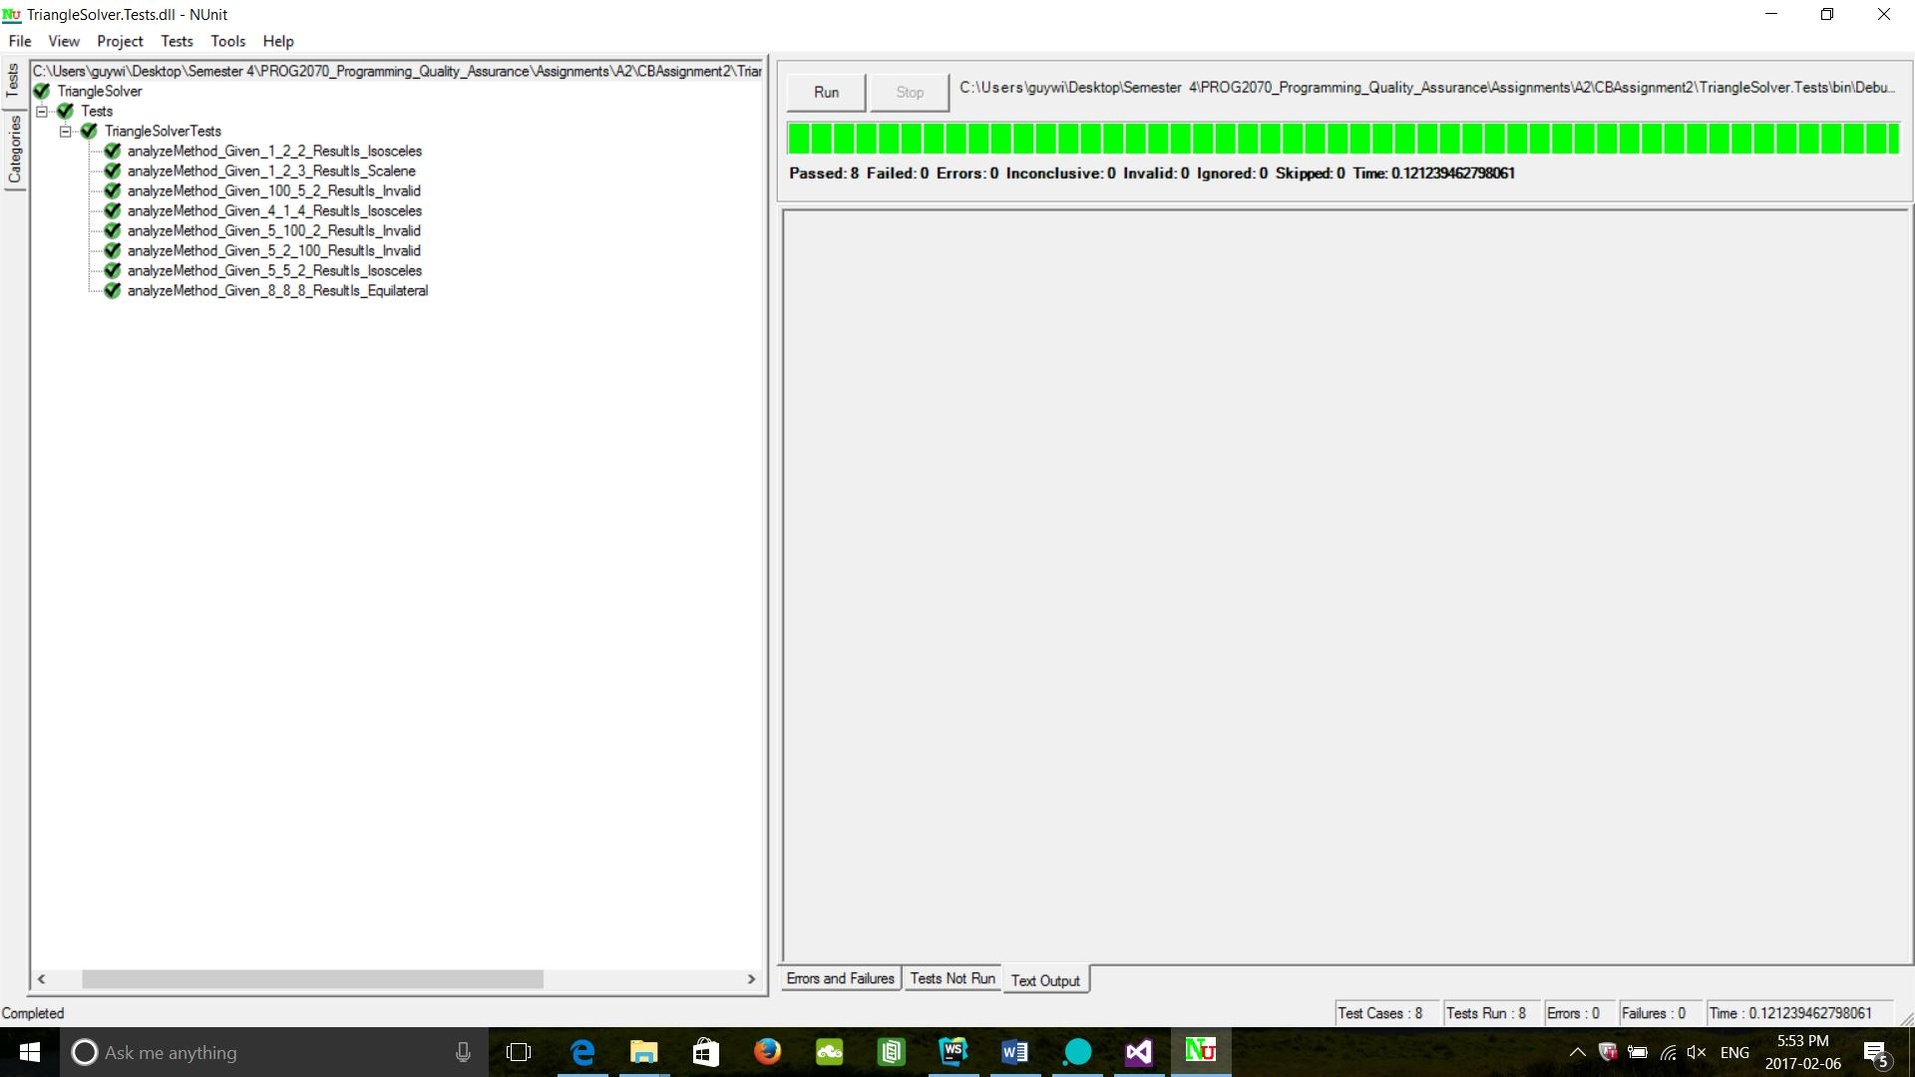



The CC value for my Analyze method is 1, as there are 10 edges and 11 nodes plus the constant value 2 for a method. I was able to maximize efficiency by not declaring variables in the method but by accessing the parameters directly. It was also made more efficient by having each decision linked to a return statement. My logic was that at every decision node the option if true would exit the method and return a response, if no then it would ask the next logic question until the only possible option was a scalene triangle by first determining if it was possible for it to even be a triangle and eliminating the other triangle types.

Chris Banks