MIRI / MVA - Lab #4 Report

Authors: Cedric Bhihe <cedric.bhihe@gmail.com> Delivery: before 2018.04.23 – 23:55
Santi Calvo <s.calvo93@gmail.com>
1. Prepare the imputed data
As in our previous Lab·#2 report, we read the Russet [1] data set and conduct a MICE imputation. The initial data set is available as Data/russet_imputed-values_mice-pmm.txt. We loaded the data in the data-frame object, X, by means of our main R script available as Lab4/lab4-script_mva.R.
2. PCA of continuous variables with Factominer; consider Cuba an outlier
We proceed to carry out the PCA with FactoMineR on the raw data, with scaling and:
- the “Cuba” individual as ind.sup
- the “demo” variable as quali.sup

PC | Eigenvalue | % of variance | Cumulative % of variance
PC 1 | 3.01905890 | 37.7382362 | 37.73824
PC 2 | 1.52126316 | 19.0157895 | 56.75403
PC 3 | 1.11643261 | 13.9554077 | 70.70943
PC 4 | 0.91408667 | 11.4260834 | 82.13552
PC 5 | 0.62099453 | 7.7624317 | 89.89795
PC 6 | 0.57351524 | 7.1689405 | 97.06689
PC 7 | 0.18333680 | 2.2917100 | 99.35860
PC 8 | 0.05131208 | 0.6414011 | 100.0000
Table 1: Eigenvalues and cumulative percentage of variance representation along principal directions.
We then check the result obtained with FactoMineR with the PCA analysis carried out manually. To do so, we apply a uniform ponderation on all observations but “cuba” which receives ponderation zero (Data/20180319-131250_arbitrary-wparam.csv). This is equivalent to considering Cuba an outlier. We suppressed the variable “demo” from the observation matrix X and standardized the resulting n x p matrix. We diagonalized the correlation matrix X^{T}NX, where N is the n x n diagonal ponderation matrix with zero weight for “Cuba”. Result were strictly identical to those previously reported in Lab reports #2 and 3.
Our implementation yields identical eigenvalues as in Lab·2.
3. Select the nd significant dimensions
We choose all eigenvalues such that their value is >=1 and their cumulated variance representativeness is >= 70% (in shaded green in Table 1). The number of significant dimensions is 3.
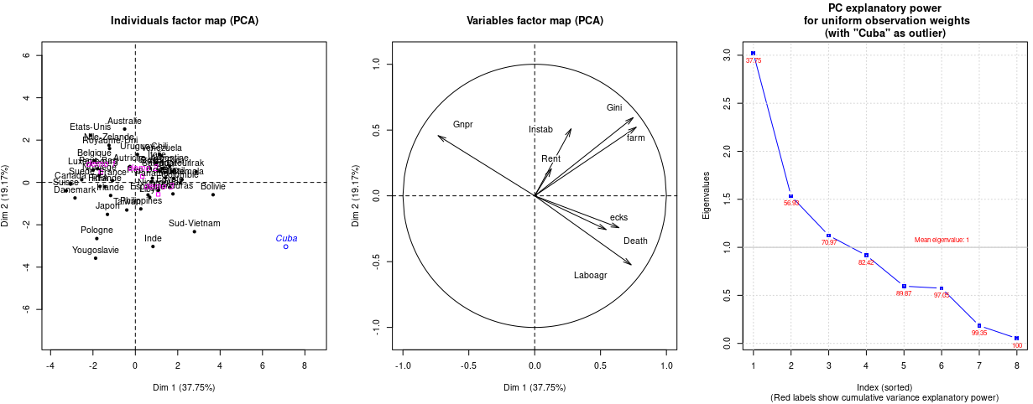
4. Perform an HC with the significant factors, decide the number of final classses to obtain and consolidate the clustering

References:
[1] B. M. Russet, “Inequality and Instability”, World politics, 21 (1964), 442-454.
[2] H. Wold, “Estimation of principal components and related models by iterative least squares,” in Multivariate Analysis (Ed. P.R. Krishnaiah), Academic Press, NY (1966), 391-420.

MICE: Multivariate Imputation by Chained Equations

