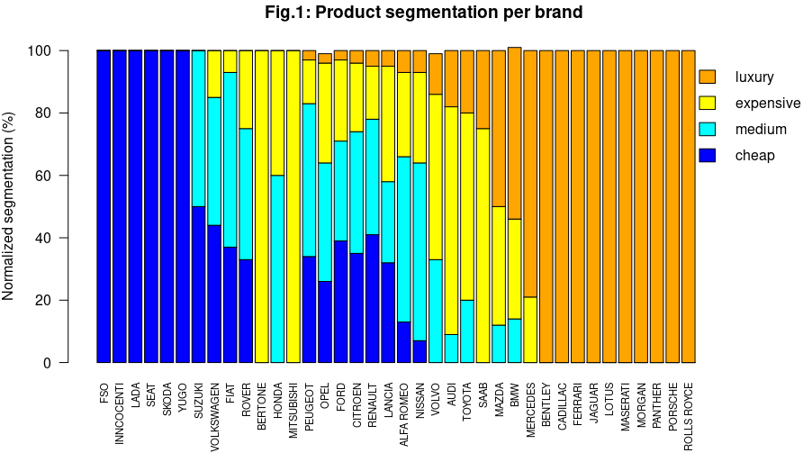
MIRI / MVA - Lab #6 Report
Car make | Product Segment | Mean(cylDisp) (liter) | Mean gasConsum (liter/100km)
ALFA-ROMEO | cheap | 1.000000 | 4.500
CITROEN | cheap | 1.250000 | 3.500
ALFA-ROMEO | medium | 2.500000 | 4.375
CITROEN | medium | 2.777778 | 3.000
VOLVO | medium | 2.200000 | 3.200
ALFA-ROMEO | expensive | 4.250000 | 2.250
CITROEN | expensive | 3.800000 | 3.200
VOLVO | expensive | 2.750000 | 2.250
ALFA-ROMEO | luxury | 5.000000 | 1.000
BENTLEY | luxury | 5.000000 | 2.000
CITROEN | luxury | 5.000000 | 2.000
VOLVO | luxury | 4.000000 | 2.000
Table 1: Summary statistics of data subsets

Authors: Cedric Bhihe <cedric.bhihe@gmail.com> Delivery: before 2018.05.14 – 23:55
Santi Calvo <s.calvo93@gmail.com>
Given data about cars and their characteristics, the goal of the analysis to be performed is to find a model to predict the price of cars as a function of their characteristics.
1. Read the file “mca_car.csv”. The data has been previously pre-processed to have it in categorical form. Perform a visualization of the information contained in the dataset, then a clustering analysis.
The cars data set contains 490 observations, with no missing. Each observation is considered active and consists of 19 attributes of which 18 are categorical or ordinal variables and 1 is continuous precio. We consider precio, precio-categ and marca as 2 response variables and 1 descriptive variable respectively. We will treat all three as supplementary.
One way to conduct preliminary data visual-ization is to inspect 2D tables such as ‘marca’ and ‘precio-categ’ to derive product segment-ation information per brand (car make). The plot of Fig.1 shows normalized row counts for each brand, where the normalization factor is the row marginal. (Maximum cumulative barplot values slightly in excess of or below 100% are due to rounding errors.)
Table 1 (right) shows how mean cylinder displacement increases and mean gas consumption decreases as product category increases. This marked scissor effect could be principally attributed to higher-end vehicles relying on hybrid or electric technology. Only 4 car makes are shown here for more clarity.

2. With the obtained data frame perform a Multiple Correspondence Analysis.
We consider variables 18 ‘marca’ and 19 ‘precio-categ’ as supplementary categorical variables, while variable 17 ‘precio’ is kept as a supplementary continuous variable. This means they do not take part of the MCA and their coordinates will be predicted. They are the reponse variables. All other variables are kept as active variables (i.e. there is no junk category). We also choose to keep (ncp=)7 explanatory dimensions and not to ventilate any category (level.ventil=0) , no matter how small its level of representation in the final result may be. The MCA is conducted on the Indicator matrix rather than the Burt table. Figs. 2 and 3 below summarize results.
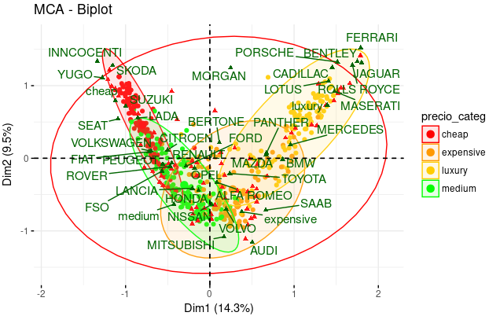Fig. 3: Biplot of individuals (color-coded id. legend), supplementary categorical variables, “marca” and “precio_categ” (green), and variables’ categories (red).
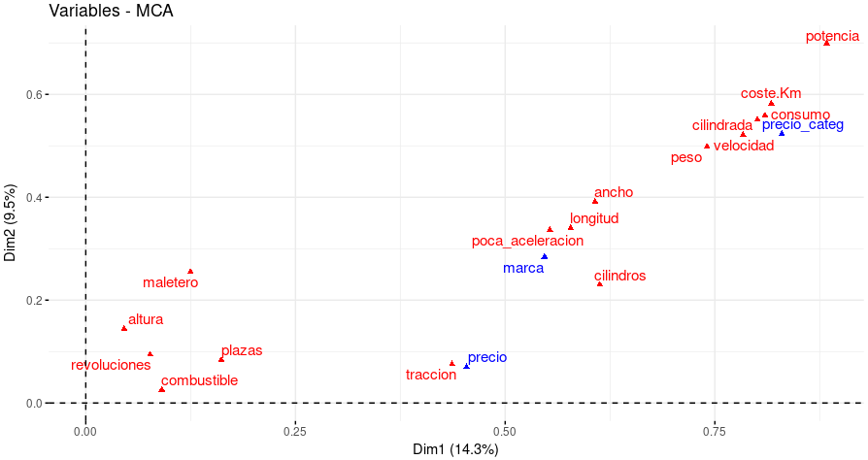Fig. 4:Active variables’ scatter plot (red), and supplementary variables “marca”, “precio_categ” (categorical), and “precio” (continuous) in blue.
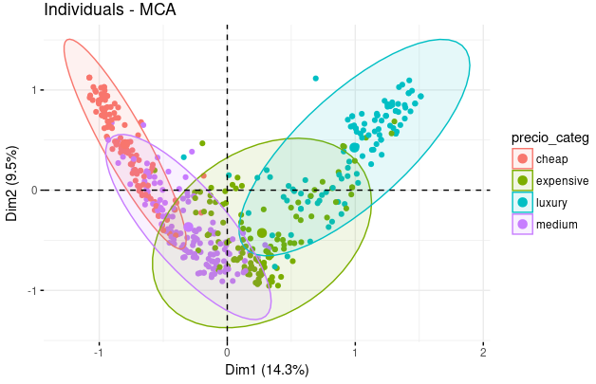Fig. 2b: Scatterplot of individuals, with color coded grouping according to the categorical variable “precio_categ”. Four partly overlapping groups are clearly visible.
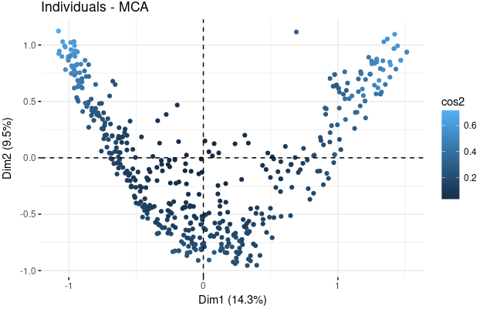Fig. 2a: Scatterplot of individuals, with color coded quality of representation (cos²) on PC1-2. Lighter blue means better representation than a darker shade.
3. Interpret the first two obtained factors.
▪ The first factorial plane, represents about 24% of the variability in the data set.
▪ A Guttman effect is visible in Figures 2 and 3. It points to diagonal overloading of the RFT (Relative Frequencies Table). The crescent shaped scatter plot of individuals and categorical variable “precio_categ” indicate that cheap, entry level vehicles are in the second quadrant, mid-range vehicles (“medium” to “expensive”) are in the 3rd and 4th quadrants while up-scale, high-end cars are in the first quadrant.
▪ Figure 3 also demonstrates how modalities of the categorical variables “marca” and “precio_categ” are the pseudo-barycenters of the individuals exhibiting the given modality.
▪ In Figure 4, distance of variable points from the origin is a measure of factor quality. Points farther from the origin indicate variables which account for more inertia and are better represented in that plane than variables closer to the origin. It is the case of “potencia”, “coste km” and “consumo”, as compared with “revoluciones”, “maletero”, “altura”, “plazas”.
▪ The closer to a PC axis any segment linking the axes’ origin and the variable points, the greater the correlation between the variable and PC. Hence “potencia”, “coste km”, “consumo” appear slightly more correlated with PC1 than with PC2 and are of good quality, whereas “traccion” appears preferentially correlated with PC1 but is of mediocre quality. A discussion of correlation for the group close to the origin (“revoluciones”, “maletero”, “altura”, “plazas”) is obviated by the fact that variables in that group are not well represented in PC1-2.
▪ As for individuals between themselves, variables in close proximity to one another have a similar profile and explanatory power. Thus:
(a) the categorical variable “precio_categ” seems to be well predicted by the group of variables in the upper right corner of Figure 4.
(b) The continuous variable “precio” is somewhat isolated and close to “traccion”. We interpret this as “precio” not being as good a good measure of product value as “precio-categ” as the price tag of a car is highly sensitive to a number of extraneous parameters such as time of year, car-dealership and location, buyer, vehicle options, whereas its price category is not.
(c) “marca” appears to be somewhat predictable based on design criteria, such as “cilindros”, “longitud”, “ancho”, and “poca_aceleracion”, the latter being the result of deliberate engine, gear-box and power-consumption profiling, often based on marketing.
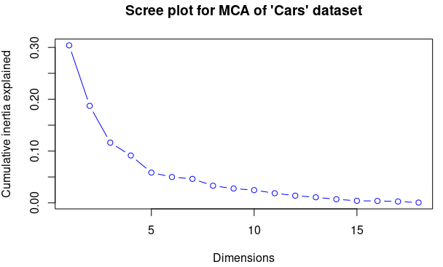Fig. 5:Cumulative inertia as explained by eigenvalues.
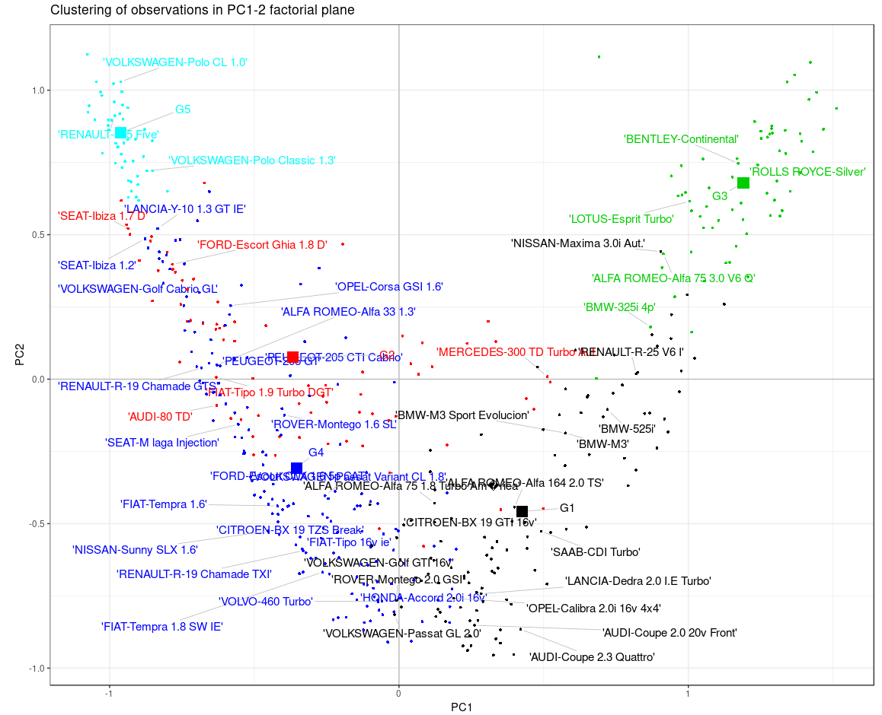Fig. 6: Color-coded clustering of observations with centroids, according to HC, before consolidation. Only 10% of observation labels are shown.
4. Decide the number of significant dimensions that you retain (by subtracting the average eigenvalue and represent the new obtained eigenvalues in a new screeplot).
Using the elbow rule on Figure 5 (right), we choose to retain nd=6 significant dimensions, which coincides with 80.7% of inertia being explained.
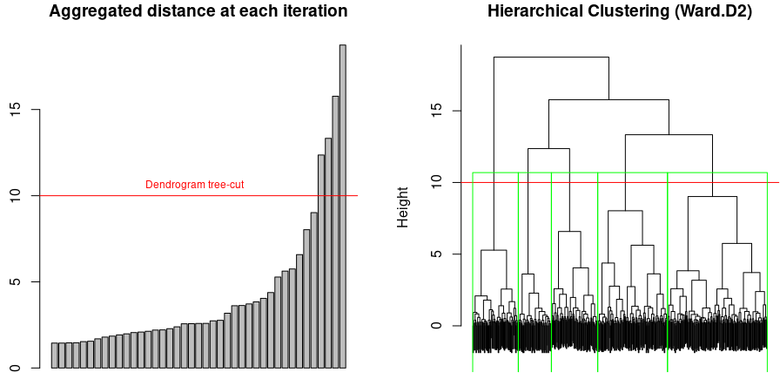Fig. 5:Aggregated distance at each iteration (left) and HC tree cutoff at 5 classes (right).
5. Perform a hierarchical clustering with the significant factors, decide the number of final classes to obtain and perform a consolidation operation of the clustering.
After building a distance matrix from the data set of individuals’ projections on the PC space (restricted to 6 dimensions), we perform a hierarchical clustering based on the Ward.D2 distance.
We represent the color-coded clustering of observations in Figure 6 below. In addition to the four known modalities “cheap”, “medium”,”expensive” and “luxury” roughly equivalent to clusters #1, 3, 4 and 5, it appears that cluster #2 mainly consists of Diesel engine vehicles. The quality index is Ib=60.97.
A k-means consolidation yields a quality index of Ib=64.28. The new plot of Figure 7 is very similar to that of Figure 6, prior to k-means consolidation. The obtained clusters are reasonably balanced in terms of size: 114, 68, 82, 146, 80 and exhibit a few mis-classified observation as demonstrated by the silhouette graph of Figure 8.

6. Using the function catdes() interpret and name the obtained clusters and represent them in the first factorial display.
Based on the clustering information previously obtained for the observations, we show for each variable the test statistics based on the Student-t for each variable’s significance.
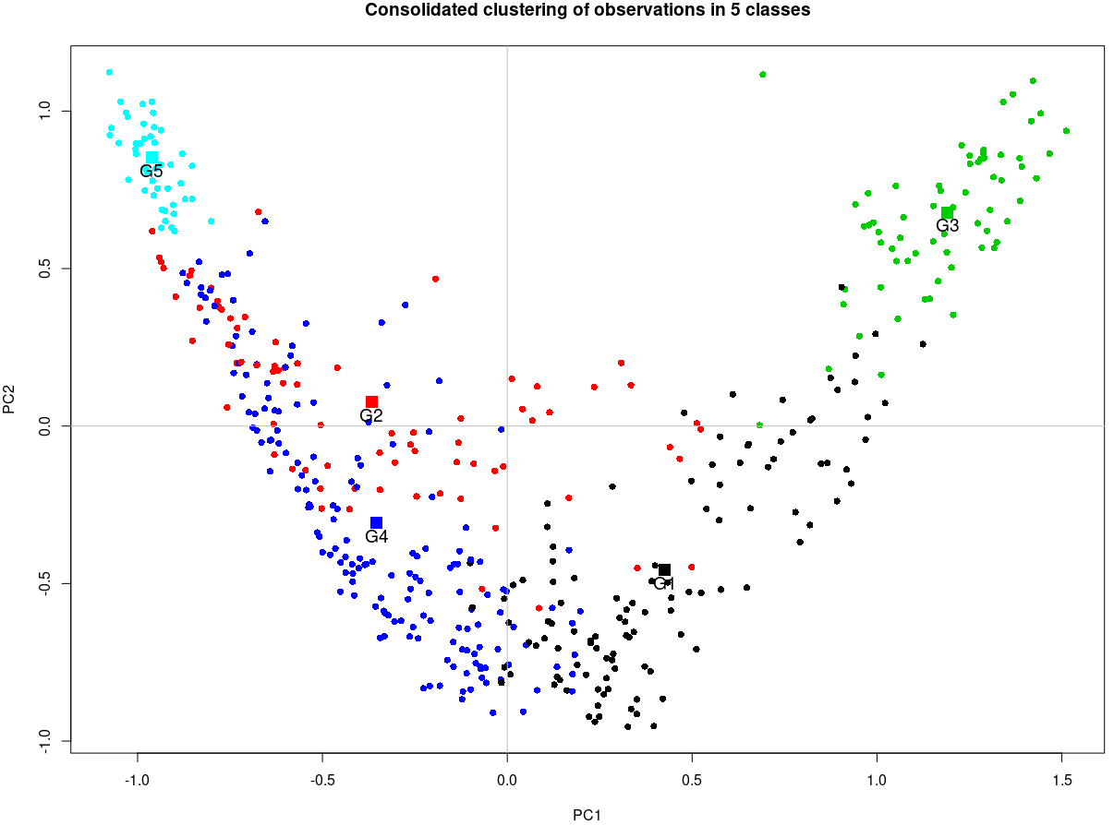Fig. 7: Color-coded clustering of observations with centroids G1 to G5, according to HC, after k-means consolidation.
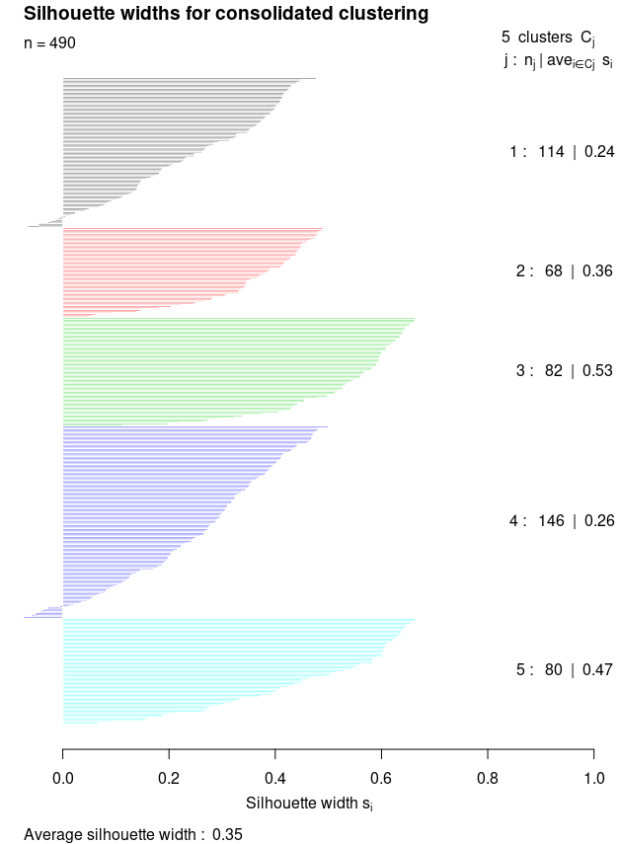Fig. 8: Silhouette graph of the consolidated clustering. A few points in clusters 1 and 4 are misclassified.
V.test is the number of std-dev below or above the overall mean values for the sample data. Values of of v.test <0 mean that the category mean is smaller than the overall average and vice versa.
The null hypothesis, for categorical variables, is that the variable’s mean in the given group is equal to the variable’s global data mean. We reject the null hypothesis at the risk 0.05 of being wrong when the p-values < 0.05. In the two Tables 3a and 3b below, we only show variables for which we reject H₀, i.e. for which the categorization is meaningful.
Cat_1 | v.test | Mean in category | Overall mean | Sd in category | Overall sd | p.value
farm | 4.947159 | 96.95185 | 92.82609 | 3.187751 | 6.668988 | 0.0000007530454
Laboagr | 4.661164 | 55.14815 | 42.43478 | 14.567096 | 21.811098 | 0.0000031442679
Gini | 4.278413 | 78.86667 | 71.19783 | 10.177790 | 14.333701 | 0.0000188230611
ecks | 3.353320 | 30.03704 | 21.60870 | 20.503805 | 20.099187 | 0.0007984840288
Death | 2.217522 | 125.07407 | 73.58696 | 228.721394 | 185.670065 | 0.0265874093464
Gnpr | -4.985790 | 258.74074 | 563.56522 | 159.908213 | 488.908040 | 0.0000006170909

Cat_2 | v.test | Mean in category | Overall mean | Sd in category | Overall sd | p.value
Gnpr | 4.985790 | 996.7368421 | 563.56522 | 471.901065 | 488.908040 | 0.0000006170909
Death | -2.217522 | 0.4210526 | 73.58696 | 1.138595 | 185.670065 | 0.0265874093464
ecks | -3.353320 | 9.6315789 | 21.60870 | 11.671876 | 20.099187 | 0.0007984840288
Gini | -4.278413 | 60.3000000 | 71.19783 | 12.160506 | 14.333701 | 0.0000188230611
Laboagr | -4.661164 | 24.3684211 | 42.43478 | 17.150144 | 21.811098 | 0.0000031442679
farm | -4.947159 | 86.9631579 | 92.82609 | 5.888455 | 6.668988 | 0.0000007530454
Table 2: Most significant variables in each categories for (a) Cat.1 with more instability and poverty and (b) Cat. 2, countries with more stability and wealth.
Table 4 (to the right) summarizes square correlation coefficient (Eta2) and p-values of the F-test in a one-way ANOVA (assuming homoscedasticity) for significant continuous variable globally, i.e. for variables, whose corresponding p-value is smaller than 0.05.
 | Eta2 | P-value
Gnpr | 0.5524023 | 0.000000003302162
farm | 0.5438751 | 0.000000005037780
Laboagr | 0.4828099 | 0.000000084441780
Gini | 0.4067737 | 0.000001866647754
ecks | 0.2498834 | 0.000404416982041
Death | 0.1092757 | 0.024844049542374
Table 3: Summary of significant variables’ correlation and p-values globally. The “Death” variable’s is shaded because we reject it as non significant based on a risk level of 0.01.
In practice it is preferable to consider a smaller risk level of 0.01. In this case this would lead us to reject variable “Death” in addition to “Rent” and “Instab” as not significant overall.

