Age | ]-inf,27] | ]27,38] | ]38,50] | ]50,inf[
modality | Prime | Middle | Mature | Senior
bin counts | 498 | 558 | 537 | 407
Income | ]-inf,34.5k] | ]34.5k,60k] | ]60k,115k] | ]115k,inf[
modality | Low | Medium | High | Obscene
bin counts | 501 | 502 | 503 | 494
Hours | ]-inf,30] | ]30,40] | ]40,inf[
modality | Part | Reduced | Full
bin counts | 344 | 1063 | 593
Table 1: Discretization of active continuous variables "Age", "Income", "Hours"
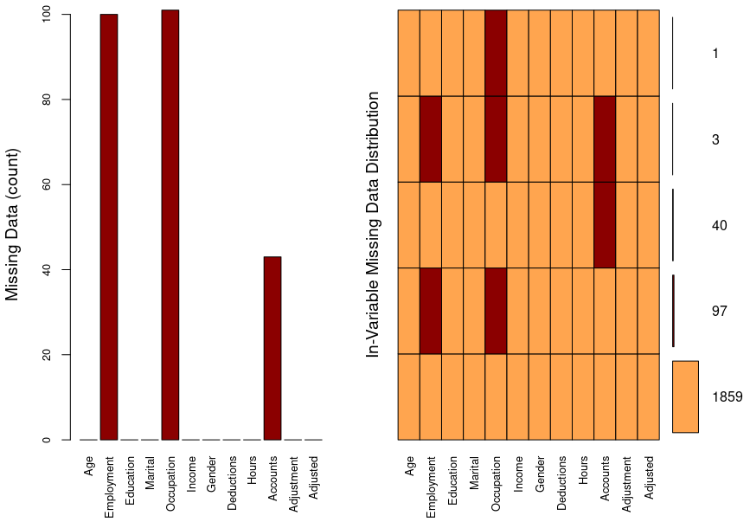Fig. 1: Missings distribution
Author: Cedric Bhihe Date: 2018.05.27
The audit data-set is a simplified financial audit data-set for modelling productive and non-productive audits of a person’s financial statement. The dataset is used to illustrate binary classification. A productive audit is one which identifies errors or inaccuracies in the information provided by a client. A non-productive audit is usually an audit which found all supplied information to be in order. The target variable is identified as Adjusted.
1. Import the Audit.xlsx file and convert it to the csv format
Using the R package xlsx, we import the xlsx formatted file, convert it to csv format using column ID as row names, before saving it to disk as a csv file. Subsequent calls to the data set, are made by directly loading the csv file in memory.
The data-set contains 2000 observations, and 11 variables beside the boolean target//dependent/response variable “Adjusted”. 1859 observations have no missing value. 141 have missings distributed according to Figure 1.
We do not perfom imputations as the R package rpart() uses surrogate variables efficiently to handle missings.
2. Decide which predictors you will use. Pre-process the corresponding variables as needed.
We define 10 predictors and 2 supplementary variables as follows:
- 6 active categorical variables: Employment","Education","Marital","Occupation","Gender","Accounts"
- 4 active continuous variables: "Age","Income","Deductions","Hours"
- 1 supplementary continuous variable: "Adjustment", which illustrates a productive audit and Adjusted=1.
- 1 supplementary categorical (yes/no or 0/1) variable: "Adjusted", which is our target/dependent variable
We pre-process the continuous variables “Age”, “Income”, “Hours” to transform them in as many categorical variables. Care is taken so each variable’s resulting bins (modalities) exhibit similar counts. “Deductions” remains a continuous variable as its discretization would yield very lopsided bins’ frequencies, between two basic modalities: “With” (4.15%) and “Without” (95.85%). See Figure 2. Table 1 (to the right) summarizes the discretization.
3. Select 1/3 of the data at the end of the data set, as test data.
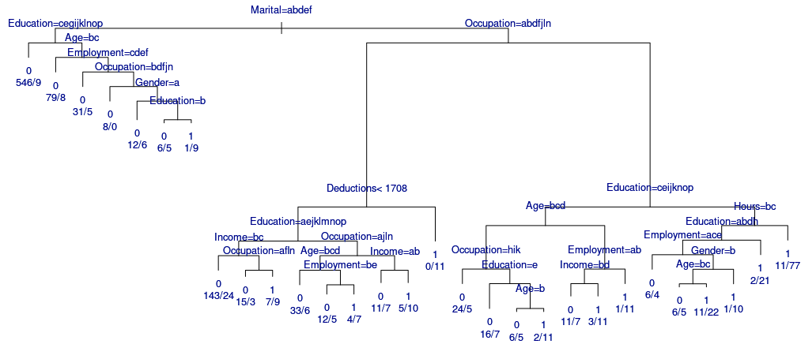Fig. 3: Fully grown decision tree for “Audit” training data-set using 10 Cross-Validation iterations and complexity parameter (cp), α_{min}=10⁻³.
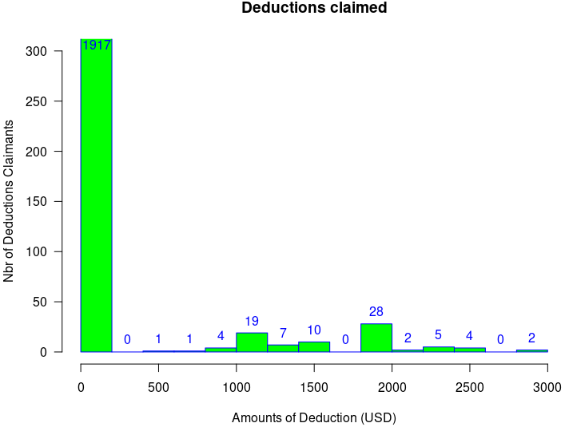Fig. 2: Histogram of deductions claimed (Numbers in blue are counts for each bucket.)
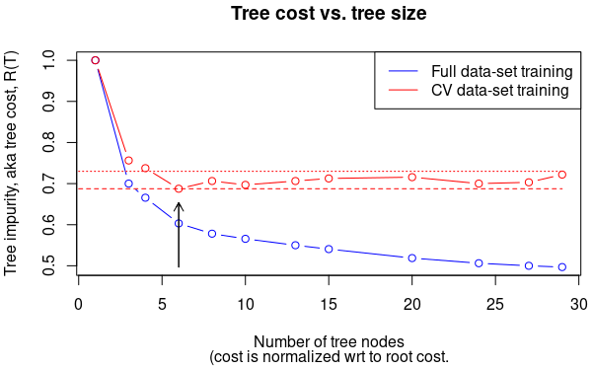

The training data-set consists of 1333 observations, while the test data-set consists of 667 observations.

4. Build the decision tree to predict var “Adjusted” using training data. Determine cutoff value for optimal decision making.
The fully grown tree for the training dataset using 10 Cross-Validation (CV) replicas, and a complexity parameter of 10⁻³ is shown on Figure 3.
Figure 4 represents the CV normalized error mean (tree cost R(T) and the whole data set based training error as a function of tree size (or α value). The complexity parameter table used to build Figure 4 is available in Appendix B.
The red horizontal dashed line represents the minimum tree impurity (MTI) level, and the red dotted line above it MTI + 1 standard error, calculated over the CV training errors for value of the complexity parameter, α, in the closed interval [0.001 , 0.150]. The optimum value of α is obtained by inspection. It corresponds to the first value of CV tree cost smaller than MTI + 1 standard error, when scanning normalized mean values of tree impurity starting at root (tree size = 1 for α = 0.150): α_{opt} = 0.01250.
Fig.4: Data-sets’ training error without (blue) and with (red) cross validation. The red dashed line represents the smallest value of CV training error while the red dotted line above it represents the same + 1 standard error. The black arrow point to the optimum number of nodes for post-pruning.
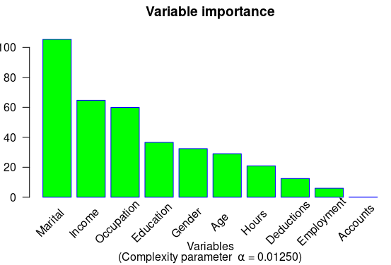
This optimum complexity parameter value allows us to post-prune the decision tree at the 5th node split. The result is shown in Figure 5 along with corresponding split rules in Appendix C. Rules obtained are self-explanatory and usefully complement the tree of Fig.5.
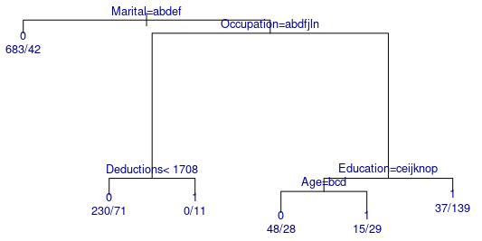Fig. 5: Optimally pruned decision tree, with α = 0.01250. Obtained tree size is 6 for 5 splits over 1333 observations.
Fig. 6: Plot of variable importance for an optimally pruned decision tree (α = 0.01250).
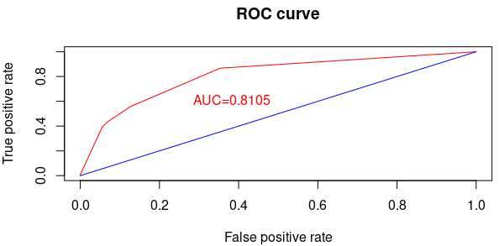Fig. 7: ROC curve for our classification model based on test data.
We notice only one small pure node (for a productive audit, i.e. Adjusted =1) in the optimal decision tree, at rule 13 and 5th node split. The leaf corresponds to only 11/13.33≈1% of the population.
Not all predictors are shown in the tree: at each node split, only the best predictor is kept at any given node.

5. Plot the importance of variables in the prediction.
Figure 6 shows variables’ importance. Most important are:
▪ Marital, Income and Occupation.
A second group of intermediate importance is made of:
▪ Education, Gender, and Age.
Least important variables are:
▪ Hours, Deductions, Employment, and Accounts.
The variable Accounts is the least important. As it is not a predictor of variable Adjusted, it would be appropriate to remove it from the decision-tree analysis, with no adverse effect on the analysis’ outcome.
6. Compute the accuracy, precision, sensitivity (recall) and AUC from the test data.
 |  | Prediction
 |  | 0 | 1
Reference  (test sample) | 0 | 488 TN | 36 FP
Reference  (test sample) | 1 | 81 FN | 62 TP
Table 2: Confusion matrix for data set “audit” (667 observations);
TN = “True Negative”, FN = “ False Negative”, FP=”False Positive”, TP=”True Positive”.
Using the training model constructed with cross-validation (denoted `AuditTree_optimum` in the adjoined R script), a classification for the test data can be predicted. On that basis we cross-tabulate observed and predicted classes with associated statistics. In doing so we consider that a positive outcome is a constructive audit, characterized by Adjusted = 1. Table 2 summarizes predicted classification results in the form of a Confusion Matrix.
Out of n=667 observations in the reference test sample, 143 form a minority of positives (P, “constructive audits”) and 524 are negatives (N).
= 82.46%
for a baseline accuracy of: 143/667 = 21.43%
= 74.51%
where Positive Predicted Val.< Negative Predicted Val.
= 43.36%
AUC = 0.8105 illustrates the ability of a binary classifier to discriminate between true and false positives. Values of AUC > 0.7 are considered good.
7. Perform a Random Forest on test data
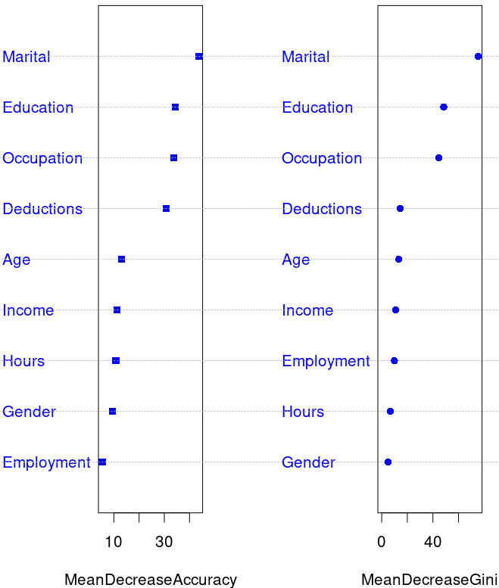Fig. 8: Variable importance as a function of decreasing accuracy (left) and Gini index (right). The mean Gini index measures tree mean node impurity.
 |  | Prediction
 |  | 0 | 1
Reference  (test sample) | 0 | 476 TN | 48 FP
Reference  (test sample) | 1 | 66 FN | 77 TP
Table 3: Confusion matrix for data set “audit_imp” (667 observations), after Random Forest classification.
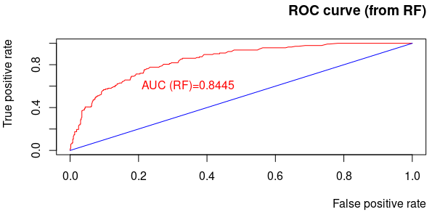Fig. 9: ROC curve for our classification model based on test data with RF.
We first impute missing values in the full data-set, using the “mice” R package.
We use the previous partition of sample data 2/3 (i.e. 1333 cases) for training and 1/3 (i.e. 667 cases) for testing.
We disregard the non-informative predictor “Accounts” and keep only v=9 explanatory variables to perform a Random Forest analysis. The number of variables to be used for classification in any node is q=√v=3 and we generate 500 trees to ensure that each test sample observation is predicted a few tens of times on average via bagging.
The new ranking importance of variables is reflected by the two curves in Figure 8 (to the right). The new prevailing predictor variables are: “Marital”, “Education”, “Occupation” and “Deductions”, a significant difference from the previous result before conducting the Random Forest analysis.
As before we build a Confusion matrix (Table 3), for which, out of n=667 observations in the imputed reference test sample, 143 form a minority of true positives (P, “constructive audits”) and 524 are true negatives (N).
= 82.91%
for the same baseline accuracy as before: 21.43%
= 74.71%
where as before Positive Predicted Val.< Negative Predicted Val.
= 53.58% (… compared to ~43% before RF !)
AUC = 0.8445 (see Figure 9 to the right)
Conclusion:
In this toy example, we see very limited improvement in terms of Accuracy and Precision, even though Sensitivity registers an improvement.
Overall RF does lead to a classification model which discriminates better than the simpler Cross-Validation approach without bagging
Appendix A: Data-set’s variables’ dictionary

ID Unique identifier for the person’s being audited.
Age Age of the person being audited.
Employment Type of employment.
Education Highest level of education.
Marital Current marital status.
Occupation Type of occupation.
Income Amount of income declared.
Gender Person’s gender.
Deductions Total amount of expenses that a person claims in their financial statement.
Hours Average number of hours worked per week.
Accounts Country in which the person has most of their money banked.
Adjustment Monetary amount of any adjustment to the person’s financial claims as a result of a productive audit. This variable is thus a measure of the size of the risk associated with the person.
Adjusted Boolean; indicates non-productive (0) and productive (1) audits.

Appendix B: Complex parameter, α, table for the decision tree
α | Nbr of tree nodes | Learn error (no CV) | CV-learn error mean | CV-learn error std-dev
0.150 | 1 | 1.0000 | 1.0000 | 0.04873
0.034 | 3 | 0.7000 | 0.7563 | 0.04398
0.031 | 4 | 0.6656 | 0.7375 | 0.04355
0.013 | 6 | 0.6031 | 0.6875 | 0.04235
0.006 | 8 | 0.5781 | 0.7063 | 0.04281
0.005 | 10 | 0.5656 | 0.6969 | 0.04258
0.005 | 13 | 0.5500 | 0.7063 | 0.04281
0.004 | 15 | 0.5406 | 0.7125 | 0.04296
0.003 | 20 | 0.5188 | 0.7156 | 0.04304
0.002 | 24 | 0.5062 | 0.7000 | 0.04266
0.002 | 27 | 0.5000 | 0.7031 | 0.04274
0.001 | 29 | 0.4969 | 0.7219 | 0.04318

Appendix C: Rules derived from the optimal decision tree (α = 0.01250, rounded to 0.013 in Appendix B)

Rule number: 13 [Adjusted=1 cover=11 (11/1333=1%) prob=1.00]
Marital= Married
Occupation= Cleaner, Clerical, Farming, Machinist, Repair, Service, Transport
Deductions>= 1708

Rule number: 15 [Adjusted=1 cover=176 (176/1333=13%) prob=0.79]
Marital= Married
Occupation= Executive, Professional, Protective, Sales, Support
Education= Associate, Bachelor, Doctorate,Master, Professional

Rule number: 29 [Adjusted=1 cover=44 (44/1333=3%) prob=0.66]
Marital= Married
Occupation= Executive, Professional, Protective, Sales,Support
Education=College, HSgrad, Vocational, Yr10, Yr11, Yr5t6, Yr7t8, Yr9
Age=Mature

Rule number: 28 [Adjusted=0 cover=76 (76/1333=6%) prob=0.37]
Marital= Married
Occupation= Executive, Professional, Protective, Sales, Support
Education= College, HSgrad, Vocational, Yr10, Yr11, Yr5t6, Yr7t8, Yr9
Age= Middle, Prime, Senior

Rule number: 12 [Adjusted=0 cover=301 (301/1333=23%) prob=0.24]
Marital= Married
Occupation= Cleaner, Clerical, Farming, Machinist, Repair, Service, Transport
Deductions< 1708

Rule number: 2 [Adjusted=0 cover=725 (725/1333=54%) prob=0.06]
Marital= Absent, Divorced, Married-spouse-absent, Unmarried, Widowed

