MIRI / MVA - Practice #8 Report
Disposa.de.connexió.a.Internet.a.la.llar | logical
Connexió.ràpida | logical
Tenen.tarifa.plana | logical
Missatges.mobil | factor
Quants.televisors.tenen | factor
TV.de.pagament | logical
Amb.quina.freqüència.usa.ordinador | factor
Utilitza.programes.ofimàtics | logical
Informàtica.avançada | logical
Aplicacions.específiques | logical
Per.oci | logical
Amb.quina.freqüència.usa.inet | factor
Català | logical
Castellà | logical
Anglès | logical
Edat | factor
Sexe | factor
Nivell.d.estudis | factor
Activitat.professional | factor
Nivell.ingressos.mensuals | factor
Estudia.per.Internet | logical
Fa.servir.correu.electrònic | logical
Fa.servir.xat | logical
Fa.teletreball | logical
Ha.comprat.aliments | logical
Ha.comprat.per.Internet | logical
Internet.per.a.l.oci | logical
Pagament.a.través.d.Internet | logical
Tràmits.amb.els.serveis.sanitaris | logical
Tràmits.per.Internet.amb.l.Admó | logical
Utilitza.serveis.banca.electrònica | logical
Visita.webs.de.l.Admó | logical
Visita.webs.sanitaris | logical
Table 1: Classes of tic_tt data-set’s 33 variables before transformation to factors.
Associated variables | p-value
Ha.comprat.per.Internet. | 1.92e-166
Ha.comprat.aliments. | 2.66e-24
Utilitza.serveis.banca.electrònica. | 1.44e-19
Amb.quina.freqüència.usa.inet. | 5.10e-19
Fa.servir.correu.electrònic. | 1.39e-10
Amb.quina.freqüència.usa.ordinador. | 1.09e-09
Visita.webs.de.l.Admó. | 3.04e-09
Anglès | 4.58e-09
Connexió.ràpida | 1.06e-08
Tenen.tarifa.plana. | 1.20e-07
Disposa.de.connexió.a.Internet.a.la.llar. | 1.70e-06
Internet.per.a.l.oci. | 1.80e-06
Nivell.d.estudis | 7.06e-06
Tràmits.per.Internet.amb.l.Admó. | 4.26e-05
Informàtica.avançada | 1.71e-04
Aplicacions.específiques | 6.03e-04
Activitat.professional | 7.06e-04
Table 2: Significant association of variables with “patdi” (p-values from Pearson chi-square test with catdes().)

Authors: Cedric Bhihe <cedric.bhihe@gmail.com> Delivery: before 2018.06.15 – 23:55
Santi Calvo <s.calvo93@gmail.com>
Study of the characteristics of people practicing payments on the Internet. We use the data-set tic_tt.csv located at Data/tic_tt.csv. It contains information about equipment and Internet usage, in the form of responses to a questionnaire.
1. Read the file: tic_tt. Check the “class” of each variable of tic_tt.
Using the R package read.csv along with option fileEncoding = "ISO-8859-1" , we import the file, without incurring in parsing errors due to diacriticals in the data-set. The data-set contains 1116 observations, and 33 column-variables beyond the 1st column used as row names. The class of each variable is summarized in Table 1. Variables are either logical (TRUE/FALSE) or factors.
2. Find the profiles of people who practice payments on the Internet
We transform all logical variables in factors and apply catdes() to the 28th variable heretofore denoted patdi: “Pagament.a.través.d.Internet.” Table 2 exhibits the degree of significant association of other variables with patdi, at a confidence level of 0.01 ((chi square test). Only p-values smaller than 0.001 are shown here for brevity. DFs and χ² values are not reported, but low p-values suggest rejection of H0.
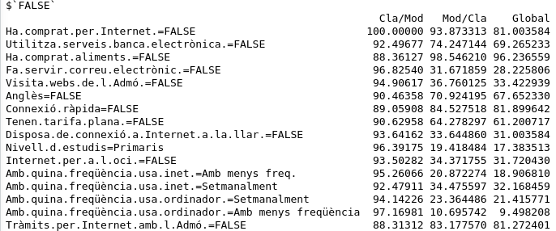
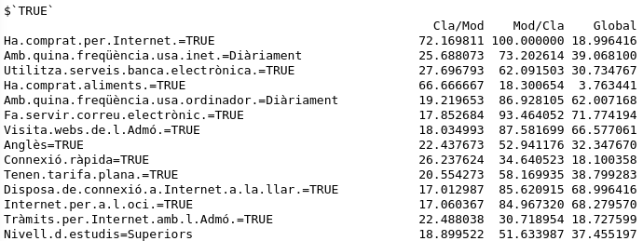
Appendix A further shows two tables where results of a v.test on the two categories (TRUE and FALSE) of patdi reveal which other variables are statistically significantly linked to one modality or the other. The v.test yields the number of standard-deviations below or above the overall mean variable realizations (or global proportion of modality occurrence) for the sample data. Values of v.test <0 mean that the patdi category mean is smaller than the overall average (it is under-represented) and vice versa. The null hypothesis, for continuous variables, is that the variable’s mean in the given category is equal to the variable’s global data mean. We reject the null hypothesis at the risk 0.01 of being wrong when the p-values < 0.01 and |v.test| > 2
In Appendix A only variables for which the v.test statistics in the patdi category is distant from its overall observed value by at least 2 standard deviations are shown. Even so we should reject variables situated in the middle of the table, whose v.test’s p-values are greater than 0.01.
We note that patdi’s two modalities are opposed and reveal opposite associations with other variables’modalities.
For patdi’s TRUE modality, variables most significantly linked are (in decreasing order of significance):
We see for instance that 100% of those possessing the modality patdi=TRUE also possess the modality Ha.comprat.per.Internet.=TRUE.
Simultaneously only 72.17% of those possessing the modality Ha.comprat.per.Internet.=TRUE also possess the modality patdi=TRUE.
Meanwhile only 18.99% of the sampled population possess the modality Ha.comprat.per.Internet. =TRUE.
Inversely, variables’modalities least related to patdi’s TRUE modality or (as represented) most significantly related to its FALSE modality are (in decreasing order of significance):
Logically 100% of those possessing the modality Ha.comprat.per.Internet.=FALSE also possess the modality patdi=FALSE. They represent 81% of the sampled population.
A summary profile for individuals not executing payments on Internet is: does not buy on internet + does not use e-bank services + does not buy food (??) + is not a user of email + does not visit webs set up by the local government + does not speak English + ...

3. Convert the tictt file to a transaction file

7. Perform a Random Forest on test data
Conclusion:

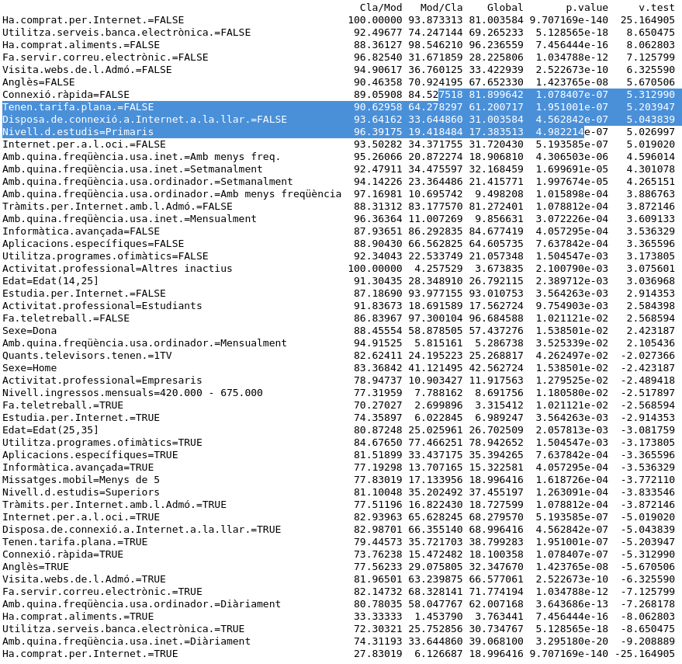
Appendix A: v.test results between variable patdi and other variables, in term of patdi‘s TRUE / FALSE modalities

patdi FALSE modality

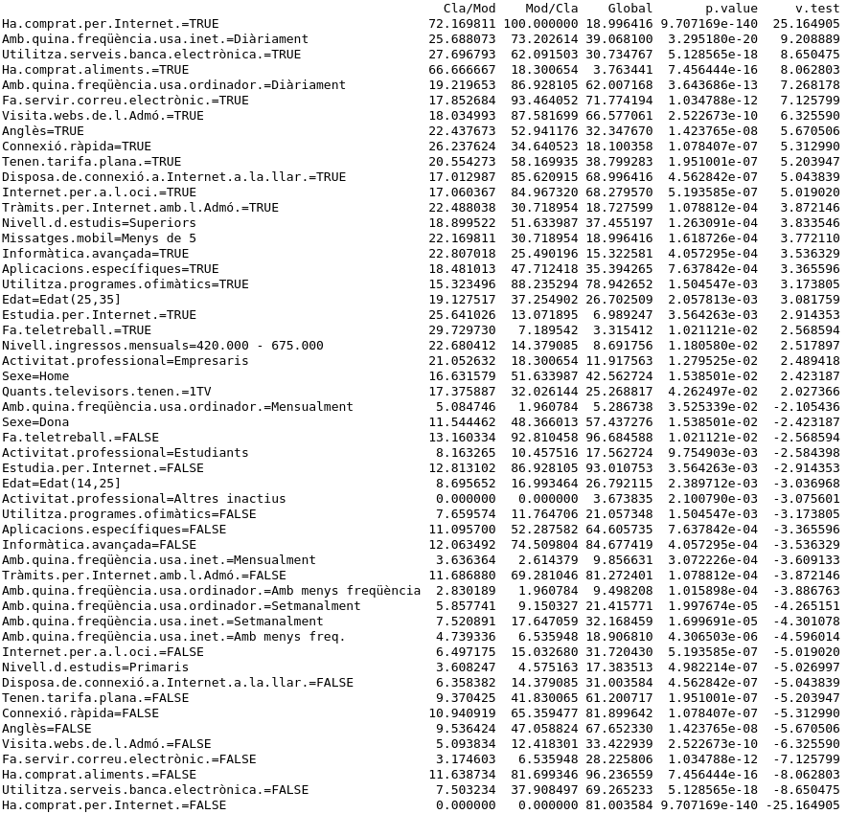
patdi TRUE modality

