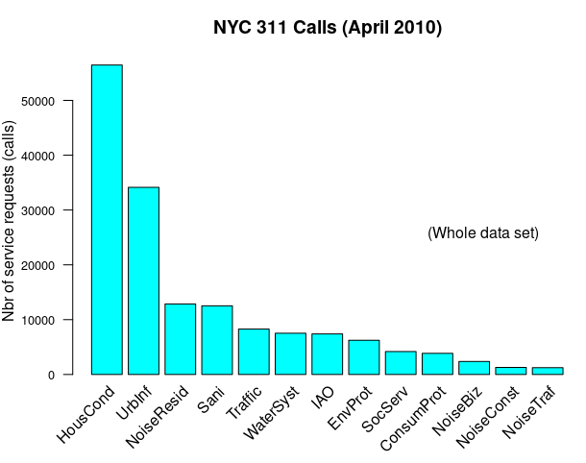
obs w/ missing ZIPs: 1206
obs w/ missing GPS coords: 19583
obs w/ missing ZIP and GPS coords: 11952
obs w/ missing ZIP, Address, GPS coords 9119

For all obs with missing ZIP
- 2976 obs miss all geoloc info
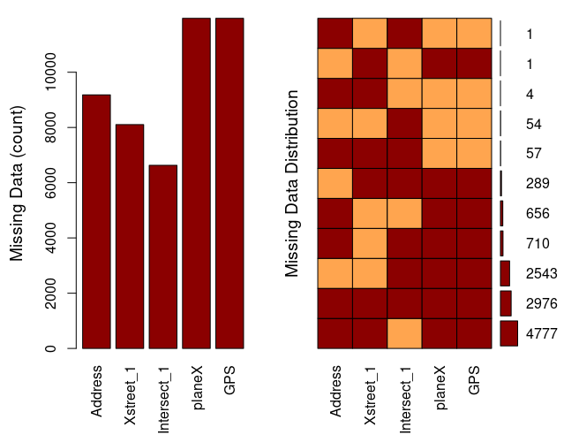

Missings per variable:
Variable Count
Address 9181
Xstreet_1 8104
Intersect_1 6630
planeX 11952
GPS 11952

Missings in combinations of variables:
Combinations Count Percent
0:0:1:0:0 54 0.447464369
0:0:1:1:1 2543 21.072257209
0:1:0:1:1 1 0.008286377
0:1:1:1:1 289 2.394763010
1:0:0:1:1 656 5.435863441
1:0:1:0:0 1 0.008286377
1:0:1:1:1 710 5.883327809
1:1:0:0:0 4 0.033145509
1:1:0:1:1 4777 39.584023865
1:1:1:0:0 57 0.472323500
1:1:1:1:1 2976 24.660258535

modalities of “all missing” categories
IAO HousCond SocServ UrbInf Sani ConsumProt WaterSyst NoiseTraf Traffic EnvProt NoiseBiz
2253 583 69 45 19 3 2 1 1 0 0
NoiseConst NoiseResid
0 0

Sum=2976 (24% of all obs missing a ZIP code have no geolocation onformation. Compare the modality distribution of 'protoYmissingZIP' 2740 complaints frequency wise with those of the whole data set
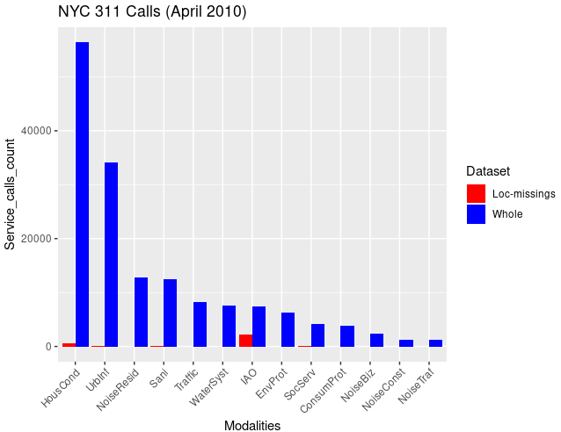
Fraction of modality 'SocServ': 1.65 %
Fraction of modality 'IAO': 30.44 %
Fraction of modality 'HousCond': 1.03 %
The Chi square test of independence of ZIP code observations and SRCs leads to a clear rejection of H0.
Nbr of cells with count <5: 453 . The contribution of low count cells to the computation of the Chi square statistic is negligible. Furthermore those cells do not contribute to a significant association between categorical variable sin the 2 way table of association. (Computed with a targeted Chi square test, we accept H0)
PCA on SRC for April 2010
Scatter plot of scores and variables’ representation in PC1-2, PC1-3 and PC2-3
The effect of ZIP code “10281” is negligible. It is not a true outlier in this context of the April 2010 data set.

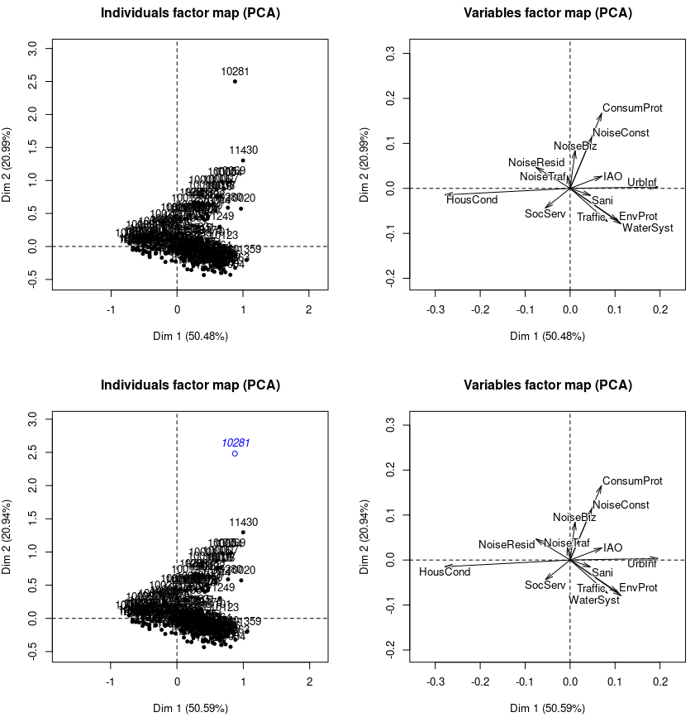
Eigenvalue percentage of variance cumulative percentage of variance
(calculated considering “10281” as supplementary individual.)
comp 1 1.695898e-01 5.059007e+01 50.59007
comp 2 7.020614e-02 2.094308e+01 71.53315
comp 3 2.310180e-02 6.891460e+00 78.42461
comp 4 1.481216e-02 4.418593e+00 82.84321
comp 5 1.133313e-02 3.380768e+00 86.22397
comp 6 9.811926e-03 2.926980e+00 89.15095
comp 7 9.478464e-03 2.827506e+00 91.97846
comp 8 8.528048e-03 2.543989e+00 94.52245
comp 9 6.751816e-03 2.014124e+00 96.53657
comp 10 6.534186e-03 1.949203e+00 98.48578
comp 11 2.860668e-03 8.533615e-01 99.33914
comp 12 2.215369e-03 6.608632e-01 100.00000
comp 13 7.034108e-33 2.098334e-30 100.00000

3 significant dimensions detected with criterion set at 72% of cumulated overall variance representation.
Correlation of variables with PCs:
Dim.1 Dim.2 Dim.3
HousCond -0.98256559 -0.05182583 -0.10610209
IAO 0.71578939 0.27375519 0.08865394
NoiseResid -0.57383121 0.35411451 0.39149768
ConsumProt 0.35721157 0.84687174 -0.22758567
Traffic 0.56976394 -0.50522920 0.15725345
UrbInf 0.92581598 0.01690264 -0.23331906
NoiseBiz 0.07689977 0.57594401 0.70690277
WaterSyst 0.69485582 -0.48567646 0.02328010
NoiseConst 0.32326221 0.76196894 -0.12446854
Sani 0.42744793 -0.14454924 0.44858883
NoiseTraf -0.10637282 0.47951506 0.32063047
EnvProt 0.71835778 -0.48830900 0.10476517
SocServ -0.41506123 -0.33199723 -0.19106544

Contribution of varibales to the construction of each dimension
Dim.1 Dim.2 Dim.3
HousCond 45.68728963 0.30703616 3.91087716
IAO 2.94094250 1.03911926 0.33118155
NoiseResid 3.42038572 3.14643565 11.68743376
ConsumProt 2.87039255 38.97177644 8.55330787
Traffic 4.04335776 7.67986858 2.26103163
UrbInf 22.43838711 0.01806658 10.46156662
NoiseBiz 0.07427798 10.06456819 46.07691026
WaterSyst 7.57090740 8.93464491 0.06238529
NoiseConst 1.36301203 18.29317180 1.48341624
Sani 1.21658732 0.33607260 9.83620974
NoiseTraf 0.02272038 1.11527876 1.51536718
EnvProt 6.55367735 7.31505437 1.02327253
SocServ 1.79806227 2.77890669 2.79704018

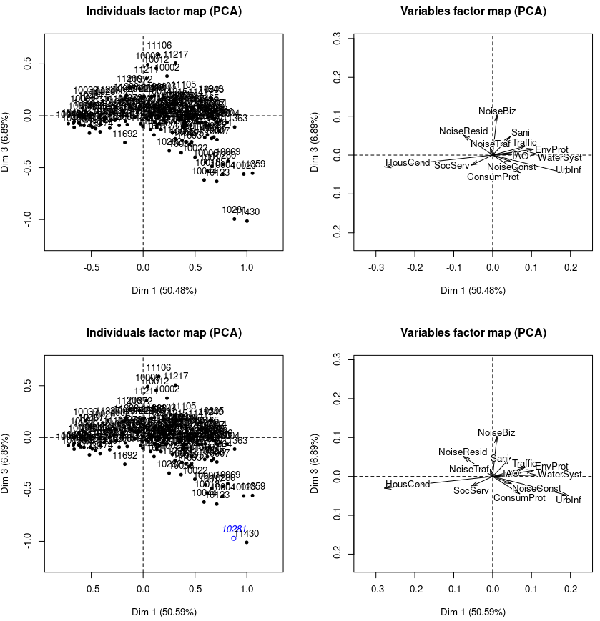

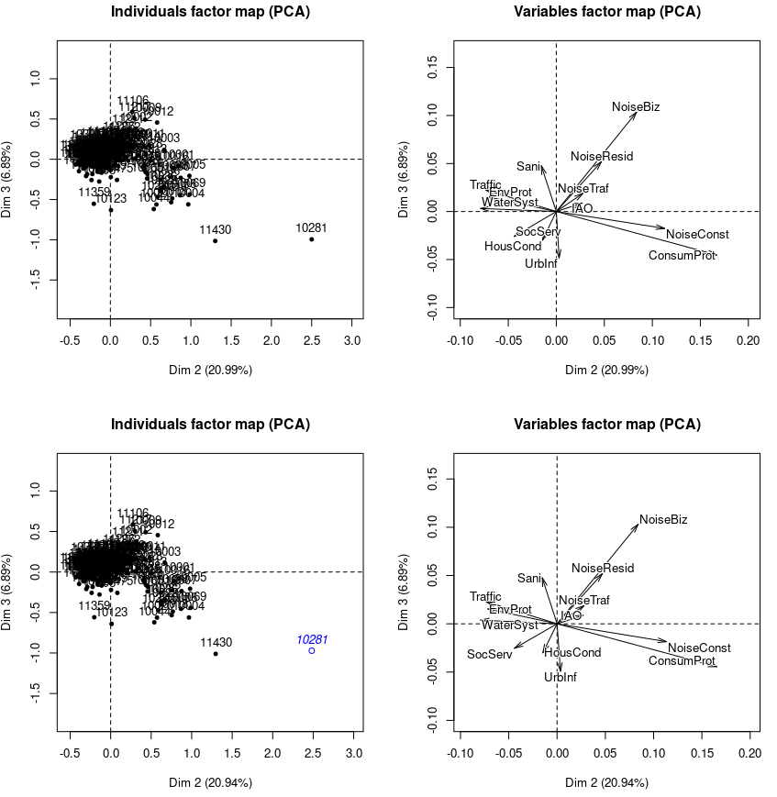
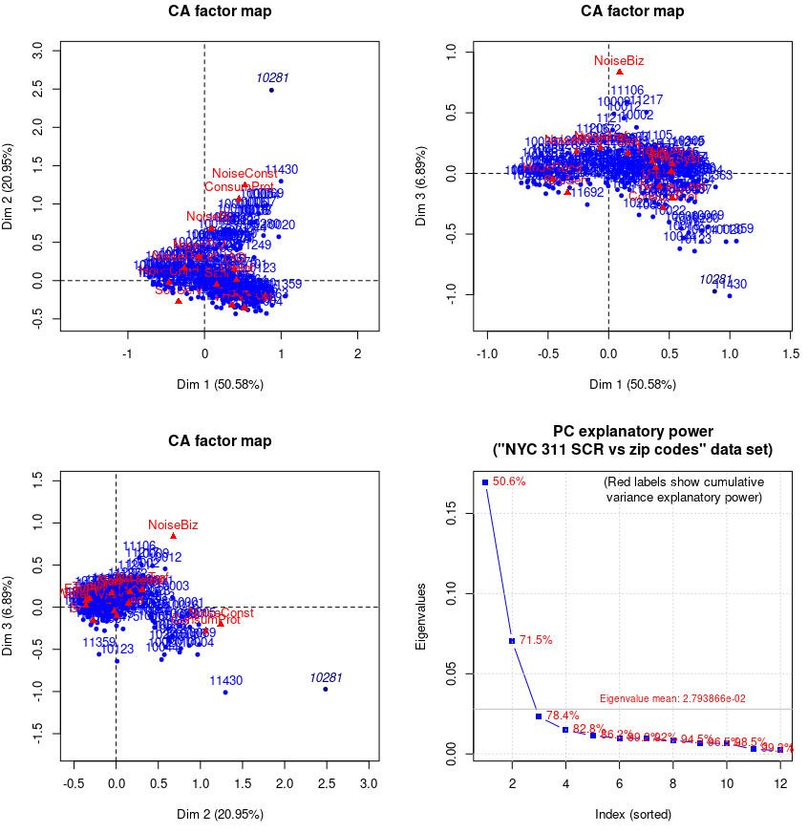

Contributions to the construction of principal directions > 10%
Dim 1 Dim 2 Dim 3
HousCond 45.68515128 0.30503717 3.912213
NoiseResid 3.42000942 3.14513175 11.690464
ConsumProt 2.87631691 39.00901070 8.556879
UrbInf 22.43720197 0.01779967 10.453181
NoiseBiz 0.07439473 10.05350513 46.086619
NoiseConst 1.36380297 18.27895121 1.477422

Inertia explanatory power for all dimensions and for the significant dimensions
iep_alldim iep_sigdim
HousCond 23.9 29.9
IAO 2.9 2.2
NoiseResid 5.3 4.1
ConsumProt 11.4 13.0
Traffic 6.3 4.9
UrbInf 13.2 15.4
NoiseBiz 6.4 6.8
WaterSyst 7.9 7.3
NoiseConst 6.6 5.9
Sani 3.4 1.7
NoiseTraf 1.0 0.4
EnvProt 6.4 6.3
SocServ 5.3 2.1

Quality of representation of col profiles with biggest contrib to PC formation
Dim 1 Dim 2 Dim 3
HousCond 0.965444766 0.0026698605 0.01126289
NoiseResid 0.329239118 0.1254025611 0.15331723
ConsumProt 0.127700459 0.7173053924 0.05175427
UrbInf 0.857138637 0.0002816293 0.05440088
NoiseBiz 0.005923206 0.3315245110 0.49987871
NoiseConst 0.104565032 0.5804563311 0.01543172

Most important individual contributors to the construction of PCs
Dim 1 Dim 2 Dim 3
10001 0.4 5.0 0.1
10002 0.3 1.4 5.8
10003 0.5 5.1 0.5
10007 0.6 2.1 0.5
10009 0.0 1.8 6.9 Dim3 Alphabet City, Downtown Manhattan
10011 0.2 2.3 0.9
10012 0.0 2.2 4.1
10013 0.7 2.3 0.0
10016 0.6 5.7 0.4 Dim2 Murray Hill in South Central Manhattan
10017 0.8 2.8 3.4
10018 0.6 2.3 3.5
10019 0.7 3.9 2.0
10022 0.7 2.9 3.5
10031 2.1 0.1 0.3
10032 2.3 0.1 0.0
10036 0.5 3.2 3.2
10040 3.0 0.0 0.3
10314 2.3 0.9 0.1
10452 3.5 0.0 0.2
10453 3.9 0.1 0.3
10457 2.4 0.1 0.5
10458 3.7 0.0 0.8
10460 2.2 0.0 0.2
10467 2.2 0.0 0.7
11106 0.1 0.5 6.3
11206 0.1 0.1 2.5
11211 0.0 0.7 6.0
11217 0.3 0.6 5.2
11225 2.1 0.0 0.4
11226 4.0 0.1 0.4 Dim1 Center of Brooklyn, near Prospect Park
11430 0.5 1.9 3.5

Results for CA:
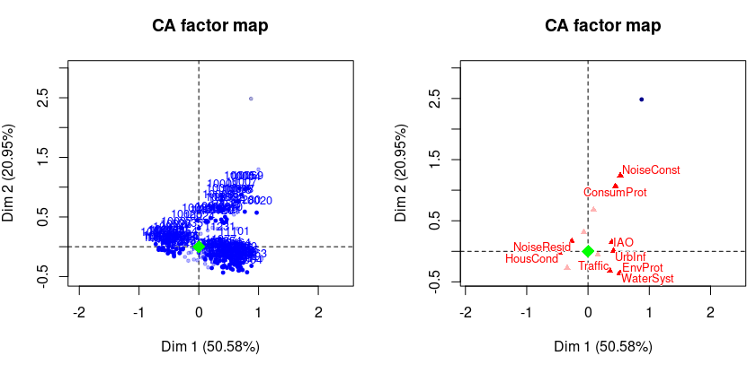
Left row profiles with cos² > 0.6 – Right col profiles with cos² > 0.4
After feature selection and extraction:
"EnvProt" and "WaterSyst" are strongly correlated in PC1-2-3
"IAO", "NoiseTraf" and "SocServ" are weakly correlated with PCs and can be dispensed with.
eigenvalue percentage of variance cumulative percentage of variance
dim 1 0.172970215 54.391548 54.39155
dim 2 0.072692304 22.858542 77.25009
dim 3 0.024123041 7.585639 84.83573
dim 4 0.012197252 3.835501 88.67123
dim 5 0.010517256 3.307216 91.97845
dim 6 0.009583801 3.013685 94.99213
dim 7 0.008195555 2.577143 97.56927
dim 8 0.007729936 2.430726 100.00000

→ 2 significant dimensions only
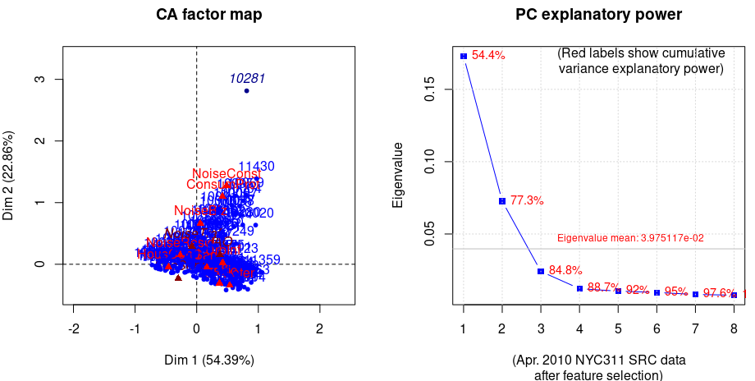
The chi square of independence between the two variables (ZIPs + SRCs) is equal to 45880.48 (p-value = 0 ).

Columns
Iner*1000 Dim.1 ctr cos2 Dim.2 ctr cos2 Dim.3 ctr cos2
HousCond | 83.937 | -0.458 46.906 0.967 | -0.042 0.934 0.008 | -0.060 5.680 0.016 |
NoiseResid | 18.725 | -0.266 3.649 0.337 | 0.151 2.787 0.108 | 0.185 12.607 0.162 |
ConsumProt | 41.344 | 0.418 2.631 0.110 | 1.100 43.271 0.761 | -0.225 5.438 0.032 |
Traffic | 22.625 | 0.370 4.544 0.347 | -0.306 7.395 0.238 | 0.095 2.123 0.023 |
UrbInf | 47.782 | 0.421 23.903 0.865 | 0.026 0.218 0.003 | -0.105 10.767 0.054 |
NoiseBiz | 23.032 | 0.060 0.035 0.003 | 0.664 9.955 0.314 | 0.860 50.349 0.527 |
EPwater | 44.201 | 0.536 15.757 0.617 | -0.341 15.220 0.250 | 0.040 0.637 0.003 |
NoiseConst | 24.135 | 0.486 1.218 0.087 | 1.275 19.940 0.601 | -0.180 1.203 0.012 |
Sani | 12.228 | 0.165 1.358 0.192 | -0.049 0.281 0.017 | 0.177 11.195 0.221 |

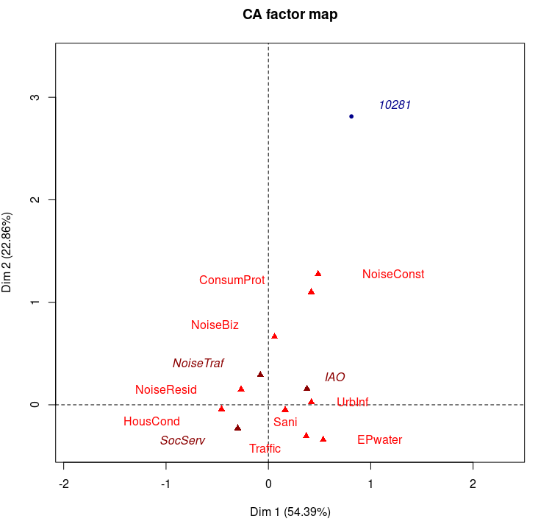
Active variable are in red, while supplementary ones are in dark red. The blue point is the supplementary individual ear-marked as outlier.
Contributions (> 10%) to the construction of the 3 first PCs after feature extraction/selection:
Dim 1 Dim 2 Dim 3
HousCond 46.90561416 0.9342768 5.6802232
NoiseResid 3.64862614 2.7871138 12.6072394
ConsumProt 2.63127856 43.2708473 5.4382810
UrbInf 23.90250351 0.2179053 10.7666437
NoiseBiz 0.03468261 9.9548084 50.3492163
EPwater 15.75720261 15.2196609 0.6372687
NoiseConst 1.21836939 19.9400153 1.2031320
Sani 1.35791871 0.2808020 11.1950591

Quality of representations within the former group (above):
Dim 1 Dim 2 Dim 3
HousCond 0.966586741 0.008091120 0.016324585
NoiseResid 0.337044153 0.108200496 0.162419498
ConsumProt 0.110084673 0.760803565 0.031730901
UrbInf 0.865264711 0.003315054 0.054355898
NoiseBiz 0.002604616 0.314182419 0.527333437
EPwater 0.616625987 0.250302272 0.003477972
NoiseConst 0.087318834 0.600580947 0.012025495
Sani 0.192081416 0.016692789 0.220850659
Individual contributions for which at least one component is greater than 20% in PC1-2-3
Dim 1 Dim 2 Dim 3
10001 0.4 5.3 0.0
10002 0.3 1.3 6.1
10003 0.4 5.4 0.7
10007 0.5 2.3 0.3
10009 0.0 1.7 7.6 Dim3
10011 0.1 2.4 1.3
10012 0.0 2.1 4.8
10013 0.7 2.4 0.0
10016 0.4 6.2 0.2 Dim2
10017 0.8 3.2 3.0
10018 0.6 2.5 3.1
10019 0.6 4.1 1.9
10022 0.7 3.2 2.9
10031 2.3 0.0 0.1
10032 2.4 0.0 0.1
10036 0.4 3.6 2.6
10040 3.1 0.0 0.7
10314 2.5 0.8 0.0
10452 3.4 0.0 0.2
10453 3.8 0.1 0.3
10457 2.5 0.1 0.6
10458 3.7 0.0 1.0
10460 2.1 0.0 0.1
11106 0.0 0.4 6.5
11206 0.1 0.1 2.8
11211 0.0 0.5 5.3
11217 0.2 0.6 5.5
11225 2.2 0.0 0.7
11226 4.0 0.1 0.6 Dim1
11372 0.0 0.2 2.2
11430 0.4 2.2 2.8

Not changed from before. Good sign.
Inertia Explanatory Power for factors (i.e. variable’s modalities)
iep_alldim iep_sigdim
HousCond 26.4 33.3
NoiseResid 5.9 3.4
ConsumProt 13.0 14.7
Traffic 7.1 5.4
UrbInf 15.0 16.9
NoiseBiz 7.2 3.0
EPwater 13.9 15.6
NoiseConst 7.6 6.8
Sani 3.8 1.0

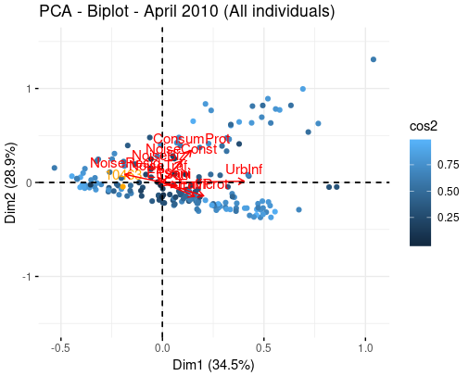
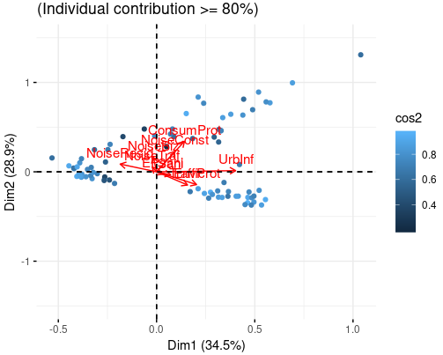
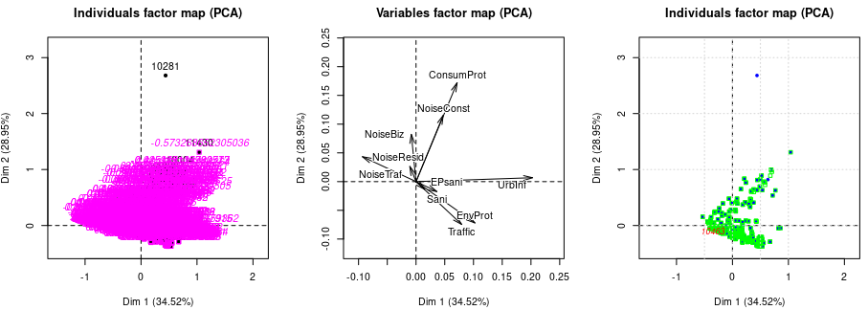
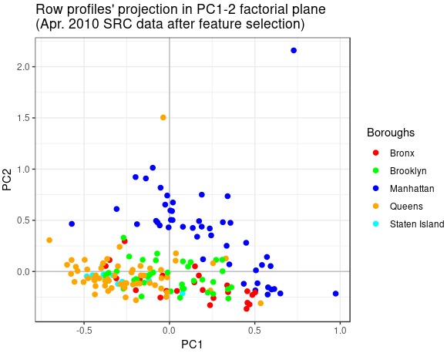
Analysis of ZIP codes’ (observations’) contributions to inertia per borough:
Borough: Manhattan
Number of ZIP codes: 47
Borough's ZIPs' % contribution to inertia (overall and in PC1-2 factorial plane):
All_dim PC1-2
42.1 30.1

Borough: Staten Island
Number of ZIP codes: 12
Borough's ZIPs' % contribution to inertia (overall and in PC1-2 factorial plane):
All_dim PC1-2
7 5

Borough: Bronx
Number of ZIP codes: 24
Borough's ZIPs' % contribution to inertia (overall and in PC1-2 factorial plane):
All_dim PC1-2
10.4 7.9

Borough: Queens
Number of ZIP codes: 60
Borough's ZIPs' % contribution to inertia (overall and in PC1-2 factorial plane):
All_dim PC1-2
23.6 12.2

Borough: Brooklyn
Number of ZIP codes: 38
Borough's ZIPs' % contribution to inertia (overall and in PC1-2 factorial plane):
All_dim PC1-2
15.7 7.7

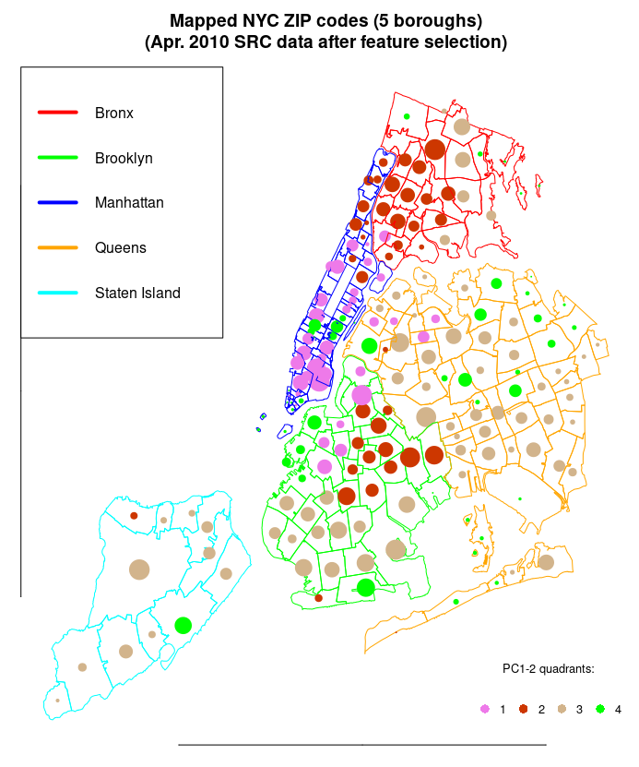

Analysis of latent features following varimax treatment:
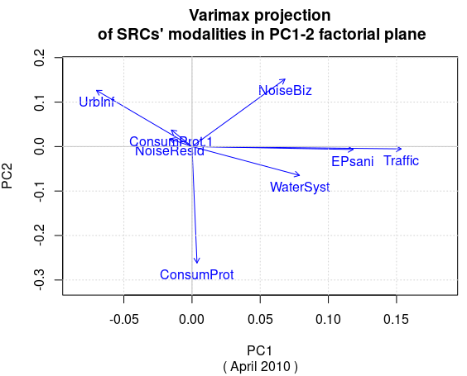
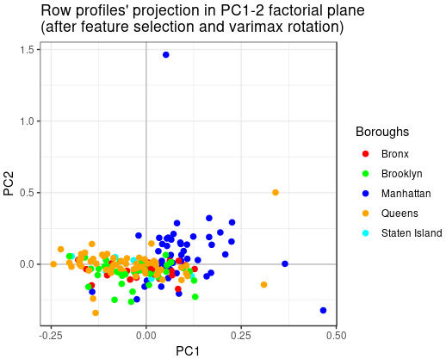
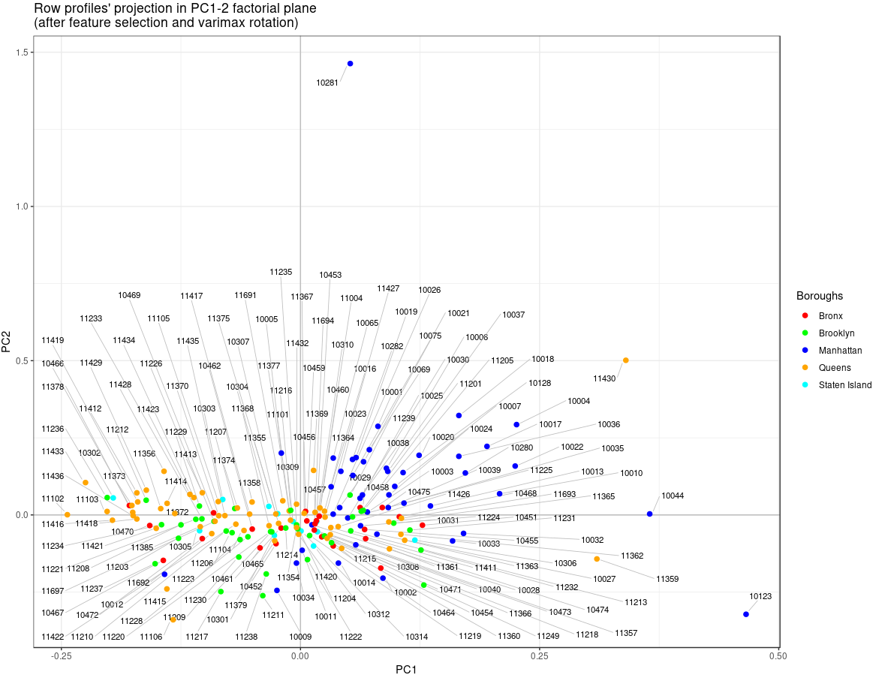

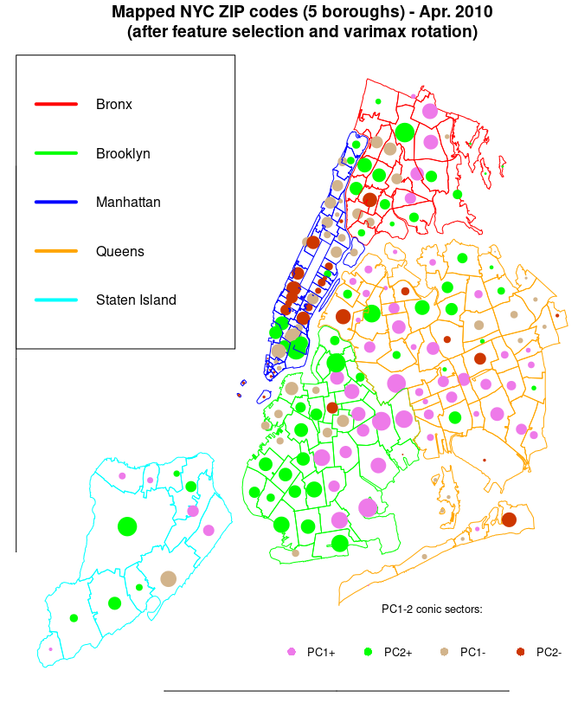
MCA with crime data:
Binning the 17 categorical variables bring some change.
▪ The bin apportionment for “HousCond” is different for 2010 from what it is for April 2014. We go from bin limits c(18,57,80) to c(3,7,13). Level labels go from c("L","H","VH","OC") to c("VL","L","M","H").
▪ Violations
Borough L M MH H
Bronx 3 2 6 14
Brooklyn 4 9 10 15
Manhattan 15 13 11 8
Queens 19 20 14 7
Staten Island 2 2 4

Misdemeanor
Borough M H VH OC
Bronx 4 0 4 17
Brooklyn 2 7 13 16
Manhattan 15 6 14 12
Queens 18 26 7 9
Staten Island 3 2 5 2

Felony
Borough ML M H VH
Bronx 3 1 8 13
Brooklyn 2 6 17 13
Manhattan 15 7 16 9
Queens 21 22 10 7
Staten Island 4 5 3 0

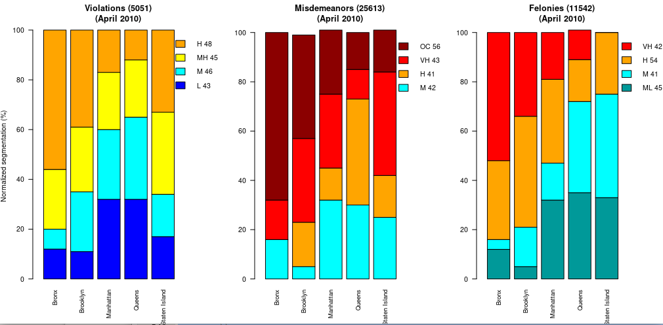
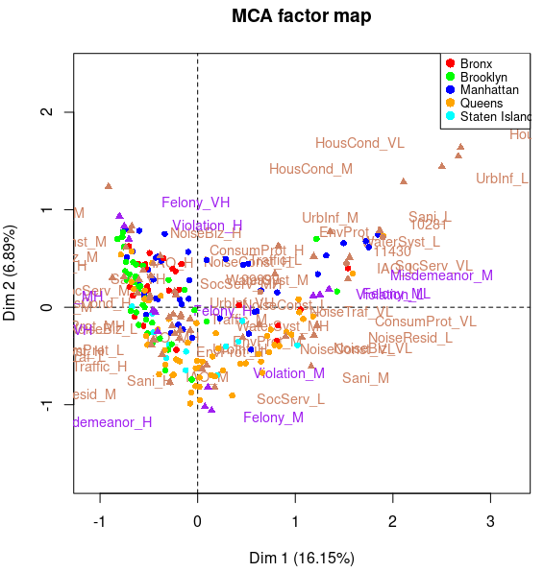
Crime factors in purple
Other factors in beige
ZIP code individuals are color coded according to borough.

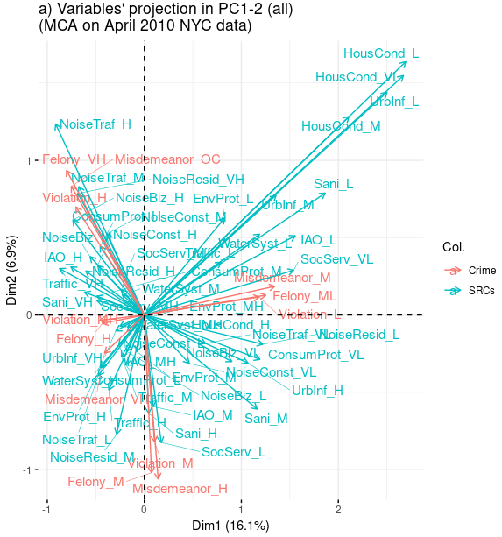
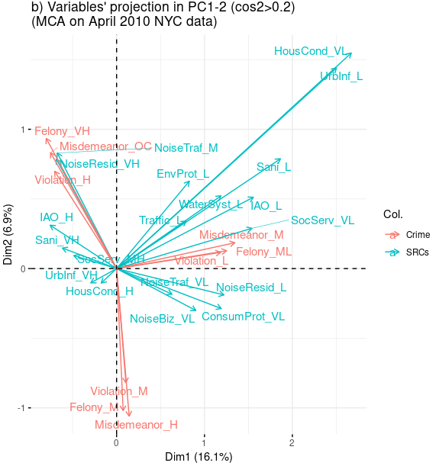
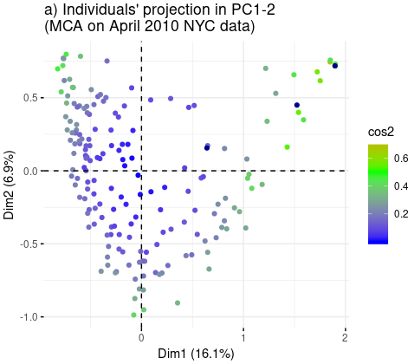
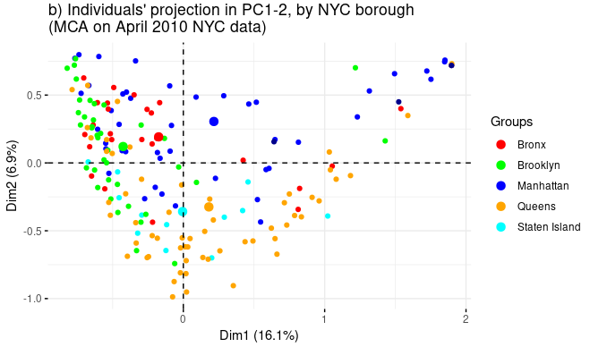
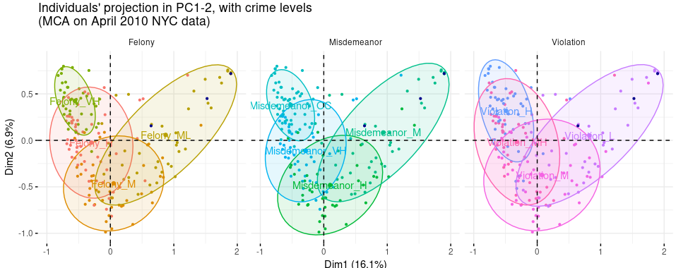
Identify ZIP codes in 2nd quadrant of PC12 var projection from MCA:
sum of all violation counts in 2nd quadrant: 2759
sum of all other violation counts: 2292

sum of all misdemeanor counts in 2nd quadrant: 15214
sum of all other misdemeanor counts: 10399

sum of all felonie counts in 2nd quadrant: 6390
sum of all other felonie counts: 11542

Clustering analysis:
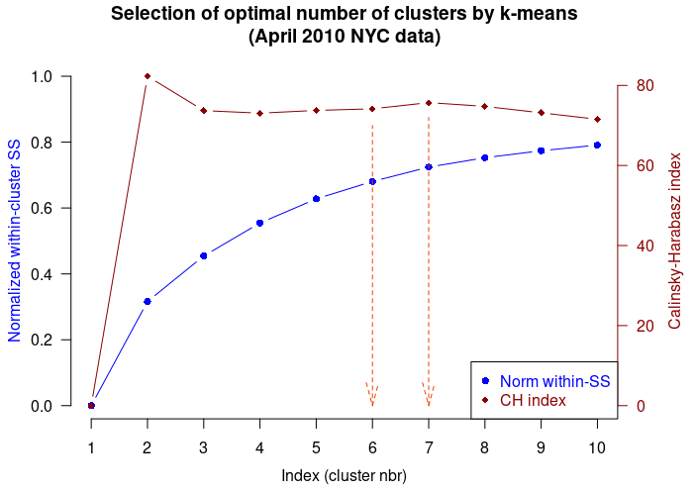
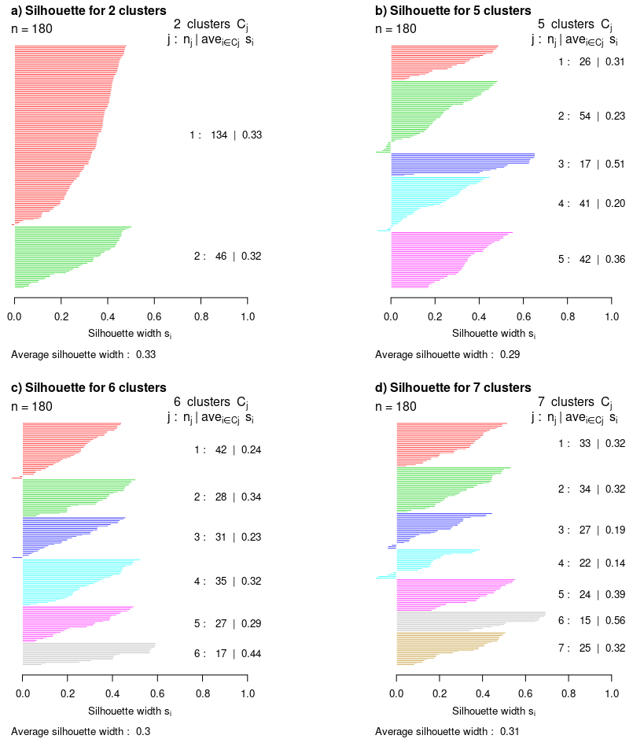
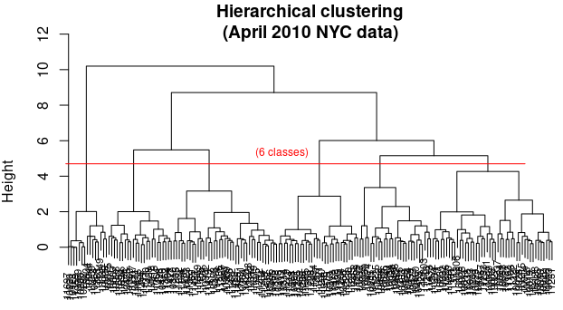
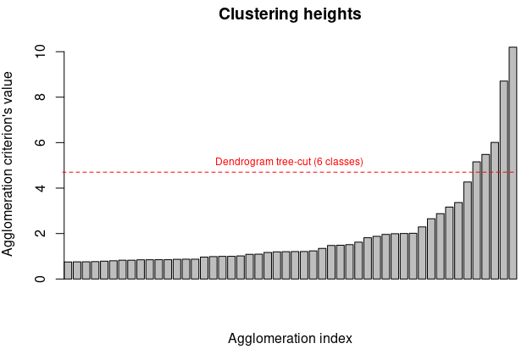
Clustering quality index for 6 classes, Ib=65.98

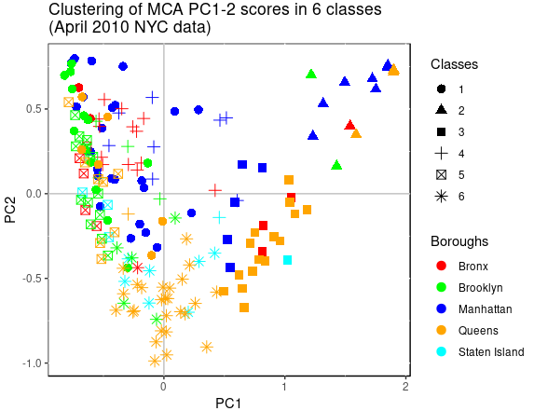
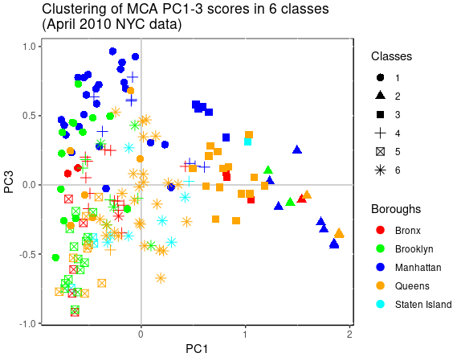
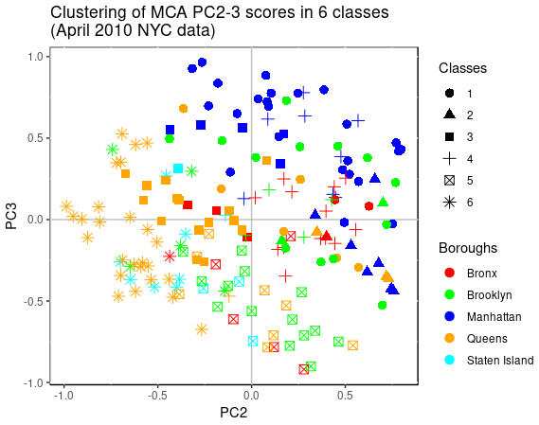

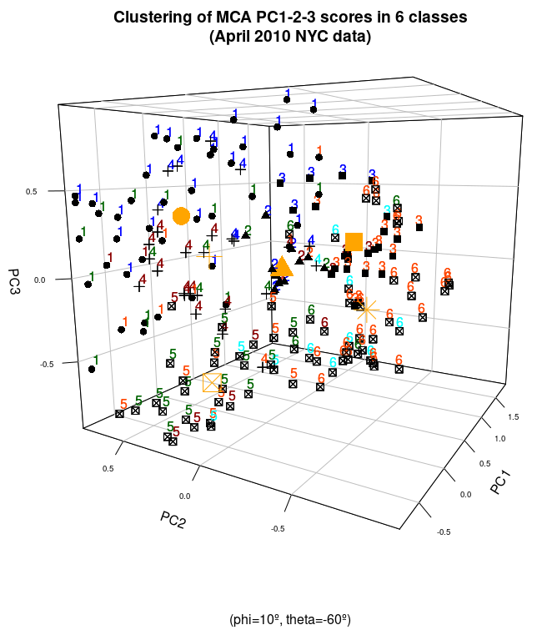
Contributions of each borough to inertia over 'nd' = 5 dimensions:
Borough: Bronx
Boroughs' % (normalized) contribution to inertia: 12.9 %

Borough: Brooklyn
Boroughs' % (normalized) contribution to inertia: 20.2 %

Borough: Manhattan
Boroughs' % (normalized) contribution to inertia: 33.9 %

Borough: Queens
Boroughs' % (normalized) contribution to inertia: 28.9 %

Borough: Staten Island
Boroughs' % (normalized) contribution to inertia: 4.2 %

For more detail:
Borough: Bronx
Number of ZIP codes: 25
Borough's ZIPs' non-normalized % contribution to inertia over (5_dim): 4.9
5_dim
10451 0.1
10452 0.1
10453 0.3
10454 0.1
10455 0.2
10456 0.2
10457 0.3
10458 0.3
10459 0.1
10460 0.2
10461 0.2
10462 0.2
10463 0.1
10464 0.5
10465 0.1
10466 0.3
10467 0.3
10468 0.1
10469 0.2
10470 0.3
10471 0.2
10472 0.2
10473 0.1
10474 0.1
10475 0.1

Borough: Brooklyn
Number of ZIP codes: 38
Borough's ZIPs' non-normalized % contribution to inertia over (5_dim): 7.7
5_dim
11201 0.2
11203 0.2
11204 0.2
11205 0.1
11206 0.3
11207 0.1
11208 0.2
11209 0.2
11210 0.1
11211 0.4
11212 0.1
11213 0.1
11214 0.1
11215 0.3
11216 0.2
11217 0.2
11218 0.1
11219 0.1
11220 0.2
11221 0.3
11222 0.2
11223 0.2
11224 0.2
11225 0.1
11226 0.3
11228 0.1
11229 0.2
11230 0.2
11231 0.1
11232 0.3
11233 0.2
11234 0.2
11235 0.2
11236 0.2
11237 0.1
11238 0.2
11239 0.4
11249 0.6

Borough: Manhattan
Number of ZIP codes: 46
Borough's ZIPs' non-normalized % contribution to inertia over (5_dim): 12.9
5_dim
10001 0.1
10002 0.4
10003 0.2
10004 0.5
10005 0.5
10006 0.3
10007 0.1
10009 0.3
10010 0.2
10011 0.2
10012 0.2
10013 0.2
10014 0.3
10016 0.2
10017 0.1
10018 0.2
10019 0.3
10020 0.8
10021 0.0
10022 0.2
10023 0.2
10024 0.1
10025 0.1
10026 0.2
10027 0.3
10028 0.3
10029 0.2
10030 0.2
10031 0.1
10032 0.1
10033 0.1
10034 0.1
10035 0.1
10036 0.1
10037 0.4
10038 0.1
10039 0.4
10040 0.2
10044 0.7
10065 0.1
10069 0.7
10075 0.2
10123 0.8
10128 0.2
10280 0.8
10282 0.8

Borough: Queens
Number of ZIP codes: 59
Borough's ZIPs' non-normalized % contribution to inertia over (5_dim): 11
5_dim
11004 0.4
11101 0.1
11102 0.0
11103 0.2
11104 0.2
11105 0.1
11106 0.2
11354 0.1
11355 0.2
11356 0.2
11357 0.1
11358 0.1
11359 0.8
11360 0.2
11361 0.1
11362 0.2
11363 0.5
11364 0.2
11365 0.1
11366 0.2
11367 0.2
11368 0.1
11369 0.1
11370 0.2
11372 0.1
11373 0.2
11374 0.1
11375 0.1
11377 0.1
11378 0.1
11379 0.1
11385 0.3
11411 0.2
11412 0.2
11413 0.1
11414 0.2
11415 0.3
11416 0.2
11417 0.1
11418 0.2
11419 0.1
11420 0.1
11421 0.2
11422 0.1
11423 0.2
11426 0.3
11427 0.3
11428 0.2
11429 0.1
11432 0.1
11433 0.1
11434 0.1
11435 0.1
11436 0.2
11691 0.1
11692 0.2
11693 0.2
11694 0.1
11697 0.8

Borough: Staten Island
Number of ZIP codes: 12
Borough's ZIPs' non-normalized % contribution to inertia over (5_dim): 1.6
5_dim
10301 0.1
10302 0.1
10303 0.1
10304 0.1
10305 0.1
10306 0.1
10307 0.3
10308 0.1
10309 0.1
10310 0.1
10312 0.2
10314 0.2
Contributions of each class to inertia over 'nd' = 5 dimensions:
Cluster's 1 normalized contribution to inertia: 22.8 %
Cluster's 2 normalized contribution to inertia: 24.9 %
Cluster's 3 normalized contribution to inertia: 13.1 %
Cluster's 4 normalized contribution to inertia: 12.3 %
Cluster's 5 normalized contribution to inertia: 13.4 %
Cluster's 6 normalized contribution to inertia: 13.4 %

For more detail:
Cluster: 1
Number of ZIP codes: 45
Clusters' (non-normalized) % contribution to inertia: 8.7
IEP_over_5_dim
10001 0.1
10002 0.4
10003 0.2
10009 0.3
10010 0.2
10011 0.2
10012 0.2
10013 0.2
10014 0.3
10016 0.2
10019 0.3
10021 0.0
10022 0.2
10023 0.2
10024 0.1
10025 0.1
10027 0.3
10028 0.3
10029 0.2
10031 0.1
10032 0.1
10033 0.1
10065 0.1
10128 0.2
10467 0.3
10472 0.2
11101 0.1
11102 0.0
11103 0.2
11201 0.2
11206 0.3
11211 0.4
11215 0.3
11217 0.2
11220 0.2
11222 0.2
11226 0.3
11231 0.1
11233 0.2
11234 0.2
11237 0.1
11238 0.2
11372 0.1
11373 0.2
11377 0.1

Cluster: 2
Number of ZIP codes: 15
Clusters' (non-normalized) % contribution to inertia: 9.5
IEP_over_5_dim
10004 0.5
10005 0.5
10006 0.3
10020 0.8
10044 0.7
10069 0.7
10123 0.8
10280 0.8
10282 0.8
10464 0.5
11239 0.4
11249 0.6
11359 0.8
11363 0.5
11697 0.8

Cluster: 3
Number of ZIP codes: 24
Clusters' (non-normalized) % contribution to inertia: 5
IEP_over_5_dim
10007 0.1
10017 0.1
10018 0.2
10038 0.1
10075 0.2
10307 0.3
10470 0.3
10471 0.2
10475 0.1
11004 0.4
11360 0.2
11362 0.2
11364 0.2
11366 0.2
11370 0.2
11411 0.2
11415 0.3
11426 0.3
11427 0.3
11428 0.2
11436 0.2
11692 0.2
11693 0.2
11694 0.1

Cluster: 4
Number of ZIP codes: 27
Clusters' (non-normalized) % contribution to inertia: 4.7
IEP_over_5_dim
10026 0.2
10030 0.2
10034 0.1
10035 0.1
10036 0.1
10037 0.4
10039 0.4
10040 0.2
10303 0.1
10451 0.1
10452 0.1
10453 0.3
10454 0.1
10455 0.2
10456 0.2
10457 0.3
10458 0.3
10459 0.1
10460 0.2
10468 0.1
10473 0.1
10474 0.1
11213 0.1
11216 0.2
11224 0.2
11225 0.1
11433 0.1

Cluster: 5
Number of ZIP codes: 30
Clusters' (non-normalized) % contribution to inertia: 5.1
IEP_over_5_dim
10301 0.1
10305 0.1
10314 0.2
10461 0.2
10462 0.2
10463 0.1
10466 0.3
10469 0.2
11203 0.2
11204 0.2
11207 0.1
11208 0.2
11209 0.2
11210 0.1
11214 0.1
11218 0.1
11221 0.3
11223 0.2
11229 0.2
11230 0.2
11235 0.2
11236 0.2
11355 0.2
11368 0.1
11375 0.1
11385 0.3
11418 0.2
11419 0.1
11434 0.1
11435 0.1

Cluster: 6
Number of ZIP codes: 39
Clusters' (non-normalized) % contribution to inertia: 5.1
IEP_over_5_dim
10302 0.1
10304 0.1
10306 0.1
10308 0.1
10309 0.1
10310 0.1
10312 0.2
10465 0.1
11104 0.2
11105 0.1
11106 0.2
11205 0.1
11212 0.1
11219 0.1
11228 0.1
11232 0.3
11354 0.1
11356 0.2
11357 0.1
11358 0.1
11361 0.1
11365 0.1
11367 0.2
11369 0.1
11374 0.1
11378 0.1
11379 0.1
11412 0.2
11413 0.1
11414 0.2
11416 0.2
11417 0.1
11420 0.1
11421 0.2
11422 0.1
11423 0.2
11429 0.1
11432 0.1
11691 0.1

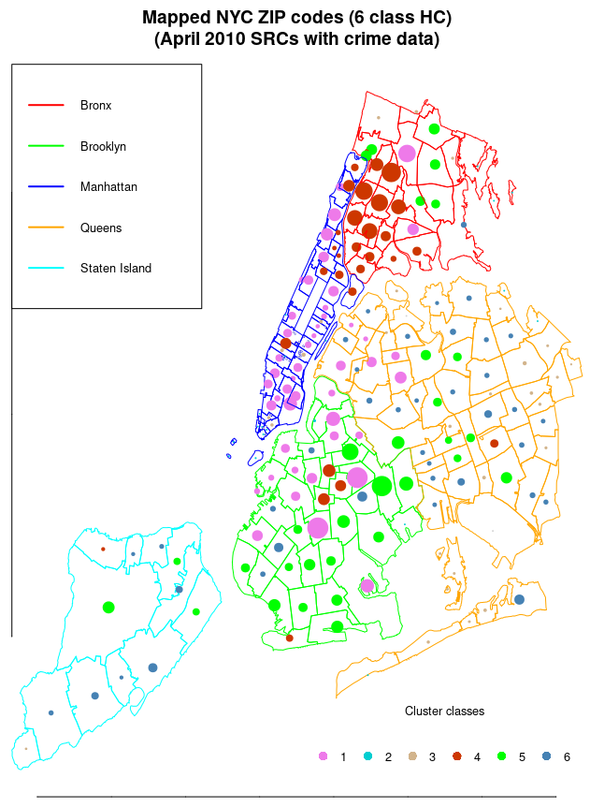
HC clustering with k-means consolidation:

Clustering quality Index for 6 classes, after k-means consolidation, Ib = 68.15

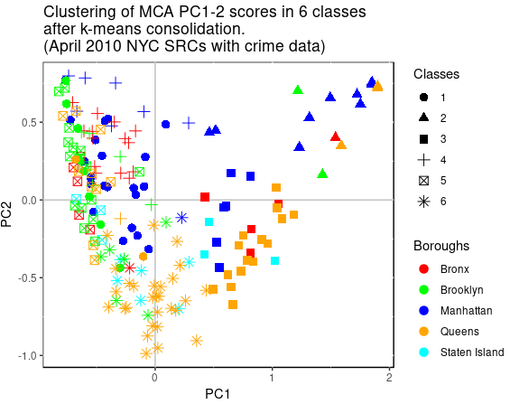

Cluster's 1 normalized contribution to inertia: 16.3 %
Cluster's 2 normalized contribution to inertia: 27 %
Cluster's 3 normalized contribution to inertia: 14.4 %
Cluster's 4 normalized contribution to inertia: 12.6 %
Cluster's 5 normalized contribution to inertia: 13.6 %
Cluster's 6 normalized contribution to inertia: 16 %

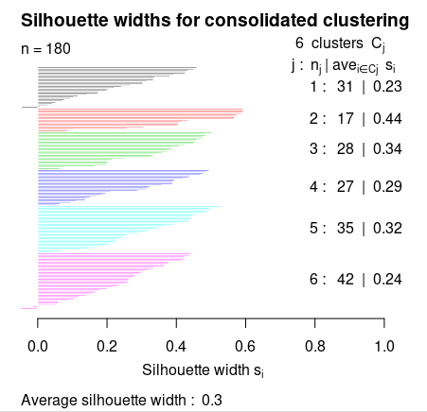
Class 1 's most significant modalities:
ConsumProt=H NoiseBiz=H NoiseConst=H NoiseConst=M IAO=H SocServ=M Misdemeanor=VH Felony=H NoiseTraf=M UrbInf=VH WaterSyst=M Violation=MH NoiseTraf=H

Class 2 's most significant modalities:
Sani=L WaterSyst=L IAO=L SocServ=VL UrbInf=L EnvProt=L Traffic=L HousCond=VL NoiseResid=L NoiseTraf=VL Violation=L Felony=ML HousCond=M Misdemeanor=M UrbInf=M NoiseBiz=VL ConsumProt=VL

Class 3 's most significant modalities:
NoiseResid=L Sani=M NoiseTraf=VL Misdemeanor=M ConsumProt=VL NoiseBiz=VL Felony=ML Traffic=L Violation=L IAO=L UrbInf=H NoiseConst=VL

Class 4 's most significant modalities:
Misdemeanor=OC Felony=VH Violation=H SocServ=MH NoiseResid=VH NoiseTraf=M WaterSyst=M Sani=VH Traffic=M

Class 5 's most significant modalities:
Traffic=VH EnvProt=H Sani=VH WaterSyst=H IAO=H NoiseResid=H SocServ=MH Felony=VH ConsumProt=M Misdemeanor=OC NoiseConst=L Violation=H NoiseBiz=M NoiseTraf=L

Class 6 's most significant modalities:
Misdemeanor=H NoiseResid=M Traffic=H Felony=M IAO=M Sani=H EnvProt=H Violation=M NoiseBiz=L ConsumProt=L WaterSyst=H
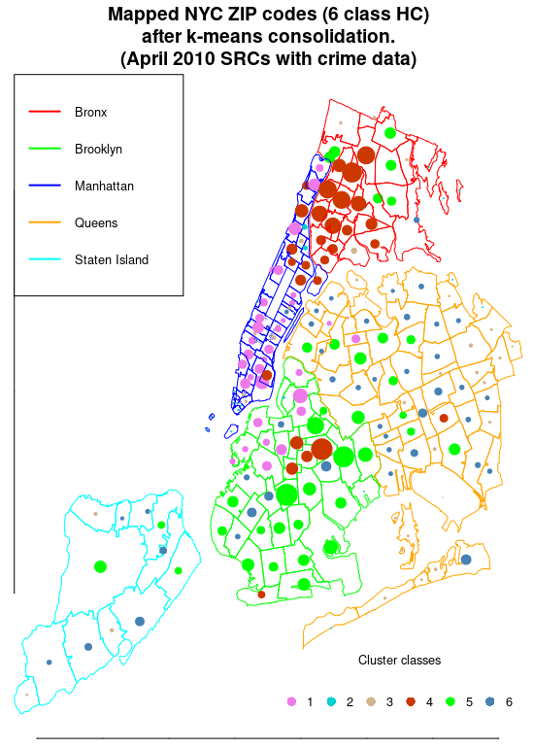
Clustering interpretation:
