TFM: Analysis of NYC’s Service Request Calls to 311
Author: Cedric Bhihe <cedric.bhihe@gmail.com>
Date: Summer 2018

Foreword
A few years ago, Ben Wellington published an article about mapping New York City’s noisiest neighborhoods, soon followed by another one producing results on the hidden circumstances behind New York City’s traffic’s permanent gridlock. Those two articles, published in the New Yorker, were meant for a wide somewhat upscale readership. However they revealed the fact that the author actually had used analytical and statistical methods based on a rich data base. That database (DB) is NYC Open Data, a trove of information geographically and temporally more precise than census tract scale data made publicly available by the US Federal Government. We tapped it. This report describes why, how and how much.

Table of Contents
Foreword 1
1. Introduction 2
2. Data-sets 3
2-1. Terms and conditions of use 3
2-2. Data scope and preparation 4
2-2-1. Duplicates, missings, and imputations 4
2-2-2. SRCs’ modality dimensional reduction 6
2-2-3. ZIP code cleaning 6
3. Multi-Variate Analysis 8
3-1. Principal Components and Correspondence Analysis (PCA, CA) 9
3-2. Multiple Correspondence Analysis (MCA) 13
3-3. Hierarchical clustering 17
3-4. Decision trees 21
4. Conclusions 26
APPENDICES 27
Appendix A: Data-set’s variables’ dictionaries 28
NYC 311 Service Request Calls – Raw Data Dictionary 28
NYPD Crime Reports – Raw Data Dictionary 30
IRS Statistics of Income per ZIP code– Raw Data Dictionary 30
Appendix B: NYPD crime categorization 33
Felonies 33
Misdemeanors 36
Violations 38
Appendix C: Index of ZIP codes and New York city boroughs 39

1. Introduction
Since 2011, between 2,500 and 12,000 daily calls to 311 are recorded in New York City, NY (NYC). Those service request calls (SRCs) are logged with a slew of attributes (more than 50 fields are available per call), on the location of the incident, its nature (e.g. noise, public housing conditions, street potholes, stray animals, rodent sighting, ailing trees, barking dogs, unsanitary food establishments, etc.). SRCs’ attributes include time and date , as well as geo-location of the incident, reason and object of the call. Simultaneously the NYPD, New York’s Police Department, registers over 1000 daily felonies, misdemeanors and violations . This affords the curious analyst a rich overview on the type of issues being reported and about their frequency. It is also an invitation to scrutinize possible correlations between the statistics of geo-located 311 SRCs and other factors such as population density, type of criminality, median income and IRS declared jobless benefits in income tax returns. We will restrict our geographical reach to ZIP based neighborhoods in the 5 boroughs of NYC: Manhattan (1), Brooklyn (2), Queens (3), The Bronx(4), and Staten Island (5). All other ZIP codes are excluded.
In the end curiosity is what really subtends every human endeavor. More specifically in our case, the motivation to embark on this study was to ascertain how much insight can be gained from realistic multidimensional data using classical multi-variate analysis (MVA) exploratory tools. We present results based on Correspondence Analysis (CA), Principal Component Analysis (PCA), Clustering and Multiple Correspondence Analysis (MCA) to conduct data exploration, feature extraction and predictive modeling. Whenever suitable an effort is made to also offer a critical discussion of obtained results. In a second
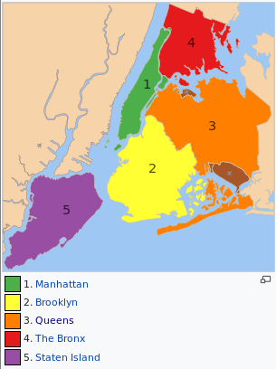Fig. 1: NYC’s five historical boroughs (source: Wikipedia)
A less theoretically minded question is ultimately to reveal evolution patterns in the urban fabric of NYC. Our objective is to try to extract predictor-variables on the scale of a ZIP code area. This is more precise than the census tract scale which may normally includes many ZIP codes. Possible applications are many:
- predict crime,
- link complaints about urban nuisance to certain neighborhoods and illustrate those neighborhoods in terms of social-economical categories,
- produce the basis reference model to help decide where to locate what business for maximum attractiveness to customers and return on investment for investors,
- optimize resources to better manage dense urban areas.
Although we provide a Table of Contents, a brief description of how this report is organized seems in order.
▪ In section 2, we present the protracted process of extracting data from various databases. This included cleaning it (in particular in terms of missing values) and modifying it from a time record format to a location oriented frequency table. Data cleaning, while not intrinsically or conceptually difficult, is a task laden with traps. It occupied over 170 hours of our time. This section sheds light on why and how. It can be skipped and the reader can jump directly to the analysis of Section 3.
▪ Section 3, encompasses the multivariate data analysis including CA and PCA on NYC311 SRCs, Clustering and MCA on 2 categorical variables and a total of 16 modalities, plus 1 (illustrative) supplementary variable and 2 quantitative variables. The analysis is performed on the April 2014 data-set, the which constitutes our training data. Our testing or validation data is the April 2015 data-set.
▪ Section 4, offers a general conclusion on obtained results and suggests new directions to pursue this work.
Due to external constraints imposed on this work, results produced in this report were obtained exclusively by relying on custom R scripts. Notwithstanding those constraints, we cannot but warmly advise interested coders, not to code with R during the data cleaning phase. R is quirky at times, and has either scant or too much documentation to wade through at other times. Being FOSS, it benefits from a community based ecosystem, and it is correct to say that the answer to many questions during development can be crowd-sourced. This however does not normally include extremely specific situations, where the coder is largely left to her own device. All in all data cleaning with R can be done, but is is at best irksome, grueling and slow depending on the exact nature of the task. Many R proponents will readily swear under oath that the same is true about any alternative to R, but heed our dispassionate advice: if you have the choice between R and Python for data cleaning, pick Python to go down the aisle and be forever thankful you did so.
All digital files (including input files, raw and processed data sets, scripts and result files) are made fully available to the reader, in a way which preserves the data structure and the files’ hierarchical organization on any computing platform. Paths in adjoined scripts and occasionally in the body of this report are shown using Unix-like formats. However they can be transposed easily to any addressing format of the file system of your choice.
From the top containing folder “NYC311”, the complete project’s file tree is organized as follows. below means that we omit mention of some intermediate data files, obtained during the preliminary data processing phase. Those files are provided for the record. Their name usually starts with a time-stamp identifying the period to which they refer and ends with __procXX.csv, where XX is a double digit processing sequence identifier.
NYC311/
|___ Bibliography/
|___ Data/
| |___ Geolocation/
| | |___ [7 shape files for NYC ZIP codes perimeter 2D drawing]
| |___ 20140400_nyc311_raw.csv
| |___ 20150400_nyc311_raw.csv
| |___ 2014_zip-income_10-14_raw.csv
| |___ 2015_zip-income_10-14_raw.csv
| |___ 20140400_nyc-crime-map_raw.csv
| |___ 20150400_nyc-crime-map_raw.csv
| |___ 2014_zip-irs-exempt-unemp.csv
| |___ 2015_zip-irs-exempt-unemp.csv
| |___ [...]
| |___ nyc_borough-zip.csv
| |___ nyc311_00083-neighbors-common-border.csv # for ghost zip 00083 processing
| |___ 20140400_nyc_whole-data-set.csv # April 2014 data-set at start of analysis
| |___ 20150400_nyc_whole-data-set.csv # April 2015 data-set at start of analysis
|___ Report/
|___ Scripts/
|__ 00_nyc311_input-parameters.R # defines basic period parameters and more
|__ 01_nyc311_data-prep.R # clean up of raw data, serv. req. modalities reduction
|__ 02_nyc311_missing-impute.R # NN-imputation or direct localization (GoogleMaps API)
|__ 03_apportion-ghost-zip_prep.R # prepare ghost ZIPs’ obs apportionment to neighbors
|__ 04_nyc311_calls-by-zip.R # consolidates service request calls modalities per ZIP
|__ 05_irs_median-inc-jobless.R # compute median income and joblessness per zip from IRS
|__ 06_nypd_data-prep.R # clean up raw data, reduce crime modalities to 3
|__ 07_nypd_crimes-by-zip.R # consolidates crime modalities per ZIP
|__ 08_consolidate-by-zip.R # general consolidation
|__ 09_apportion-ghost-zip_proc.R # apportion ghost ZIP’s categorical variables’ counts

2. Data-sets

2-1. Terms and conditions of use
All raw data-sets used in this project are public and accessible for free under the US Freedom of Information Act (FOIA). Their use is regulated by the terms and conditions of use pertaining to each governing body responsible for their publication or production. Data dictionaries are generally made available in Appendix A, and the web pages harboring those terms are:
- http://www1.nyc.gov/home/terms-of-use.page for ZIP code centric and time-based NYC311 SRC data
- https://data.cityofnewyork.us/Business/Zip-Code-Boundaries/i8iw-xf4u for geometric ZIP code area boundary data
- https://www.irs.gov/statistics for ZIP code-centric income tax declaration data made available by the IRS
- https://www.census.gov/topics/income-poverty/income/data/tables/acs.html
for ZIP code-centric unemployment benefit declared to the IR

2-2. Data scope and preparation
Data was generally available from various location on the web, from 2011 onward. We specialized our study to the months of April 2014 and April 2015 in order to be able to handle the corresponding volume of data. Raw files are available in ods and cvs formats at NYC311/Data/. Census data on population densities per ZIP code area was only available to us for the year 2016 and only for a limited number of ZIP code areas. We therefore do not include it in either one of our data-sets.

2-2-1. Duplicates, missings, and imputations
Every downloaded data-set was already fully labelled. A rapid inspection of raw data shows that "NA" (non-assigned / not-available) or erroneous values, referred to as “missings”, exist, but in such proportion that dealing with them was tractable. As described below, we either imputed, re-imputed, suppressed or researched missings by cross-referencing them between DBs, with the goal of avoiding issues of data bias.
Service request calls (SRCs) to NYC 311:
The two data sets yyyy0400_nyc311_raw.csv contain the raw data of NYC SRCs for yyyy={2014,2015} as downloaded from NYC Open Data. That includes the call’s object (description), date, time, ZIP codes and/or location (in several forms) of the reported matter and other less relevant information. We checked that data-sets contains SRCs (heretofore referred to as “dupes”) from different callers with the same object. Tracking down dupes is inherently complex and we did not attempt it. More importantly, our study is concerned with people’s spontaneous and independent tendency to call NYC 311 about aspects of their urban environment, which are important to them. In that sense dupes need not be eliminated; they are significant and represent a natural weighting for the data-set’s observations. This will naturally influence observations’ weights as represented later by marginals (row sums) in frequency tables.
Period | Raw data’s obs number | Obs # with missing ZIP | Obs # missing all location info | Service requests’ modalities # | Unique  ZIP
April 2014 | 81645 | 3206 | 2740 | 170 | 278
April 2015 | 101890 | 4231 | 3069 | 178 | 260
Table 1: Summary table of salient missings and other characteristics for raw NYC 311 SRCs data sets
(before data cleaning). SRCs’ modalities are available in the 2 files:
Report/yyyy0400_nyc311_proc01_modalities.csv with yyyy={2014,2015}
Raw (unfiltered) data characteristics are shown in Table 1. Figures 2 and 3 below represent missings for the period April 2014.

As can be observed on Figure 2 below, during the April 2014 period, 2740 observations or 3.4% of all observations, and 85.5% of the 3206 observations missing a ZIP code have no other geographic locator. Those observations cannot be attributed to any ZIP code and are therefore useless. Figure 3 compares the service request calls’ modality distributions for observations missing all location information (including a ZIP code and denoted “loc-missing”) and the whole data set. It is readily apparent that simply eliminating “Loc-missing” observations would disrupt our analysis in terms of the SocServ modality, while for other modalities the effect would be negligible.
For that reason, we proceeded to impute a ZIP code to the 466 RFC observations missing it in 2014, but not included in the Loc-missing subset of missings. In practice those observations miss a ZIP code but are nevertheless endowed with some other geolocation information:
- an address, and/or
- 2 cross-streets in the form of (Xstreet_1,Xstreet_2), and/or
- an cross-road in the form of (Intersect_1,Intersect_2), and/or
- planar (Euclidian) coordinates (planeX, planeY), and/or
- GPS coordinates (latitude and longitude)
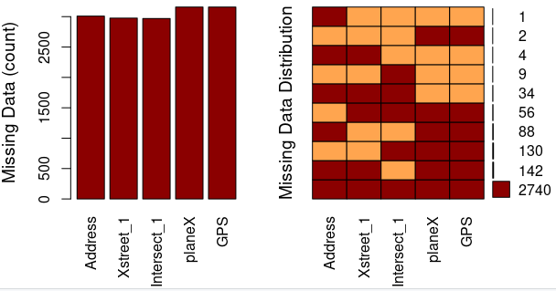Fig. 2: Analysis of missings for April 2014 on the 3206 raw observations missing a ZIP code.
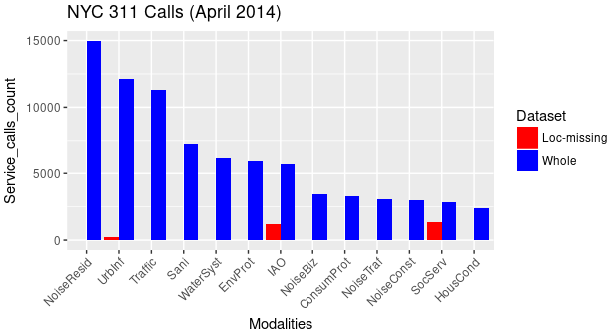Fig. 3: NYC 311 SRCs’ modality distribution for the whole data-set (blue) and for observations missing all location information.
Imputation was done by fully implementing automated requests to GoogleMaps, through its API, in R, for each one of the aforementioned cases. As a result more than 97% of all 466 observations missing a ZIP code could be imputed for the April 2014 data-set. The rest including the Loc-missing subset of observations were given the bogus ZIP code “99999” to be uses later as a supplementary observation.
As there is no structural difference between the April 2014 and April 2015 data-sets, graphical analysis results for missings were only shown for April 2014. From Table 1, in April 2015, 3069 observations or 3.0% of all observations, and 72.5% of all observations missing a ZIP code have no other geographic locator. Here again we treat missings following the same pattern and with a similar success rate as before.
NYPD’s crime reports:
Crimes are reported according to 3 general categories, which coincide with the crime modalities used in our analysis. In decreasing order of severity, they are: felonies, misdemeanors, and violations. . They are described and instances listed in Appendix B per the NYPD’s DB.
Data made publicly available by NYDP is completely devoid of ZIP information. However it does include planar localization and regular GPS coordinates. Because of the large amount of data involved in this study (close to 80,000 criminal observations) and of Google’s imposed limitation on the number of queries (2500/day/account, as of 2018.04.30) , relying on our Google Maps API’s implementation to impute a ZIP code to each crime was not deemed practical. We therefore developed two original algorithms to determine the ZIP code of each NYPD crime observation based on its planar (Cartesian) coordinates.
The first algorithm to be developed was based on nearest neighbor topological distance. It uses previously compiled ZIP code areas with planar and/or GPS coordinates for SRCs to NYC 311. The ZIP code of the 311 SRC closest in space to a crime’s GPS or planar coordinates is imputed to the crime. This method is approximate and yield mixed results.
The second algorithm is exact and yields excellent results. It determines the ZIP code of every crime observation based on its planar coordinates and shape-formatted ZIP boundaries mapping data, downloaded from the NYC Open Data repository and made available to the reader under Data/Geolocation/.
The latter algorithm is general and is implemented in the form of a function, whichBoxF(), available at Scripts/06_nypd_data-prep.R. Its reaches its imputation target in more than 96% of all recorded observations. The rest, i.e. less than 4%, falls in the missings category and kept in supplementary observation with imputed bogus ZIP code “99999”. Tables 2 below summarizes missing ZIP code “99999” imputation for crime data collected by NYPD in April 2014 and April 2015. A Chi square test of the NYPD crime data-sets’ missings show that there is a significant association between missings and crime modalities. Simply suppressing missings would introduce a bias in the distribution.
April 2014 | Felony | Misdemeanor | Violation | Total |  | April 2015 | Felony | Misdemeanor | Violation | Total
non-missings | 11,327 | 22,094 | 4,784 | 38,205 |  | non-missings | 11,669 | 22,080 | 5,010 | 38,759
missings | 481 | 985 | 64 | 1,530 |  | missings | 193 | 473 | 11 | 677
Total | 11,808 | 23,079 | 4,848 | 39,735 |  | Total | 11,862 | 22,553 | 5,021 | 39,436
Table 2: Summary of misssings after imputation for the NYPD’s crime datasets in NYC

2-2-2. SRCs’ modality dimensional reduction
Service Request Calls’ modality dimensional reduction was conducted by applying filters tailored to the semantics of the raw data’s two columns: “Complaint”, and “Descriptor”.
Service request calls’ modalities | Modality description | Service request call  frequencies |  | Change in rank from 2014 to 2015
Service request calls’ modalities | Modality description | April 2014 | April 2015 | Change in rank from 2014 to 2015
NoiseResid | Residential Noise | 19.00% | 17.50% | ‒
UrbInf | Urban Infrastructure | 15.00% | 13.40% | ➘
Traffic | Traffic related Issues | 14.30% | 17.20% | ➚
Sani | Unsanitary Conditions | 9.20% | 10.50% | ‒
WaterSyst | Water Systems | 7.80% | 7.60% | ‒
EnvProt | Environmental Protection | 7.60% | 5.90% | ‒
IAO | Inspect, Audit, Order | 5.80% | 5.20% | ➘
NoiseBiz | Commercial Noise | 4.40% | 4.90% | ➘
ConsumProt | Comsumer Protection | 4.20% | 3.40% | ➘
NoiseTraf | Traffic Noise | 3.90% | 5.40% | ➚➚
NoiseConst | Construction Noise | 3.80% | 3.70% | ➚
HousCond | Housing Conditions | 3.10% | 3.40% | ‒
SocServ | Social Services | 1.90% | 1.90% | ‒
Total number of SRCs |  | 78825 | 98649 | ➚➚
Table 3: SRCs’ consolidated modalities after dimensional reduction. The right most column indicates changes in modality ranking from 2014 to 2015.
The reduced modalities data-sets exhibit 13 modalities down from 170 and 178 (in Table 1, for April 2014 and April 2015 respectively) according to the description and distribution of Table 3. Noise related complaints remain the first reason for SRC to 311 with overall frequencies in noise related calls of 31.1% and 31.5% in 2014.and 2015 respectively. Table 3 is based on data after ZIP cleaning and missings imputation.
SRC modality ranking change show that the perceived (and perhaps also real) traffic noise related SRCs increased markedly between April 2014 and April 2015.

2-2-3. ZIP code cleaning
At this data preparation stage, our data consists of a mixture of correctly formed and ill-formed ZIP fields for each observation. An ill-formed ZIP code is a code that does not have 5 digits or does not exists officially or is otherwise not consistently found in federal US government DBs.
For our purposes, ill-formed ZIPs include ZIP+4 codes of the form 11355-1024, where the last four digits identify a geographic segment or a PO box within the five-digit ZIP delivery area. In those cases we simply suppress string characters ranging from position 6 to the end.
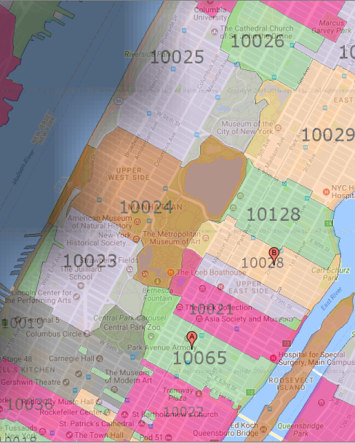Fig. 4: Detail of the ZIP code area map of Manhattan, showing how neighboring ZIP code areas pave Central Park piece-wise.
Other inadmissible ZIP codes are ghost ZIP codes. One of them appears in our DBs as “00083”. The NYC 311 service request call data-set includes it along with surrounding and overlapping ZIP codes. So do the NYPD’s crime DB, and the topological ZIP code area boundary DB also found in the NYC Open Data repository. Within the NYC area it designates the Central Park area in Manhattan. But because it overlaps with other official ZIP code areas surrounding it, observations identified by that ZIP code should be instead apportioned to neighboring ZIP code areas. Figure 4 (above) reveals the Zip mapping in that area, showing official ZIP code areas boundaries mapping Central Park in Manhattan. Surrounding ZIP codes are 10019, 10022, 10065, 10023, 10021, 10075, 10028, 10024, 10128, 10025, 10029, and 10026.
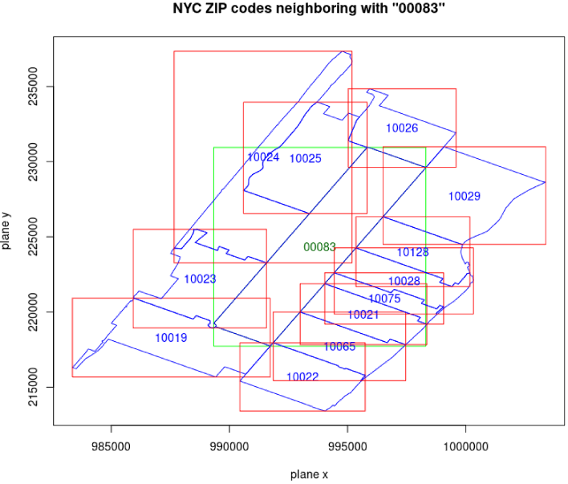Fig.5: New York City government ZIP code limits mapping Central Park in Manhattan and resorting to ghost ZIP code 00083 (at center in green).
ZIP code | Common boundary length (ft) | Common boundary length proportion (%)
00083 | 32,710.8 | 100.0
10019 | 2,651.4 | 8.1
10022 | 259.2 | 0.8
10065 | 2,341.4 | 7.2
10023 | 4,864.4 | 14.9
10021 | 2,150.5 | 6.6
10075 | 833.0 | 2.5
10028 | 1,889.7 | 5.8
10024 | 3,748.7 | 11.5
10128 | 2,371.1 | 7.2
10025 | 5,031.3 | 15.4
10029 | 3,749.0 | 11.5
10026 | 2,821.2 | 8.6
Table 4: 00083 ghost ZIP code area shared boundary analysis.
The use of ZIP code 00083 is incompatible with IRS and Census Agency DBs. To overcome that difficulty we calculate the common boundaries between the 00083 ZIP code area boundary and surrounding ZIP areas boundaries. Our goal is to apportion observations attributed to ZIP code 00083 to surrounding ZIP codes areas proportionally to the lengths of the boundaries they share, and in a way which should remain modality agnostic.
Figure 5 represents the Cartesian topological mapping, and Table 3 shows the computed proportion of common boundary lengths between Central Park’s 00083 ghost ZIP and surrounding ZIP code areas. The algorithm developed can operate on arbitrary sets of ZIP codes.
After correcting for ill-formed ZIP codes, ghost ZIP codes, and ZIP codes situated outside the 5-borough area, we observe respectively 208 and 206 unique observation ZIP codes in each one of our data sets: April 2014 and April 2015.
The starting point for our statistical analysis of section 3 are the two data-set located at:
NYC311/
|___ Data/
|___ 20140400_nyc_whole-data-set.csv
|___ 20150400_nyc_whole-data-set.csv
Inexplicably we note a few cases (fewer than 30 observations per data set) of missing response variables (“medianInc” and “jlBenefit”) in each data set. This means that the Internal Revenue Service (IRS) chose not to make the corresponding ZIP code area’s tax return statistical data public. This should not pose a problem for the coming clustering analysis (classification) , but obviously does so in any regression-like approach.
So the reader may comfortably relate ZIP codes to NYC boroughs, we provide a list of more than 200 ZIP codes and their corresponding boroughs in Appendix C.

3. Multi-Variate Analysis
To approach our data, we first consider the contingency table made of the NYC 311 service request calls (SRC) categorical variable’s 13 modalities and 208 zip codes seen as the modalities of a second categorical variable we name Location. Among the zip codes the last one, “99999”, will be treated a supplementary variable.
We identify 26 zip codes with row marginals smaller than 5/(sum of calls), where for April 2014 the total number of calls so far retained in our analysis was 78,672. We suppress those ZIP codes from our contingency table, on the grounds of they representing less than 0.2% of monthly SRCs (see footnote). The resulting table for April 2014 is made of 181 zip codes (row labels, row index i) and 13 SRC modalities (column labels, column index j).
Next we identify table cells where low frequency and (simultaneously) high contributions to the χ²-statistic value for the test of association of the two categorical variables may perturb the subsequent analysis. We define as low cell count or low frequency any contingency table cell count smaller than 5. There are 346 such cells. Based on the chi-square-test statistic:
we calculated the contribution of every low frequency cell to the overall χ² statistic value and found that for low frequency cells: (i) no contribution exceeds 1%, and (ii) only 1 contributions exceed 0.1%, for a 2-sided χ² test statistics of 43,338. As a result the Pearson chi-square test for significant association (dependence) between row & column categories is deemed appropriate. It led to the clear rejection of the null hypothesis, with a p-value of the order of 10⁻⁴:
H0: “In the population, the two categorical variables are independent.”
The above p-value was computed from Monte-Carlo simulations with 10,000 replicates.
Inspecting marginals, we see that SRC modalities with lowest weight across zip codes are:
“SocServ” (f_{∙j}≈0.019 for j=11), followed by HousCond (f_{∙j}≈0.030 for j=1), and “NoiseConst” (f_{∙j}≈0.038 for j=4).

3-1. Principal Components and Correspondence Analysis (PCA, CA)
From the contingency table made of the SRC categorical variable’s 13 modalities and 208 zip codes, we build a conditional frequency matrix, which we appropriately center based on a cloud centroid (of column marginals) with embedded χ² metric. We perform a PCA on that matrix excluding ZIP code “99999”. We first include “10463” and then repeat the analysis considering it as a supplementary observation. The number of significant dimensions is 3, based on the criterion that the total explained inertia be at least 70%. Results are graphically summarized in figures 5a, 5b and 5c.
When included in the analysis, ZIP code “10463” stands out as the biggest individual contributor to the construction of the 3 first dimensions with 17%, 22%, and a whopping 52% for PC1, PC2 and PC3 respectively. The ZIP code area roughly represents a one kilometer radius in the Bronx, known as Riverdale. Topologically neighboring ZIP areas are: 10467, 10468, 10471. Riverdale has one of the highest population density in NYC with more than 30,000 housing units and more than 18,000 registered inhabitants per square kilometer. Understandably HousCond and other SRCs to NYC 311 are disproportionately large in Riverdale, when compared to other NYC areas.
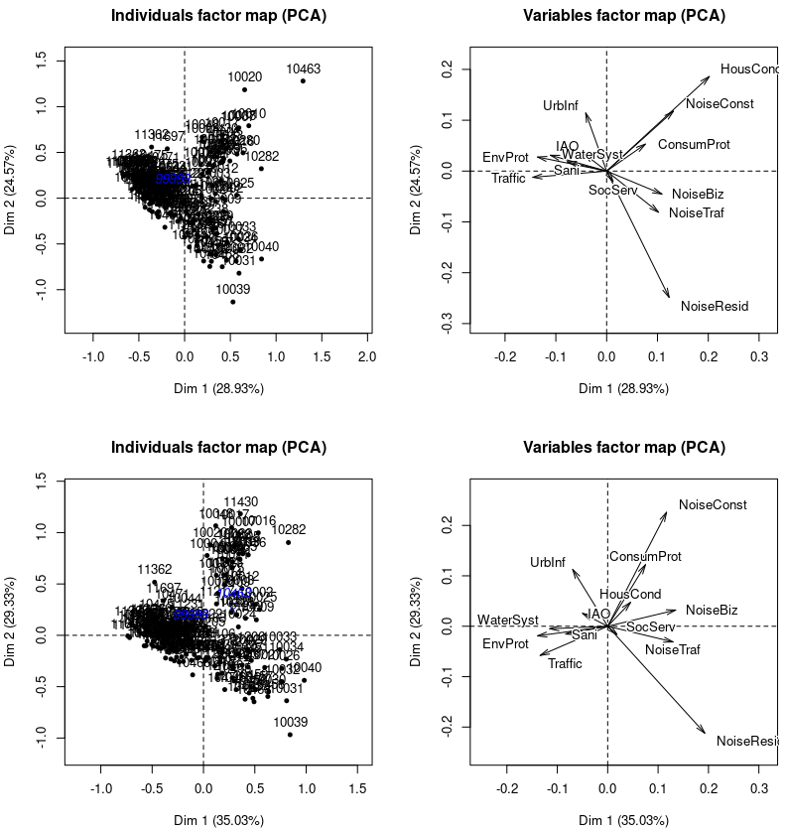
Fig. 5a: Weighted observations’ and variables’ first factorial plane (PC1-2) scatter plots obtained by PCA: (top) including and (bottom) excluding ZIP code “10463”. The effect of the χ² metric is incorporated in the projections. Supplementary bogus ZIP code “99999” and outlier “10463” when not included are represented in blue on the left plots.
Besides a noticeable change in cloud shape, a pronounced change takes place when we consider “10463” as supplementary. It concerns principally the variable HousCond, whose:
▪ quality of representation decreases markedly from (0.32, 0.27, 0.41) to (0.15,0.17, 0.01), and
▪ contributions to the construction of dimensions goes from (25%, 25%, 45%) to (1.3%,1.7%, 0.5%)
for dimensions PC1, PC2, and PC3 respectively. Meanwhile the contributions and quality of representation of the other two main variables NoiseResid and NoiseConst are somewhat redistributed among dimensions or in some cases increased: e.g. for NoiseResid goes from 0.94 to 0.98.
The first factorial plane (PC1-2) registers an increase in inertia explanatory power (from 55% to 64%). Meanwhile PC2-3 and PC1-3 register a decrease from 49.1% to 43.5% and from 44.8 % to 37.8% respectively. We will therefore concentrate on the first factorial plane to analyze variable influence. Confirmation of our preliminary conclusions may be sought in PC1-3 and PC2-3 plots.
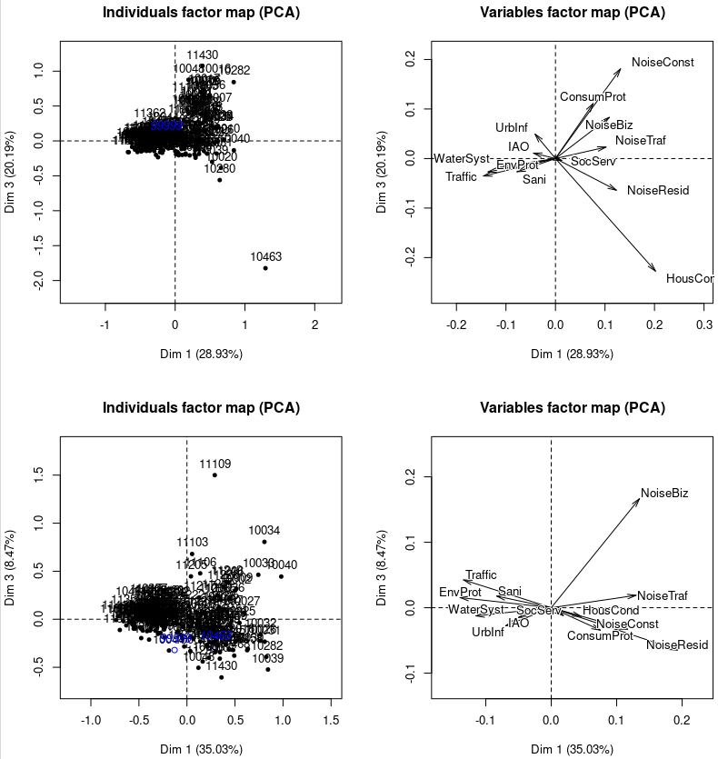Fig. 5b: Weighted observations’ and variables’ second factorial plane (PC1-2) scatter plots obtained by PCA: (top) including and (bottom) excluding ZIP code “10463”. The effect of the χ² metric is incorporated in the projections.
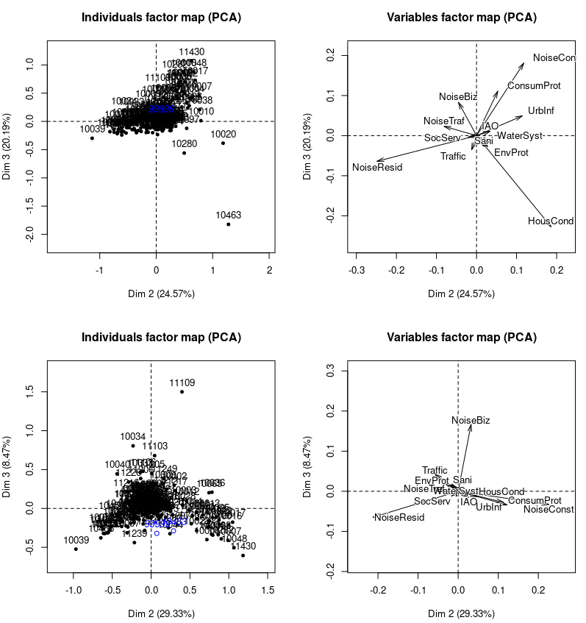Fig. 5c: Weighted observations’ and variables’ third factorial plane (PC2-3) scatter plots obtained by PCA: (top) including and (bottom) excluding ZIP code “10463”. The effect of the χ² metric is incorporated in the projections.

Inertia Explanatory Power (IEP) | all_dim (%) | signif_dim (%)
HousCond | 3.0 | 1.0
Sani | 4.3 | 1.7
NoiseResid | 19.4 | 19.1
NoiseConst | 15.9 | 14.5
NoiseBiz | 10.8 | 10.4
UrbInf | 6.0 | 4.0
Traffic | 9.1 | 5.1
NoiseTraf | 6.5 | 4.0
WaterSyst | 6.4 | 3.0
ConsumProt | 7.3 | 4.8
SocServ | 0.9 | 0.2
IAO | 2.4 | 0.7
EnvProt | 8.1 | 4.4
Table 5: Variables’ inertia explanatory power over all dimension and over only significant dimensions
We further observe on the variable factor maps with “10463” as supplementary that:
▪ NoiseConst and ConsumProt appear to be collinear, however we do not eliminate ConsumProt, as it captures more than 4% of the data’s dynamics.
▪ EnvProt and Sani are collinear and may be merged.
▪ EnvProt and WaterSyst are strongly correlated and may also be merged.
▪ NoiseConst and HousCond being collinear and HousCond being a weak variable with IEP=1% for the retained significant dimensions, justifies doing away with HousCond.
▪ IAO and SocServ seem to play a negligible role and may be dispensed with.
Next we conduct Correspondence Analysis (CA) with row marginals as row profile’s weights, incorporate the χ² metric effect into the row-profile cloud projected on PC1-2, PC1-3 and PC2-3.
In Fig. 6, row (blue) and column (red) profiles are projected together as biplots, after feature selection and extraction, considering ZIP codes “99999” and “10463” as supplementary observations. The scree plot reveals 2 significant dimensions with eigenvalues (in decreasing order of inertia representation): 0.160, 0.139 for a total explained variance of almost 73%.
Distances between same-colored points are distances in the χ² sense to correct for the relative scarcity of factors. A red point (column profile) is a barycenter for the blue points (row profiles) expressing that column modality, weighted by said column, and vice versa. Differently colored points may appear close, but no conclusion can be drawn from it. Close and identically colored points have similar profiles.
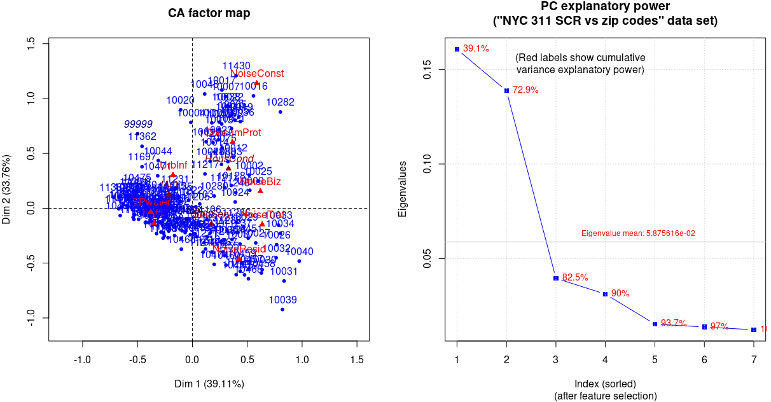
Fig. 6: Scatter and scree plots of row (blue) and column (red) factors in first factorial planes PC1-2, for 2 significant dimensions. The effect of the χ² metric is incorporated in the projections. ZIPs codes 99999 and 10463 are considered supplementary. Feature selection and extraction were performed based on early PCA conclusions.
Figures 7 and 8 exhibit variable and individual projections in PC1-2 after feature selection and extraction.
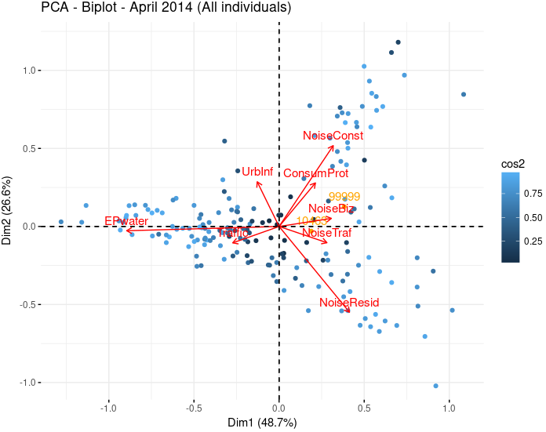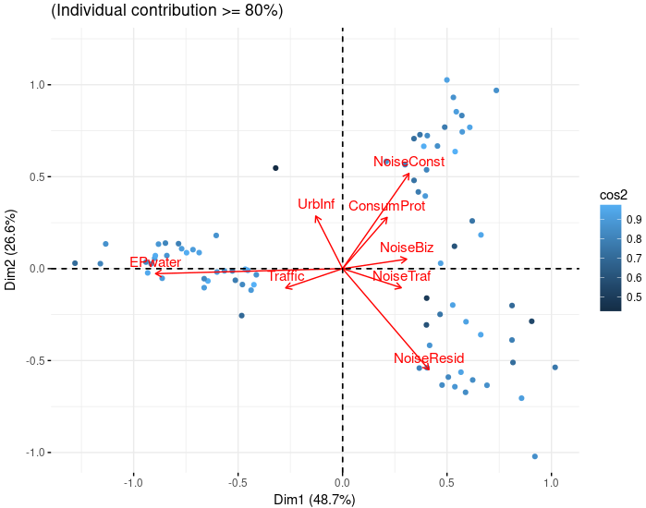
Fig. 7: Biplots in the 1st factorial plane PC1-2 for April 2014. The effect of the χ² metric is incorporated in the projections. ZIPs codes 99999 and 10463 are included (in gold) and both feature selection and extraction were performed based on previous PCA observations. Both figures show color-coded individuals, according to their quality of representation (cos2). The right plot is restricted to individuals whose contributions to the construction of the first 2 dimension is greater than 80%. Arrows represent direction of growth for variables.
Figure 7 clearly shows that HousCond and UrbInf are anticorrelated: areas of high incidence for HousCond exhibit low incidence of UrbInf related calls, as if populations beset by housing woes were less prone than others to complain about their surrounding urban infrastructure. Also worthy of note is the fact that NoiseResid and NoiseConst are not correlated.
By means of the borough-based color visualization of Figure 8, one further notes that:
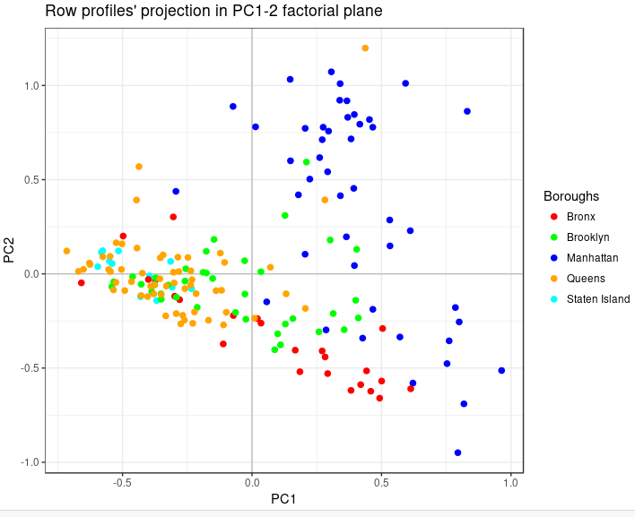Fig. 8: First factorial plane map of individual ZIP codes for the period April 2014, color coded according to the NYC borough to which they belong.
▪ Manhattan’s make-up (green dots) is heterogeneous appears characterized by NoiseConst, ConsumProt, and NoiseResid,
▪ Queens (blue dots) and and Staten Island (mauve dots) ZIP codes are consistent with higher incidences of Epwater related complaints,
▪ the Bronx (orange dots) seems best characterized by NoiseResid, and Epwater related complaints,
▪ Brooklyn’s ZIP codes projections (kaki dots) are relatively difficult to interpret as they seems to simultaneously extend in the directions of the 3 variables: NoiseConst, NoiseResid, and Epwater. Brooklyn’s observations cannot be dismissed as they represent 14,4% of all explained variance and 9.2% of explained variance in the 1st factorial plane.
Inertia Explanatory Power (IEP) | number of ZIP codes | all_dim (%) | signif_dim (%)
Bronx | 24 | 12.7 | 10.3
Brooklyn | 38 | 14.4 | 9.2
Manhattan | 46 | 43.0 | 34.9
Queens | 60 | 20.5 | 12.4
Staten Island | 12 | 8.8 | 7.7
Table 6: Inertia explanatory power by individual ZIP codes grouped by borough, computed over all dimensions (3rd column) and over the significant dimensions (4th column).
Table 6 summarizes SRC individuals’ explanatory power per borough for all dimensions and for only the first factorial plane (i.e. for the 2 significant dimensions).
In the present case, applying the varimax method to find latent concepts in order to interpret results in the two significant directions does not bring further insight as demonstrated by the plot of figure 9. The newly rotated variables’ projections does not improve on the previous representation of figure 7. In particular it does not reveal new easy-to-interpret latent information.
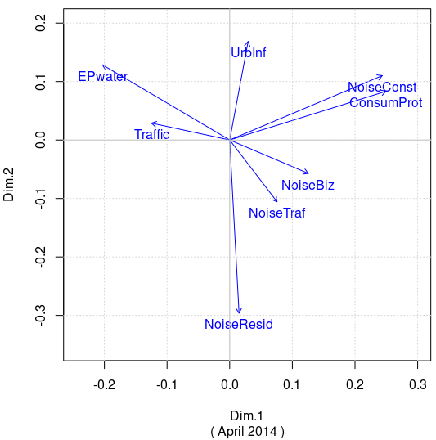
Fig. 9: Maximized significance of projected variables in the rotated first factorial plane PC1-2 (using the varimax method).

We close this initial exploration with a topographical map (figure 10) of individuals (i.e. ZIP codes), color-coded according to the position of their projection in the PC1-2 factorial plane, following figure 7.

▪ The 1st and 4th PC1-2 quadrants (blue and red) coincide with larger numbers of noise related SRCs, geographically related to Manhattan, the Bronx, north and central Brooklyn.
▪ The 2nd and 3rd quadrants (green and tan) are more related to environmental and water management SRCs, geographically related to Staten Island, Queens and the rest of Brooklyn.
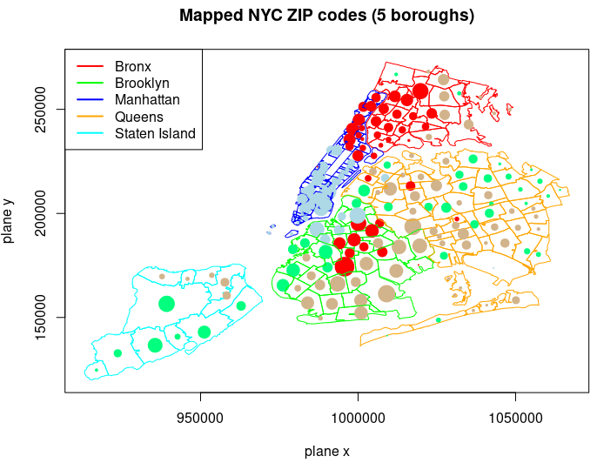

Figure 10: Topographical representation of ZIP codes’ projection quadrant in the first factorial plane for the period April 2014.

Dot sizes are proportional to the number of SRCs in a given ZIP code area

Dot colors represent the row profiles’projections in the PC1-2 quadrants:
1st quadrant (blue),
2nd quadrant (green),
3rd quadrant (tan),
4th quadrant(red).

3-2. Multiple Correspondence Analysis (MCA)
To supplement our previous CA on SRCs per location, we now add NYPD crime data in the form of 3 modalities in increasing degree of gravity: violations (4,699 counts), misdemeanors (21,734 counts) and felonies (11,156 counts). Those events were recorded during the sole month of April 2014 and were distributed over 181 zip codes and 5 boroughs. In order to conduct MCA we discretized our multivariate contingency table so that every modality (column) is now expressed in the form of ordinal values related to 4 buckets (bins) of similar sizes.
Discretization makes losing some information unavoidable. However it also allows us to extract 2 way contingency tables involving crime modalities and NYC boroughs. How we went from frequencies (counts) to ordinal variables is shown next for the sample consisting of NYPD’s records of 21,734 misdemeanors in April 2014. The sample quantiles corresponding to the distribution of counts per ZIP code was:
Min. 1st Qu. Median Mean 3rd Qu. Max
0.0 32.0 87.0 120.1 179.0 705.0
Based on quantiles, the chosen bucket intervals were: < 33 – 87 – 178 – >178. Corresponding ordinal variable values are summarized in tabular form below. They may differ for non crime related variables (RSCs) where ordinal values may refer to a different count scale. This however is not detrimental.
Count interval upper bound | 2~3 | 6~16 | 20~33 | ~38 | 85~91 | 150~180 | > 180
Ordinal variable value | VL | ML | M | MH | H | VH | OC
 | Very low | Medium low | Medium | Medium high | High | Very high | “Out of Control”
The normalized crime segmentation per borough, for each crime modality is shown next, in Figure 8.
For each crime modality, Fig. 8 is interpreted in terms of the relative proportions of ZIP code areas in each borough belonging to a low, medium, high or very high crime count bucket. For instance, for the 4860 misdemeanors committed in Manhattan ZIP code areas inApril 2104:
- 30% of ZIP code exhibited a medium (M – cyan) crime count, (14/46)
- 21% of ZIP codes exhibited a high (H – orange) crime count, (10/46)
- 26% of ZIP codes exhibited a very high (VH – red) crime count, (12/46)
- 21% belong to the bucket of extremely large crime counts, dubbed “out of control” (OC – dark red), (10/46)
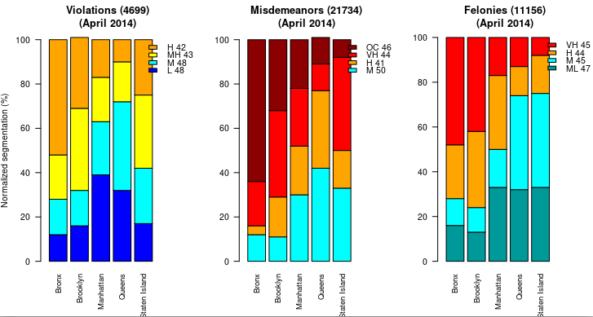Fig. 8: Borough crime index shown as normalized (to 100) segmentation for each crime modality as a function of borough. Legends show color-coded ordinal values followed by the bucket size across boroughs.
Figure 8 does not inform us on the number of crime committed in each borough, but rather on the distribution of hot “crime spots” within each borough. The Bronx clearly shows a tendency to concentrate high crime areas, across all three modalities, when compared to other boroughs. It is followed in that by Brooklyn, Manhattan, Queens and Staten Island, in the cases of misdemeanors and felonies.
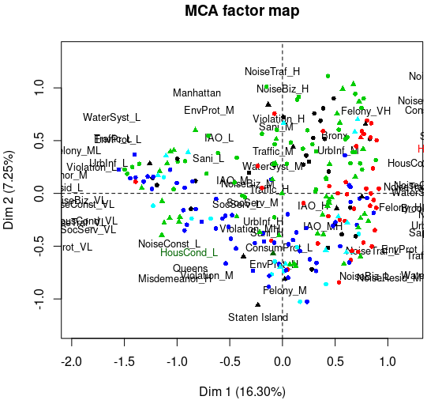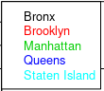Fig. 9: Variable factor plot in the first factorial plane.
We conducted MCA on the indicator matrix, specifying column Borough as qualitative supplementary, and columns medianInc (median income) and jlBenef (jobless benefit) as quantitative supplementary variables. Figure 9 represents the plot of variable factors in the first factorial plane, color coded by borough. In this factorial plane PC1-2 as in others (PC1-3 and PC2-3) we did not detect structure by mere visual inspection. The factors of the supplementary variable Borough are shown as black triangles. Plotting the supplementary quantitative variable (Fig. 10), we note a slight anticorrelation between medianInc and jlBenef. in PC1-2, although medianInc is not well represented in PC1-2. Next to this we also note that jlBenef seems to be correlated with Dim1 (PC1) at a 0.77 level.
The v.test relative to the significance of a modality value in a given PC’s direction brings a mixed picture of significant values with |v.test| >2 along certain dimensions and |v.test| < 2 along others. We recall that for that test, the Null Hypothesis,H0, specifies that the mean of all projections along a given direction of individuals expressing that modality is 0 (individuals who express that modality are chosen at random). The test measures how much the modality’s mean along a specific direction differs from the same modality mean overall, in units of std-dev.
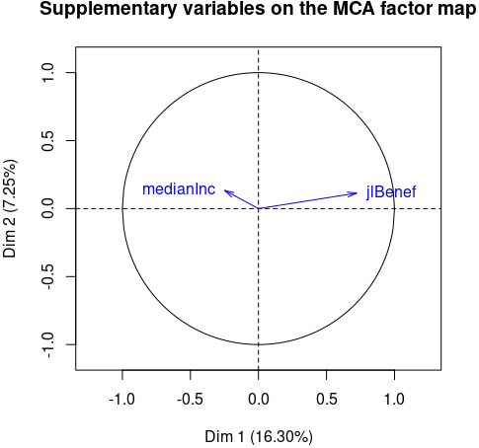Fig. 10: Plot of supplementary quantitative variable medianInc and jlBenef in PC1-2.
Despite the realtive diffculty encountered so far in this exploration, we can list which 3 variables most closely identify with each dimension according to their η² value:
Dim1: NoiseResid, Felony, Misdemeanor and Sani
Dim2: NoiseTraf, NoiseResid, Noise Biz
Dim3: Violation, Felony, NoiseCOnst, Sani
In the present case the difficulty in interpreting the significance of v.test values may be due to the nature of the data itself, and/or to the technique used to explore its structure.
Finally, we close the MCA discussion with two graph, partially redundant with already presented elements. As in Figure 9, figure 11 represents variable factors in the first factorial plane, color coded by borough. This time however we add concentration ellipses to illustrate the fact that a straightforward borough based clustering does not adequately represent data structure. Fig 12 illustrate how variable factor with small weights are farther away from the origin of the factorial plane and therefore exhibit higher values of cos2.
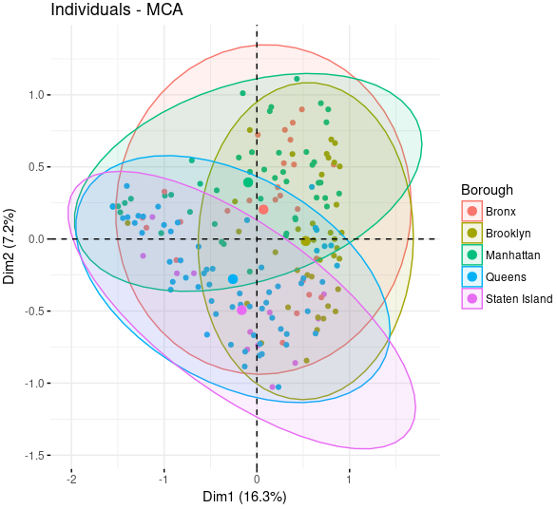Fig. 11: Variable factors in PC1-2, color coded by borough.
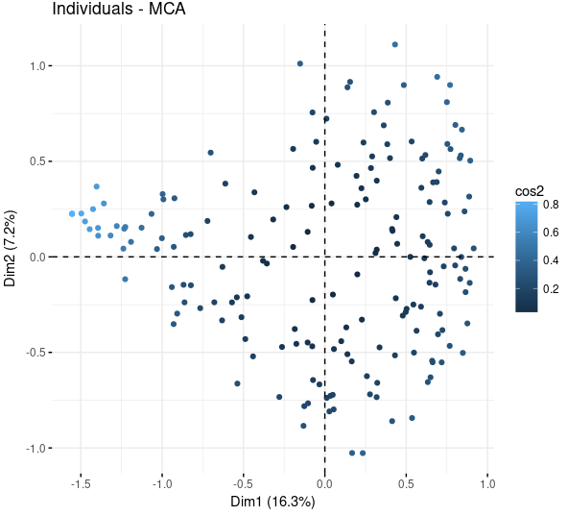Fig. 12: Variable factors in PC1-2, color coded by cos2.

3-3. Hierarchical clustering
First we carried out probabilistic clustering with k-means replications. Next we deployed a hierarchical clustering, and finally, we computed a clustering consolidation using k-means.
As pointed out before, we first deploy a probabilistic clustering analysis using 10 k-means replications and the number of clusters analyzed are in the range of [2,10].
As we show in the Figure 13, for each experiment, we calculate two criteria to zero down on the optimal number of clusters:
- within-cluster inertia’s sum of squares over total inertia’s sum of squares, referred to as the “normalized within-cluster SS criterion”
- Calinsky – Harabasz index
We can observe that the resulting graph in the Figure 13 suggests that the optimal cluster number (signaled by a vertical grey line) is 3.
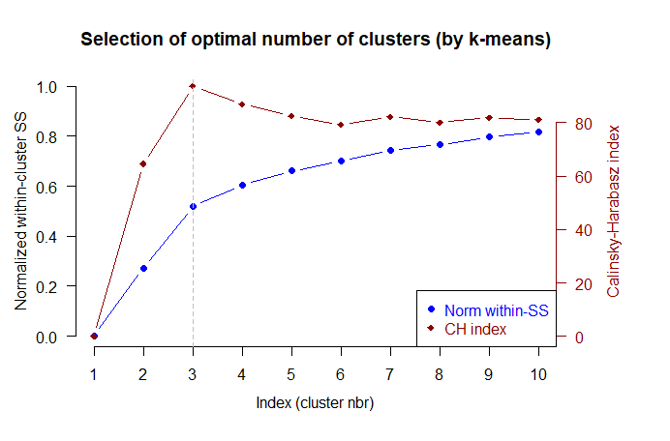
Figure 13. Selection of optimal number of clusters

Afterwards, we compute the hierarchical clustering. Then, as mentioned at the beginning of this section we conclude with a k-means consolidation.
Input for the clustering algorithm is the Euclidian distance matrix based on ψ (projections of obervations on the principal directions).
We relied on the ward.D2 distance measure. It takes into account the inertia associated with each cluster's centroid, i.e. each cluster’s centroid is weighted by the same-cluster observations surrounding it.

We observe, from the hierarchical clustering diagram (Figure 14) and from the dendrogram (Figure 15) as well that the number of clusters could be 3, with centroids G1 and G2 shown in Table 7:

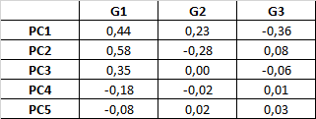
Table 7. Centroids of the clusters
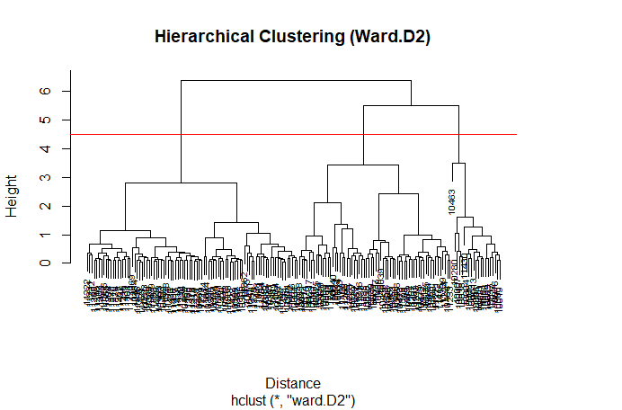
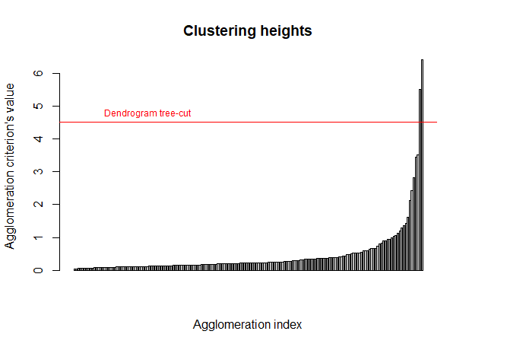
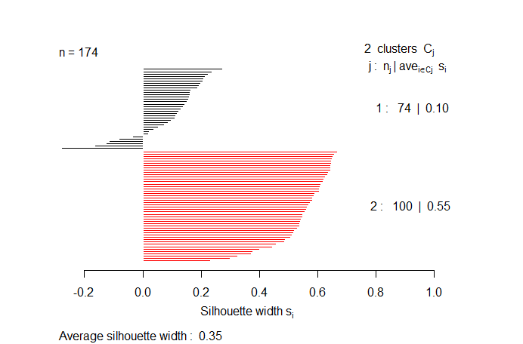
Figure 14. Hierarchical clustering diagram with Ward.D2 distance measure.
Figure 15. Dendogram - Clustering heights.
Figure 16. Silhouette for 2 clusters.
After clustering, we applied the silhouette method for 2, 3 and 4 clusters. The obtained result seems to confrm that, 3 clusters would be the optimal solution. For 2 clusters case, we can observe a significant unbalance in the S-width, besides thare are also some negative values what could yield to erroneous categorizations in certain cases.
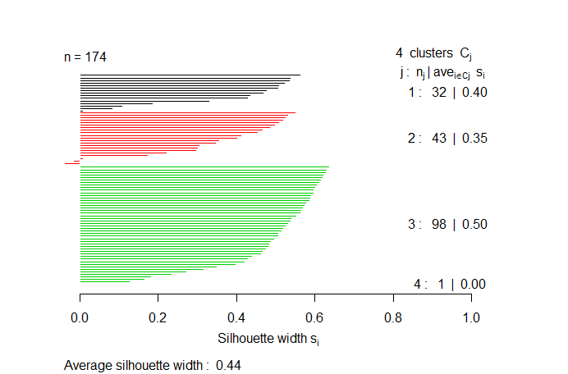
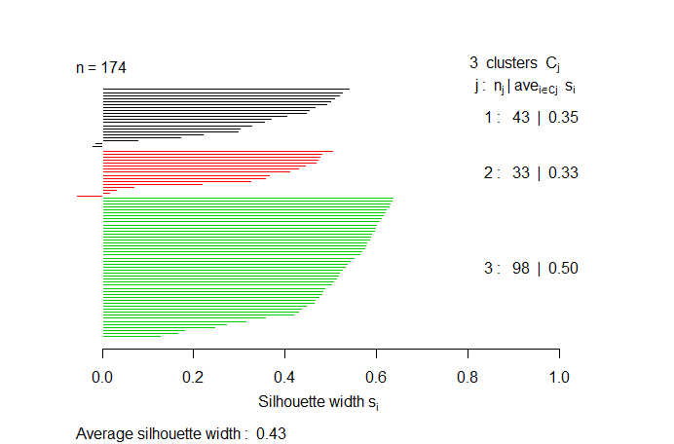
As mentioned, for 3 clusters case, the 3 groups present quite well balanced S-width and almost any negative value. For 4 clusters, it is obvious that does not have any sense since one cluster is formed by a lonely observation (in our case zip code).
Figure 17. Silhouette for 3 clusters.
Figure 18. Silhouette for 4 clusters.
We visualize this first partition result (in 3 clusters) in the first factorial plane in the Figure 19.
The consolidation result is represented in the Figure 20, based on the k-means method, with the 3 centroids.

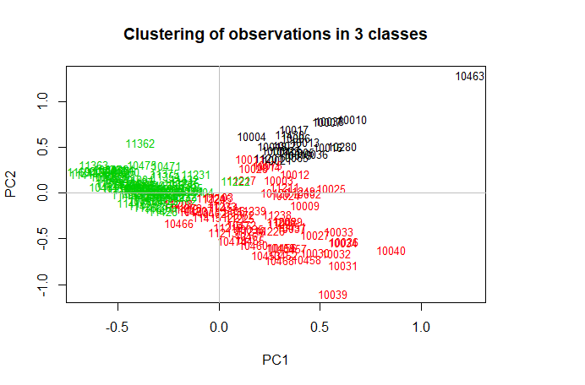
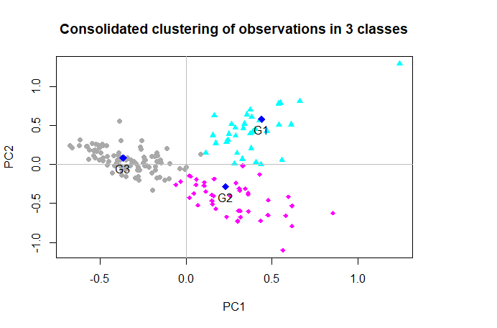
Figure 19. Clustering of observations in 3 clusters.
Figure 20. Consolidated clustering of observations in 3 clusters.

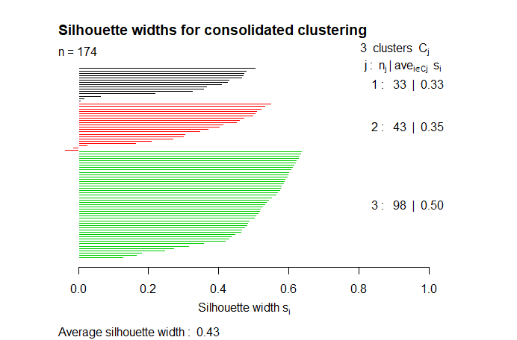
Figure 21. Silhouette for 3 clusters after consolidatoin.
In the Figure 21, we show the silhouette for 3 clusters after consolidation. It is easy to observe that there is not signifcant diferency from the previous one.

Categorical description to interpret the clusters:

We perform a categorical description based on previous cluster information (categorization for the observations).
We also present in Table 8 the test statistics for each category and for each variable’s significance.
V.test is the number of std-dev below or above the overall mean values for the sample data. Values of v.test <0 mean that the category mean is smaller than the overall average and vice versa.
The null hypothesis, for continuous variables, is that the variable’s mean in the given group is equal to the variable’s global data mean.

We reject the null hypothesis at the risk 0.05 of being wrong when the p-values <0.05. Therefore, in the mentioned tables, we just show variables for which we reject H0, i.e. for which the categorization is meaningful.
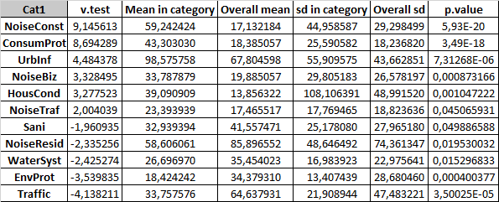
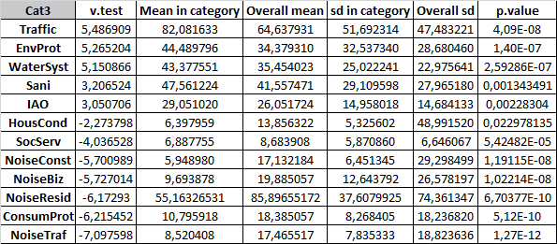
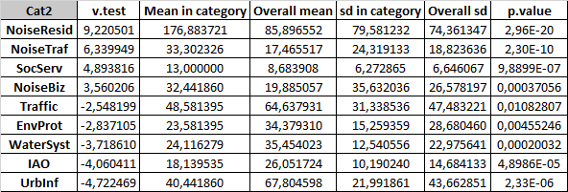
Table 8. Most significant variables in each categories for Cat1, Cat2 and Cat3
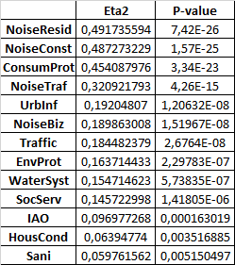
Table 9 is the summary of the square correlation coefcient (Eta2) and p-values of the F-test in a one-way ANOVA (assuming homoscedasticity) for signifcant continuous variable globally, i.e. for variables, whose corresponding p-value is smaller than 0.05.
Table 9. Summary of significant variables’ correlation and p-values globally

3-4. Decision trees

In this section we subject our dataset to a decision tree classification algorithm.

We built 2 possible decision trees, each related to a separate decision variable in our data set: medianInc, and jlBenef.
It is important to mention that we will just carry out the complete analysis focusing on the variable “medianInc”. The variable “jlBenef” have been exploit with a non-reliable data which in our case means that the data used to create the variable is quite biased.

Before building the trees we split the dataset in training (80% of individuals) and test (20% of individuals).
In the Figures 22 and 23 we present the aforementioned decision trees. We used 10 Cross-
Validation (CV) replicas, and a complexity parameter of 10^-3 as parameters for building the trees.
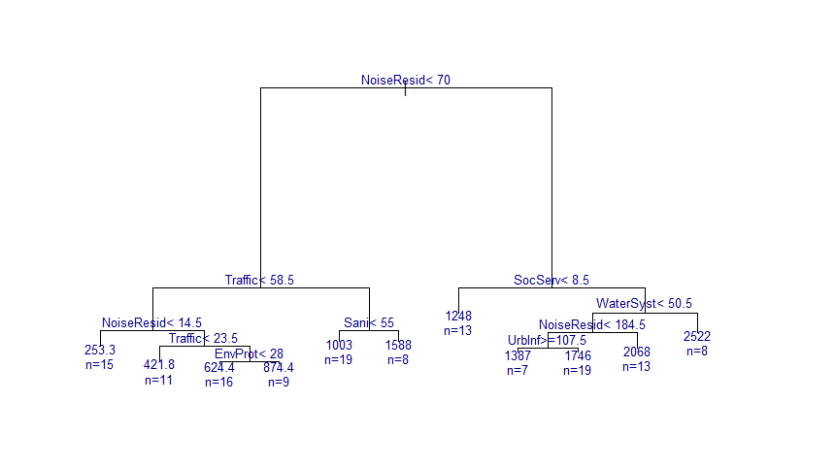
Figure 22. Fully grown decision tree for training data-set and “jlBenef” as decision variable.
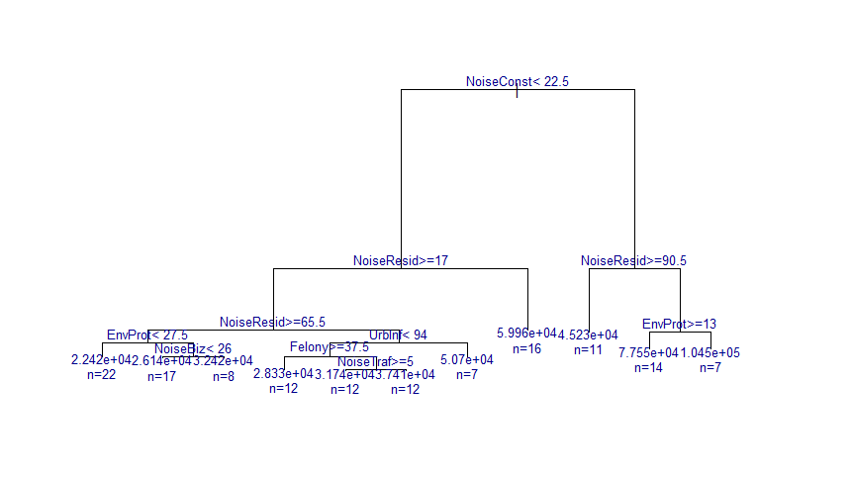
Figure 21. Fully grown decision tree for training data-set and “medianInc” as decision variable.

In Figure 23 we present the Cross-Validation normalized mean error and the whole data set based training error as a function of tree size. In this graph we include a red horizontal dashed line which represents the minimum tree impurity (MTI) level, and the red dotted line above it MTI + 1. A black arrow points to the optimum number of nodes for post-pruning.

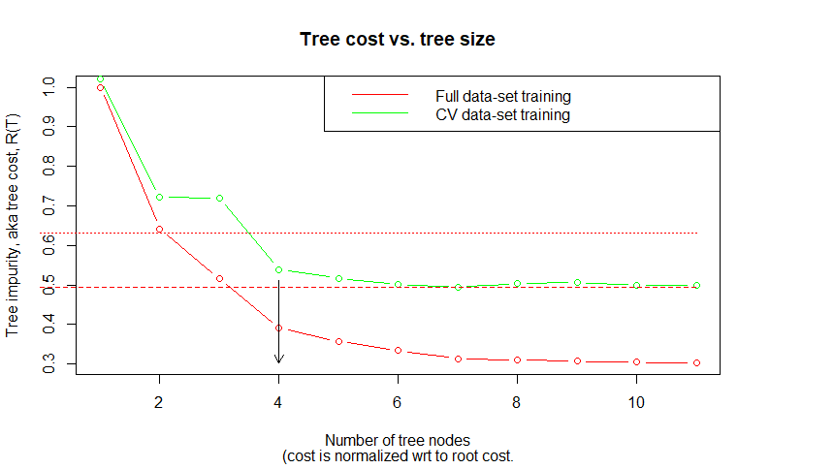
Figure 23. Data-sets’ training error with and without cross validation.
The optimum value of the complexity parameter, α, corresponds to the first value of CV tree cost smaller than MTI + 1 standard error, when scanning normalized mean values of tree impurity starting at root: αopt = 0.03489.
Up to this point, we are able to post-prune the decision tree by using the obtained optimum complexity parameter. The result tree obtained is shown in Figure 24 along with corresponding split rules.

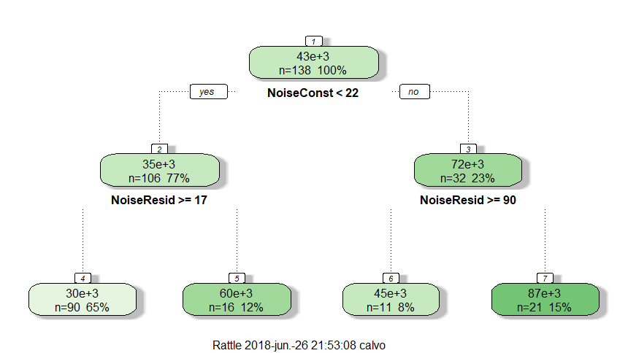
Figure 24. Optimally pruned decision tree, with α = 0.03489.

We, therefore, obtain an optimal tree of size 4 with 3 splits.
Rule number: 4 [medianInc=30240.9222222222 cover=90 (65%)]
NoiseConst< 22.5
NoiseResid>=17

Rule number: 7 [medianInc=86539.2380952381 cover=21 (15%)]
NoiseConst>=22.5
NoiseResid< 90.5

Rule number: 5 [medianInc=59963.4375 cover=16 (12%)]
NoiseConst< 22.5
NoiseResid< 17

Rule number: 6 [medianInc=45225.8181818182 cover=11 (8%)]
NoiseConst>=22.5
NoiseResid>=90.5

Observing the decision rules we can appreciate something quite important and interesting: It seems that the variables with most impact in the data set are those regarding with the noise.
This interesting characteristic can be confirm by calculating the importance of the varibles. The Figure 25 shows the mentioned importance of variables and there we can observe that, effectively, the most influencial variables of the data set are those related with the noise in the city.

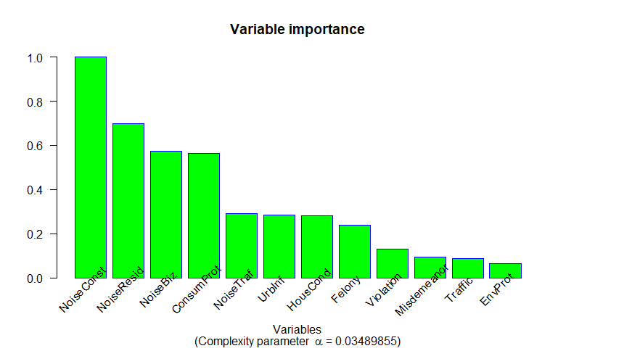
The last step should be to use the test data set in order to predict the medianInc values for the corresponding zip codes. Note that since our decision variable is not categorical and, obviously, the predicted values for each observation are just 4 (same than the size of the optimal decision tree) we can not compute a confusion matrix. On the other hand what we can do is compute a result-table to see the predictions made by our tree for each “medianInc” in the tes data set.
Figure 25. Normalized importance of the variables for an optimally pruned decision tree (α = 0. 03489).
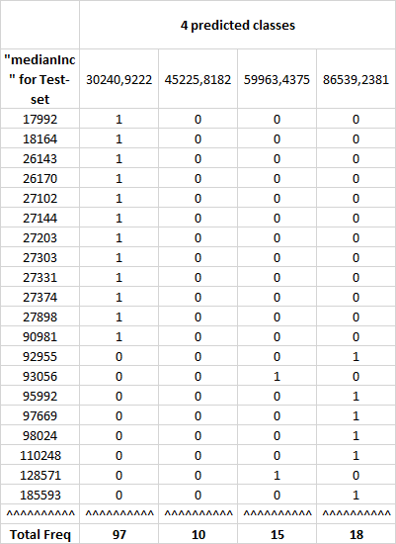
Table 10 shows an slice of the aforementioned results-table (the whole table is too big to be shown in this report, its length is equal to the size of the test data set).
Table 10. Slice of the original results-table which contains the predictions for each value of “medianInc” in the test data set.
Predicted values are consistent with our expectation: the first 12 medianInc values are predicted as the first category “30240”, which in fact is the one which contains them all.
We can, as well, observe in this table, that the majority of the zip codes would have a medianInc predicted value of “30240”, which is our first category in the optimal decision tree.

4. Conclusions
The composite data set used in this work is formed by data originating from different digital sources. Data preprocessing and generally speaking ETL at data mining statge occupied about 80% of our time and required more than 3400 lines of R code. We finally produced a fully automated ETL pipeline capable to process complex, composite data unattended. The corresponding code as well as this report and original data are all freely available at https://www.github.com/Cbhihe/nyc311.
Data mining revealed that data is all too often incomplete, sometimes wrong, or statistically unreliable as was the case for the continuous variable jlBenef (source: IRS) which proved patchy at best.
In the first half of our data exploration, we showed how we gain limited information from classical approaches such as CA / PCA and MCA. Data structure or semantics was not readily observable based on the determination of directions of maximum variance. We learnt from that effort that low frequency cells do have a dramatic impact, in particular on CA and MCA results. This led us to gradually purge our dataset from such spurious effects.
In the second half or the study, we deployed generic tools of clustering (unsupervised statistical learning) and classification based on decision trees (supervised learning). Our approach was based on the exact same data set as before: April 2014. We revealed a optimal number of 3 clusters after consolidation. It also revealed that observation (ZIP code) “10463” is a meaningful observation (or “row-profile”) and at the same time a true outlier, presumably with considerable influence on our analytical results. The fact that we came to that conclusion at the end of our survey prevented us from running our simulations and test on the data set purged from “10463”. Considering “10463” as a supplementary observation and repeating our analysis would be the first step in a further effort to analyze our data sets.
Classification led us to a number of conclusions:
- an optimally pruned decision tree with four classes or nodes (Fig. 24) demonstrate the importance of noise related variables in decisive splits. This is fully consistent with urban life as it is experienced by New Yorkers (practically without distinction).
- a unbalanced distribution of individuals in leaves, shows that most of them are assigned to the lowest value of predicted income: USD 30,240. This in itself may indicate the fact that we have not yet captured or understood the hidden structure of the data set. This in turn may be due to an inappropriate or incomplete set of available explanatory variables.
- a predictive classification or a regression on a continuous variable such as medianInc would be usefully supplemented by a measure of quality, based not on a traditional confusion table, but on a multi-target (or -output) regression method such as support-vector-machine (SVM) based regression.
As they stand, results presented in this document would benefit from a comparison with results obtained with the more diversified toolkit of Machine Learning. Random Forest would be a prime candidate to extend this work.

APPENDICES
---

Appendix A: Data-set’s variables’ dictionaries

NYC 311 Service Request Calls – Raw Data Dictionary
Column Name | Description
Unique Key | Unique identifier of a Service Request (SR) in the open data set
Created Date | Date SR was created  Date in format MM/DD/YY HH:MM:SS AM/PM
Closed Date | Date SR was closed by responding agency.  Date in format MM/DD/YY HH:MM:SS AM/PM
Agency | Acronym of responding City Government Agency
Agency Name | Full Agency name of responding City Government Agency
Complaint Type | This is the fist level of a hierarchy identifying the topic of the incident or condition. Complaint Type may have a corresponding Descriptor (below) or may stand alone.
Descriptor | This is associated to the Complaint Type, and provides further detail on the incident or condition. Descriptor values are dependent on the Complaint Type, and are not always required in SR.
Status | Status of SR submitted: Assigned, Canceled, Closed, Pending, +… (Prior column indicates most frequent)
Due Date | Date when responding agency is expected to update the SR. This is based on the Complaint Type and internal SLAs. Date in format MM/DD/YY HH:MM:SS AM/PM
Resolution Action Updated Date | Date when responding agency last updated the SR.  Date in format MM/DD/YY HH:MM:SS AM/PM
Resolution Description | Describes the last action taken on the SR by the responding agency. May describe next or future steps.
Location Type | Describes the type of location used in the address information
Incident Zip | Incident location zip code, provided by geo validation.
Incident Address | House number of incident address provided by submitter.
Street Name | Street name of incident address provided by the submitter
Cross Street 1 | First Cross street based on the geo validated incident location
Cross Street 2 | Second Cross Street based on the geo validated incident location
Intersection Street 1 | First intersecting street based on geo validated incident location
Intersection Street 2 | Second intersecting street based on geo validated incident location
Address Type | Type of incident location information available (Values: Address; Block face; Intersection; LatLong; Placename)
City | City of the incident location provided by geovalidation.
Landmark | If the incident location is identified as a Landmark the name of the landmark will display here
Facility Type | If available, this field describes the type of city facility associated to the SR
Community Board | Provided by geovalidation.
Borough | Provided by the submitter and confirmed by geovalidation.
X Coordinate (State Plane) | Geo validated, X coordinate of the incident location.
Y Coordinate (State Plane) | Geo validated, Y coordinate of the incident location.
Latitude | Geo based Lat of the incident location
Longitude | Geo based Long of the incident location
Location | Combination of the geo based lat & long of the incident location
Park Facility Name | If the incident location is a Parks Dept facility, the Name of the facility will appear here
Park Borough | The borough of incident if it is a Parks Dept facility
School Name | If the incident location is a Dept of Education school, the name of the school will appear in this field. If the incident is a Parks Dept facility its name will appear here.
School Number | If the incident location is a Dept of Education school, the Number of the school will appear in this field. This field is also used for Parks Dept Facilities.
School Region | If the incident location is a Dept of Education School, the school region number will be appear in this field.
School Code | If the incident location is a Dept of Education School, the school code number will be appear in this field.
School Phone Number | If the facility = Dept for the Aging or Parks Dept, the phone number will appear here. (note - Dept of Education facilities do not display phone number)
School Address | Address of facility of incident location, if the facility is associated with Dept of Education, Dept for the Aging or Parks Dept
School City | City of facilities incident location, if the facility is associated with Dept of Education, Dept for the Aging or Parks Dept
School State | State of facility incident location, if the facility is associated with Dept of Education, Dept for the Aging or Parks Dept NY
School Zip | Zip of facility incident location, if the facility is associated with Dept of Education, Dept for the Aging or Parks Dept
School Not Found | Y' in this field indicates the facility was not found (Y; N; BLANK)
School or Citywide Complaint | If the incident is about a Dept of Education facility, this field will indicate if the complaint is about a particualr school or a citywide issue. (Y; N; BLANK)
Vehicle Type | If the incident is a taxi, this field describes the type of TLC vehicle.
Taxi Company Borough | If the incident is identified as a taxi, this field will display the borough of the taxi company.
Taxi Pick Up Location | If the incident is identified as a taxi, this field displays the taxi pick up location
Bridge Highway Name | If the incident is identified as a Bridge/Highway, the name will be displayed here.
Bridge Highway Direction | If the incident is identified as a Bridge/Highway, the direction where the issue took place would be displayed here.
Road Ramp | If the incident location was Bridge/Highway this column differentiates if the issue was on the Road or the Ramp.
Bridge Highway Segment | Additional information on the section of the Bridge/Highway were the incident took place.
Garage Lot Name | Related to DOT Parking Meter SR, this field shows what garage lot the meter is located in
Ferry Direction | Used when the incident location is within a Ferry, this field indicates the direction of ferry
Ferry Terminal Name | Used when the incident location is Ferry, this field indicates the ferry terminal where the incident took place.

NYPD Crime Reports – Raw Data Dictionary
CMPLNT_NUM | Randomly generated persistent ID for each complaint
CMPLNT_FR_DT | Exact date of occurrence for the reported event (or starting date of occurrence if CMPLNT_TO_DT exists)
CMPLNT_FR_TM | Exact time of occurrence for the reported event (or starting time of occurrence if CMPLNT_TO_TM exists)
CMPLNT_TO_DT | Ending date of occurrence for the reported event if exact time of occurrence is unknown
CMPLNT_TO_TM | Ending time of occurrence for the reported event if exact time of occurrence is unknown
RPT_DT | Date event was reported to police
KY_CD | Three digit offense classification code
OFNS_DESC | Description of offense corresponding with key code (KY_CD)
PD_CD | Three digit internal classification code (more granular than Key Code)
PD_DESC | Description of internal classification corresponding with PD code; more granular than Offense Description (OFNS_DESC).
CRM_ATPT_CPTD_CD | Crime completion indicator (completed, attempted but failed, interrupted prematurely)
LAW_CAT_CD | Level of offense (felony, misdemeanor, violation)
JURIS_DESC | Jurisdiction responsible for incident. Either internal (Police, Transit, Housing) or external (Correction, Port Authority, etc."
BORO_NM | The name of the borough in which the incident occurred
ADDR_PCT_CD | The precinct in which the incident occurred
LOC_OF_OCCUR_DESC | "Specific location of occurrence in or around the premises (inside, opposite of, in front of, at the rear of)
PREM_TYP_DESC | Specific description of premises (grocery store, residence, street, etc.)
PARKS_NM | Name of NYC park, playground or greenspace of occurrence if applicable (state parks are not included)
HADEVELOPT | Name of NYCHA housing development of occurrence if applicable
X_COORD_CD | X-coordinate for New York State Plane Coordinate System, Long Island Zone (NAD 83) in units of feet (FIPS 3104)
Y_COORD_CD | "Y-coordinate for New York State Plane Coordinate System, Long Island Zone (NAD 83) in units of feet (FIPS 3104)
Latitude | "Latitude coordinate for Global Coordinate System, WGS 1984, decimal degrees (EPSG 4326) "
Longitude | "Longitude coordinate for Global Coordinate System, WGS 1984, decimal degrees (EPSG 4326)

IRS Statistics of Income per ZIP code– Raw Data Dictionary
IRS Documentation Guide (year 2014)
Contents
A. Overview
B. Nature of Changes
C. Population Definitions and Tax Return Addresses
D. Disclosure Protection Procedures
E. File Characteristics
F. Selected Income and Tax Items
G. Endnotes

A. Overview
The Statistics of Income (SOI) division bases its ZIP code data on administrative records of individual income tax returns (Forms 1040) from the Internal Revenue Service (IRS) Individual Master File (IMF) system. Included in these data are returns filed during the 12-month period, January 1, 2015 to December 31, 2015. While the bulk of returns filed during the 12-month period are primarily for Tax Year 2014, the IRS received a limited number of returns for tax years before 2014 and these have been included within the ZIP code data.

B. Nature of Changes
The following changes have been made to the Tax Year 2014 ZIP Code data:
• Two new variables have been added for volunteer prepared returns: volunteered income tax assistance (VITA) and tax counseling for the elderly (TCE) prepared returns.
• Five new variables, related to the Affordable Care Act (ACA), have been added to the data: Excess advance premium tax credit repayment, Total premium tax credit, Advance premium tax credit, Health care individual responsibility payment, and Net premium tax credit. Please refer to section F for a complete list of variables and their corresponding names.

C. Population Definitions and Tax Return Addresses
• ZIP Code data are based on population data that was filed and processed by the IRS during the 2015 calendar year.
• State totals may not be comparable to State totals published elsewhere by SOI because of specific disclosure protection features in the ZIP code data.
• Data do not represent the full U.S. population because many individuals are not required to file an individual income tax return.
• The address shown on the tax return may differ from the taxpayer’s actual residence.
• State codes were based on the ZIP code shown on the return.
• Excluded were tax returns filed without a ZIP code and returns filed with a ZIP code that did not match the State code shown on the return.
• Excluded were tax returns filed using Army Post Office (APO) and Fleet Post Office addresses, foreign addresses, and addresses in Puerto Rico, Guam, Virgin Islands, American Samoa, Marshall Islands, Northern Marianas, and Palau.

D. Disclosure Protection Procedures
SOI did not attempt to correct any ZIP codes on the returns; however, it did take the following precautions to avoid disclosing information about specific taxpayers:
• ZIP codes with less than 100 returns and those identified as a single building or nonresidential ZIP code were categorized as “other” (99999).
• Income and tax items with less than 20 returns for a particular AGI class were combined with another AGI class within the same ZIP Code. Collapsed AGI classes are identified with a double asterisk (**).
• All number of returns variables have been rounded to the nearest 10.
• Excluded from the data are items with less than 20 returns within a ZIP code.
• Excluded from the data are tax returns with a negative adjusted gross income.
• Excluded are tax returns representing a specified percentage of the total of any particular cell. For example, if one return represented 75 percent of the value of a given cell, the return was suppressed from the tabulation. The actual threshold percentage used cannot be released.

E. File Characteristics
The ZIP code data are available in three formats:
(1) Individual state excel files—14zp##xx.xls (## = 01-51; xx = AL-WY)
(2) A comma separated file (.csv) with AGI classes —14zpallagi.csv
(3) A comma separated filewithout AGI classes(The AGI_STUB variable has been set to zero for this file)—14zpallnoagi.csv
For all the files, the money amounts are reported in thousands of dollars.

F. Selected Income and Tax Items
STATEFIPS | The State Federal Information Processing System (FIPS) code
STATE | The State associated with the ZIP code
ZIPCODE | 5-digit Zip code
AGI_STUB | Size of Adjusted Gross Income (AGI)  1 = $1 under $25,000  2 = $25,000 under $50,000  3 = $50,000 under $75,000  4 = $75,000 under $100,000  5 = $100,000 under $200,000  6 = $200,000 or more
N1 | Number of returns
… | …

G. Endnotes:
For complete individual income tax tabulations at the State level, see the historic table posted to Tax Stats at http://www.irs.gov/uac/SOI-Tax-Stats---Historic-Table-2.
Does not include returns with adjusted gross deficit.
The "Number of volunteer prepared returns" shows counts of returns prepared by IRS-certified volunteers to taxpayers with limited income, persons with disabilities, limited English speaking taxpayers, current and former members of the military, and taxpayers who are 60 years of age and older.
“Qualified dividends” are ordinary dividends received in tax years beginning after 2002 that meet certain conditions and receive preferential tax rates. The maximum qualified dividends tax rate is 15%.
Includes the Alaskan permanent fund, reported by residents of Alaska on Forms 1040A and 1040EZ's.
This fund only applies to statistics in the totals, and the state of Alaska.
Earned income credit includes both the refundable and non-refundable portions. The non-refundable portion could reduce income tax and certain related taxes to zero. The earned income credit amounts in excess of total tax liability, or amounts when there was no tax liability at all, were refundable. See footnote 6 below for explanation of the refundable portion of the earned income credit.
The refundable portion of the earned income credit equals total income tax minus the earned income credit. If the result is negative, this amount is considered the refundable portion. No other refundable credits were taken into account for this calculation.
Income tax reflects the amount reported on Form 1040 line 56. It also includes data from Form 1040A and 1040EZ filers.
“Total tax liability” differs from “Income tax”, in that “Total tax liability” includes the taxes from recapture of certain prior-year credits, tax applicable to individual retirement arrangements (IRA's), social security taxes on self-employment income and on certain tip income, advanced earned income payments, household employment taxes, and certain other taxes listed in the Form 1040 instructions.
[10] Reflects payments to or with-holdings made to "Total tax liability". This is the amount the tax filer owes when the income tax return is filed.
[11] The amount of over-payments the tax filer requested to have refunded.

Appendix B: NYPD crime categorization
Crime modalities are: felony, misdemeanor, and violation.
FELONY is the most serious of offenses and gives rise to a more thorough classification. Felonies are lettered, with Class A being the most serious and Class E being the least serious. They are also divided into a smaller sub category; violent and non violent. In the state of NY, a non-violent, Class D felony would call for 1 to 4 years of probation. However, a violent Class D felony would automatically require a prison sentence of at least 2 years. What characterizes each felony as violent or non-violent is usually the presence of a weapon (possession of a firearm) or bodily harm to another person (aggravated assault/battery). A Class A Felony (e.g a 1st degree murder) is punishable by life in prison, with or without parole, depending on the circumstances.
MISDEMEANOR is the second type of criminal offenses, less severe than felonies but more serious than violations. Misdemeanors can carry up to a year in jail. In addition to jail time, a person convicted of a misdemeanor can also be subject to fines, probation, community service or restitution (victim compensation). A classic case of a misdemeanor would be simple assault, possession of a small amount of marijuana, or driving under the influence.
VIOLATION (also known as “infractions”) is a minor offense. A speeding ticket, public intoxication, or jaywalking are some of the many petty offenses that could fall under the umbrella of violations. Violations are punishable by fines primarily, and do not result in jail or prison time.
In the subsequent listings, a number following a label within each category indicates the degree of the charge within that category, i.e. sub-categorization for judicial purposes.

Felonies
RAPE 1 (means “1st degree rape”, etc.)
LARCENY,GRAND BY OPEN/COMPROMISE CELL PHONE ACCT
LARCENY,GRAND BY OPEN CREDIT CARD (NEW ACCT)
RAPE 3
FRAUD,UNCLASSIFIED-FELONY
LARCENY,GRAND BY DISHONEST EMP
BURGLARY,RESIDENCE,NIGHT
SEX CRIMES
RAPE 2
LARCENY,GRAND BY BANK ACCT COMPROMISE-REPRODUCED CHECK
SODOMY 1
LARCENY,GRAND BY THEFT OF CREDIT CARD
LARCENY,GRAND BY FALSE PROMISE-NOT IN PERSON CONTACT
LARCENY,GRAND FROM RESIDENCE, UNATTENDED
SEXUAL ABUSE
LARCENY,GRAND FROM BUILDING (NON-RESIDENCE) UNATTENDED
COERCION 1
PUBLIC ADMINISTRATION,UNCLASSI
COMPUTER TAMPER/TRESSPASS
LARCENY,GRAND FROM OPEN AREAS, UNATTENDED
LARCENY,GRAND BY IDENTITY THEFT-UNCLASSIFIED
BURGLARY,RESIDENCE,UNKNOWN TIM
BURGLARY,RESIDENCE,DAY
LARCENY,GRAND BY FALSE PROMISE-IN PERSON CONTACT
TAMPERING 1,CRIMINAL
RAPE 1,ATTEMPT
LARCENY,GRAND BY CREDIT CARD ACCT COMPROMISE-EXISTING ACCT
LARCENY,GRAND BY BANK ACCT COMPROMISE-TELLER
FORGERY,ETC.,UNCLASSIFIED-FELO
NY STATE LAWS,UNCLASSIFIED FEL
CRIMINAL CONTEMPT 1
LARCENY,GRAND BY BANK ACCT COMPROMISE-ATM TRANSACTION
LARCENY,GRAND BY ACQUIRING LOST CREDIT CARD
MISCHIEF,CRIMINAL, UNCL 2ND
ARSON 2,3,4
RECKLESS ENDANGERMENT 1
MISCHIEF, CRIMINAL 3 & 2, OF M
LARCENY,GRAND OF VEHICULAR/MOTORCYCLE ACCESSORIES
LARCENY,GRAND FROM STORE-SHOPL
LARCENY,GRAND BY BANK ACCT COMPROMISE-UNCLASSIFIED
LARCENY,GRAND BY ACQUIRING LOS
LARCENY,GRAND FROM VEHICLE/MOTORCYCLE
LARCENY,GRAND OF AUTO
BURGLARY,COMMERCIAL,NIGHT
LARCENY,GRAND FROM RETAIL STORE, UNATTENDED
BURGLARY,COMMERCIAL,UNKNOWN TI
LARCENY,GRAND FROM PERSON,PICK
LARCENY,GRAND OF MOTORCYCLE
LARCENY,GRAND BY EXTORTION
WEAPONS POSSESSION 3
FORGERY,DRIVERS LICENSE
LARCENY,GRAND FROM PERSON,PERSONAL ELECTRONIC DEVICE(SNATCH)
ROBBERY,OPEN AREA UNCLASSIFIED
LARCENY,GRAND FROM NIGHT CLUB, UNATTENDED
CONTROLLED SUBSTANCE,INTENT TO
ASSAULT 2,1,UNCLASSIFIED
CONTROLLED SUBSTANCE,POSSESS.
ROBBERY,DWELLING
IMPRISONMENT 1,UNLAWFUL
STRANGULATION 1ST
LARCENY,GRAND FROM EATERY, UNATTENDED
STOLEN PROPERTY 2,1,POSSESSION
LARCENY, GRAND OF AUTO - ATTEM
BURGLARY,TRUCK NIGHT
ROBBERY,PERSONAL ELECTRONIC DEVICE
BURGLARY,UNCLASSIFIED,NIGHT
LARCENY,GRAND OF BICYCLE
ARSON, MOTOR VEHICLE 1 2 3 & 4
WEAPONS POSSESSION 1 & 2
CONTROLLED SUBSTANCE, SALE 5
FORGERY,M.V. REGISTRATION
ASSAULT 2,1,PEACE OFFICER
ROBBERY,COMMERCIAL UNCLASSIFIED
FORGERY-ILLEGAL POSSESSION,VEH
ROBBERY,RESIDENTIAL COMMON AREA
LARCENY,GRAND FROM PERSON, BAG OPEN/DIP
CONTROLLED SUBSTANCE,SALE 1
BRIBERY,PUBLIC ADMINISTRATION
IMPERSONATION 1, POLICE OFFICER
MARIJUANA, SALE 1, 2 & 3
ROBBERY,PUBLIC PLACE INSIDE
MENACING 1ST DEGREE (VICT NOT
CRIMINAL MIS 2 & 3
ROBBERY, PAYROLL
ROBBERY,HOME INVASION
CONTROLLED SUBSTANCE,SALE 3
LARCENY,GRAND FROM PERSON,PURS
THEFT,RELATED OFFENSES,UNCLASS
LARCENY,GRAND FROM PERSON,UNCL
ROBBERY,CAR JACKING
AGGRAVATED HARASSMENT 1
BURGLARY,COMMERCIAL,DAY
LARCENY,GRAND BY BANK ACCT COMPROMISE-UNAUTHORIZED PURCHASE
ROBBERY,POCKETBOOK/CARRIED BAG
CONTROLLED SUBSTANCE, POSSESSI
UNAUTHORIZED USE VEHICLE 2
CONTROLLED SUBSTANCE, INTENT T
BURGLARY,TRUCK DAY
MARIJUANA, POSSESSION 1, 2 & 3
ROBBERY,OF TRUCK DRIVER
CRIMINAL DISPOSAL FIREARM 1 &
CONTROLLED SUBSTANCE,SALE 2
LARCENY,GRAND BY OPEN BANK ACCT
BURGLARY,UNCLASSIFIED,UNKNOWN
FORGERY,PRESCRIPTION
SODOMY 2
GAMBLING 1,PROMOTING,BOOKMAKIN
AGGRAVATED CRIMINAL CONTEMPT
ROBBERY, CHAIN STORE
FALSE REPORT 1,FIRE
ROBBERY,PHARMACY
ROBBERY,LICENSED MEDALLION CAB
STOLEN PROPERTY-MOTOR VEH 2ND,
LARCENY,GRAND OF TRUCK
ROBBERY,LIQUOR STORE
LARCENY,GRAND FROM PERSON,LUSH WORKER(SLEEPING/UNCON VICTIM)
BRIBERY, POLICE OFFICER
ARSON 1
TRESPASS 1,CRIMINAL
ROBBERY,UNLICENSED FOR HIRE VEHICLE
CONTROLLED SUBSTANCE, SALE 4
ROBBERY,BICYCLE
OBSCENE MATERIAL - UNDER 17 YE
ROBBERY,BANK
ROBBERY,NECKCHAIN/JEWELRY
LARCENY,GRAND PERSON,NECK CHAI
ROBBERY,BODEGA/CONVENIENCE STORE
DRUG PARAPHERNALIA, POSSESSE
CUSTODIAL INTERFERENCE 1
ESCAPE 2,1
PROMOTING A SEXUAL PERFORMANCE
BURGLARY,UNCLASSIFIED,DAY
ROBBERY,GAS STATION
MENACING 1ST DEGREE (VICT PEAC
USE OF A CHILD IN A SEXUAL PER
CONSPIRACY 2, 1
SEX TRAFFICKING
INCOMPETENT PERSON,KNOWINGLY ENDANGERING
TAX LAW
MANUFACTURE UNAUTHORIZED RECOR
MISCHIEF, CRIMINAL 3&2, BY FIR
ROBBERY,ON BUS/ OR BUS DRIVER
ROBBERY,ATM LOCATION
LARCENY,GRAND FROM TRUCK, UNATTENDED
OBSCENITY 1
CHILD ABANDONMENT
INTOXICATED DRIVING,ALCOHOL
HOMICIDE, NEGLIGENT, VEHICLE,
MAKING TERRORISTIC THREAT
BURGLARY,UNKNOWN TIME
KIDNAPPING 2
BAIL JUMPING 1 & 2
FACILITATION 3,2,1, CRIMINAL
SOLICITATION 3,2,1, CRIMINAL
END WELFARE VULNERABLE ELDERLY PERSON
AGGRAVATED SEXUAL ASBUSE
LARCENY,GRAND FROM PIER, UNATTENDED
ROBBERY,BAR/RESTAURANT
SODOMY 3
SUPP. ACT TERR 2ND
LARCENY, GRAND OF MOPED
LARCENY,GRAND FROM BOAT, UNATTENDED
SALE SCHOOL GROUNDS 4
KIDNAPPING 1
ROBBERY,CHECK CASHING BUSINESS

Misdemeanors
ASSAULT 3
LARCENY,PETIT FROM BUILDING,UN
FRAUD,UNCLASSIFIED-MISDEMEANOR
AGGRAVATED HARASSMENT 2
SEXUAL ABUSE 3,2
CRIMINAL MISCHIEF 4TH, GRAFFIT
SEXUAL MISCONDUCT,INTERCOURSE
CRIMINAL MISCHIEF,UNCLASSIFIED 4
MISCHIEF, CRIMINAL 4, BY FIRE
MISCHIEF, CRIMINAL 4, OF MOTOR
LARCENY,PETIT OF LICENSE PLATE
CHILD, ENDANGERING WELFARE
UNAUTHORIZED USE VEHICLE 3
VIOLATION OF ORDER OF PROTECTI
PUBLIC ADMINISTATION,UNCLASS M
LARCENY,PETIT BY CREDIT CARD U
CUSTODIAL INTERFERENCE 2
LARCENY,PETIT FROM OPEN AREAS,
NY STATE LAWS,UNCLASSIFIED MIS
LARCENY,PETIT FROM STORE-SHOPL
FORGERY,ETC.-MISD.
LARCENY,PETIT FROM AUTO
STOLEN PROPERTY 3,POSSESSION
LARCENY,PETIT BY FALSE PROMISE
CONTEMPT,CRIMINAL
LARCENY,PETIT BY CHECK USE
BRIBERY,COMMERCIAL
MENACING,UNCLASSIFIED
OBSTR BREATH/CIRCUL
ADM.CODE,UNCLASSIFIED MISDEMEA
LARCENY,PETIT OF VEHICLE ACCES
LEWDNESS,PUBLIC
CONTROLLED SUBSTANCE, POSSESSI
MARIJUANA, POSSESSION 4 & 5
WEAPONS, POSSESSION, ETC
INTOXICATED DRIVING,ALCOHOL
TRESPASS 2, CRIMINAL
THEFT,RELATED OFFENSES,UNCLASS
ACCOSTING,FRAUDULENT
MARIJUANA, SALE 4 & 5
LARCENY,PETIT OF MOTORCYCLE
LARCENY,PETIT OF BICYCLE
RECKLESS ENDANGERMENT 2
LEAVING SCENE-ACCIDENT-PERSONA
IMPERSONATION 2, PUBLIC SERVAN
RESISTING ARREST
TRAFFIC,UNCLASSIFIED MISDEMEAN
LARCENY,PETIT BY ACQUIRING LOS
TRESPASS 3, CRIMINAL
LARCENY,PETIT FROM TRUCK
IMPRISONMENT 2,UNLAWFUL
BURGLARS TOOLS,UNCLASSIFIED
THEFT OF SERVICES, UNCLASSIFIE
LARCENY,PETIT FROM BOAT
LARCENY,PETIT BY DISHONEST EMP
RECKLESS ENDANGERMENT OF PROPE
TAX LAW
UNAUTH. SALE OF TRANS. SERVICE
PETIT LARCENY-CHECK FROM MAILB
IMPAIRED DRIVING,DRUG
ASSEMBLY,UNLAWFUL
BAIL JUMPING 3
FALSE REPORT UNCLASSIFIED
RECORDS,FALSIFY-TAMPER
SEXUAL MISCONDUCT,DEVIATE
PROSTITUTION, PATRONIZING 4, 3
SALE OF UNAUTHORIZED RECORDING
DRUG PARAPHERNALIA, POSSESSE
CHILD,ALCOHOL SALE TO
GAMBLING 2,PROMOTING,UNCLASSIF
CHECK,BAD
FALSE REPORT BOMB
LARCENY, PETIT OF AUTO - ATTEM
RECKLESS DRIVING
AGRICULTURE & MARKETS LAW,UNCL
TAMPERING 3,2, CRIMINAL
PROSTITUTION 4,PROMOTING&SECUR
GENERAL BUSINESS LAW,TICKET SP
LARCENY,PETIT OF BOAT
POSSESSION HYPODERMIC INSTRUME
ALCOHOLIC BEVERAGE CONTROL LAW
GAMBLING, DEVICE, POSSESSION
STOLEN PROP-MOTOR VEHICLE 3RD,
CHILD,OFFENSES AGAINST,UNCLASS
LARCENY,PETIT OF AUTO
PUBLIC SAFETY,UNCLASSIFIED MIS
LARCENY, PETIT OF MOPED
DOG STEALING
DIS. CON.,AGGRAVATED
RIOT 2/INCITING
MENACING,PEACE OFFICER
JOSTLING
PERJURY 3,ETC.
ESCAPE 3
PUBLIC HEALTH LAW,UNCLASSIFIED
COMPUTER UNAUTH. USE/TAMPER
FALSE ALARM FIRE
NUISANCE,CRIMINAL,UNCLASSIFIED
WOUNDS,REPORTING OF
LARCENY, PETIT FROM COIN MACHINE

Violations
HARASSMENT,SUBD 3,4,5
HARASSMENT,SUBD 1,CIVILIAN
MARIJUANA, POSSESSION
ALCOHOLIC BEVERAGES,PUBLIC CON
THEFT OF SERVICES- CABLE TV SE
POSSES OR CARRY A KNIFE
ADM.CODE,UNCLASSIFIED VIOLATIO
PEDDLING,UNLAWFUL
TRESPASS 4,CRIMINAL SUB 2
DISORDERLY CONDUCT
IMITATION PISTOL/AIR RIFLE
PARKR&R,UNCLASSIFIED VIOLATION
NY STATE LAWS,UNCLASSIFIED VIO
APPEARANCE TICKET FAIL TO RESP
IMITATION PISTOL/AIR RIFLE
TRAFFIC,UNCLASSIFIED INFRACTION
LOITERING,GAMBLING,OTHER
ENVIRONMENTAL CONTROL BOARD
INAPPROPIATE SHELTER DOG LEFT
EXPOSURE OF A PERSON
UNDER THE INFLUENCE OF DRUGS

Appendix C: Index of ZIP codes and New York city boroughs
ZIP Borough
10001 Manhattan
10002 Manhattan
10003 Manhattan
10004 Manhattan
10005 Manhattan
10006 Manhattan
10007 Manhattan
10009 Manhattan
10010 Manhattan
10011 Manhattan
10012 Manhattan
10013 Manhattan
10014 Manhattan
10016 Manhattan
10017 Manhattan
10018 Manhattan
10019 Manhattan
10020 Manhattan
10021 Manhattan
10022 Manhattan
10023 Manhattan
10024 Manhattan
10025 Manhattan
10026 Manhattan
10027 Manhattan
10028 Manhattan
10029 Manhattan
10030 Manhattan
10031 Manhattan
10032 Manhattan
10033 Manhattan
10034 Manhattan
10035 Manhattan
10036 Manhattan
10037 Manhattan
10038 Manhattan
10039 Manhattan
10040 Manhattan
10041 Manhattan
10044 Manhattan
10045 Manhattan
10048 Manhattan
10065 Manhattan
10069 Manhattan
10075 Manhattan
10103 Manhattan
10107 Manhattan
10111 Manhattan
10112 Manhattan
10118 Manhattan
10119 Manhattan
10121 Manhattan
10128 Manhattan
ZIP Borough
10129 Manhattan
10162 Manhattan
10163 Manhattan
10167 Manhattan
10170 Manhattan
10172 Manhattan
10178 Manhattan
10203 Manhattan
10259 Manhattan
10278 Manhattan
10280 Manhattan
10281 Manhattan
10282 Manhattan
10301 Staten Island
10302 Staten Island
10303 Staten Island
10304 Staten Island
10305 Staten Island
10306 Staten Island
10307 Staten Island
10308 Staten Island
10309 Staten Island
10310 Staten Island
10312 Staten Island
10314 Staten Island
10451 Bronx
10452 Bronx
10453 Bronx
10454 Bronx
10455 Bronx
10456 Bronx
10457 Bronx
10458 Bronx
10459 Bronx
10460 Bronx
10461 Bronx
10462 Bronx
10463 Bronx
10464 Bronx
10465 Bronx
10466 Bronx
10467 Bronx
10468 Bronx
10469 Bronx
10470 Bronx
10471 Bronx
10472 Bronx
10473 Bronx
10474 Bronx
10475 Bronx
11004 Queens
11101 Queens
11102 Queens
ZIP Borough
11103 Queens
11104 Queens
11105 Queens
11106 Queens
11109 Queens
11201 Brooklyn
11202 Brooklyn
11203 Brooklyn
11204 Brooklyn
11205 Brooklyn
11206 Brooklyn
11207 Brooklyn
11208 Brooklyn
11209 Brooklyn
11210 Brooklyn
11211 Brooklyn
11212 Brooklyn
11213 Brooklyn
11214 Brooklyn
11215 Brooklyn
11216 Brooklyn
11217 Brooklyn
11218 Brooklyn
11219 Brooklyn
11220 Brooklyn
11221 Brooklyn
11222 Brooklyn
11223 Brooklyn
11224 Brooklyn
11225 Brooklyn
11226 Brooklyn
11228 Brooklyn
11229 Brooklyn
11230 Brooklyn
11231 Brooklyn
11232 Brooklyn
11233 Brooklyn
11234 Brooklyn
11235 Brooklyn
11236 Brooklyn
11237 Brooklyn
11238 Brooklyn
11239 Brooklyn
11249 Brooklyn
11251 Brooklyn
11354 Queens
11355 Queens
11356 Queens
11357 Queens
11358 Queens
11359 Queens
11360 Queens
11361 Queens
ZIP Borough
11362 Queens
11363 Queens
11364 Queens
11365 Queens
11366 Queens
11367 Queens
11368 Queens
11369 Queens
11370 Queens
11371 Queens
11372 Queens
11373 Queens
11374 Queens
11375 Queens
11377 Queens
11378 Queens
11379 Queens
11385 Queens
11411 Queens
11412 Queens
11413 Queens
11414 Queens
11415 Queens
11416 Queens
11417 Queens
11418 Queens
11419 Queens
11420 Queens
11421 Queens
11422 Queens
11423 Queens
11426 Queens
11427 Queens
11428 Queens
11429 Queens
11430 Queens
11432 Queens
11433 Queens
11434 Queens
11435 Queens
11436 Queens
11451 Queens
11691 Queens
11692 Queens
11693 Queens
11694 Queens
11695 Queens
11697 Queens
99999 bogus ZIP

https://www.newyorker.com/tech/elements/mapping-new-york-noise-complaints
https://www.newyorker.com/tech/elements/uber-isnt-causing-new-york-citys-traffic-slowdown
https://opendata.cityofnewyork.us/
ZIP or “Zone Improvement Plan” is a territorial mapping used by the US Postal Service (USPS) since 1963 to optimize mail delivery.
The FOIA is a companion to the US Privacy Act of 1974 (5 U.S.C. 552a). Under the FOIA, anyone residing legally in the USA can make a request for a Federal Agency record.
A χ²-test of independence on the small contingency table made of ZIP codes to be suppressed and their RFCs’ modalities led us to accept the null hypothesis of independence. To that end, data was reduced so no zero valued marginals could perturb the test.

