Dynamic evolution of individuals by borough

PC1-2 biplot projection of MCA results color coded by borough (autonomous basis)
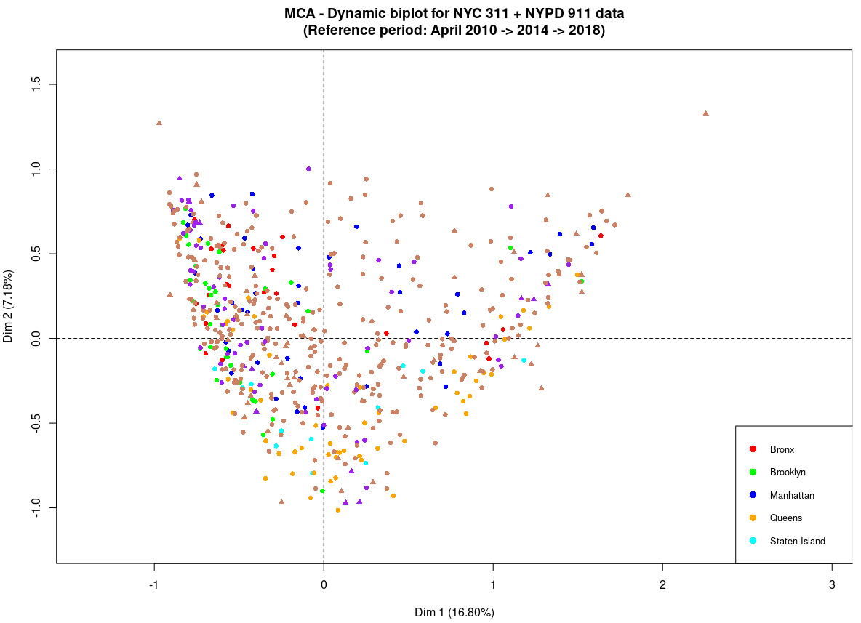
Triangles represent categorical variables’ modalities’ levels (64 in total): 52 are tan colored and not crime related, 12 are purple-colored are crime related.
Round dots represent scores, color-coded by borough for the reference period April 2010 and tan-colored for April 2014 and April 2018.

The Bronx
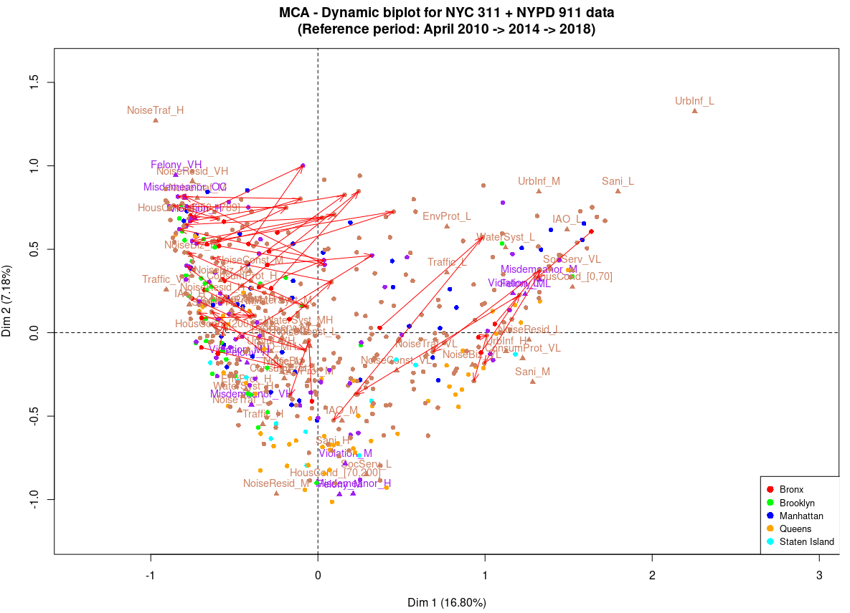
Brooklyn
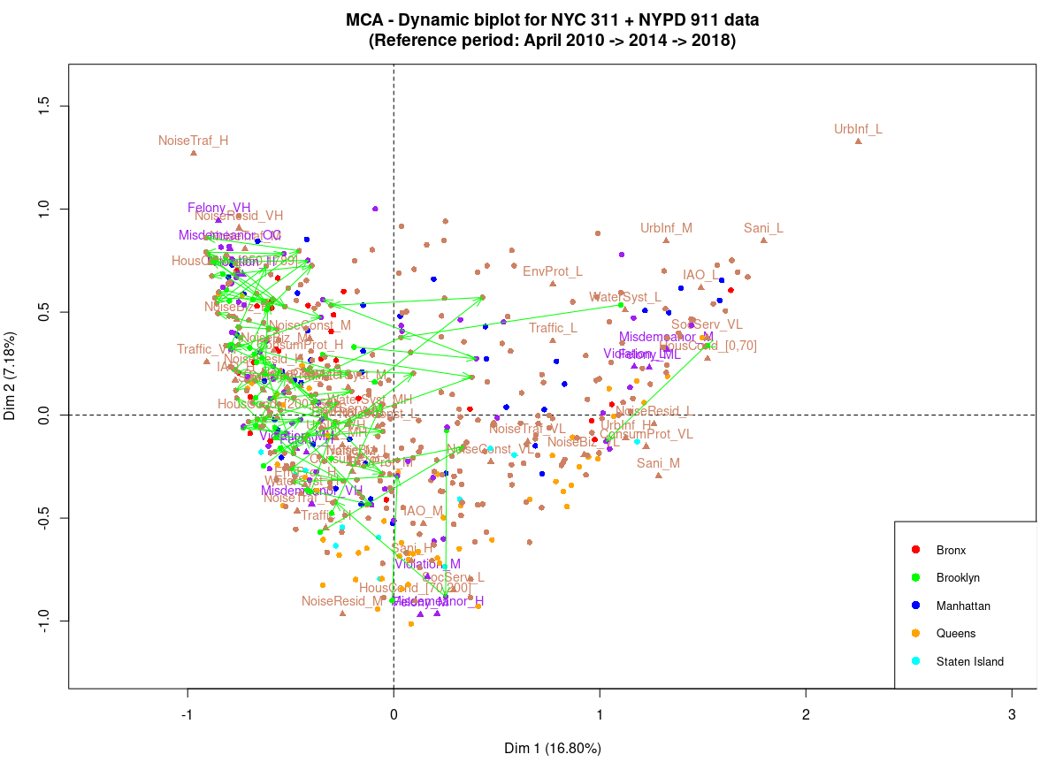

Manhattan
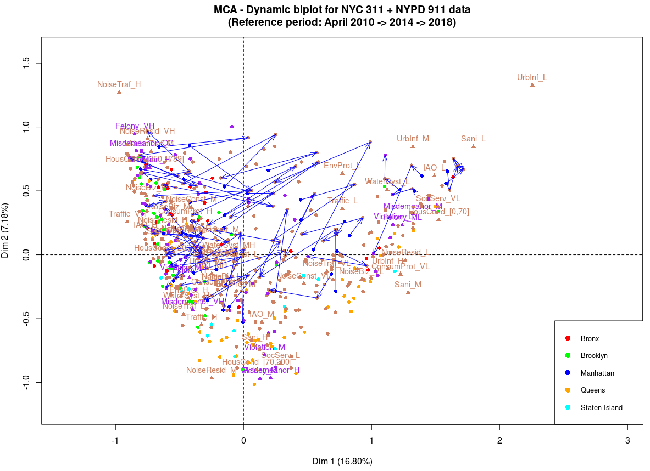

Queens
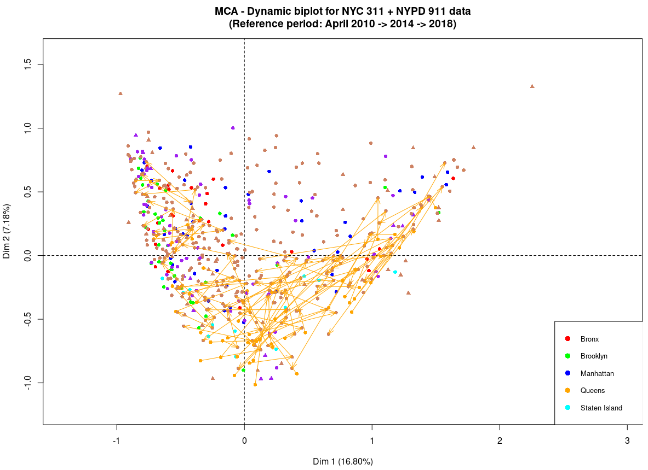
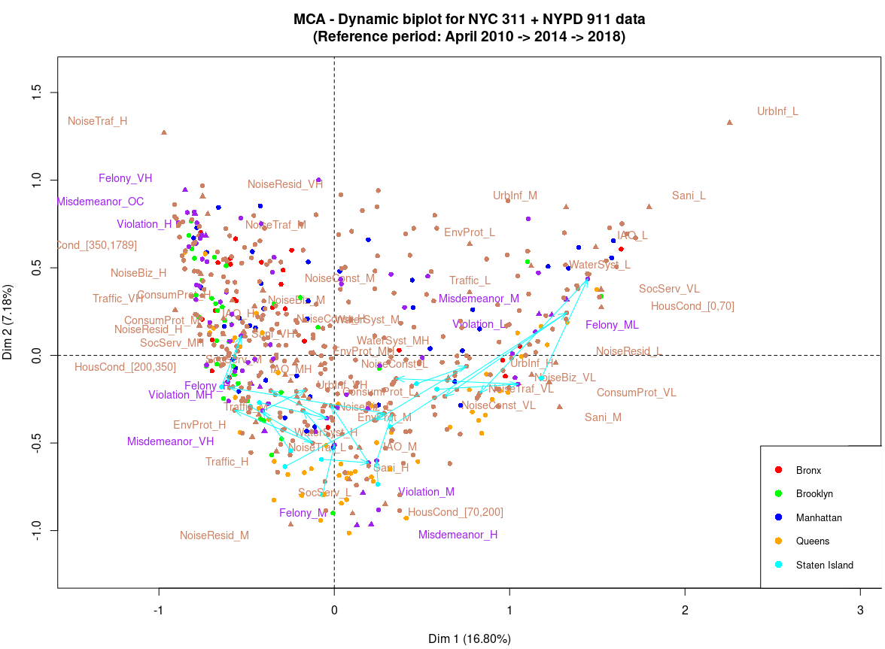
Staten Island

PC1-2 biplot projection of MCA results color coded by borough (common basis)
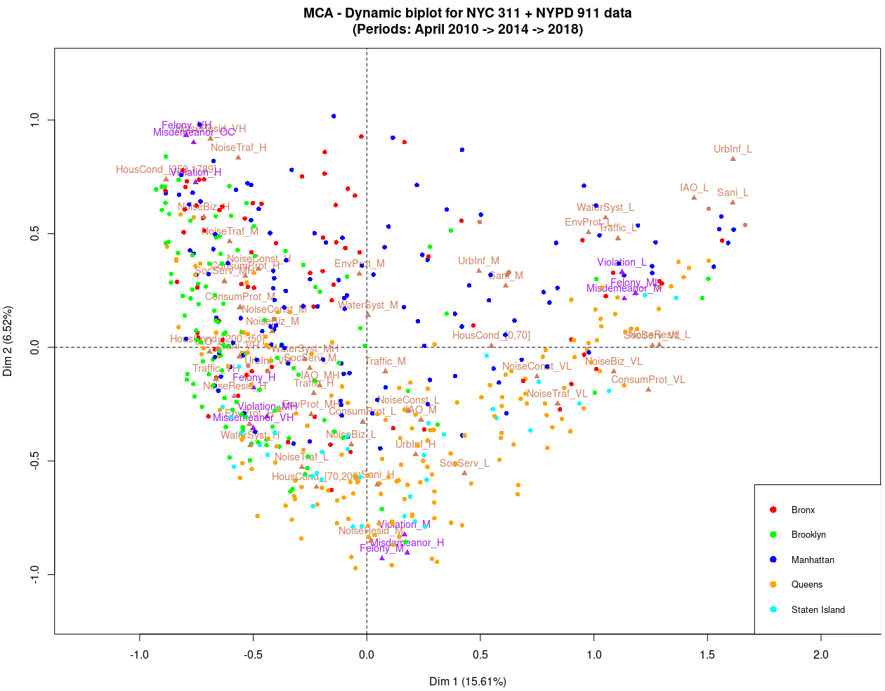
Triangles represent categorical variables’ modalities’ levels (64 in total): 52 are tan colored and not crime related, 12 are purple-colored are crime related.
Round dots represent scores, color-coded by borough for the reference period April 2010 and tan-colored for April 2014 and April 2018.

The Bronx
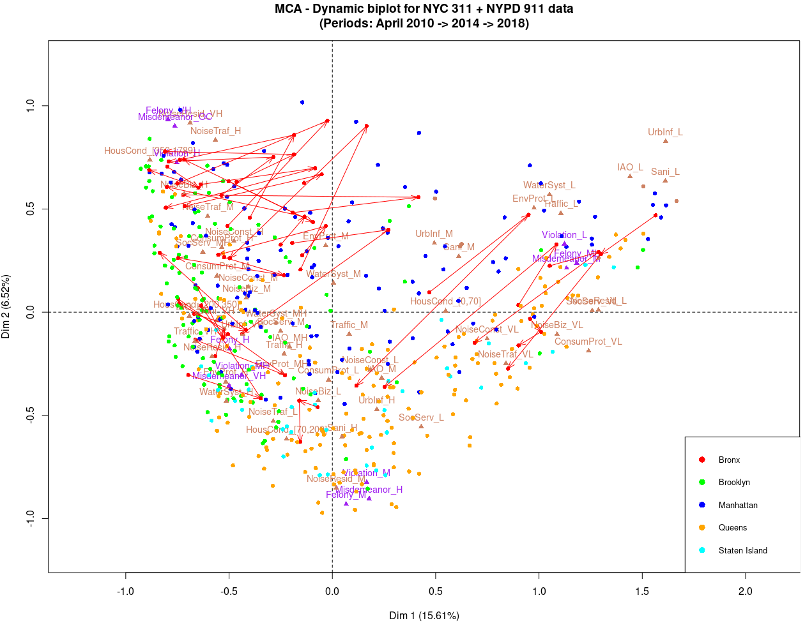
Brooklyn
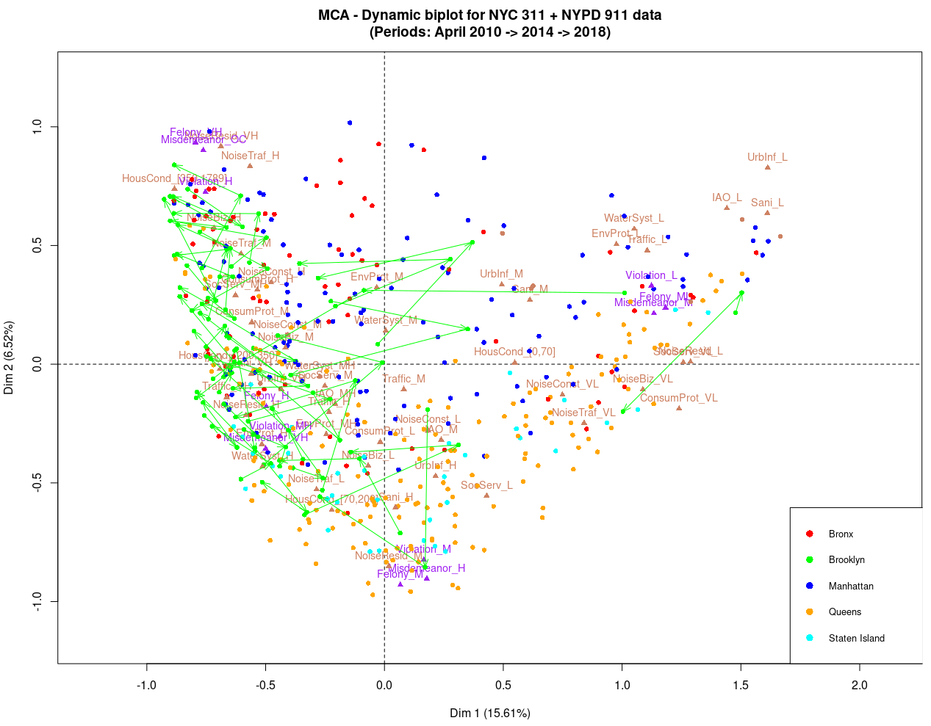

Manhattan
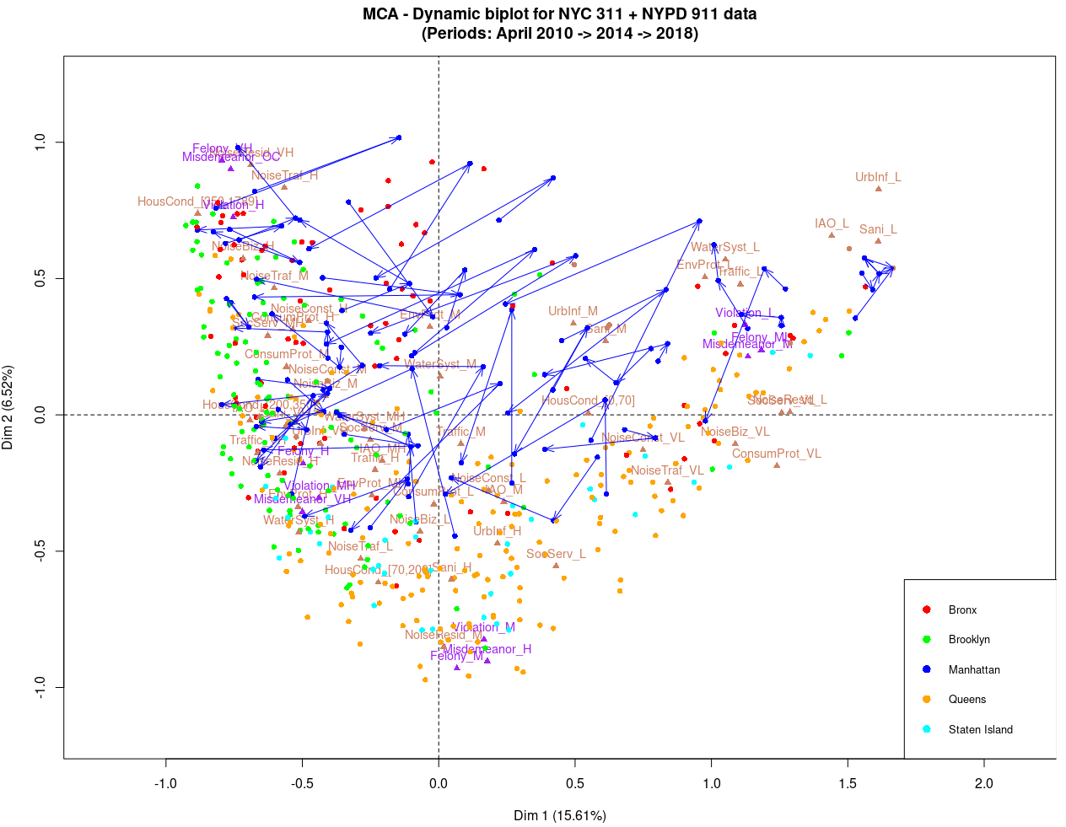

Queens
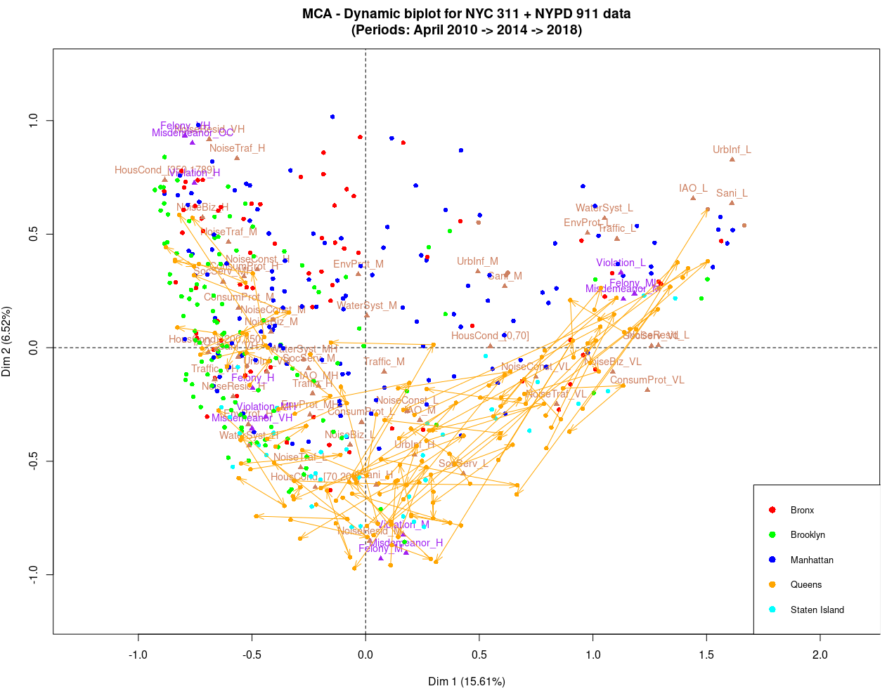
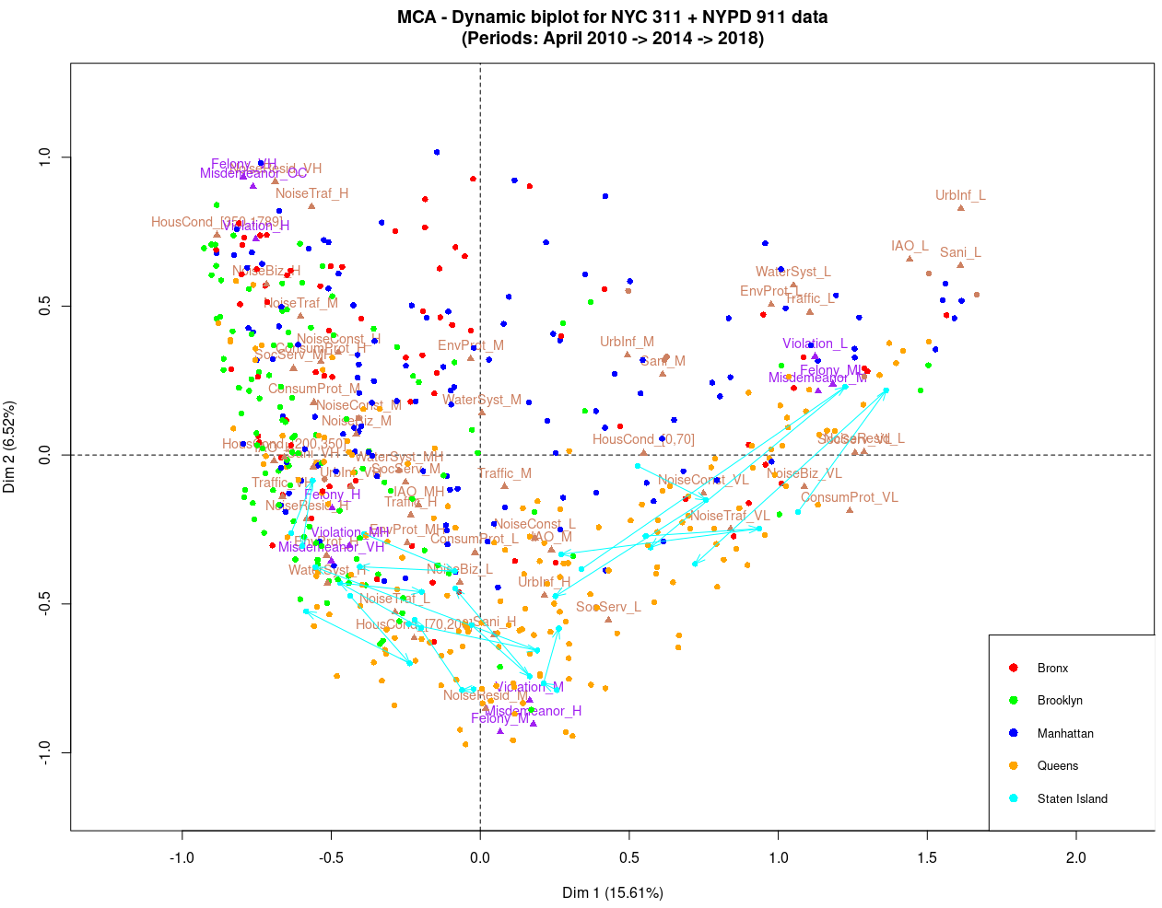
Staten Island

