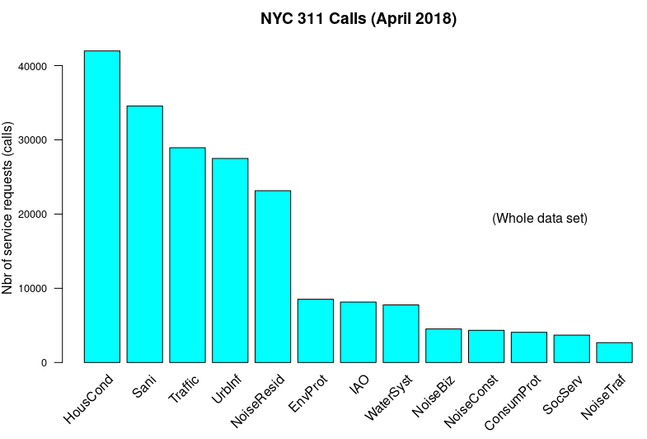

obs w/ missing ZIPs: 7,581
obs w/ missing GPS coords: 16,632
obs w/ missing ZIP and GPS coords: 7,759
obs w/ missing ZIP, Address, GPS coords 5,959

For all obs with missing ZIP
- 2485 obs miss all geoloc info
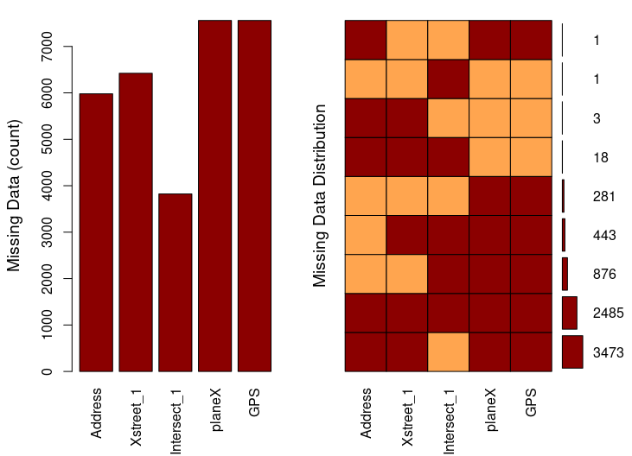
Missings per variable:
Variable Count
Address 5980
Xstreet_1 6422
Intersect_1 3823
planeX 7559
GPS 7559

Missings in combinations of variables:
Combinations Count Percent
0:0:0:1:1 281 3.70663501
0:0:1:0:0 1 0.01319087
0:0:1:1:1 876 11.55520380
0:1:1:1:1 443 5.84355626
1:0:0:1:1 1 0.01319087
1:1:0:0:0 3 0.03957262
1:1:0:1:1 3473 45.81189817
1:1:1:0:0 18 0.23743569
1:1:1:1:1 2485 32.77931671

mod_allmissing
SocServ IAO HousCond UrbInf Sani ConsumProt EnvProt NoiseBiz NoiseConst NoiseResid
1122 903 313 107 38 1 1 0 0 0
NoiseTraf Traffic WaterSyst
0 0 0

2485 (32.8% of all obs missing a ZIP code) have no geolocation information. Compare the modality distribution of those complaints, frequency wise, with those of the whole data set.
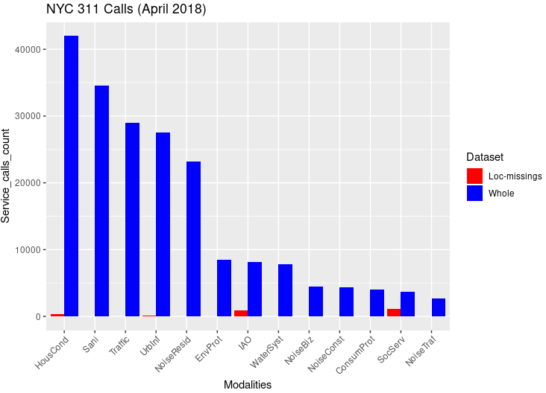
Fraction of modality 'SocServ': 30.4 %
Fraction of modality 'IAO': 11.1 %
Fraction of modality 'HousCond': 0.8 %
The Chi square test of independence of ZIP code observations and SRCs leads to a clear rejection of H0.
5181 observations are fed to the Google API in an attempt to attribute a ZIP code and GPS coordinates to their corresponding event. 5354 Google Cloud geocode API queries are made as a result, at a cost of 26.77€). Of the 5181 observations 347 are left without GPS and ZIP code.
> table(protoY[imputeTo99999_idx,3]) # before “99999” imputation
ConsumProt EnvProt HousCond IAO NoiseBiz NoiseConst NoiseResid NoiseTraf Sani SocServ
5 3 96 9 0 2 0 0 32 3
Traffic UrbInf WaterSyst
7 175 15
Shows that as for other sample years the most represented modality is UrbInf. This is due to how the Google Cloud geocode API for localization functions. It does not perform well when two streets are tangent to one another but do not physically cross one another.
Nbr of unique ZIP codes in data set = 184 after consolidation:
ZIP code 10027 absorbed ZIP code 10115
ZIP code 11101 absorbed ZIP code 11109
A Chi square test shows that there is significant association between categorical variables in the 2 way contingency table. (We reject H0)
Nbr of cells with count <5: 337 . The contribution of low count cells to the computation of the Chi square statistic is negligible. No low count cells contribute 1 or more to the Chi square metric.
We perform a second Chi square test based on the contingency table made of low count row profiles only. Again we reject the null hyothesis as the p-value is 0.0002 for a chi square statistics of 441,
PCA on SRCs for April 2018
Scatter plot of scores and variables’ representation in PC1-2, PC1-3 and PC2-3
The effect of ZIP code “11430” and “11371” is negligible. It is not as true an outlier as “10430” (Riverdale, the Bronx) in the April 2010 data set. Nevertheless we include them as SUP individuals.
Eigenvalue percentage of variance cumulative percentage of variance
(calculated considering “11430” (JFK airport) and “11371” (La Guardia airport) as supplementary individuals.)

eigenvalue % of variance cumulative % of variance
comp 1 1.561362e-01 3.580064e+01 35.80064
comp 2 1.065764e-01 2.443702e+01 60.23766
comp 3 3.853845e-02 8.836526e+00 69.07419
comp 4 3.606266e-02 8.268848e+00 77.34304
comp 5 2.621650e-02 6.011212e+00 83.35425
comp 6 2.085334e-02 4.781486e+00 88.13573
comp 7 1.555735e-02 3.567162e+00 91.70289
comp 8 9.704461e-03 2.225147e+00 93.92804
comp 9 8.686851e-03 1.991818e+00 95.91986
comp 10 7.538626e-03 1.728540e+00 97.64840
comp 11 6.465050e-03 1.482379e+00 99.13078
comp 12 3.790908e-03 8.692216e-01 100.00000

4 significant dimensions detected with criterion set at 72% of cumulated overall variance representation.
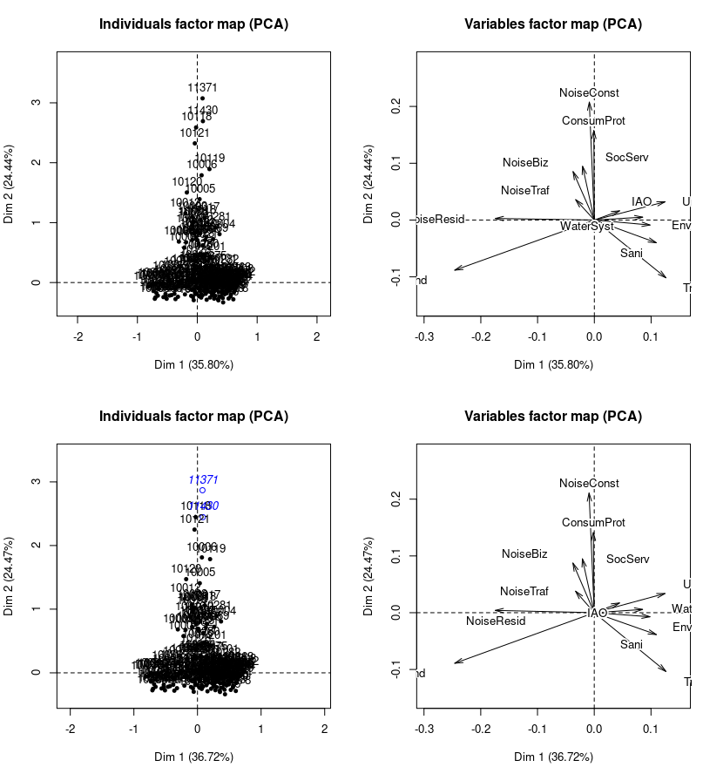
Contribution of variables to the construction of each dimension
Dim.1 Dim.2 Dim.3 Dim.4
Sani 7.663637491 1.42659793 0.04187663 4.3902074
ConsumProt 0.001651857 19.14947109 5.09171769 1.4742624
NoiseBiz 0.904831412 7.34655210 4.61517491 2.5331514
NoiseResid 19.474381324 0.01584991 2.83865159 0.1092133
WaterSyst 4.643049276 0.03191124 0.07427844 1.0967126
Traffic 10.211814772 10.28548249 6.00289245 51.5545842
NoiseTraf 0.692606882 1.37858621 63.72175449 10.7511770
UrbInf 9.945916357 1.09751130 1.47445739 7.0005306
HousCond 38.692669750 7.61935028 4.40638568 2.8311684
SocServ 0.279180678 8.64575794 4.08063279 0.2662813
IAO 1.268239087 0.28298221 0.01425036 0.1643788
NoiseConst 0.053365702 42.67064828 4.50535636 0.2233713
EnvProt 6.168655412 0.04929903 3.13257122 17.6049612

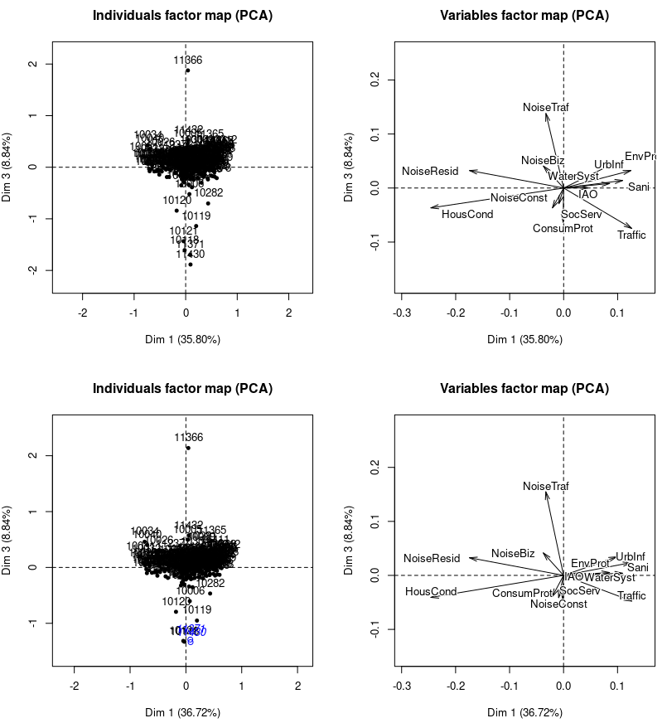
Correlation of variables with PCs:
Dim.1 Dim.2 Dim.3 Dim.4
Sani 0.621560875 -0.21891971 0.02254436 -0.22554111
ConsumProt -0.009573849 0.84148539 -0.26080642 0.13712123
NoiseBiz -0.243375642 0.56611275 0.26969517 0.19522744
NoiseResid -0.867931798 0.02021320 0.16259067 0.03116079
WaterSyst 0.664396733 0.04496406 0.04123282 -0.15480653
Traffic 0.574920985 -0.47101736 -0.21628320 0.61930893
NoiseTraf -0.175736253 0.20239641 0.82708023 0.33194258
UrbInf 0.739491747 0.20053183 0.13970529 -0.29743592
HousCond -0.898108992 -0.32534306 -0.14871055 -0.11647013
SocServ -0.161429826 0.73334868 -0.30282427 0.07558375
IAO 0.558425048 0.21533358 -0.02904444 -0.09638383
NoiseConst -0.039967119 0.92258042 -0.18018645 0.03920148
EnvProt 0.637931760 -0.04655497 0.22305669 -0.51667031

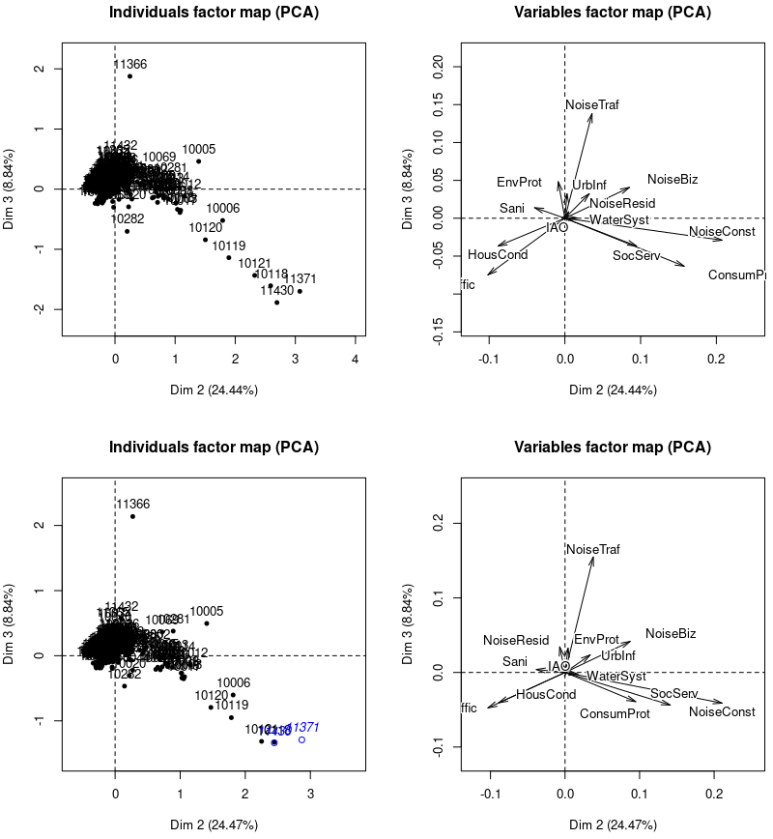
Generally speaking as for other time periods (April 2010 and 2014):
- “NoiseTraf” and “HousCond” are nearly orthogonal.
- etc.
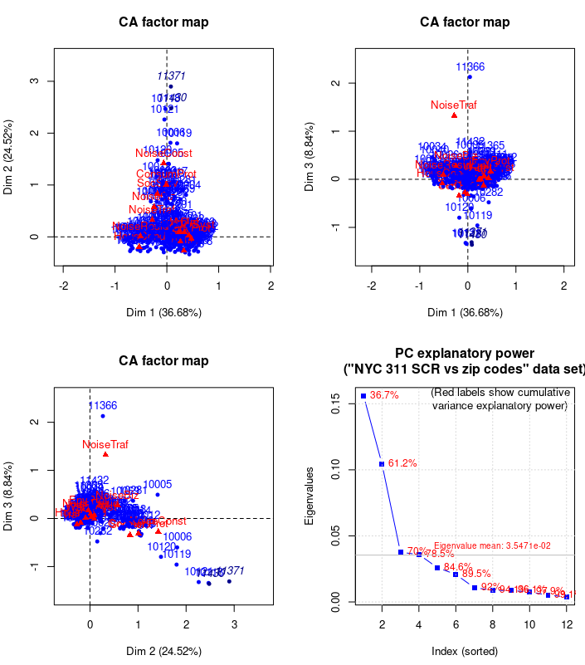
Contributions to the construction of principal directions > 10%
Dim 1 Dim 2 Dim 3
ConsumProt 0.001714527 19.42535316 5.197787
NoiseResid 19.473149010 0.01518322 2.832599
Traffic 10.215163807 10.22457239 6.365455
NoiseTraf 0.692681141 1.36325022 63.191799
HousCond 38.688309435 7.59334245 4.370598
NoiseConst 0.053676847 42.54405996 4.434335

Inertia explanatory power for all dimensions and for the significant dimensions
iep_alldim iep_sigdim
Sani 7.3 4.5
ConsumProt 6.7 6.8
NoiseBiz 5.6 3.5
NoiseResid 9.5 9.4
WaterSyst 3.9 2.3
Traffic 11.3 14.2
NoiseTraf 8.2 9.1
UrbInf 6.7 5.9
HousCond 17.6 21.3
SocServ 3.9 3.3
IAO 1.5 0.7
NoiseConst 12.3 13.8
EnvProt 5.6 5.1

Quality of representation of col profiles with biggest contrib to PC formation
Dim 1 Dim 2 Dim 3
ConsumProt 0.00009377674 0.7101053632 0.06849580
NoiseResid 0.75330020880 0.0003925537 0.02640047
Traffic 0.33060387467 0.2211622162 0.04963486
NoiseTraf 0.03088827521 0.0406292725 0.67891557
HousCond 0.80653471136 0.1057984906 0.02195225

Most important individual contributors to the construction of PCs
Dim 1 Dim 2 Dim 3
10001 0.0 5.1 1.0
10002 0.2 2.6 0.4
10003 0.0 8.7 2.2 --- max contr to construct of Dim 2
10006 0.0 2.4 0.7
10009 0.4 3.0 0.1
10011 0.0 3.9 0.0
10012 0.1 6.0 0.3
10013 0.0 3.1 0.0
10014 0.0 4.8 0.0
10016 0.0 4.1 0.5
10017 0.0 2.2 0.7
10018 0.0 2.5 0.8
10019 0.0 4.3 0.3
10022 0.0 2.5 0.3
10023 0.0 2.3 0.5
10031 4.7 0.0 1.2 --- max contr to construct of Dim 1
10032 2.1 0.0 0.4
10033 3.0 0.0 0.1
10034 2.7 0.0 4.3
10036 0.0 2.3 0.6
10038 0.0 2.1 0.4
10040 2.1 0.0 2.9
10312 2.4 0.0 1.1
10314 3.1 0.0 0.6
10452 3.2 0.5 0.1
10453 3.7 0.8 0.0
10458 3.7 0.7 0.3
10467 2.6 0.7 0.3
10468 3.2 0.3 0.1
11226 2.2 0.7 0.3
11365 0.6 0.0 2.5
11366 0.0 0.3 45.7 --- max contr to construct of Dim 3
11432 0.0 0.1 5.8

Results for CA:
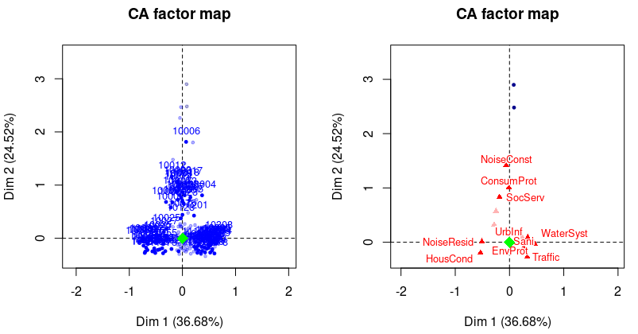
Left row profiles with cos² > 0.6 – Right col profiles with cos² > 0.4
After feature selection (i.e. setting “WaterSyst”, “SocServ” and “IAO” as SUP variables):
eigenvalue percentage of variance cumulative percentage of variance
dim 1 0.159204045 37.412748 37.41275
dim 2 0.108277422 25.445056 62.85780
dim 3 0.039776913 9.347524 72.20533
dim 4 0.039391240 9.256891 81.46222
dim 5 0.026394997 6.202791 87.66501
dim 6 0.022423225 5.269429 92.93444
dim 7 0.011761538 2.763947 95.69839
dim 8 0.009485556 2.229094 97.92748
dim 9 0.008819280 2.072520 100.00000

→ 2 significant dimensions only
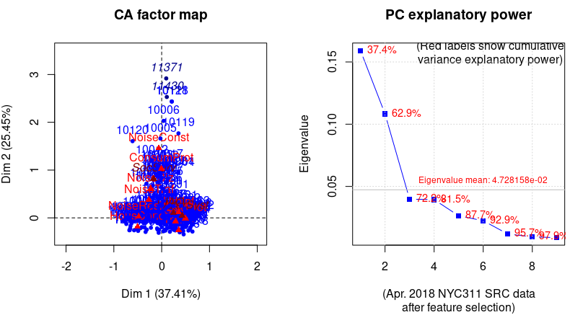
Eigenvalues
Dim.1 Dim.2 Dim.3 Dim.4 Dim.5 Dim.6 Dim.7 Dim.8 Dim.9
Variance 0.159 0.108 0.040 0.039 0.026 0.022 0.012 0.009 0.009
% of var. 37.413 25.445 9.348 9.257 6.203 5.269 2.764 2.229 2.073
Cumulative % of var. 37.413 62.858 72.205 81.462 87.665 92.934 95.698 97.927 100.000

The chi square of independence between the two variables (ZIPs + SRCs) is equal to 45880.48 (p-value = 0 ).

Columns
Iner*1000 Dim.1 ctr cos2 Dim.2 ctr cos2 Dim.3 ctr cos2
Sani | 34.824 | 0.290 10.179 0.465 | -0.072 0.913 0.028 | -0.012 0.069 0.001 |
ConsumProt | 34.158 | -0.006 0.000 0.000 | 1.030 21.429 0.679 | -0.326 5.834 0.068 |
NoiseBiz | 25.911 | -0.232 0.851 0.052 | 0.611 8.703 0.364 | 0.228 3.285 0.050 |
NoiseResid | 40.378 | -0.481 18.755 0.739 | 0.026 0.082 0.002 | 0.077 1.902 0.019 |
Traffic | 53.932 | 0.357 12.933 0.382 | -0.260 10.068 0.202 | -0.062 1.555 0.011 |
NoiseTraf | 38.212 | -0.267 0.669 0.028 | 0.378 1.970 0.056 | 1.402 73.839 0.769 |
UrbInf | 35.443 | 0.354 11.944 0.536 | 0.115 1.843 0.056 | 0.042 0.681 0.008 |
HousCond | 74.312 | -0.505 37.215 0.797 | -0.188 7.535 0.110 | -0.090 4.682 0.025 |
NoiseConst | 60.505 | -0.061 0.056 0.001 | 1.458 47.454 0.849 | -0.332 6.695 0.044 |
EnvProt | 27.858 | 0.498 7.398 0.423 | -0.008 0.003 0.000 | 0.110 1.457 0.021 |

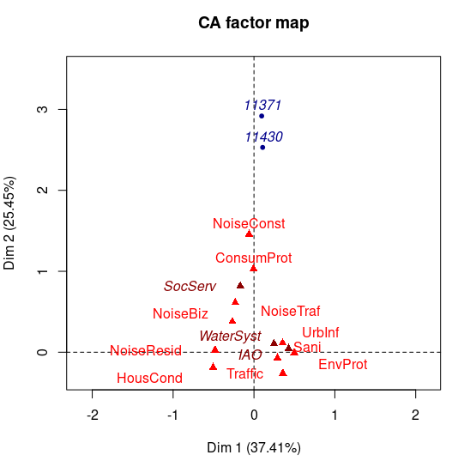
Active variable are in red, while supplementary ones are in dark red. The blue point is the supplementary individual(s) ear-marked as outlier(s).
Contributions (> 10%) to the construction of the 3 first PCs after feature extraction/selection:
Dim 1 Dim 2 Dim 3
Sani 10.1790494853 0.91300192 0.06893129
ConsumProt 0.0004277188 21.42883722 5.83449066
NoiseResid 18.7545648111 0.08226928 1.90219037
Traffic 12.9330401060 10.06849957 1.55523628
NoiseTraf 0.6692209145 1.96950630 73.83854163
UrbInf 11.9437459610 1.84344646 0.68125174
HousCond 37.2151691227 7.53488560 4.68218845
NoiseConst 0.0557624983 47.45380132 6.69527668

Quality of representations within the former group (above):
Dim 1 Dim 2 Dim 3
Sani 0.46535969758 0.028388147 0.0007873629
ConsumProt 0.00001993502 0.679267301 0.0679419843
NoiseResid 0.73946893231 0.002206147 0.0187388918
Traffic 0.38177384513 0.202140862 0.0114704092
NoiseTraf 0.02788176901 0.055807427 0.7686186420
UrbInf 0.53648739344 0.056316195 0.0076454592
HousCond 0.79728830113 0.109788251 0.0250623198
NoiseConst 0.00146724118 0.849208050 0.0440154147

Individual contributions for which at least one component is greater than 20% in PC1-2-3
Dim 1 Dim 2 Dim 3
10001 0.0 4.4 0.7
10002 0.3 3.0 0.2
10003 0.0 8.5 2.3 ---- Dim2
10005 0.0 2.4 0.7
10006 0.0 2.7 0.9
10009 0.4 3.2 0.2
10011 0.0 3.8 0.1
10012 0.1 6.0 0.3
10013 0.0 3.2 0.0
10014 0.0 5.4 0.2
10016 0.0 3.8 0.5
10017 0.0 2.1 0.6
10018 0.0 2.4 0.7
10019 0.0 4.4 0.3
10022 0.0 2.4 0.3
10031 4.6 0.0 0.9 ----- Dim1
10032 2.1 0.0 0.4
10033 3.0 0.0 0.1
10034 2.7 0.0 4.3
10040 2.0 0.0 2.9
10312 2.6 0.0 0.5
10314 2.9 0.0 0.2
10452 3.3 0.5 0.1
10453 3.5 0.8 0.0
10456 2.1 0.6 0.2
10458 3.5 0.8 0.4
10467 2.4 0.6 0.4
10468 3.1 0.3 0.1
11226 2.1 0.7 0.2
11365 0.7 0.0 2.6
11366 0.0 0.4 55.1 ---- Dim3
11432 0.0 0.1 6.7

Not changed from before. Good sign.
Inertia Explanatory Power for factors (i.e. variable’s modalities)
iep_alldim iep_sigdim
iep_alldim iep_sigdim
Sani 8.2 5.6
ConsumProt 8.0 8.3
NoiseBiz 6.1 3.9
NoiseResid 9.5 10.0
Traffic 12.7 10.5
NoiseTraf 9.0 10.6
UrbInf 8.3 6.9
HousCond 17.5 22.5
NoiseConst 14.2 17.6
EnvProt 6.5 4.0

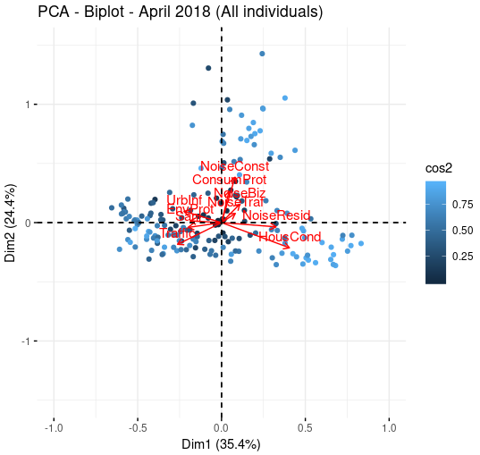
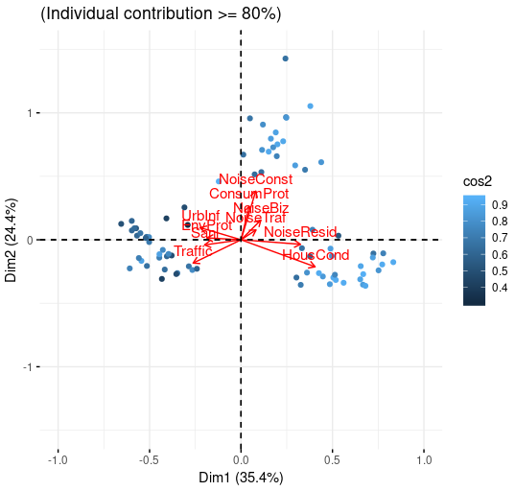
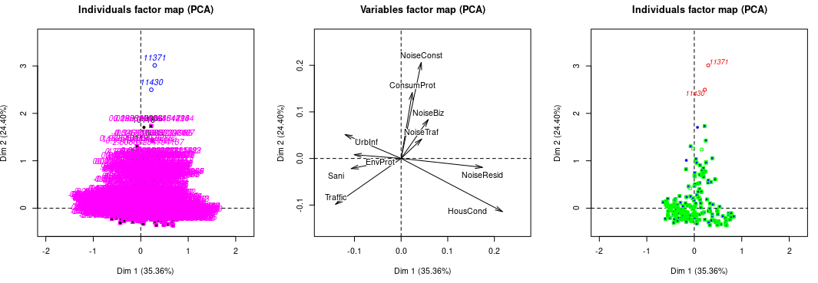
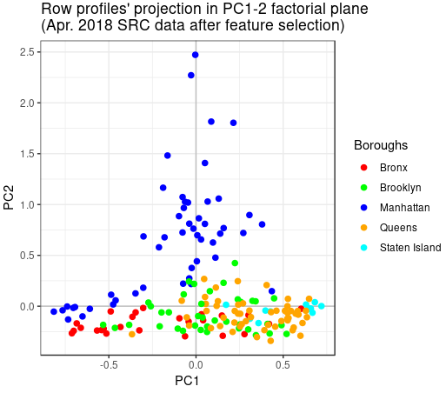
Analysis of ZIP codes’ (observations’) contributions to inertia per borough:
Borough: Manhattan
Number of ZIP codes: 50
Borough's ZIPs' % contribution to inertia (overall and in PC1-2 factorial plane):
All_dim PC1-2
34.0 27.7

Borough: Staten Island
Number of ZIP codes: 12
Borough's ZIPs' % contribution to inertia (overall and in PC1-2 factorial plane):
All_dim PC1-2
9.2 4.9

Borough: Bronx
Number of ZIP codes: 25
Borough's ZIPs' % contribution to inertia (overall and in PC1-2 factorial plane):
All_dim PC1-2
13.1 10.8

Borough: Queens
Number of ZIP codes: 57
Borough's ZIPs' % contribution to inertia (overall and in PC1-2 factorial plane):
All_dim PC1-2
28.1 19.9

Borough: Brooklyn
Number of ZIP codes: 38
Borough's ZIPs' % contribution to inertia (overall and in PC1-2 factorial plane):
All_dim PC1-2
14.9 8.3

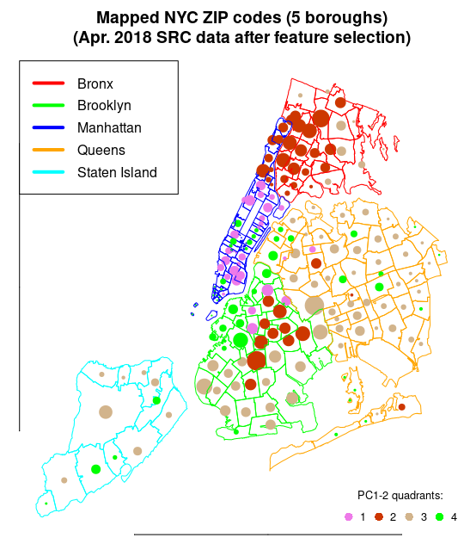
Analysis of latent features following varimax treatment:
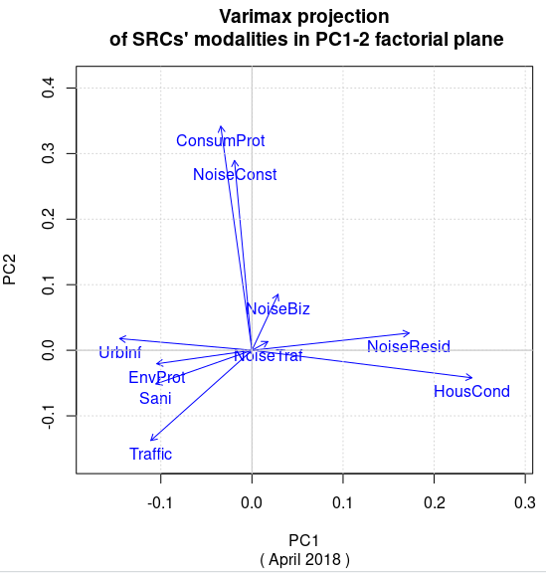
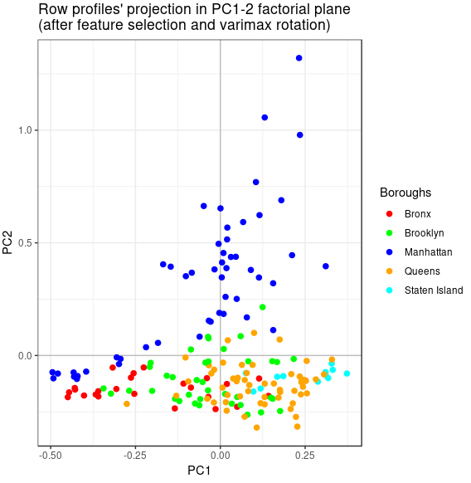
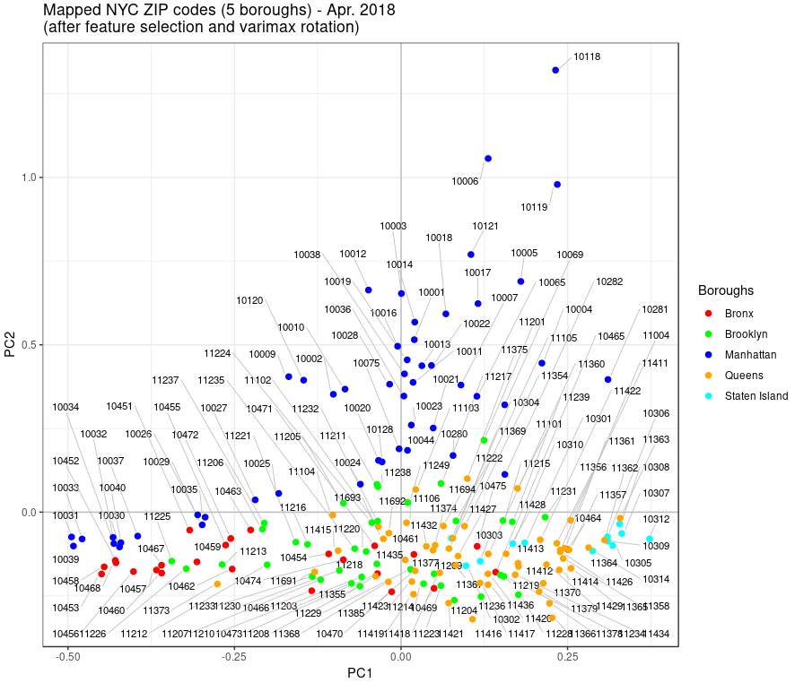

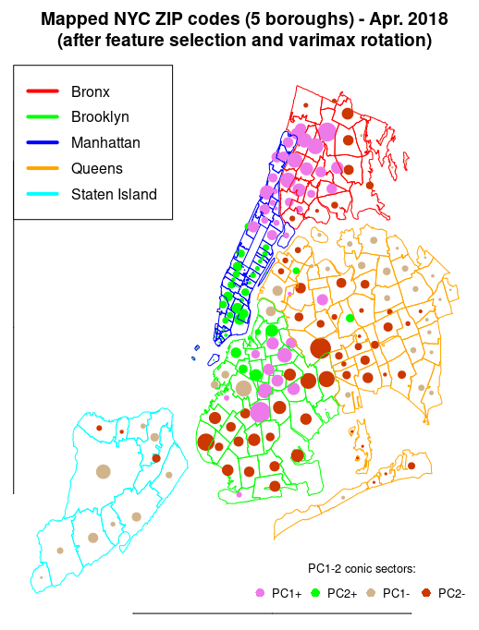
MCA with crime data:
Binning the 17 categorical variables brings some change when compared to reference year 2014, in particular in the distribution and frequency of “HousCond” related SRCs.
HousCond:
below or equal to 56 SRCs - bin count: 48
between 57 and 137 SRCs - bin count: 45
between 138 and 298 SRCs- bin count: 46
above 298 SRCs - bin count: 46
Sani:
below or equal to 18 SRCs - bin count: 17
between 19 and 31 SRCs - bin count: 5
between 32 and 54 SRCs- bin count: 5
above 54 SRCs - bin count: 158
NoiseResid:
below or equal to 29 SRCs - bin count: 44
between 30 and 61 SRCs - bin count: 29
between 62 and 123 SRCs- bin count: 48
above 123 SRCs - bin count: 64
NoiseConst:
below or equal to 1 SRCs - bin count: 28
between 2 and 5 SRCs - bin count: 39
between 6 and 20 SRCs- bin count: 63
above 20 SRCs - bin count: 55
NoiseBiz:
below or equal to 3 SRCs - bin count: 41
between 4 and 9 SRCs - bin count: 42
between 10 and 27 SRCs- bin count: 50
above 27 SRCs - bin count: 52
UrbInf:
below or equal to 33 SRCs - bin count: 13
between 34 and 55 SRCs - bin count: 6
between 56 and 87 SRCs- bin count: 23
above 87 SRCs - bin count: 143
Traffic:
below or equal to 24 SRCs - bin count: 21
between 25 and 54 SRCs - bin count: 25
between 55 and 87 SRCs- bin count: 26
above 87 SRCs - bin count: 113
NoiseTraf:
below or equal to 4 SRCs - bin count: 63
between 5 and 11 SRCs - bin count: 46
between 12 and 23 SRCs- bin count: 44
above 23 SRCs - bin count: 32
WaterSyst:
below or equal to 19 SRCs - bin count: 39
between 20 and 29 SRCs - bin count: 31
between 30 and 44 SRCs- bin count: 44
above 44 SRCs - bin count: 71
ConsumProt:
below or equal to 5 SRCs - bin count: 38
between 6 and 13 SRCs - bin count: 46
between 14 and 23 SRCs- bin count: 53
above 23 SRCs - bin count: 48
SocServ:
below or equal to 2 SRCs - bin count: 34
between 3 and 6 SRCs - bin count: 38
between 7 and 11 SRCs- bin count: 24
above 11 SRCs - bin count: 89
IAO:
below or equal to 14 SRCs - bin count: 20
between 15 and 23 SRCs - bin count: 27
between 24 and 33 SRCs- bin count: 35
above 33 SRCs - bin count: 103
EnvProt:
below or equal to 16 SRCs - bin count: 37
between 17 and 26 SRCs - bin count: 30
between 27 and 41 SRCs- bin count: 45
above 41 SRCs - bin count: 73
Violation:
below or equal to 7 SRCs - bin count: 45
between 8 and 20 SRCs - bin count: 43
between 21 and 38 SRCs- bin count: 39
above 38 SRCs - bin count: 58
Misdemeanor:
below or equal to 33 SRCs - bin count: 53
between 34 and 87 SRCs - bin count: 41
between 88 and 178 SRCs- bin count: 49
above 178 SRCs - bin count: 42
Felony:
below or equal to 17 SRCs - bin count: 53
between 18 and 45 SRCs - bin count: 48
between 46 and 91 SRCs- bin count: 46
above 91 SRCs - bin count: 38

Violation
Borough L M MH H
Bronx 2 2 4 17
Brooklyn 4 5 12 17
Manhattan 20 10 11 9
Queens 17 22 10 10
Staten Island 1 4 2 5

Misdemeanor
Borough M H VH OC
Bronx 2 3 6 14
Brooklyn 4 7 15 12
Manhattan 18 7 15 10
Queens 25 21 8 5
Staten Island 3 3 5 1

Felony
Borough ML M H VH
Bronx 4 3 8 10
Brooklyn 4 7 14 13
Manhattan 19 9 13 9
Queens 21 23 9 6
Staten Island 4 6 2 0

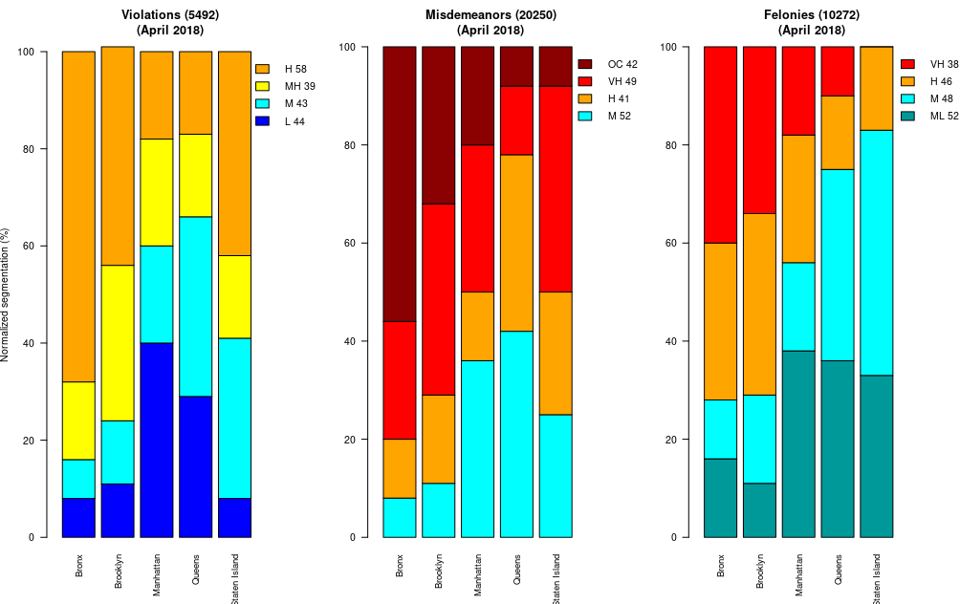

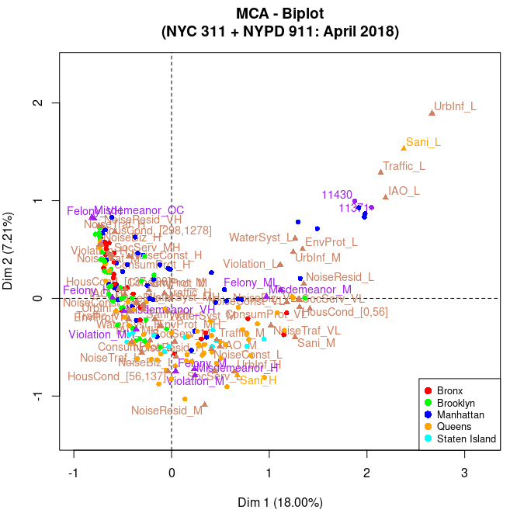
- Crime factors and supplementary individuals in purple
- Other factors in beige
- ZIP code individuals are color coded according to borough.
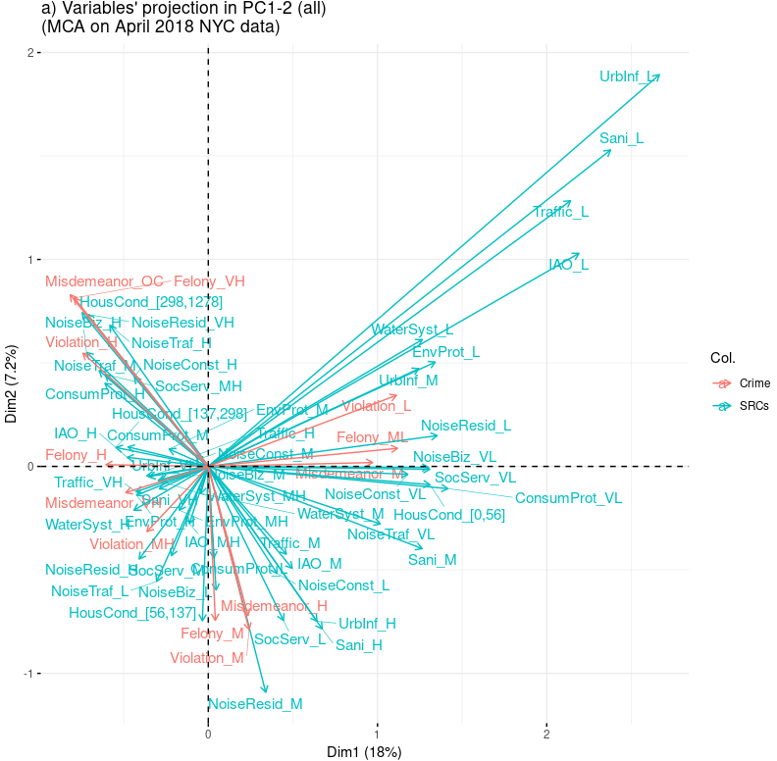
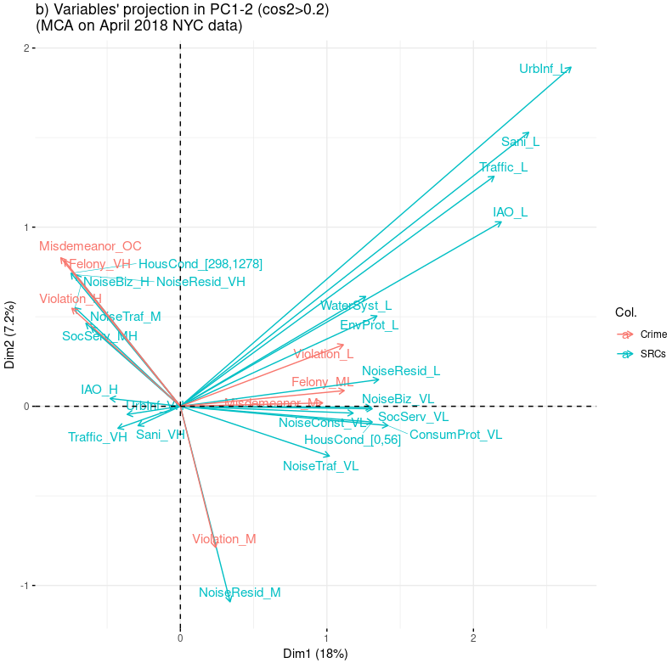
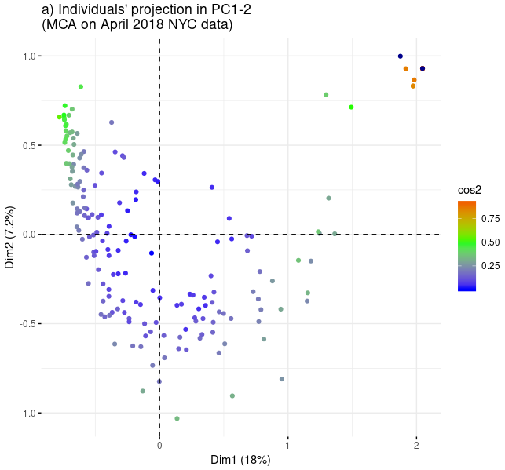
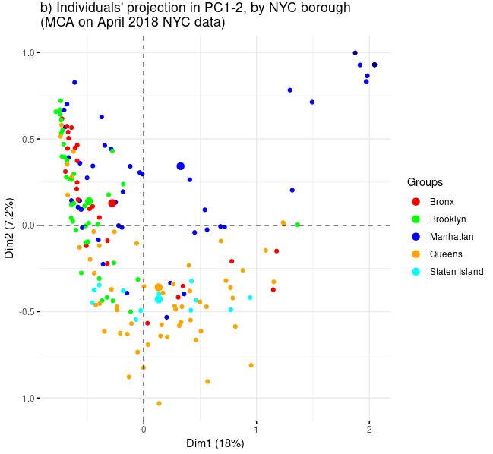
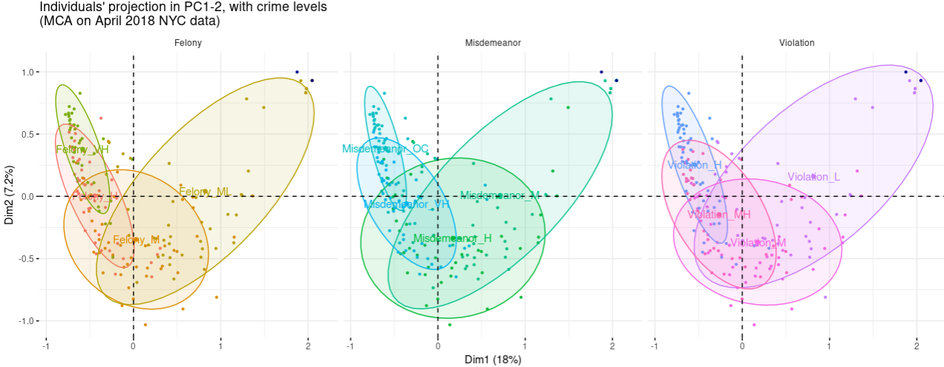
Identify ZIP codes in 2nd quadrant of PC12 var projection from MCA:
sum of all violation counts in 2nd quadrant: 3312
sum of all other violation counts: 2180

sum of all misdemeanor counts in 2nd quadrant: 12680
sum of all other misdemeanor counts: 7550

sum of all felonie counts in 2nd quadrant: 6430
sum of all other felony counts: 10272

Clustering analysis:
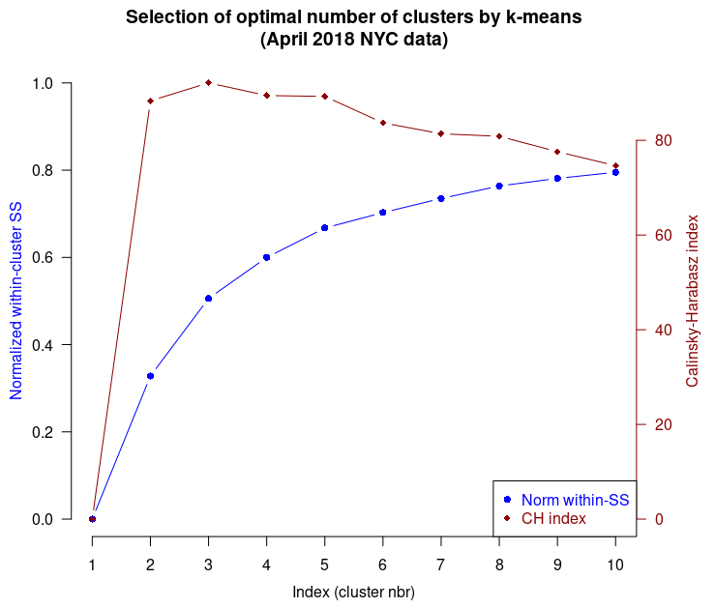
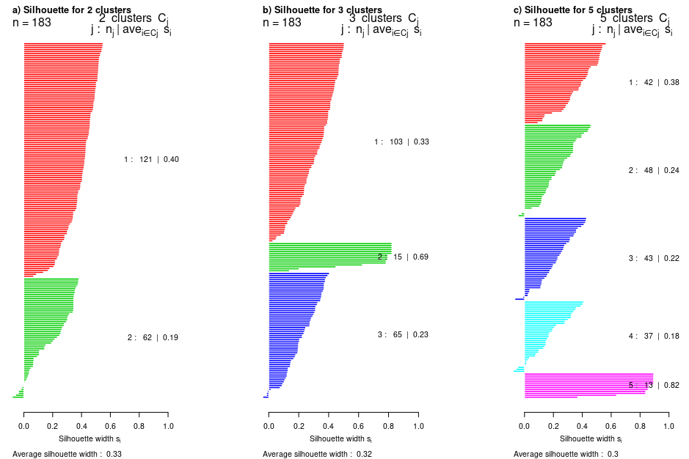
Choose 5 classes.
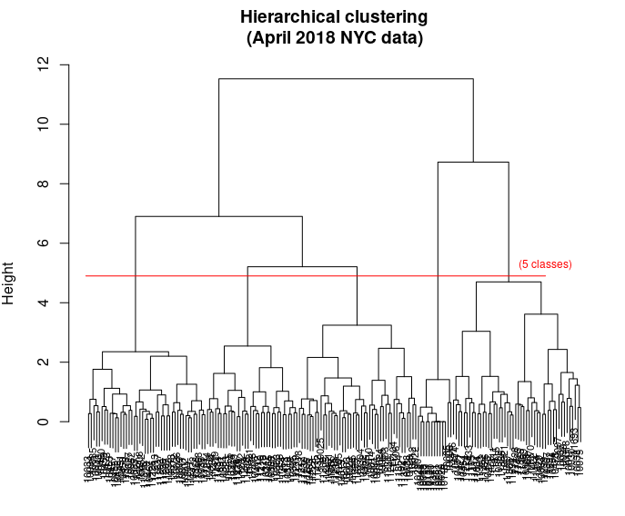
Clustering quality index for 5 classes, Ib=63.73
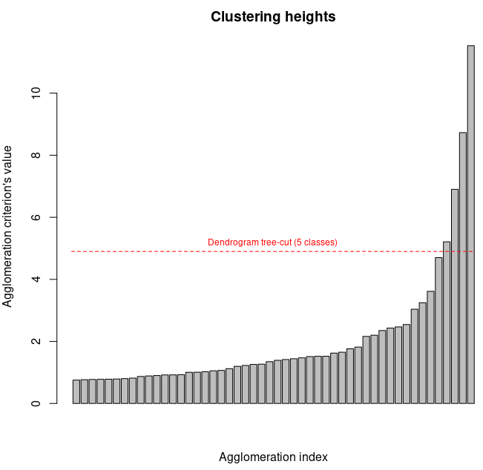
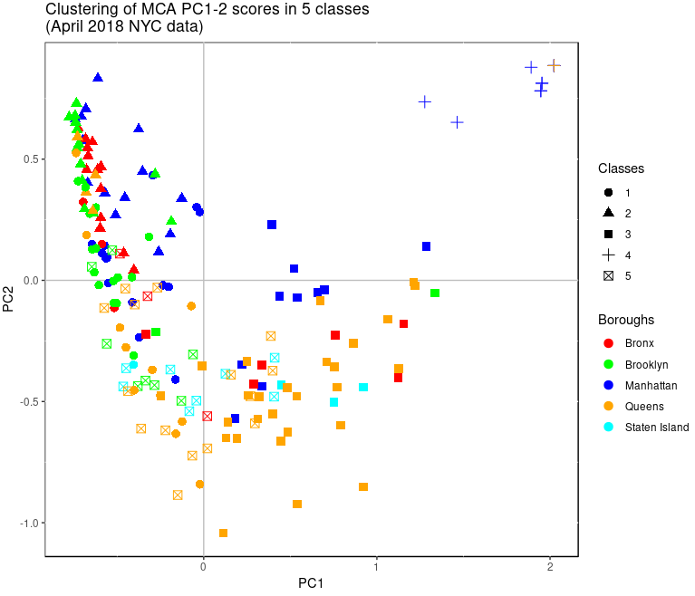
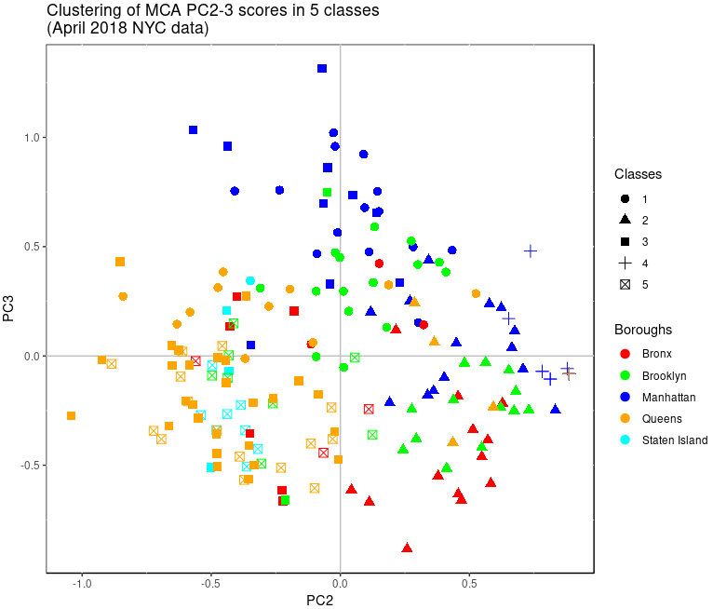
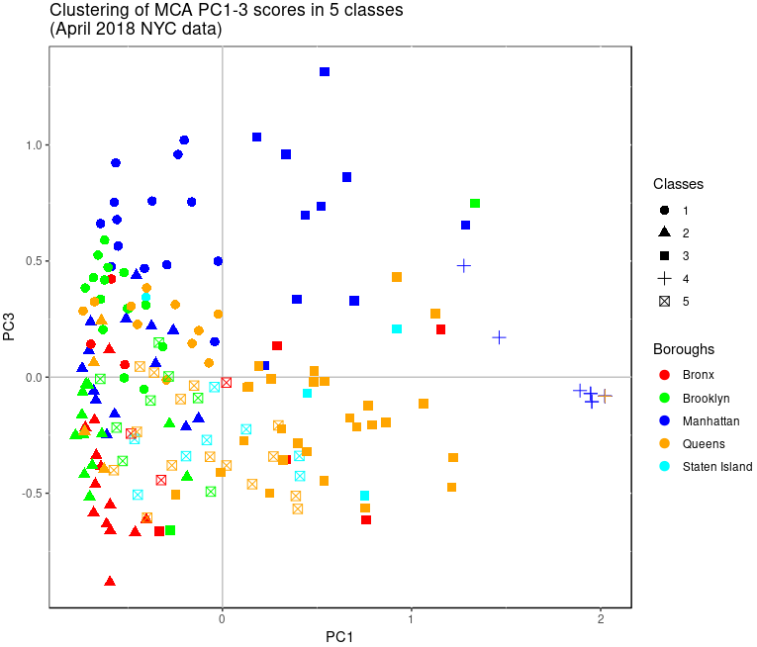

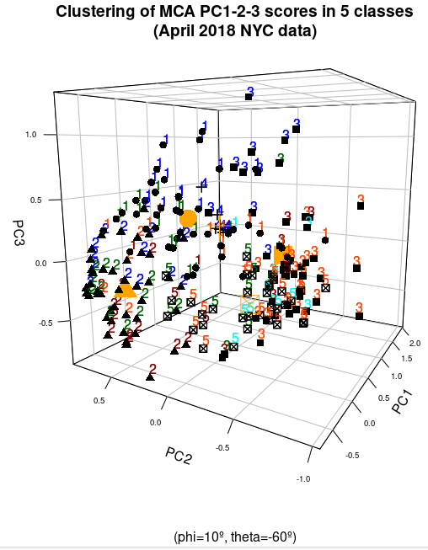
Contributions of each borough to inertia over 'nd' = 5 dimensions:
Bronx’ % (normalized) contribution to inertia: 11.6 %
Brooklyn's % (normalized) contribution to inertia: 15.4 %
Manhattan's % (normalized) contribution to inertia: 41.6 %
Queens' % (normalized) contribution to inertia: 26.4 %
Staten Island's % (normalized) contribution to inertia: 5 %
For more details (over 5 dim, non normalized):
Borough: Bronx
Number of ZIP codes: 25
Borough's ZIPs' non-normalized % contribution to inertia over (5_dim): 4.6

Borough: Brooklyn
Number of ZIP codes: 38
Borough's ZIPs' non-normalized % contribution to inertia over (5_dim): 6.1

Borough: Manhattan
Number of ZIP codes: 46
Borough's ZIPs' non-normalized % contribution to inertia over (5_dim): 16.5

Borough: Queens
Number of ZIP codes: 59
Borough's ZIPs' non-normalized % contribution to inertia over (5_dim): 10.5

Borough: Staten Island
Number of ZIP codes: 12
Borough's ZIPs' non-normalized % contribution to inertia over (5_dim): 2.0

Contributions of each cluster class to inertia over 'nd' = 5 dimensions:
Cluster 1 's normalized contribution to inertia: 16.1 %
Cluster 2 's normalized contribution to inertia: 18.4 %
Cluster 3 's normalized contribution to inertia: 28.5 %
Cluster 4 's normalized contribution to inertia: 25.9 %
Cluster 5 's normalized contribution to inertia: 11.1 %

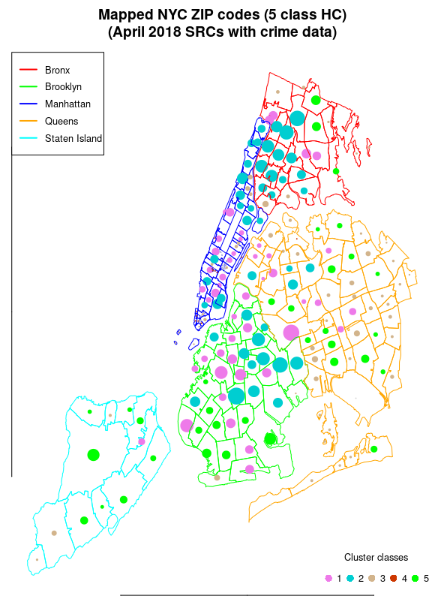

HC clustering with k-means consolidation:
Clustering quality index for 5 classes, after k-means consolidation, Ib = 66.75
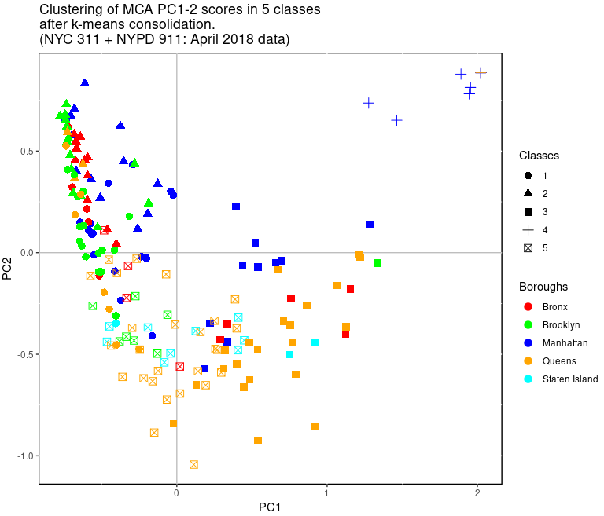
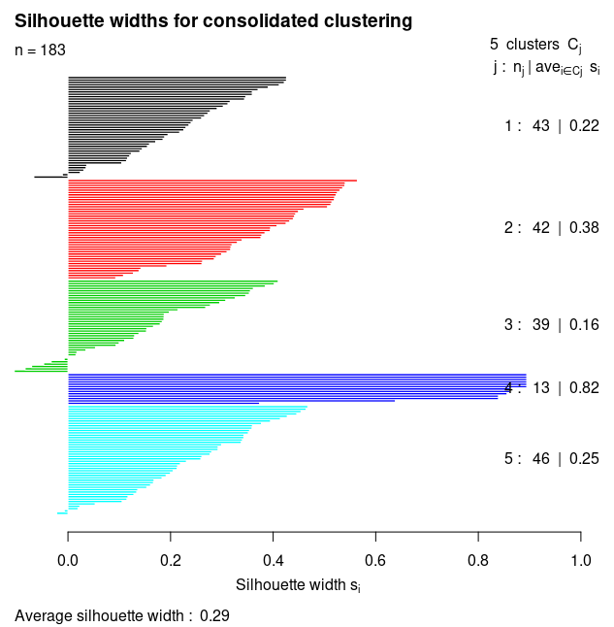
Cluster 1 's normalized contribution to inertia: 15.9 %

Cluster 2 's normalized contribution to inertia: 17.9 %

Cluster 3 's normalized contribution to inertia: 24.9 %

Cluster 4 's normalized contribution to inertia: 25.9 %

Cluster 5 's normalized contribution to inertia: 15.4 %
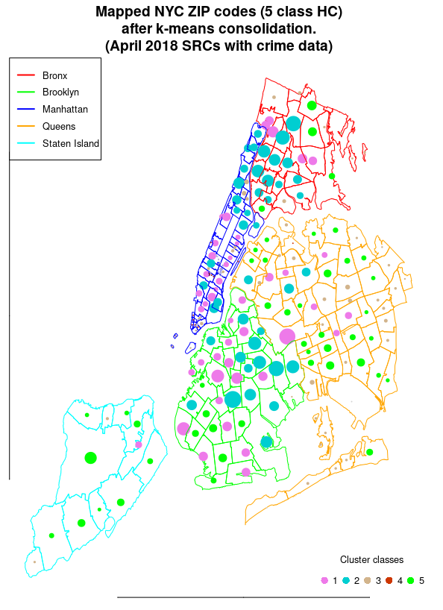
Var. most significantly related to construction of classes:
UrbInf Misdemeanor Sani NoiseResid HousCond

Var. least significantly related to construction of classes:
SocServ NoiseBiz NoiseConst EnvProt WaterSyst

Clustering interpretation:
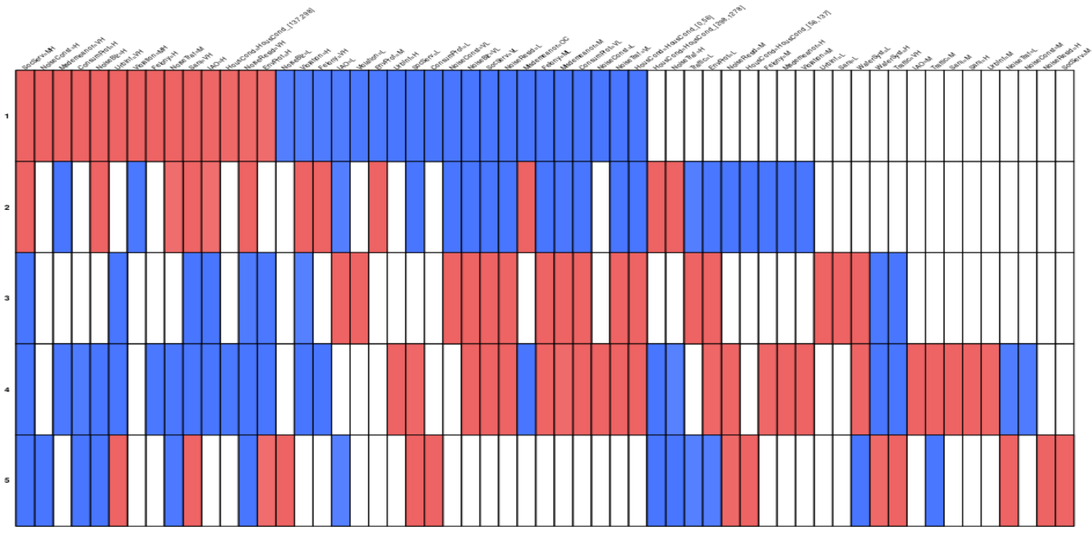
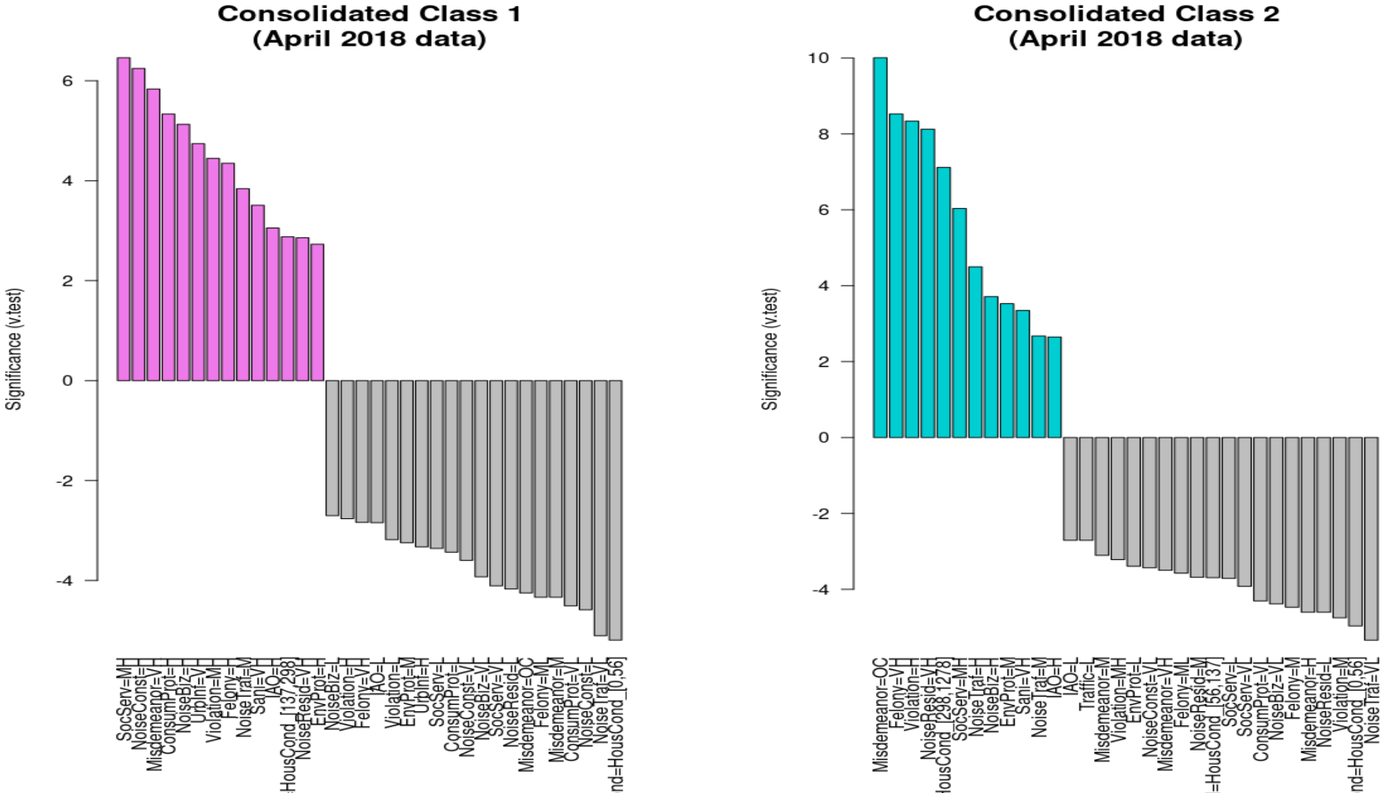
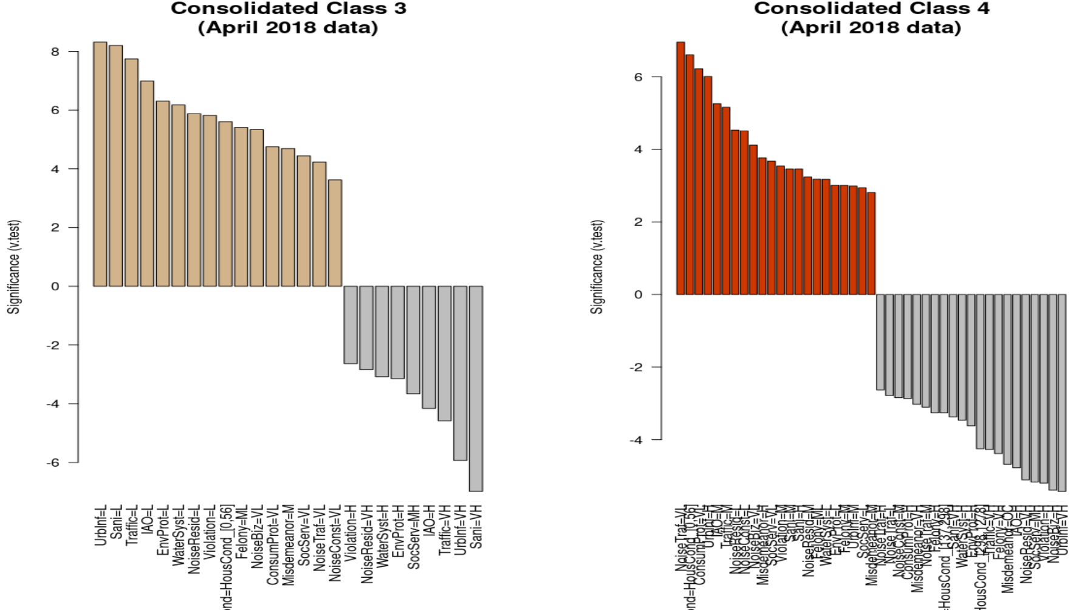

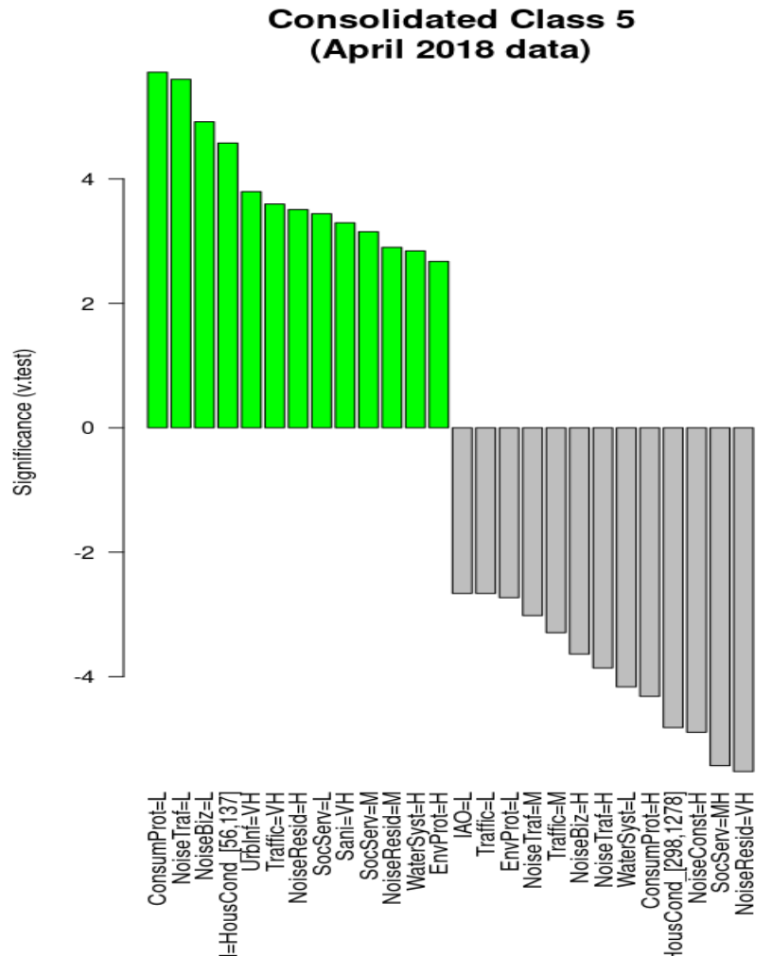
Class 1 's most significant modalities:
SocServ=MH NoiseConst=H Misdemeanor=VH ConsumProt=H NoiseBiz=H UrbInf=VH Violation=MH Felony=H NoiseTraf=M Sani=VH IAO=H HousCond=[137,298] NoiseResid=VH EnvProt=H

Class 2 's most significant modalities:
Misdemeanor=OC Felony=VH Violation=H NoiseResid=VH HousCond=[298,1278] SocServ=MH NoiseTraf=H NoiseBiz=H EnvProt=M Sani=VH NoiseTraf=M IAO=H

Class 3 's most significant modalities:
UrbInf=L Sani=L Traffic=L IAO=L EnvProt=L WaterSyst=L NoiseResid=L Violation=L HousCond=[0,56] Felony=ML NoiseBiz=VL ConsumProt=VL Misdemeanor=M SocServ=VL NoiseTraf=VL NoiseConst=VL

Class 4 's most significant modalities:
NoiseTraf=VL HousCond=[0,56] ConsumProt=VL UrbInf=H IAO=M Traffic=M NoiseResid=L NoiseConst=L NoiseBiz=VL Misdemeanor=H SocServ=VL Violation=M Sani=M Sani=H NoiseResid=M Felony=ML WaterSyst=L EnvProt=L Felony=M UrbInf=M SocServ=L Misdemeanor=M

Class 5 's most significant modalities:
ConsumProt=L NoiseTraf=L NoiseBiz=L HousCond=[56,137] UrbInf=VH Traffic=VH NoiseResid=H SocServ=L Sani=VH SocServ=M NoiseResid=M WaterSyst=H EnvProt=H

