BAKKEN PRODUCTION TREND ANALYSIS
and Oil Production Forecast
Historical period: May 2003 - December 2025
Forecast horizon: January 2026 - December 2027

29,442  Clean monthly records | 130  Unique wells | 535,289 bbl  2025 oil production
497,842 bbl  2026 P50 forecast | 480,676 bbl  2027 P50 forecast | 5.8%  Backtest MAPE

Report purpose: Provide a transparent production-history review, identify field-level trends, and estimate near-term oil production using decline-curve analysis.
Prepared from the supplied Bakken production dataset
28 July 2026

Table of contents
The report is organized as a decision-oriented technical review.
Section | Topic | Page
1 | Executive summary | 3
2 | Dataset scope and variable definitions | 4
3 | Data quality and preprocessing | 5
4 | Monthly oil production history | 6
5 | Annual oil production and decline | 7
6 | Gas and water production trends | 8
7 | Well activity and productivity | 9
8 | Gas-oil ratio and water-cut behavior | 10
9 | Well-level production performance | 11
10 | Forecast methodology and model selection | 12
11 | Backtest validation | 13
12 | Production forecast for 2026-2027 | 14
13 | Monthly forecast, limitations and conclusions | 15

Scope note: The forecast is an aggregate statistical decline forecast for the wells in the workbook. It is not a reserves estimate and does not include planned drilling, workovers, shut-ins or economic limits.

1. Executive summary
The dataset describes monthly oil, gas and water production from 130 Bakken wells. After removing exact duplicate records, the cleaned history contains 29,442 well-month rows from May 2003 through December 2025.
333,099 bbl (Dec 2006)  Peak monthly oil | 3.53 million bbl (2007)  Peak annual oil | 582,214 bbl  2024 oil
535,289 bbl  2025 oil | -8.1%  2025 year-on-year | 31.72 million bbl  Cumulative oil

Principal findings
- The production system is mature. Annual oil production in 2025 was about 84.8% below the 2007 peak.
- The number of active wells remained broadly stable near 123 wells in recent years, while production per active well declined substantially.
- Gas-oil ratio increased over the life of the dataset, indicating progressively more gas relative to oil, although it eased in 2024-2025.
- Water cut has remained elevated at roughly 38-41% in recent years, but is variable and influenced by individual high-water months.
- A hyperbolic decline model fitted to the most recent 120 months gave the best 2025 backtest performance, with MAPE of approximately 5.8%.
- The P50 forecast is 497,842 bbl for 2026 and 480,676 bbl for 2027, representing declines of about 7.0% and 3.4%, respectively.
Decision implication: Without new drilling or material production optimization, aggregate oil output is expected to continue declining, but at a slower rate than the 2025 year-on-year drop.

2. Dataset scope and variable definitions
Each row represents one well production record for a reporting month. The reporting date is normally the last day of the month; repeated dates are expected because many wells report during the same month.
Column | Interpretation
API # | Unique well identifier. The combination of API number and report month should normally identify one well-month record.
C | A time field imported as 12:00 AM for every row; it carries no analytical information in this dataset.
RptDate | End-of-month reporting date for the production period.
Formation | Producing geological formation; all records in the workbook are labeled Bakken.
Lease_Unit | Lease or unit identifier associated with the well.
BBLS_OIL_COND | Monthly oil or condensate volume in barrels.
MCF_GAS | Monthly natural-gas volume in thousand cubic feet.
BBLS_WTR | Monthly produced-water volume in barrels.
DAYS_PROD | Number of producing days reported for the well in that month.

Analytical scope
- Monthly and annual aggregation of oil, gas and water.
- Calendar-day field rates, active-well counts and oil per active well-month.
- Gas-oil ratio and water-cut trend analysis.
- Well ranking by cumulative oil and recent production.
- Aggregate decline-curve forecasting through December 2027.

3. Data quality and preprocessing
Data cleaning was performed before trend calculation and forecasting. Exact duplicates were removed, while negative production values were retained as likely reporting corrections or reversals.
Check | Result | Treatment
Raw records | 29,692 | Input workbook row count.
Exact duplicate records | 250 | All duplicates belonged to API 25-083-22199-00-00 and repeated 250 monthly records.
Clean records | 29,442 | Used for all results in this report.
Missing values | 0 | No missing values in the nine supplied columns.
DAYS_PROD > 31 | 1 | One record reports 73 days; flagged as invalid but does not affect calendar-day field-rate forecasting.
DAYS_PROD = 0 | 1,135 | Represents reported months with no producing days.
Negative oil values | 5 | Small correction entries; retained in aggregate totals.
Negative water values | 10 | Correction entries; retained in aggregate totals.

Preprocessing rules
- Converted report dates to monthly timestamps and sorted chronologically.
- Removed only exact duplicate rows; no interpolation was used for production volumes.
- Aggregated production by month and divided by calendar days to obtain field BOPD.
- Defined an active well as a row with DAYS_PROD greater than zero.
- Used total monthly oil as the forecast target; the DAYS_PROD anomaly was therefore not used in model fitting.
Important correction: The cleaned 2024 and 2025 oil totals are 582,214 bbl and 535,289 bbl. These values supersede preliminary totals calculated before duplicate removal.

4. Monthly oil production history
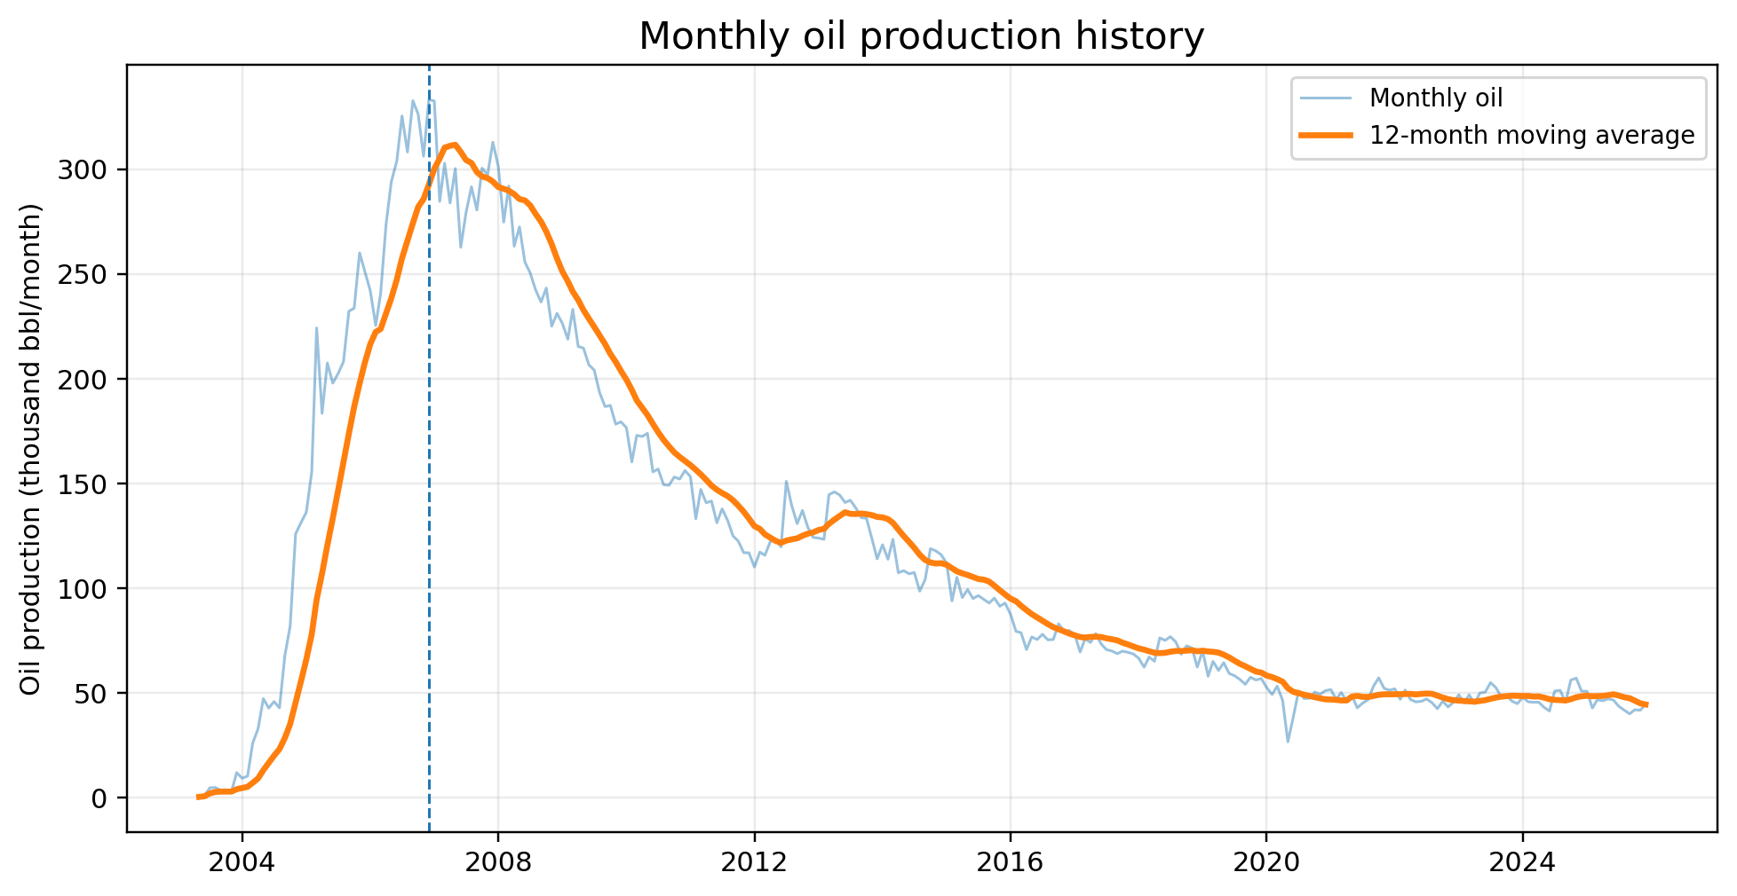
Figure 1. Monthly oil production and 12-month moving average, May 2003 - December 2025.
Monthly production rose rapidly after 2003 as wells entered the dataset. The highest monthly oil volume was 333,099 bbl in December 2006. The 12-month moving average shows a broad decline after the 2006-2008 plateau, interrupted by shorter periods of stabilization or recovery.

Trend interpretation
- 2003-2007: rapid development and production build-up.
- 2007-2013: high production followed by gradual decline and temporary stabilization.
- 2014-2020: stronger decline, with a pronounced fall in 2020.
- 2021-2024: relatively stable field output around 0.56-0.59 million bbl/year.
- 2025: renewed decline, with monthly oil generally between about 40,000 and 51,000 bbl.

5. Annual oil production and decline
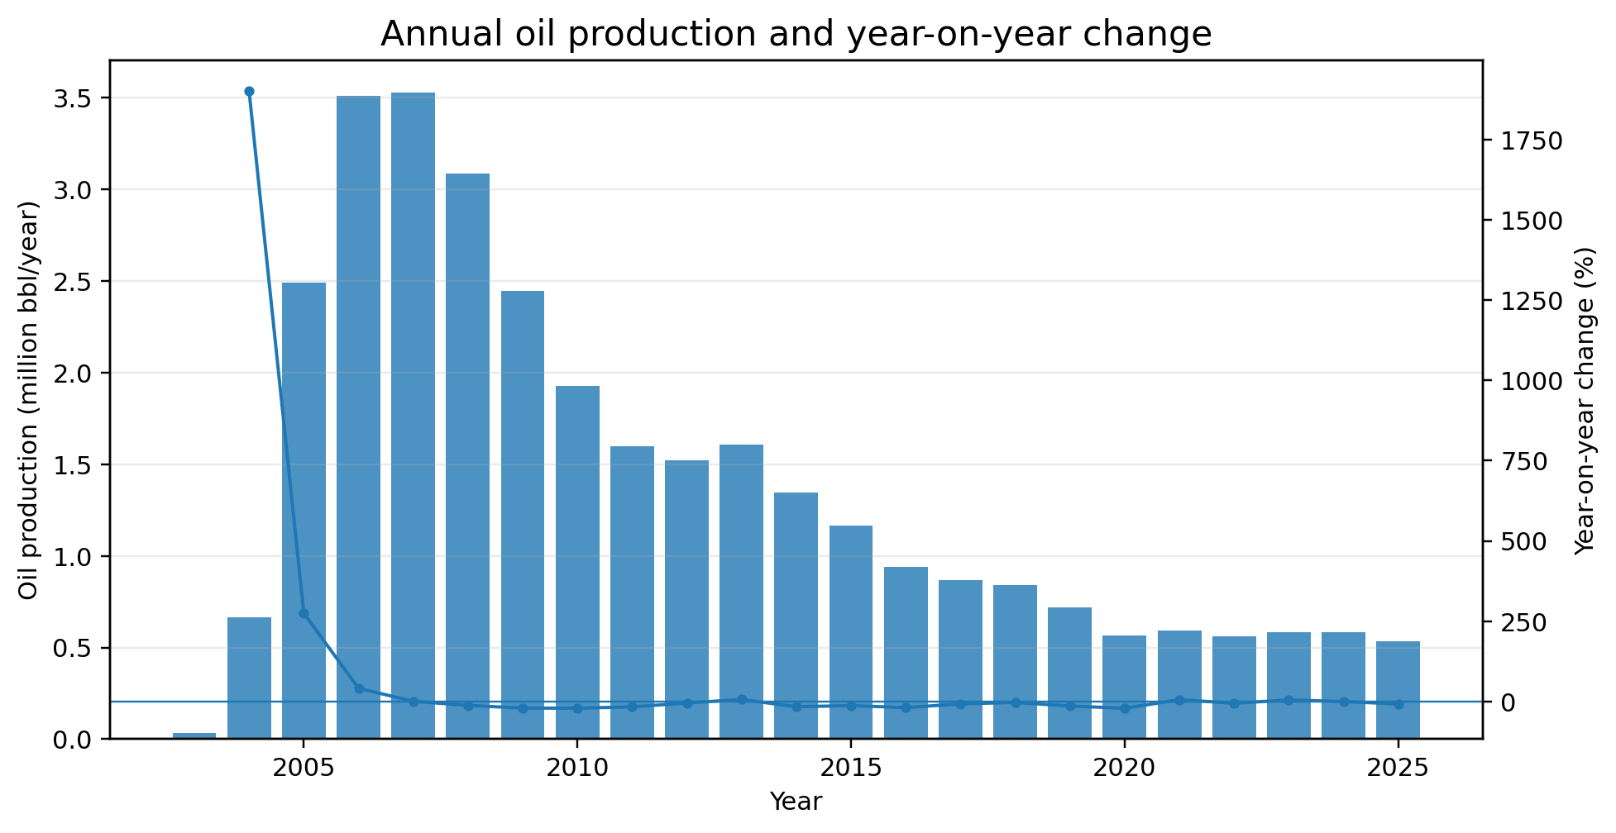
Figure 2. Annual oil production and year-on-year change. The first and last years are partial/full according to dataset coverage.
Year | Oil (bbl) | YoY change | Avg. active wells
2004 | 665,297 | 1901.3% | 9.2
2007 | 3,528,543 | 0.5% | 91.0
2010 | 1,928,850 | -21.1% | 114.7
2015 | 1,165,377 | -13.3% | 122.0
2020 | 564,502 | -21.4% | 120.1
2024 | 582,214 | -0.4% | 123.2
2025 | 535,289 | -8.1% | 123.2
Annual oil peaked at 3.53 million bbl in 2007. By 2025, output had fallen to 0.535 million bbl, an 84.8% reduction from the annual peak. The implied compound decline from 2007 to 2025 is approximately 10% per year, although the trajectory is not uniform.

6. Gas and water production trends
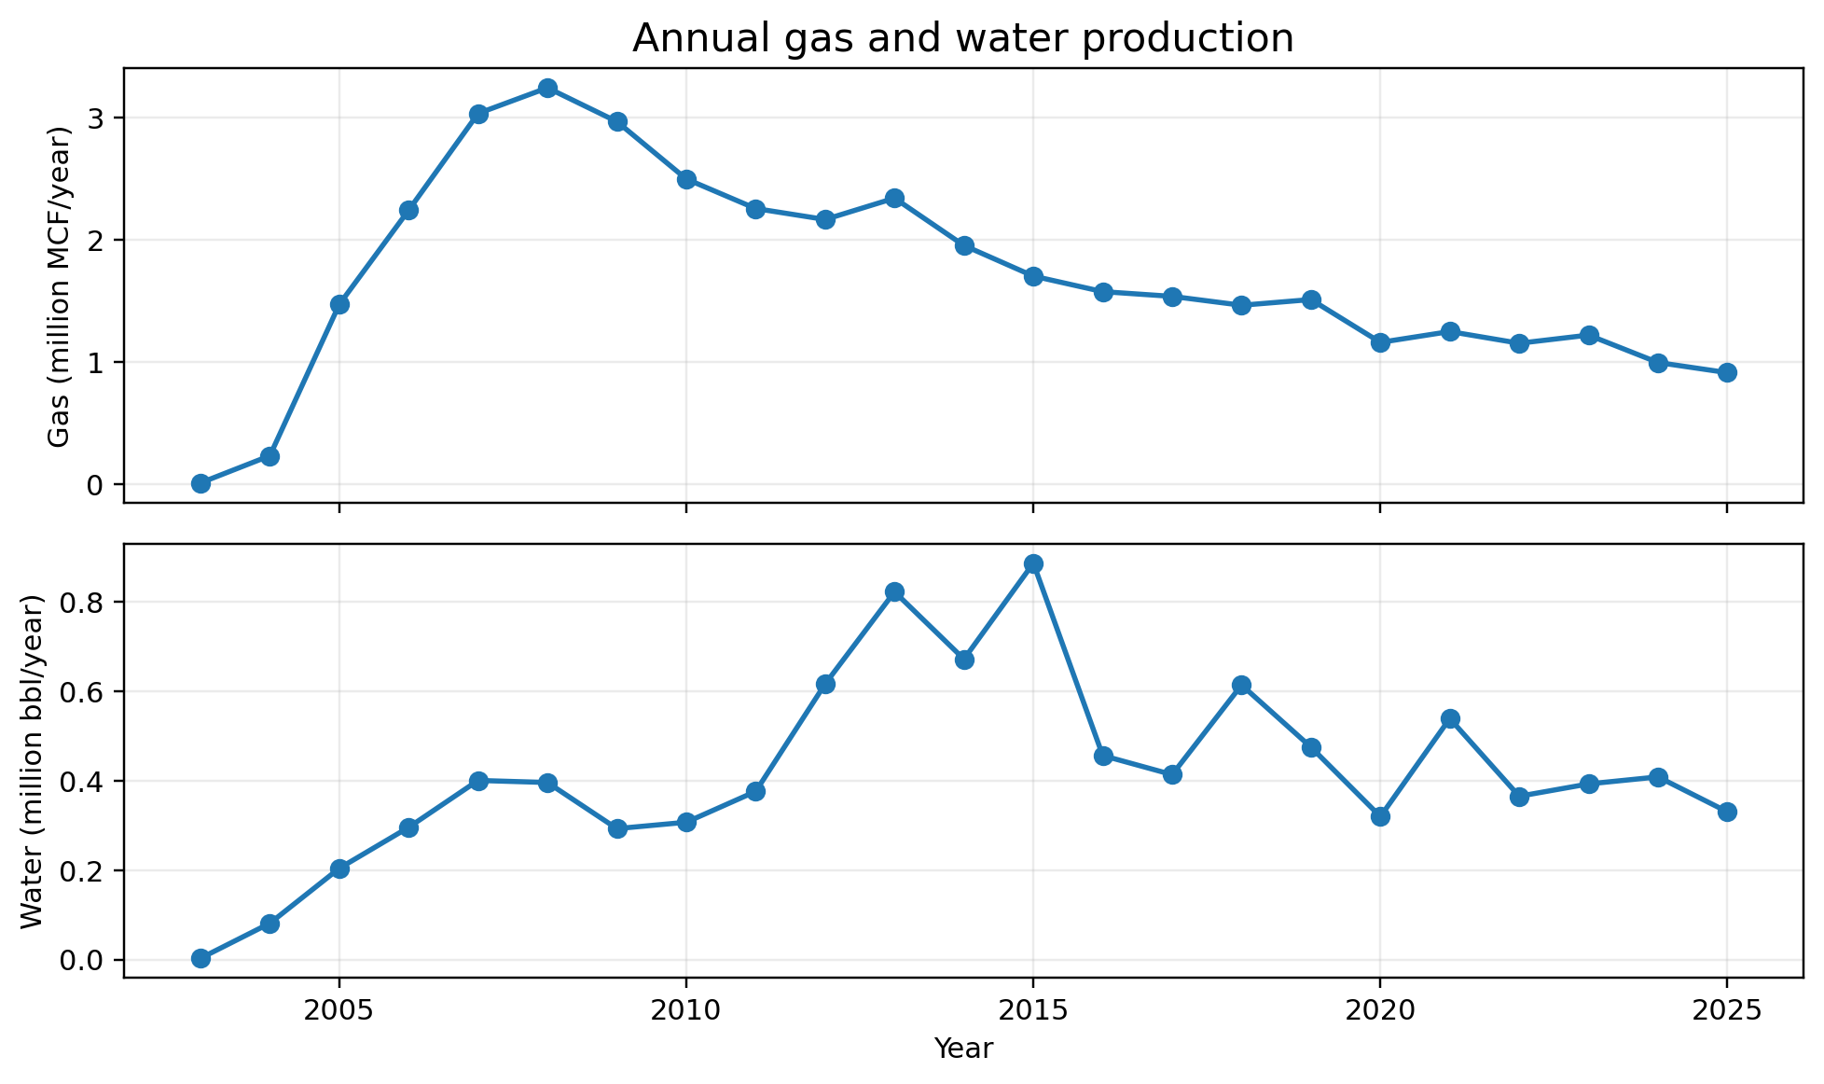
Figure 3. Annual natural-gas and produced-water volumes.
Gas production generally followed the oil-development cycle, but the gas decline has been less proportional than the oil decline. Produced-water volumes are more irregular, reflecting well-specific water behavior, operational changes and occasional large water-reporting events.
Metric | Volume | Period
Peak annual gas | 3,244,419 MCF | 2008
2025 gas | 914,837 MCF | 2025
Peak annual water | 886,974 bbl | 2015
2025 water | 330,472 bbl | 2025
Cumulative gas | 38,936,678 MCF | 2003-2025
Cumulative water | 9,672,485 bbl | 2003-2025
Operational relevance: Increasing gas fraction and persistent water production can affect separation capacity, lifting efficiency, disposal requirements and the economic limit of mature wells.

7. Well activity and average productivity
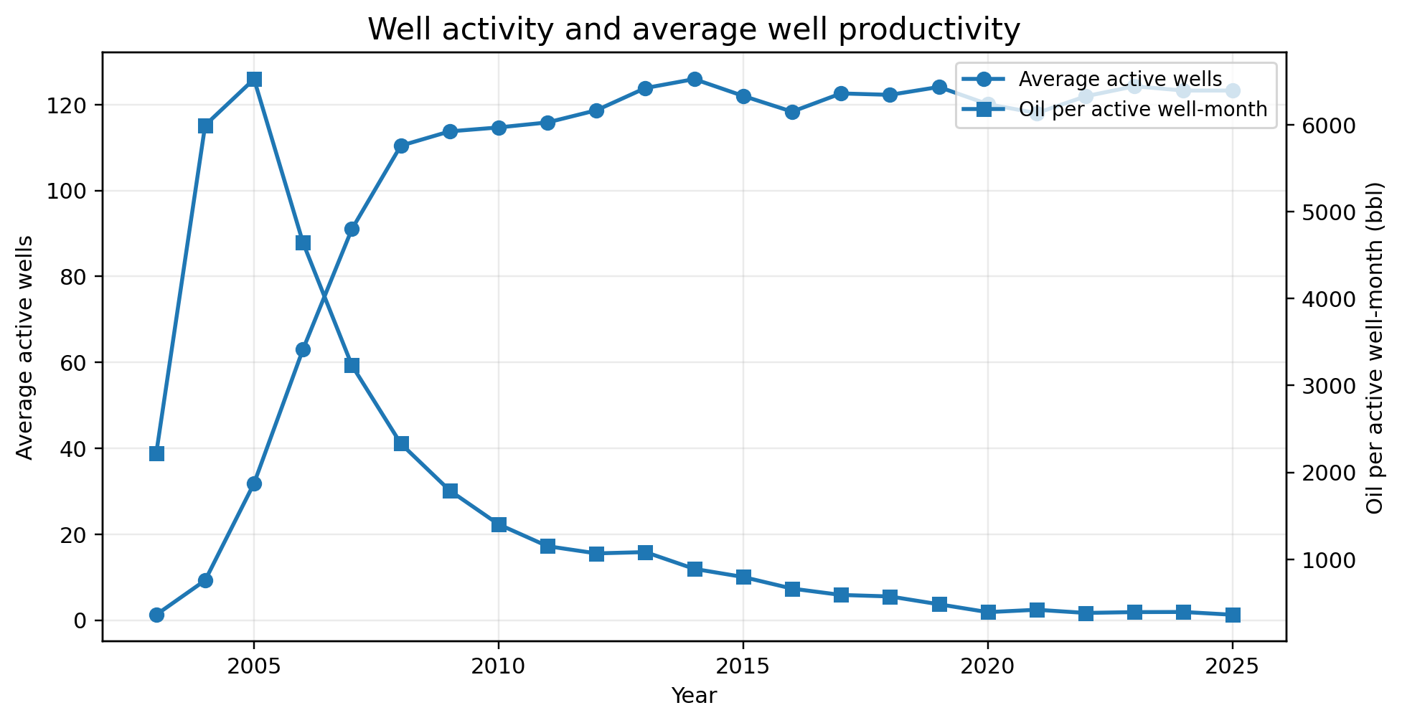
Figure 4. Average active-well count and oil produced per active well-month.
Year | Avg. active wells | Oil / active well-month (bbl) | Avg. field BOPD
2007 | 91.0 | 3,231 | 9,668
2015 | 122.0 | 796 | 3,193
2020 | 120.1 | 392 | 1,543
2025 | 123.2 | 362 | 1,467
The active-well count increased as the field developed and has remained near 118-124 wells for much of the last decade. However, oil per active well-month fell from about 3,231 bbl in 2007 to about 362 bbl in 2025. This indicates that the aggregate decline is primarily a productivity decline rather than a large reduction in the number of producing wells.
Interpretation: Maintaining a nearly constant active-well count does not prevent field decline when the underlying well rates continue to fall.

8. Gas-oil ratio and water-cut behavior
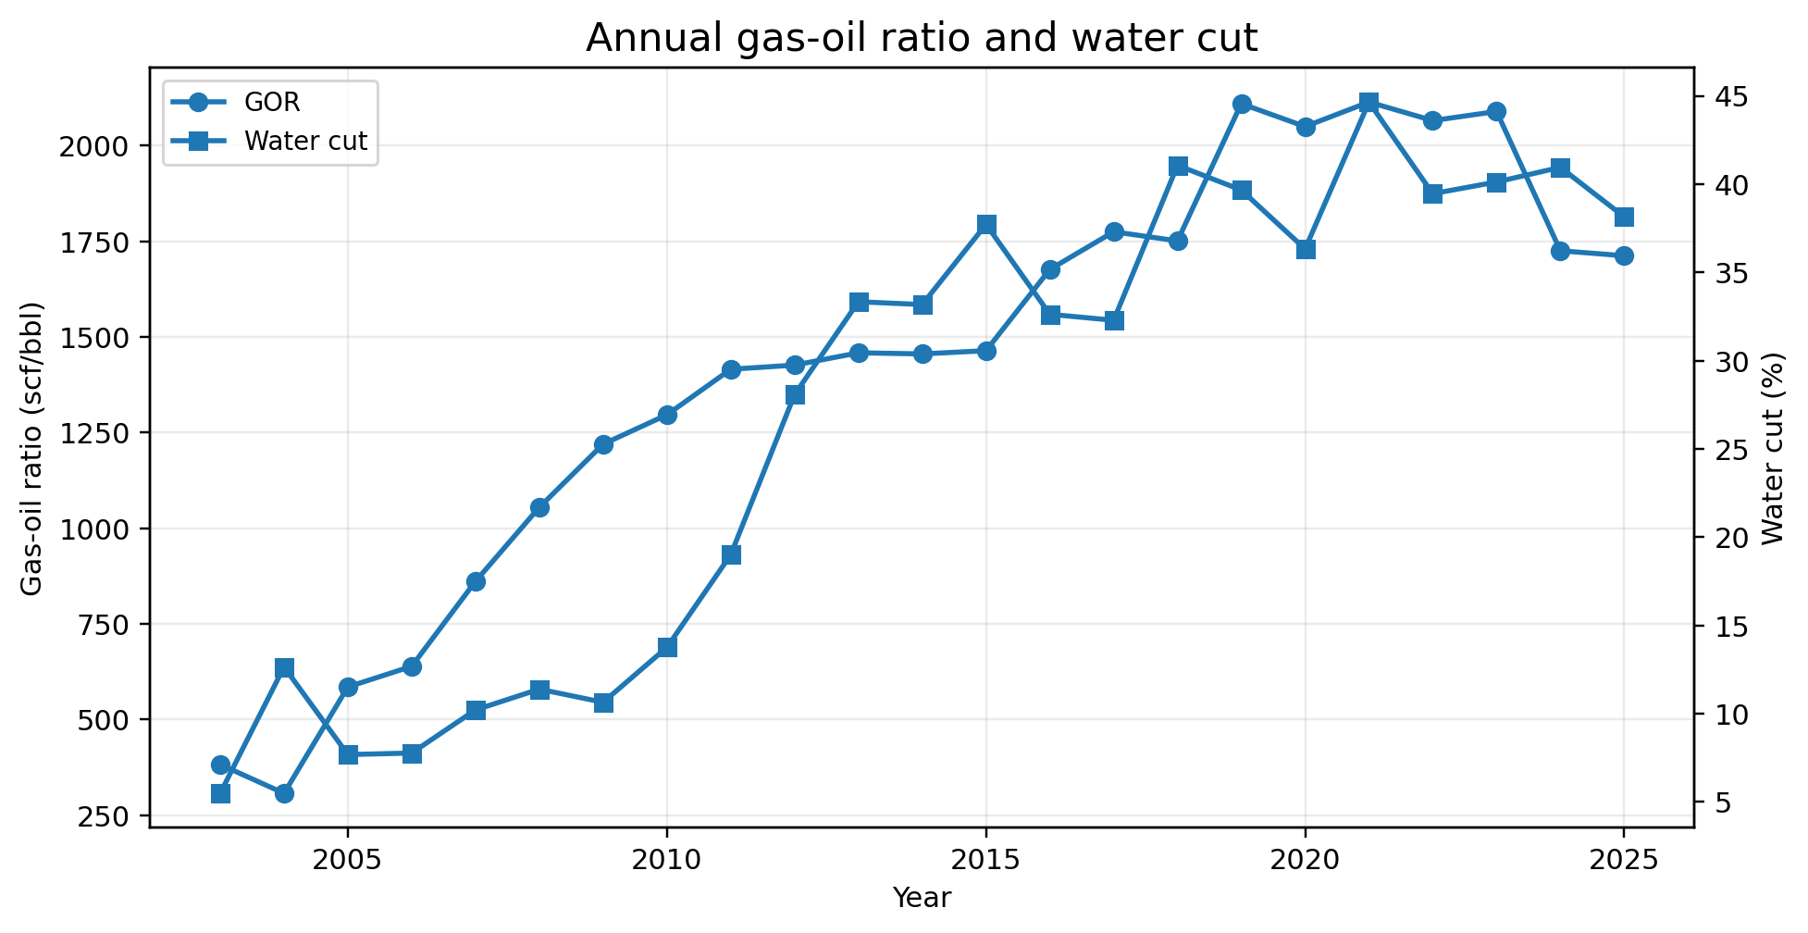
Figure 5. Annual average gas-oil ratio and water cut calculated from monthly aggregate volumes.
Year | Average GOR (scf/bbl) | Average water cut
2007 | 861 | 10.2%
2015 | 1,464 | 37.7%
2020 | 2,050 | 36.3%
2024 | 1,725 | 40.9%
2025 | 1,712 | 38.1%
GOR increased from roughly 861 scf/bbl in 2007 to more than 2,000 scf/bbl around 2019-2023, before declining to about 1,712 scf/bbl in 2025. Water cut rose from about 10% near the annual oil peak to roughly 38% in 2025.

Engineering implications
- Higher GOR may reflect pressure depletion, changing phase behavior, gas breakthrough or relative-permeability effects.
- Elevated water cut increases handling and disposal cost and can reduce oil-lifting efficiency.
- Field-level ratios are weighted aggregates; well-level diagnostics are required to distinguish reservoir effects from individual-well anomalies.

9. Well-level production performance
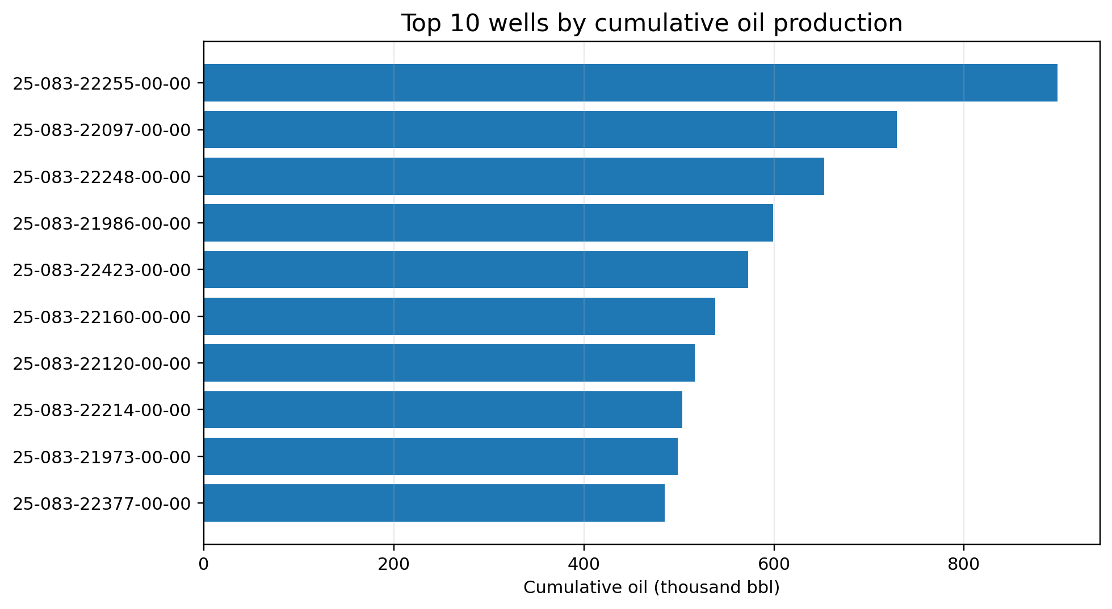
Figure 6. Top 10 wells ranked by cleaned cumulative oil production.
API well | Cumulative oil (bbl) | 2025 oil (bbl)
25-083-22255-00-00 | 898,070 | 2,593
25-083-22097-00-00 | 729,379 | 6,132
25-083-22248-00-00 | 652,560 | 4,954
25-083-21986-00-00 | 598,932 | 5,418
25-083-22423-00-00 | 572,987 | 5,208
25-083-22160-00-00 | 537,924 | 2,557
25-083-22120-00-00 | 516,452 | 4,168
25-083-22214-00-00 | 503,286 | 9,050

Leading 2025 producers
- 25-083-22196-00-00: 33,079 bbl in 2025.
- 25-083-22478-00-00: 31,234 bbl in 2025.
- 25-083-22357-00-00: 25,724 bbl in 2025.
- 25-083-22040-00-00: 22,163 bbl in 2025.
- 25-083-22210-00-00: 19,194 bbl in 2025.
Historical leaders are not necessarily the strongest current producers. Mature-field surveillance should therefore combine cumulative production, recent rate, downtime, water cut and decline behavior.

10. Forecast methodology and model selection
The forecast target is aggregate monthly oil production for the wells in the workbook. Models were fitted to field calendar-day oil rate and converted back to monthly volumes using the number of calendar days.

Decline models evaluated
Model | Equation | Interpretation
Exponential | q(t) = qi exp(-D t) | Constant fractional decline rate.
Harmonic | q(t) = qi / (1 + D t) | Decline slows with time; equivalent to hyperbolic b = 1.
Hyperbolic | q(t) = qi / (1 + b Di t)^(1/b) | Flexible decline with curvature controlled by b.
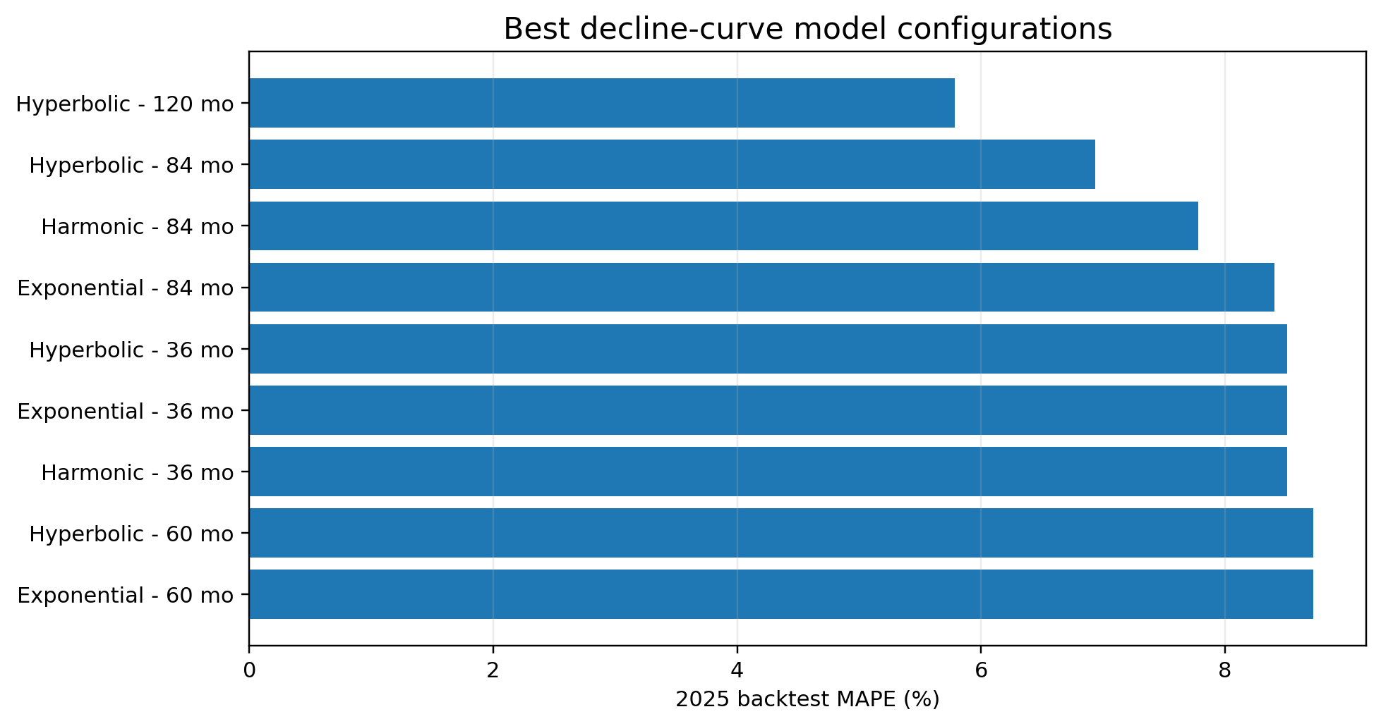
Figure 7. Best model/window configurations ranked by 2025 backtest MAPE.
The selected configuration was a hyperbolic model fitted to 120 months of history. Its 2025 MAPE was 5.8%, with RMSE of 3,258 bbl/month. The final fit through December 2025 produced qi = 2,784 BOPD, Di = 0.0126 per month and b = 2.00.
Model caution: The fitted b value reached the imposed upper bound of 2.0. This suggests strong flattening and is one reason the forecast horizon is limited to two years.

11. Backtest validation
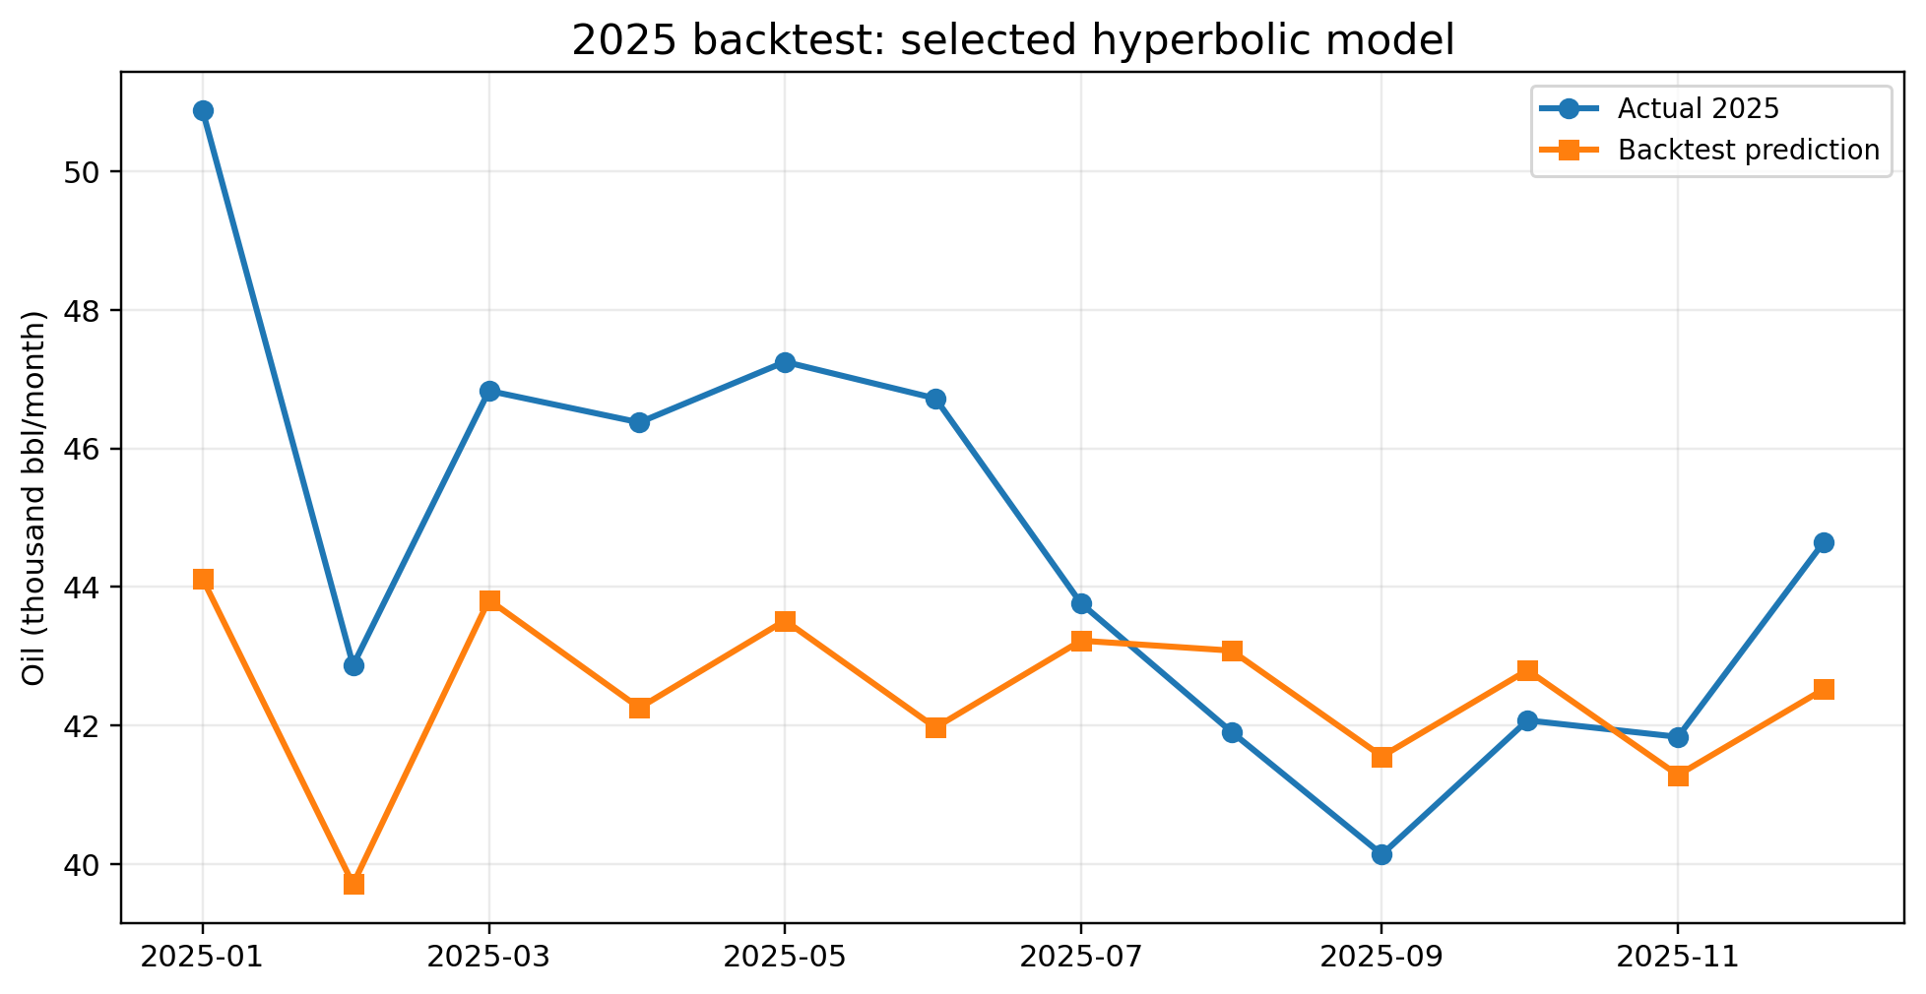
Figure 8. Actual 2025 monthly oil compared with the prediction made using data only through December 2024.

The selected model achieved MAPE of 5.8%, MAE of 2,674 bbl/month and RMSE of 3,258 bbl/month. It underpredicted the first half of 2025 and tracked the second half more closely; operational fluctuations are not captured by a smooth decline curve.
2025 month | Actual | Predicted | Error
Jan | 50,879 | 44,115 | -13.3%
Feb | 42,869 | 39,709 | -7.4%
Mar | 46,833 | 43,812 | -6.5%
Apr | 46,376 | 42,254 | -8.9%
May | 47,251 | 43,515 | -7.9%
Jun | 46,723 | 41,970 | -10.2%
Jul | 43,762 | 43,224 | -1.2%
Aug | 41,907 | 43,081 | 2.8%
Sep | 40,137 | 41,554 | 3.5%
Oct | 42,073 | 42,798 | 1.7%
Nov | 41,835 | 41,283 | -1.3%
Dec | 44,644 | 42,521 | -4.8%

12. Production forecast for 2026-2027
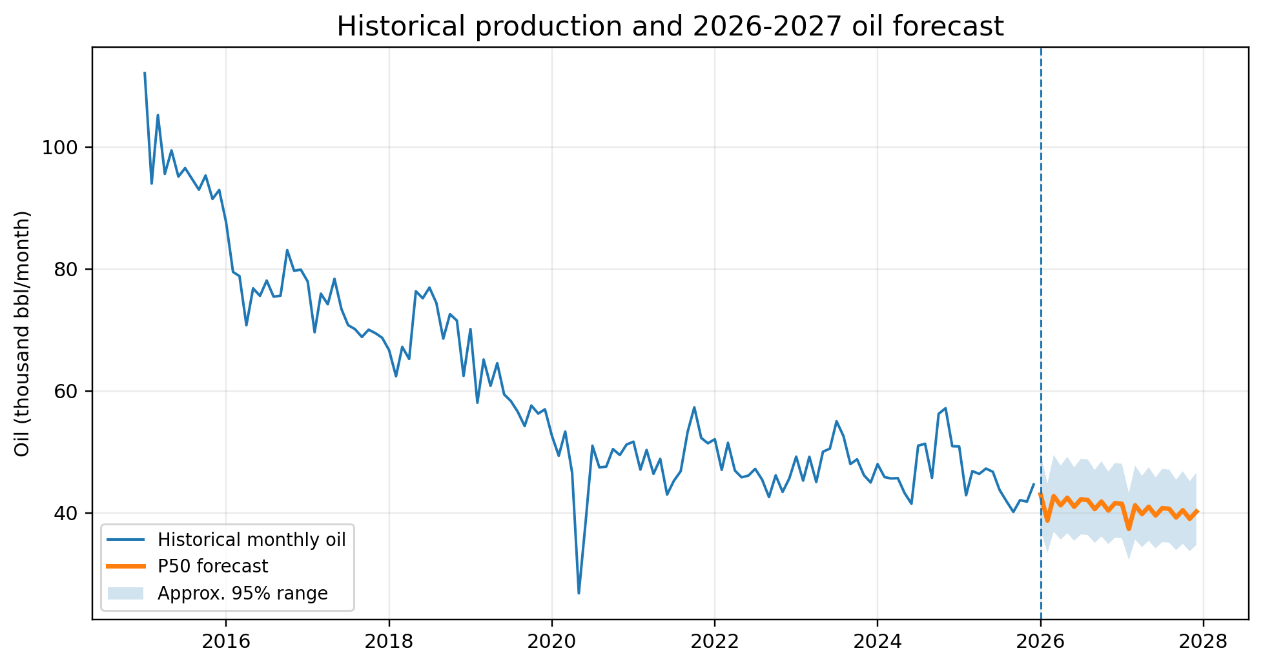
Figure 9. Historical monthly oil since 2015 and the P50 forecast with an approximate 95% statistical range.
Year | P50 oil (bbl) | Lower 95% | Upper 95% | Change
2026 | 497,842 | 429,896 | 576,527 | -7.0%
2027 | 480,676 | 415,073 | 556,648 | -3.4%
The central forecast declines from 535,289 bbl in 2025 to 497,842 bbl in 2026 and 480,676 bbl in 2027. The modeled rate of decline moderates with time because of the hyperbolic shape.
Model reference | 2026 (bbl) | 2027 (bbl)
Exponential | 452,495 | 422,026
Harmonic | 474,242 | 451,950
Hyperbolic | 497,842 | 480,676
Forecast meaning: The uncertainty interval measures recent statistical variation around the curve. It does not represent full business uncertainty from new wells, maintenance, commodity prices or operating decisions.

13. Monthly forecast, limitations and conclusions

Monthly P50 oil forecast
Month | 2026 oil | 2027 oil | 2026 BOPD | 2027 BOPD
Jan | 43,001 | 41,471 | 1,387 | 1,338
Feb | 38,719 | 37,349 | 1,383 | 1,334
Mar | 42,734 | 41,231 | 1,379 | 1,330
Apr | 41,228 | 39,787 | 1,374 | 1,326
May | 42,472 | 40,996 | 1,370 | 1,322
Jun | 40,977 | 39,561 | 1,366 | 1,319
Jul | 42,215 | 40,764 | 1,362 | 1,315
Aug | 42,088 | 40,650 | 1,358 | 1,311
Sep | 40,609 | 39,229 | 1,354 | 1,308
Oct | 41,838 | 40,424 | 1,350 | 1,304
Nov | 40,369 | 39,013 | 1,346 | 1,300
Dec | 41,592 | 40,202 | 1,342 | 1,297

Limitations
- The model is aggregate and does not forecast each well separately.
- No future drilling, re-fracturing, workovers, shut-ins or facility constraints are scheduled.
- Reported production corrections and one invalid DAYS_PROD value remain in the source history, although they do not materially control the aggregate forecast.
- The high fitted hyperbolic b factor can produce optimistic long-term tails; forecasts beyond 2027 should use terminal decline and economic-limit assumptions.
- The statistical interval is not equivalent to petroleum-reserves P10/P50/P90 classification.

Conclusions and recommendations
1. Use 497,842 bbl for 2026 and 480,676 bbl for 2027 as the base-case aggregate forecast.
2. Update the model quarterly as new production data become available.
3. Perform well-level DCA for the highest-current-rate wells and for wells with abnormal water or downtime.
4. Integrate completion, pressure, artificial-lift and intervention data before using the forecast for reserves or investment decisions.
Final conclusion: The supplied Bakken well set is in a mature decline phase. Stable active-well counts are not offsetting declining well productivity, so continued aggregate oil decline is the most likely near-term outcome without new capital or operational intervention.

