

Republic of the Philippines

Laguna State Polytechnic University

Province of Laguna

**QuickPC Payroll Management System**

Prepared by: Albert Q. Pasco

Course & Section: BSCS 2-A

Date: July 9, 2020

**TABLE OF CONTENTS**

* Introduction
* System User-interface
* SQL server script
* System code

**Introduction**

A QuickPC payroll management system is a software program designed to organize all the tasks of employee payment and tax filing. These tasks include keeping track of hours, calculating wages, tracking attendance, withholding taxes and deductions, printing and delivering checks, completing direct deposits, paying premiums to insurance carriers, and/or paying employment taxes to the government. This software can be purchased through an HR software vendor or included in an HR software package as a module within a comprehensive system.

QuickPC payroll is something that has to be done accurately and regularly, so it makes sense for companies to monitor staff income in a system that automates these processes. Payroll software can mitigate errors, improve compliance, and save time. With increasingly easy-to-use options, they can also maintain more control of the payroll process with this software, which allows them to compile reports at their own pace and make changes quickly if the need arises.

**System User-interface**

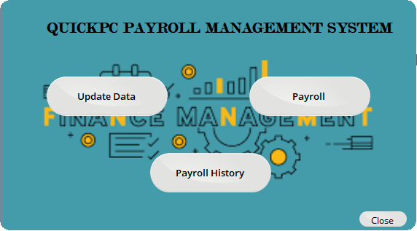

*Main screen of the system application.*

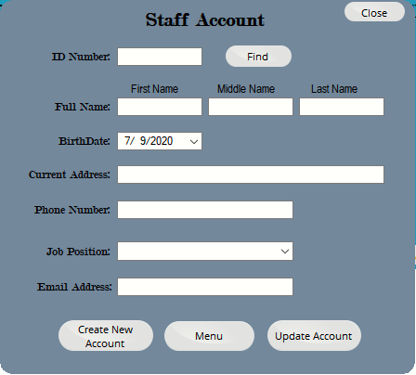

*Creation/Updating account information of employees.*

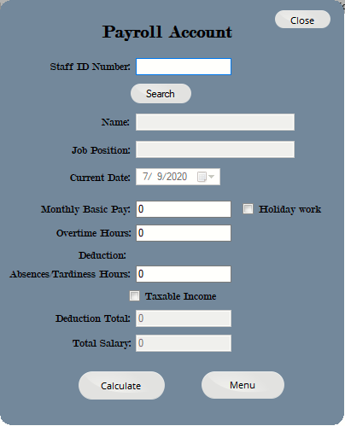

*Payroll Account information and calculating total salary and deduction of taxes.*

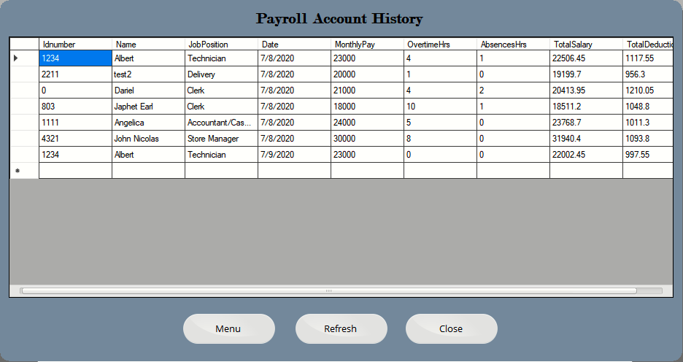

*Application previously computed payroll of the employees recorded into Microsoft SQL Server Database.*

**SQL server script**

SQL server connection string of the system:



SQL String for Insert data into database:



SQL String for Update data into database:



SQL String for Retrieving data from database:





**System code**

Main form of the system: *c# and sql script.



Creation/Updating Employees Account: *c# and sql script.



Payroll Account information: *c# and sql script.



Computing Overall Payroll: *c++ dll



Payroll history: *c# and sql script