Republic of the Philippines

Laguna State Polytechnic University

Province of Laguna

**COLLEGE OF COMPUTER STUDIES**

**Bachelor of Science in Computer Science**

**LSPU CCS VO-AG ROOM MANAGEMENT SYSTEM**

**In Partial Fulfillment**

**Of the Requirements**

**In**

**Object Oriented Programming**

**CMSC 203**

**by**

**ALBERT Q. PASCO**

**DARIEL POLESTICO**

**MIKE NEO RENGHIE C. RATAC**

**OUR PROGRAM IS ALL ABOUT?**

* The Room Scheduling System in VOAG Building as a management reporting tool to help get the work done on time. Used to assist the user to locate the specific task.

**OBJECTIVES**

* Is to make more convenient to use, for what user’s needs.
* To reduce the complexity of schedule and for quick view of the user enables to assist them.

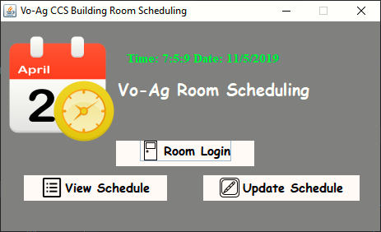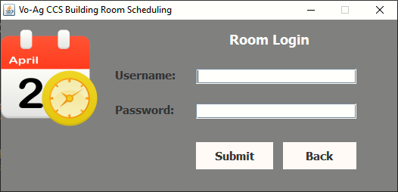SCREENSHOT OF THE PROGRAM:

**INHERITANCE:**

This is our main menu or Parent of program. That can call the others form by the button event.

JButton btnNewButton = new JButton("View Schedule");

btnNewButton.addActionListener(new ActionListener() {

public void actionPerformed(ActionEvent e) {

view.mainview();

frmVoagCcsBuilding.dispose();

}

});

JButton btnRoomLogin = new JButton("Room Login");

btnRoomLogin.addActionListener(new ActionListener() {

public void actionPerformed(ActionEvent arg0) {

position.pos();

frmVoagCcsBuilding.dispose();

}

});

JButton btnUpdateSchedule = new JButton("Update Schedule");

btnUpdateSchedule.addActionListener(new ActionListener() {

public void actionPerformed(ActionEvent e) {

login_update.log();

frmVoagCcsBuilding.dispose();

}

});

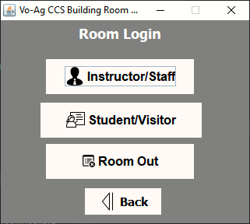

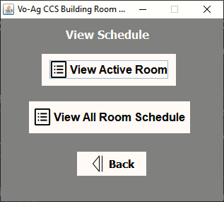

This is the Sub-Menu that can call the child form.

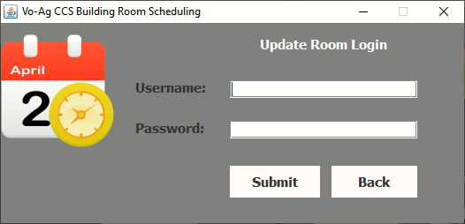My Condition in log in section.

**DATA ABSTRACTION:**



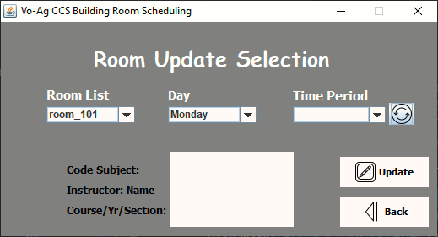

btnSubmit.addActionListener(new ActionListener() {

public void actionPerformed(ActionEvent e) {

String uname = txtfuser.getText();

String pass = passwordField.getText();

if (uname.equals("ccsvoag") && pass.equals("ccsvoag")) {

JOptionPane.showMessageDialog(frmVoagCcsBuilding, "Successfully Login!");

updaterm.update();

frmVoagCcsBuilding.dispose();

} else if (txtfuser.getText().equals("") || passwordField.getText().equals("")) {

JOptionPane.showMessageDialog(frmVoagCcsBuilding, "Please Input!");

} else {

JOptionPane.showMessageDialog(frmVoagCcsBuilding, "Incorrect Username or Password");

}

}

});

JButton btnupdate = **new** JButton("Update");

btnupdate.addActionListener(**new** ActionListener() {

**public** **void** actionPerformed(ActionEvent e) {

**if**(textArea.getText().equals("")){

JOptionPane.showMessageDialog(frmVoagCcsBuilding,

"Please Input!");

}

**else** {

**try** {

String sql = "UPDATE " + cbroom.getSelectedItem().toString()

+ " SET "

+ cbday.getSelectedItem().toString() + " = '" +

textArea.getText() + "' where Period='"

+ cbtime.getSelectedItem().toString() + "'";

pst = con.prepareStatement(sql);

pst.execute();

JOptionPane.showMessageDialog(**null**, "Successfuly Updated!");

} **catch** (Exception ex) {

JOptionPane.showMessageDialog(**null**, ex);

}

}

}

});

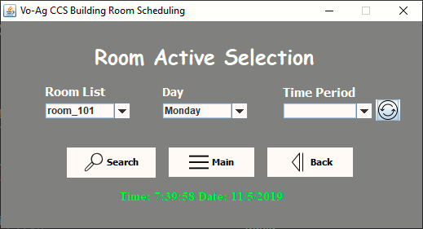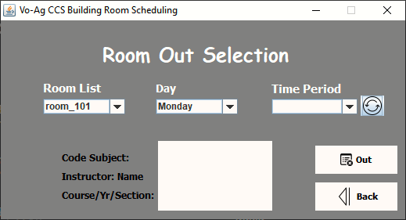

Function of Search button to view the active room information.

Function of Refresh button to retrieve the active room time.

**public** **void** actionPerformed(ActionEvent arg0) {

**if** (comboBox_room.getSelectedItem() == "room_102") {

String sql = "select * from room_102 where Period=?";

String tmp = (String) comboBox_period.getSelectedItem();

**try** {

pst = con.prepareStatement(sql);

pst.setString(1, tmp);

rs = pst.executeQuery();

**if** (rs.next()) {

String mon = rs.getString(comboBox_day.getSelectedItem().toString());

JOptionPane.showMessageDialog(**null**, mon);

} **else** **if** (comboBox_day.getSelectedItem().toString() != **null**) {

JOptionPane.showMessageDialog(**null**, "No Classes");

}

} **catch** (Exception ex) {

JOptionPane.showMessageDialog(**null**, ex);

}

**public** **void** actionPerformed(ActionEvent e) {

**try** {

Class.forName("com.mysql.jdbc.Driver");

} **catch** (ClassNotFoundException ef) {

ef.printStackTrace();

}

**try** {

con = DriverManager.getConnection("jdbc:mysql://localhost:3306/ccsrmlog", "root", "");

} **catch** (SQLException e1) {

e1.printStackTrace();

}

comboBox_period.removeAllItems();

**if** (comboBox_room.getSelectedItem() == "room_101") {

**try** {

String sql = "select * from room_101";

pst = con.prepareStatement(sql);

rs = pst.executeQuery();

**while** (rs.next()) {

String period = rs.getString("Period");

comboBox_period.addItem(period);

}

} **catch** (Exception ew) {

JOptionPane.showMessageDialog(**null**, ew);

}

}

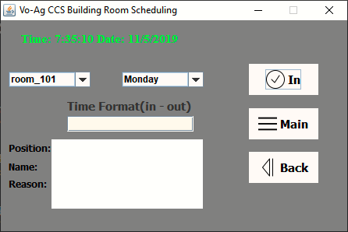

**public** **void** actionPerformed(ActionEvent e) {

**if**(textField_time.getText().equals("") || textArea.getText().equals("")){

JOptionPane.showMessageDialog(frmVoagCcsBuilding, "Please Input!");

}

**else** {

**try** {

Class.forName("com.mysql.jdbc.Driver");

} **catch** (ClassNotFoundException ef) {

ef.printStackTrace();

}

**try** {

String sql = "INSERT INTO " + comboBox_room.getSelectedItem().toString() + "(Period, "

+ comboBox_day.getSelectedItem().toString() + ") VALUES (?,?)";

con = DriverManager.getConnection("jdbc:mysql://localhost:3306/ccsrmlog", "root", "");

pst = con.prepareStatement(sql);

pst.setString(1, textField_time.getText());

pst.setString(2, textArea.getText());

pst.executeUpdate();

JOptionPane.showMessageDialog(**null**, "Insert Successfuly");

textArea.setText("");

} **catch** (SQLException | HeadlessException ex) {

JOptionPane.showMessageDialog(**null**, ex);

}

}

}

});

Function of Room Log-In button to add into a database.

This form, they view the all schedule per room. By the calling class User (List of the Column).

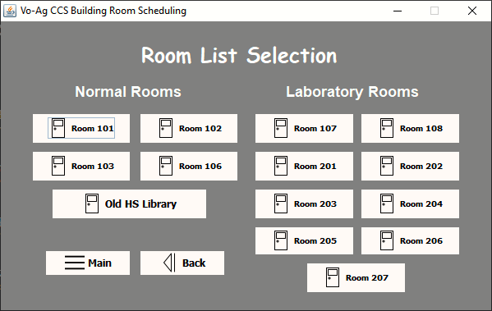

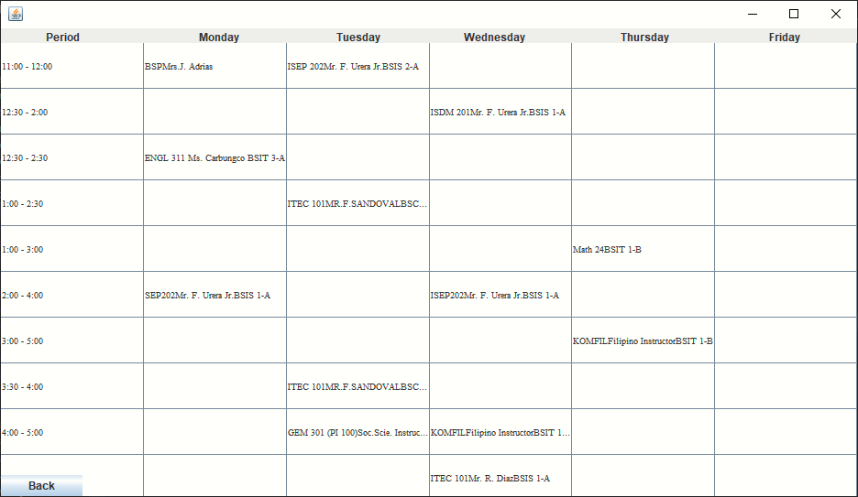



When click the button Room 101 to call the form.

**ENCAPSULATION:**

btnrm101.addActionListener(new ActionListener() {

public void actionPerformed(ActionEvent e) {

rm101.rm101();

frmVoagCcsBuilding.dispose();

}

});

We use Array List to get the value from User Class then from database.

public ArrayList<User> userList() {

ArrayList<User> userList = new ArrayList<>();

try {

Class.forName("com.mysql.jdbc.Driver");

con = DriverManager.getConnection("jdbc:mysql://localhost:3306/ccsrmschedule", "root", "");

String sql = "select * from room_101";

pst = con.prepareStatement(sql);

rs = pst.executeQuery();

User user;

while (rs.next()) {

user = new User(rs.getString("Period"), rs.getString("Monday"), rs.getString("Tuesday"),

rs.getString("Wednesday"), rs.getString("Thursday"), rs.getString("Friday"));

userList.add(user);

}

} catch (Exception e) {

JOptionPane.showMessageDialog(null, e);

}

return userList;

}

User class:

public class User {

private String Period, Monday, Tuesday, Wednesday, Thursday, Friday;

public User(String Period, String Monday, String Tuesday, String Wednesday, String Thursday, String Friday) {

this.Period = Period;

this.Monday = Monday;

this.Tuesday = Tuesday;

this.Wednesday = Wednesday;

this.Thursday = Thursday;

this.Friday = Friday;

}

public String getPeriod() {

return Period;

}

public String getMonday() {

return Monday;

}

public String getTuesday() {

return Tuesday;

}

public String getWednesday() {

return Wednesday;

}

public String getThursday() {

return Thursday;

}

public String getFriday() {

return Friday;

}

}



public void viewall() {

ArrayList<User> all = userList();

DefaultTableModel model = (DefaultTableModel) table.getModel();

Object[] column = new Object[6];

for (int i = 0; i < all.size(); i++) {

column[0] = all.get(i).getPeriod();

column[1] = all.get(i).getMonday();

column[2] = all.get(i).getTuesday();

column[3] = all.get(i).getWednesday();

column[4] = all.get(i).getThursday();

column[5] = all.get(i).getFriday();

model.addRow(column);

}

}