Task 1: Bayesian Decision Theory

1a) Optimal Boundary

1. Bayesian Decision Theory refers to a decision theory which is informed by Bayesian probability.
2. Goal: Minimize the misclassiﬁcation rate
3. Optimal decision boundary: Posterior probability

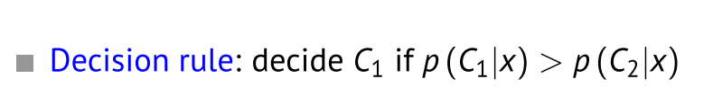

1b) Decision Boundaries