In these learning materials, students will understand and explore the structure of HTML and embed CSS styles.

**Activity Overview**

The activity highlights the basic structure of HTML and how CSS transforms the layout structure of the webpage. The web design composes of three pages the homepage, the new normal page, and the policies page. Each web page is divided into several sections the top section or division is for the banner and login forms. The second section is for the navigation bar or sometimes it is called a menu bar, the user is able to switch pages. The final section is for the body or main content where each page has a different context for example the new normal page contains photos and videos.

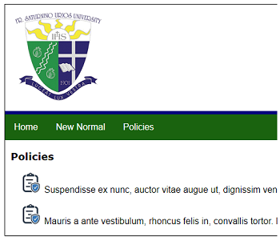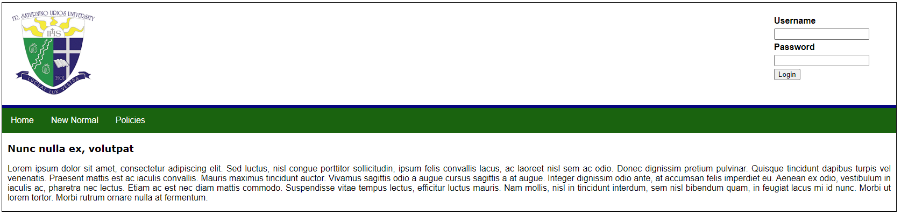

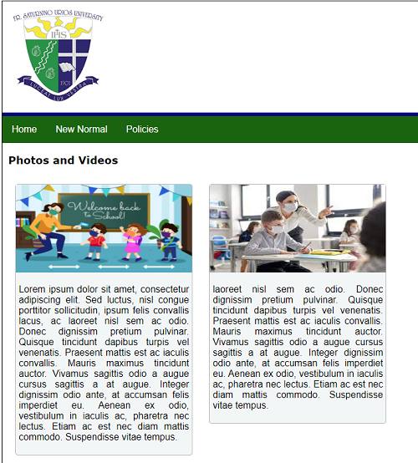

**Learning Outcomes**

* Create HTML page
  + Add header meta information
  + Add stylesheet links
  + Add elements
* Create CSS
  + CSS ruleset
  + Compare id and class
  + Identify the properties of an element
  + CSS selectors
  + CSS images and fonts

Download the lab.zip and extract it to your computer. The image below is the list of files inside the zip file.

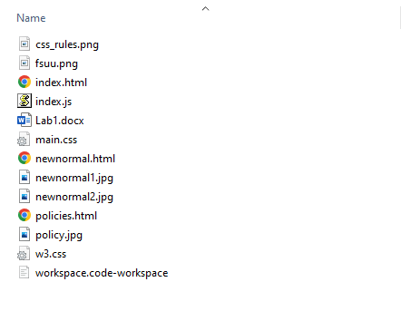

**Recommended software and other requirements**

* Visual Studio Code Editor
* Chrome Web Browser
* Image Editor Tool
* Internet Connection
  + For HTML and CSS references
  + For Text Generator / ISPUM Lorem
  + For Image Generator / Lorem Picsum
  + Others

**Activity Glossary of Terms**

**Emmet** (formerly Zen Coding) is a set of plug-ins for text editors that allow for high-speed coding and editing in HTML, XML, XSLT, and other structured code formats via content assist.

**Lorem Ipsum** is simply dummy text of the printing and typesetting industry.

**Lorem Picsum** provides random or specific uploaded images as placeholders.

**CSS RuleSet**

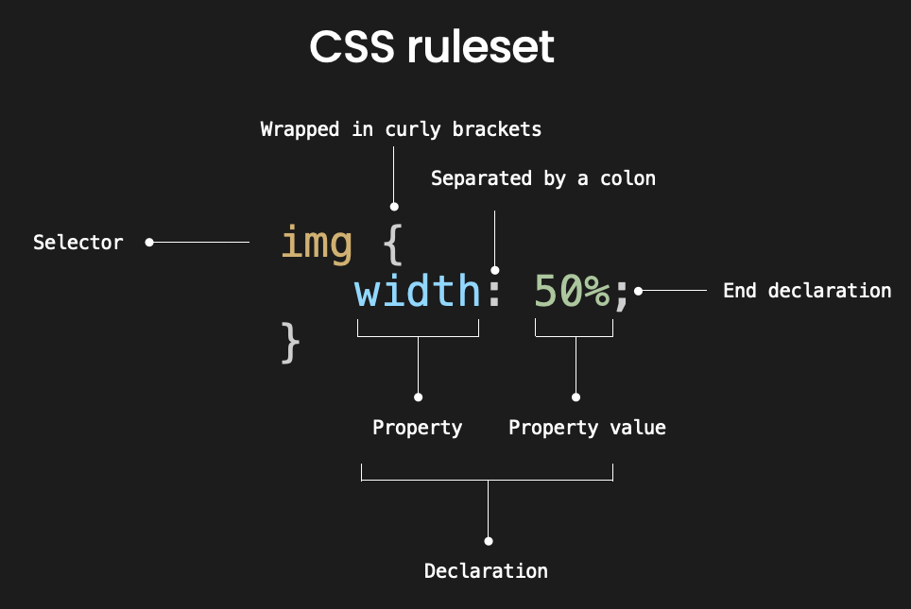

**Step-by-step**

1. Create a file, name **index.html** then add the following code blocks:

Add an HTML5 template by typing the code shown below.

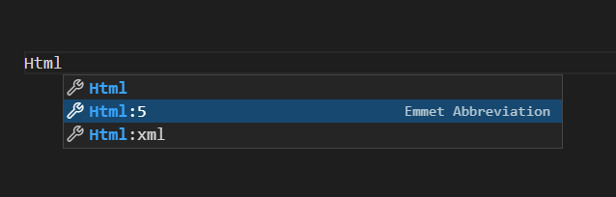

After clicking the highlighted code, the generated code is added to the page as shown below.

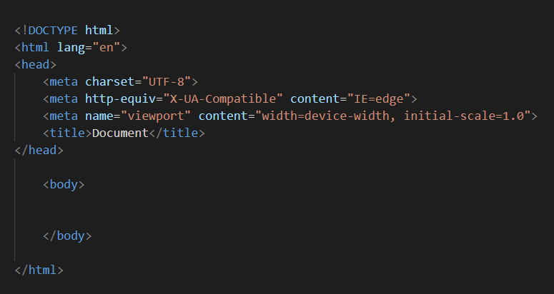

Create a body container or the general purpose section. Any elements inside this section will have visually appeared on the page. A class name ***container*** is assigned to this div which will be used in further CSS manipulation on this division.

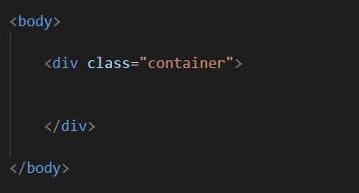

Add another div, and assigned a class name ***header.*** Add a “Weg page Logo” by adding an ***img*** HTML element.

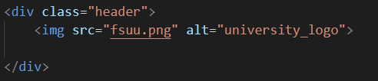

Add another div, and assigned a class name ***header.*** Add a “Login Form” by adding the following codes. The form consists of three HTML elements the label, input, and button with a method value of “POST”. Don’t worry about the functionality of the form at this moment soon will cover how forms will work.

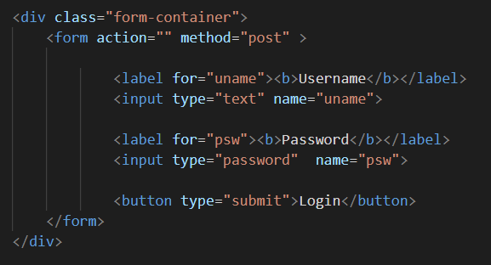

Add another div, and assigned a class name ***headerlinestrip.*** This line of code will add separation from the top section to the navigation bar.



Add another div, and assigned a class name ***nav-bar.*** Add a list of items under the elements of **UL (unordered list)** with a class name ***nbar*.** Each item adds a hyperlink as a reference to a page that the user can follow by clicking or tapping it.

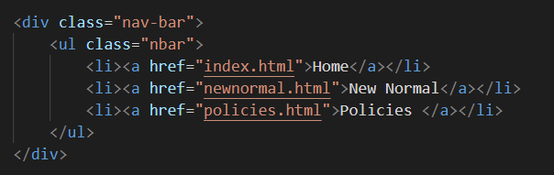

Finally, on this page add a div and assigned class name ***body-container.*** Any dynamic content will be placed in this section.

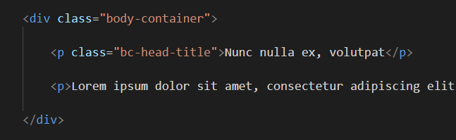

1. Create a file, name **newnormal.html** then add the following code blocks:

On this page, we only modify the dynamic content section. This page shows how the multimedia component will be put in place in the HTML.

I used the term ***CARD*** here to represent the individual images and their description.

**CARD 2**

**CARD 1**

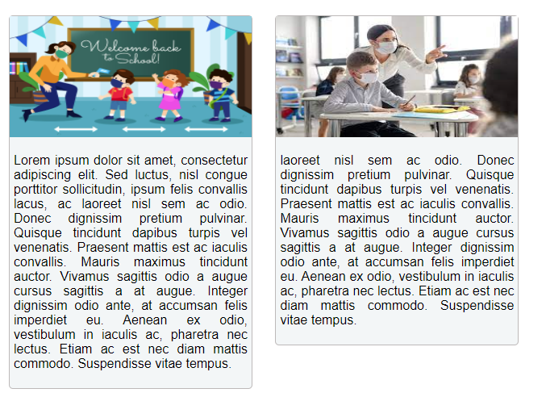

The image below shows the mark-up codes for adding cards in the section “body-container”.

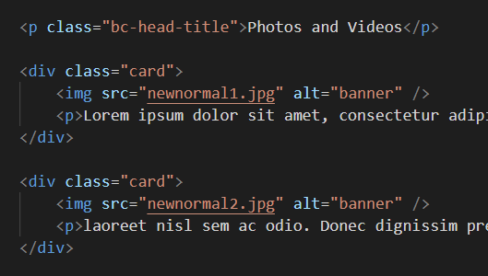

1. Create a file, name **policies.html** then add the following code blocks:

On this page, we only modify the dynamic content section. This page shows how to change, from the default list type to the image list type.

The image below shows the mark-up codes for adding **image list style** in the section “body-container”.

