Design Iteration Process
From “Game Addiction” to a Time-Prioritisation Prototype — DECO3500 Team 3 (Assignment 3: Design Project)
This document traces how the team's design direction evolved from the initial “gaming addiction” domain to the current proof-of-concept prototype, across three stages: (1) research and reframing, (2) ideation, and (3) convergence on a buildable prototype. Supporting evidence — the interview protocol, synthesised user stories, and raw iteration notes — is kept in documentation/interviews/ and documentation/design/iterations/. Papers supporting each decision below are detailed in documentation/design/Literature_Research.docx.

Stage 1 — Research & Reframing: “Gaming Is Not the Enemy”

What we did
The project began in the gaming addiction domain. To understand real player experiences rather than assume a deficit framing, the team ran semi-structured Gaming Experience Interviews with five participants, covering regular play habits, session behaviour, moments where players intended to stop but didn't, social context around play, the impact of gaming on other life responsibilities, and any prior attempts to self-regulate play time.

What we found
Two synthesised user stories from the interviews drove the reframing:
- Story 1 — Time reduction ≠ problem solved. Participants who used device-level time restrictions found that once the restriction lapsed, play behaviour resumed quickly — the restriction changed access to the game, not the underlying desire to play. Freed-up time did not reliably convert into study, exercise, or other valued activity; it was often absorbed by other digital distractions instead.
- Story 5 — Same behaviour, different meaning. Two participants with similarly high play time described opposite psychological relationships to it: one framed heavy play as an autonomous, satisfying investment of free time after real-world responsibilities were met; the other associated heavy play with escaping a lack of achievement or confidence in daily life. Identical “hours played” corresponded to opposite underlying states.

Insight
Measuring or limiting “hours played” is targeting the wrong variable. What actually matters is (a) whether gaming is displacing a higher-priority real-life responsibility at a given moment, and (b) whether any reduction in play is self-endorsed (an autonomous choice) rather than externally imposed — because these two cases produce the same surface behaviour but represent entirely different outcomes for the player.

Decision
The team explicitly ruled out building a blocking or restriction tool. The design opportunity was reframed as: help players weigh gaming against real responsibilities at the moment of choice, preserving their autonomy rather than removing it.

Stage 2 — Ideation: From Competitive Gamification to Ambient Social Awareness

Solution 1: Time Adventure Wheel
The first brainstorm targeted MOBA players specifically: introduce a ranking/gamification layer over real-life tasks so that completing them feels as rewarding as in-game achievement, indirectly reducing excessive play. This became the Time Adventure Wheel — a tabletop RPG-themed device where five character roles map to five activity categories (Mage–Study, Warrior–Work, Bard–Entertainment, Ranger–Other, Priest–Rest). Each morning, players place role tokens into eight daily time slots on a rotating selector ring; completing a planned slot launches that character into a central arena to battle a mechanical dragon, defeated only once every planned activity for the day is complete.
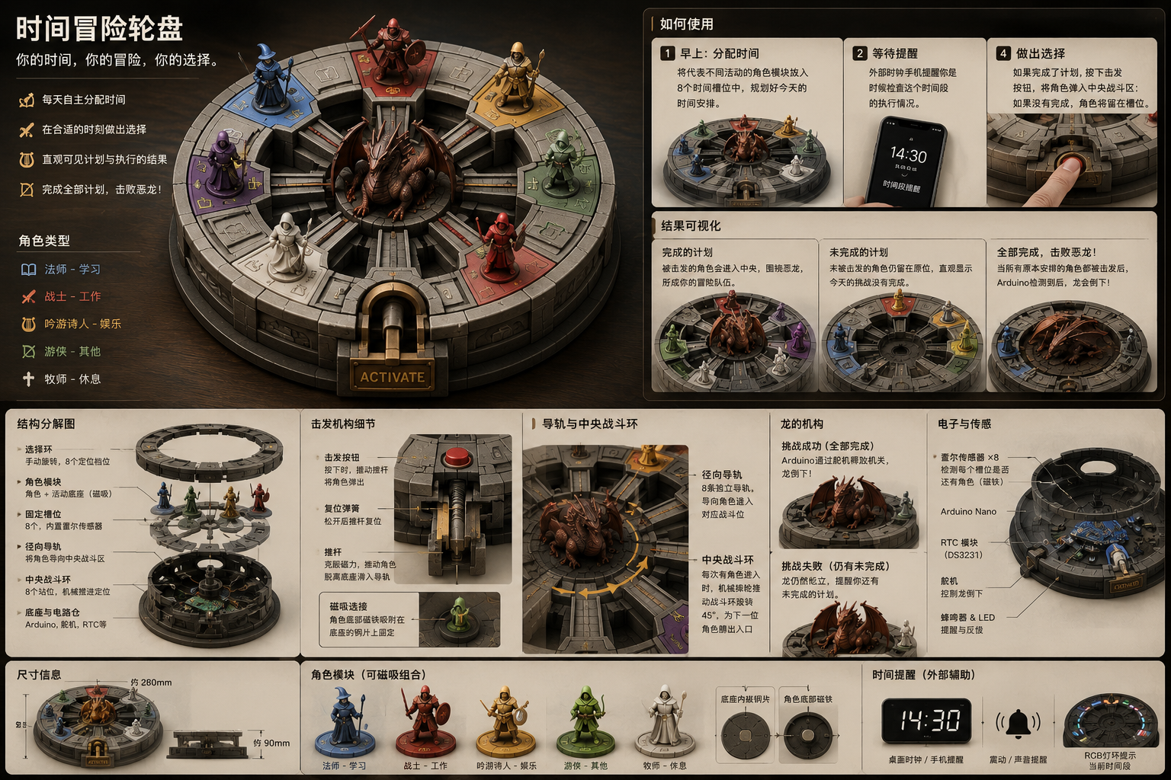
Solution 1 — Time Adventure Wheel: role tokens, 8 time slots, and a dragon boss battle triggered by completing the day's plan.

Review: why Solution 1 didn't proceed
- Fabrication complexity — the concept required a custom mechanical rig (radial rails, spring-loaded launch mechanism, magnetic role-token bases) driven by an Arduino Nano, RTC module, 8 Hall-effect sensors and servos, which was not realistic to build reliably within the project timeline.
- Narrow framing — the RPG/MOBA-ranking premise did not generalise well beyond that specific player segment.
- Contradicted Stage 1's insight — “defeating a dragon” is still a win/lose, competitive framing, in tension with the autonomy-preserving, non-judgemental tone the interview findings called for (see Literature Research, Stage 2, papers 5–6).

Solution 2: Time Becomes a Physical Landscape
The concept was simplified into a tangible, modular-block timeline. Physical blocks shaped by activity category (Study, Gaming, Rest, Social) are laid along a rail spanning 6 AM to 9 PM, across two rows — “Planned” and “Actual” — so the gap between intention and behaviour is visible at a glance rather than hidden in a log file. A “Shared Rhythm” panel displays friends' or housemates' timelines alongside the player's own, explicitly framed as “different rhythms, shared awareness — companionship, not competition.”
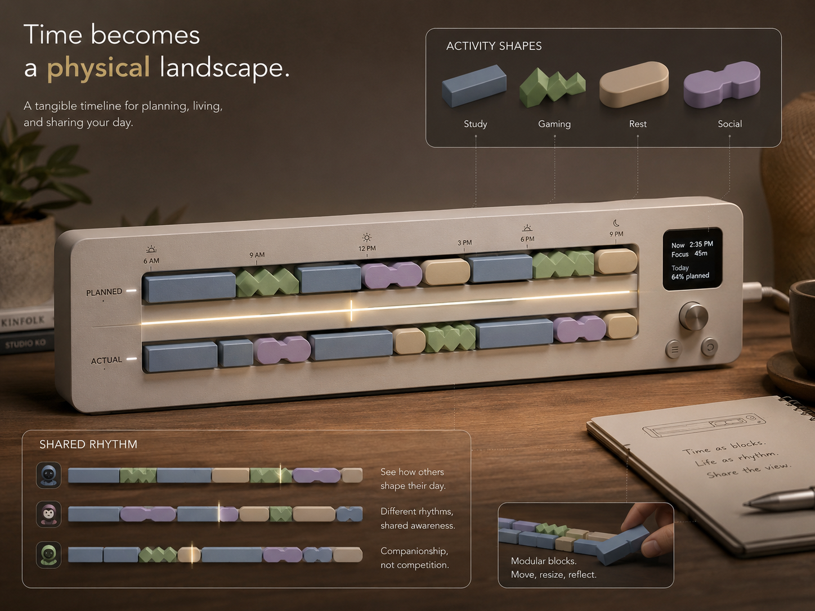
Solution 2 — Physical Time Landscape: Planned vs. Actual block timeline, with a Shared Rhythm panel for ambient social awareness.
This is the pivot point of the project: competitive win/lose gamification was replaced with low-pressure, ambient social awareness, directly answering Stage 1's finding that autonomy and self-endorsement matter more than external judgement or ranking.

Stage 3 — Convergence: Current Prototype (Time Token + Time Sand Tower)

What changed
Reviewing Solution 2 for build feasibility ahead of the Week 12 exhibit, the team further simplified the mechanism into two connected physical components that are realistic to fabricate as a working proof-of-concept.

Time Token
A physical cube exists per activity category (Work/Study, Entertainment, Rest). Flipping a token over starts a countdown, shown as an LED dot pattern (one dot = one hour, counting down 4→3→2→1→0), with a vibration alert once time is up. This is Stage 1's moment-of-choice prioritisation opportunity made physical: flipping a token is a deliberate, situational commitment to one activity over the others available right now.

Time Sand Tower
When a token session ends, the player “charges” it into a shared public device: the elapsed hour is released as colour- and shape-coded sand (by activity type) into a collection column, visually accumulating into that day's “time trajectory.” Multiple towers displayed side-by-side let the household or team compare rhythms ambiently at the end of the day — the fabricable, lower-electronics-complexity descendant of Solution 2's Shared Rhythm panel.
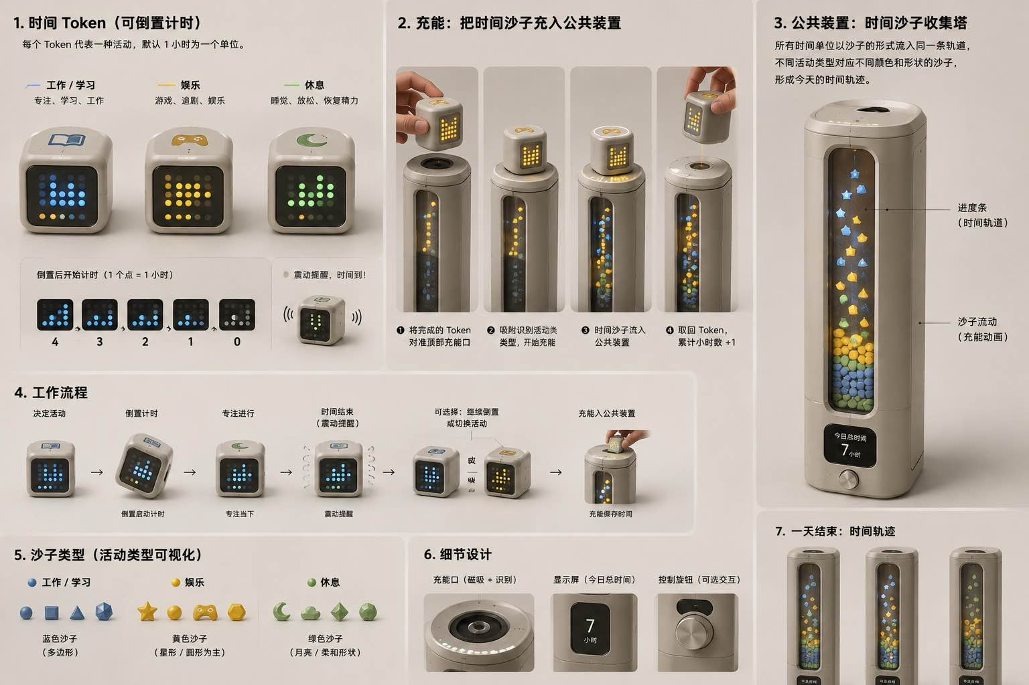
Solution 3 (current prototype) — Time Token countdown + Time Sand Tower: individual time-boxing feeding a shared, ambient end-of-day visualisation.

Why this is the current direction
This concept satisfies all three stages of the project's reasoning: Stage 1 (a prioritisation aid, not a blocker — self-endorsed and autonomy-preserving), Stage 2 (ambient, non-competitive social awareness in place of ranking), and the assignment brief's requirement for a demonstrable, multi-user social/mobile prototype achievable within the team's build constraints. It is the solution currently being built out as the interactive proof-of-concept prototype.

