Assignment 2
- Give an XML file named as “employee.xml” with the following contents:

<?xml version="1.0" encoding="UTF-8"?>
<employees>
<employee employee_no="E0101">
<name>Nguyen Tan Thanh</name>
<dob>1986-02-07</dob>
<address>23 Vo Thi Sau, Hai Ba Trung, Ha Noi</address>
<email>thanhnt@fpt.edu.vn</email>
<phone_no>098632322</phone_no>
<place_of_work>Ha Noi</place_of_work>
</employee>
<employee employee_no="E0102">
<name>Nguyen Hung Dung</name>
<dob>1983-02-07</dob>
<address>190 Cau Dien, Tu Liem, Ha Noi</address>
<email>dungnh@fpt.edu.vn</email>
<phone_no>098334522</phone_no>
<place_of_work>Ha Noi</place_of_work>
</employee>
</employees>

- Build an application have several functions as below:

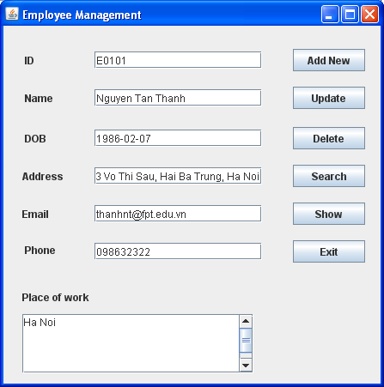

when the user presses the button show, all data of the employee are display on the table in the new frame as below:

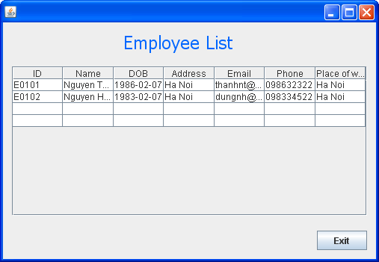

When user click to button Add New, Update, Delete or Search; the program should perform an action to add new employee, update employee information, delete employee or search information of an employee.
Information user input must be validated before save in XML file.

NOTE: Build a runnable .jar file and include in the zip file. The submission without the .jar file will not be graded. The .jar file must use a relative path to open/save to or from .xml file in the same folder.

You can design all functions by your creative

