Universiti Kebangsaan Malaysia
TC6414 | Data Knowledge Discovery & Data Mining
Assignment 1 | Data Preprocessing and Feature Selection
Lecturer: Assoc. Prof. Dr. Zalinda Othman
Student Name: ZHANG CHENCHUAN
Matrix NO: P162614
Date: April 2026

1.0 INTRODUCTION

1.1 Background and Objectives
Diabetes mellitus is a major global health problem because it is chronic, progressive, and associated with severe complications when it is not detected early. Machine learning provides a useful decision-support approach because routine clinical variables such as glucose level, body mass index, age, insulin, and blood pressure can be analysed together to estimate diabetes risk. Previous studies show that predictive modelling for diabetes depends strongly on careful data preprocessing because raw medical data often include missing, noisy, and unevenly scaled measurements (Olisah et al., 2022; Tasin et al., 2023).
The objective of this study is to apply data preprocessing and feature selection to two diabetes datasets, namely the Pima Indians Diabetes Database and the Frankfurt Hospital Diabetes Dataset. The prepared dataset is then used for Logistic Regression classification. This workflow follows the view that effective diabetes classification requires appropriate cleaning, transformation, standardization, dimensionality reduction, and feature selection before model evaluation (Chang et al., 2023).

2.0 DATA ACQUISITION

2.1 Dataset Overview
Dataset A is the Pima Indians Diabetes Database, a widely used binary classification dataset from UCI/Kaggle. It contains 768 records and 9 columns: eight clinical attributes and one target variable, Outcome, where 0 indicates no diabetes and 1 indicates diabetes.
PIMA dataset information
RangeIndex: 768 entries, 0 to 767
Data columns (total 9 columns):
# Column Non-Null Count Dtype
0 Pregnancies 768 non-null int64
1 Glucose 768 non-null int64
2 BloodPressure 768 non-null int64
3 SkinThickness 768 non-null int64
4 Insulin 768 non-null int64
5 BMI 768 non-null float64
6 DiabetesPedigreeFunction 768 non-null float64
7 Age 768 non-null int64
8 Outcome 768 non-null int64
dtypes: float64(2), int64(7)
Figure 2.1.1 Mental health information displayed about features or attributes utilized in the dataset
Dataset B is the Frankfurt Hospital Diabetes Dataset obtained from a public GitHub source. It uses the same nine-column structure as the PIMA dataset and contains 2,000 records. Because both datasets share the same attributes, they can be integrated directly after missing value handling.
Frankfurt dataset information
RangeIndex: 2000 entries, 0 to 1999
Data columns (total 9 columns):
# Column Non-Null Count Dtype
0 Pregnancies 2000 non-null int64
1 Glucose 2000 non-null int64
2 BloodPressure 2000 non-null int64
3 SkinThickness 2000 non-null int64
4 Insulin 2000 non-null int64
5 BMI 2000 non-null float64
6 DiabetesPedigreeFunction 2000 non-null float64
7 Age 2000 non-null int64
8 Outcome 2000 non-null int64
dtypes: float64(2), int64(7)
Figure 2.1.2 Frankfurt dataset information displayed about features or attributes utilized in the dataset
Both datasets contained zeros in clinical columns where a true zero value is medically implausible. Therefore, zeros in Glucose, BloodPressure, SkinThickness, Insulin, and BMI were treated as missing values.

2.2 Tools and Libraries Used
The analysis was implemented in Python using a runnable Jupyter Notebook suitable for Google Colab. Pandas was used for data manipulation, NumPy for numerical operations, Scikit-learn for preprocessing, feature selection, dimensionality reduction, and modelling, while Matplotlib and Seaborn were used for visualization.

3.0 DATA PREPARATION
Data preparation is the process of converting raw data into a consistent, reliable, and model-ready format. In medical prediction tasks, this stage is especially important because missing values, skewed distributions, different measurement scales, and redundant variables can distort the learning process and reduce model reliability. The preparation steps in this study follow common preprocessing practice for healthcare machine learning pipelines (Li et al., 2023).

3.1 Handling Missing Values
Zeros in the five selected clinical attributes were interpreted as missing data because a glucose level, blood pressure, skin thickness, insulin value, or BMI of zero is not clinically meaningful for living patients. After replacing these zeros with NaN, the missingness pattern was visualized for both datasets.
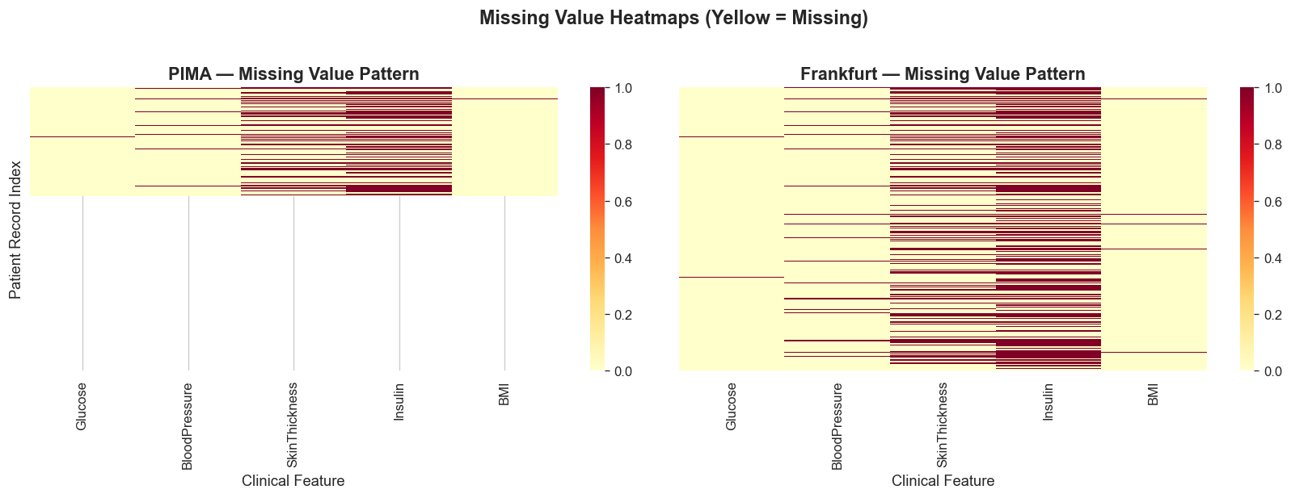
Figure 3.1.1 Missing value heatmap for PIMA and Frankfurt datasets
Attribute | PIMA missing before imputation | Frankfurt missing before imputation | PIMA missing after imputation | Frankfurt missing after imputation
Glucose | 5 | 13 | 0 | 0
BloodPressure | 35 | 90 | 0 | 0
SkinThickness | 227 | 573 | 0 | 0
Insulin | 374 | 956 | 0 | 0
BMI | 11 | 28 | 0 | 0
Median imputation was used separately for each dataset. The median was chosen because it is more robust than the mean when medical variables contain outliers or skewed distributions. This was especially relevant for insulin and skin thickness, where missingness was comparatively high.

3.2 Data Integration
The PIMA and Frankfurt datasets were combined to improve population diversity by joining data from a United States-based dataset and a Germany-based hospital dataset. A source column was added before merging so that the contribution of each dataset could be checked after concatenation.
The integrated dataset contained 2,768 rows and 10 columns before dropping the temporary source column. The source distribution was 768 records from PIMA and 2,000 records from Frankfurt. The class distribution after integration was 1,816 records for Outcome 0 and 952 records for Outcome 1.

3.3 Data Transformation
Logarithmic transformation using np.log1p() was applied to Insulin and DiabetesPedigreeFunction. This transformation reduces right-skewness while preserving zero-compatible computation, which makes the distributions more suitable for linear modelling.
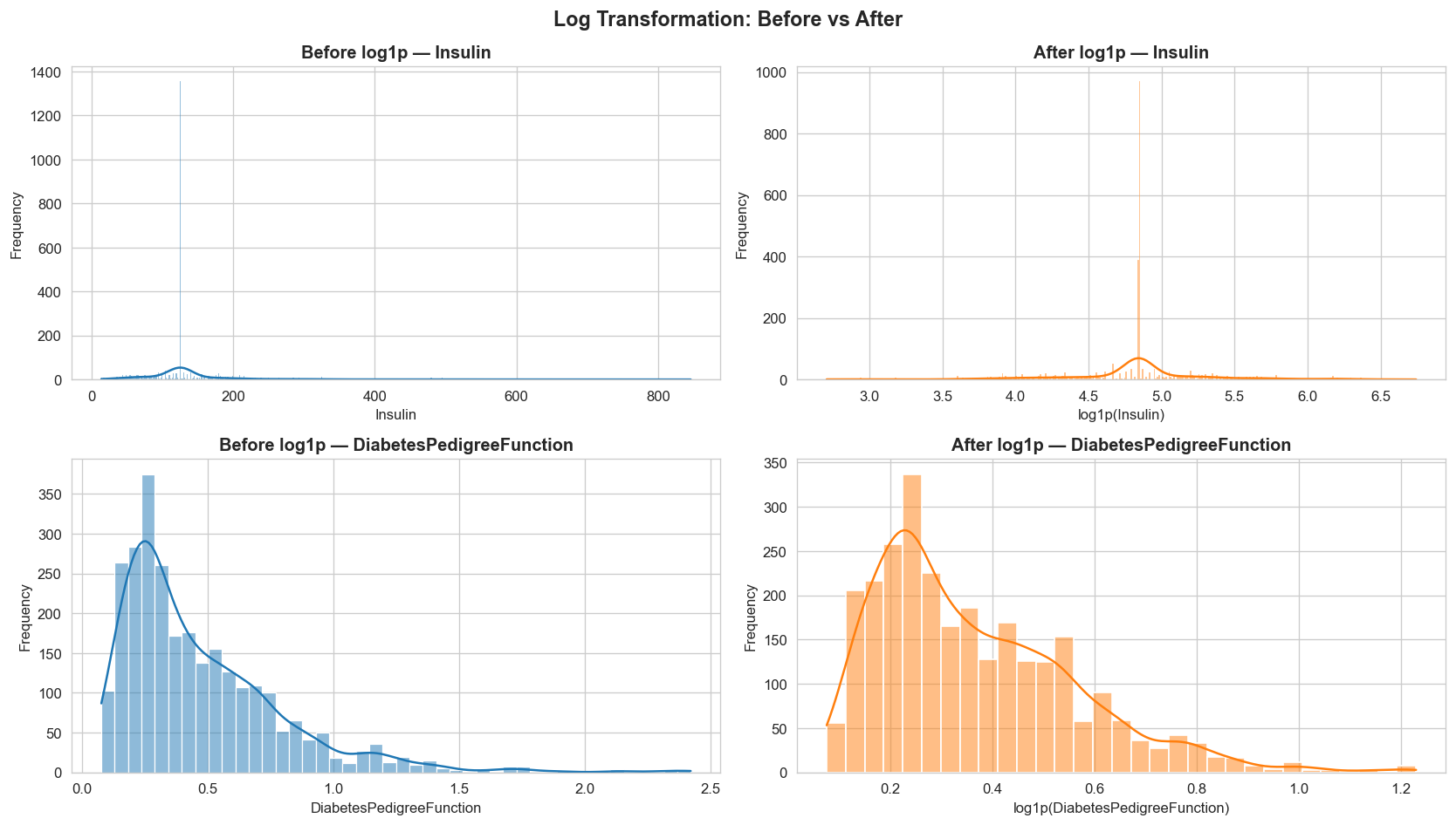
Figure 3.3.1 Before and after log transformation for Insulin and Diabetes Pedigree Function

3.4 Data Standardization
Standardization was performed using Scikit-learn’s StandardScaler, which converts each feature into a Z-score with mean approximately 0 and standard deviation approximately 1. This step was required because the attributes used different scales, for example glucose and insulin are much larger numerically than diabetes pedigree function.
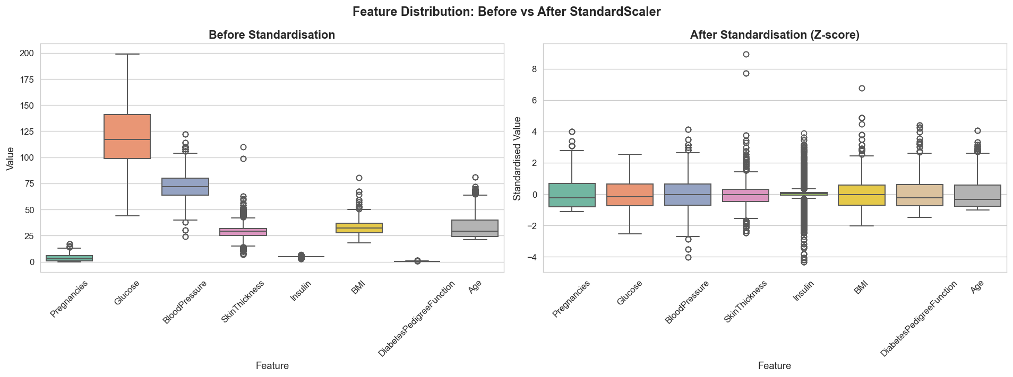
Figure 3.4.1 Boxplot comparison before and after standardization

3.5 Dimensionality Reduction
Principal Component Analysis was used to examine how much variance could be represented by a smaller set of components. PCA was used for analysis only; the original scaled features were retained for the feature selection stage so that the selected variables remained clinically interpretable.
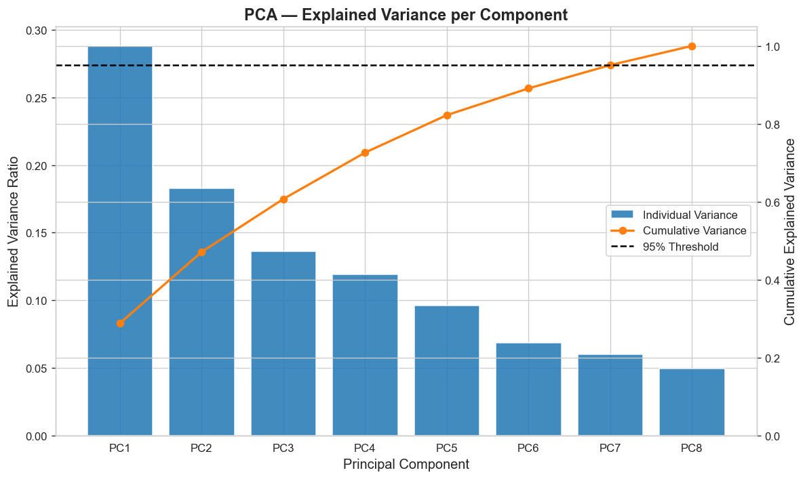
Figure 3.5.1 PCA individual and cumulative explained variance
Seven principal components were needed to explain at least 95% of the variance. The cumulative variance reached 0.9507 at PC7, showing that most information was retained only after keeping nearly all original dimensions.

4.0 FEATURE SELECTION

4.1 Feature Selection Overview
Feature selection aims to identify the most relevant predictors, reduce noise, simplify the model, and improve generalization. Two methods were used: Mutual Information and Recursive Feature Elimination. Mutual Information evaluates dependency between each feature and the target, while RFE repeatedly removes weaker features using a predictive estimator. These methods are commonly used in diabetes prediction workflows to compare statistical relevance and model-based relevance (Olisah et al., 2022).

4.2 Mutual Information
Mutual Information measures how much knowing a feature reduces uncertainty about the target variable. Higher scores indicate stronger dependency between the feature and diabetes outcome. Features above the median MI score were selected.
Rank | Feature | MI Score
1 | DiabetesPedigreeFunction | 0.3510
2 | BMI | 0.1914
3 | Glucose | 0.1831
4 | Insulin | 0.1342
5 | Age | 0.0851
6 | SkinThickness | 0.0430
7 | BloodPressure | 0.0317
8 | Pregnancies | 0.0291
Figure 4.2.1.1 Mutual Information scores table
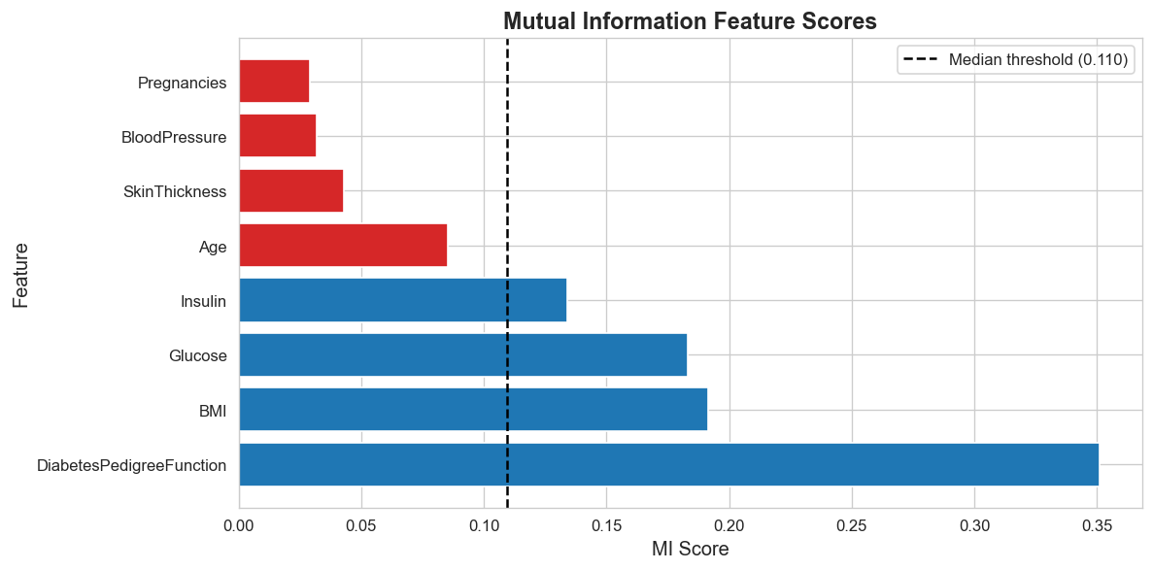
Figure 4.2.1.2 Mutual Information feature score bar chart
The selected MI features were DiabetesPedigreeFunction, BMI, Glucose, and Insulin. These features were selected because their MI scores were above the median threshold of 0.1096.

4.3 Recursive Feature Elimination (RFE)
Recursive Feature Elimination was implemented using Logistic Regression as the base estimator with n_features_to_select = 5. RFE iteratively removes the least useful variables until the required number of predictors remains.
Feature | Selected | Ranking
Age | True | 1
BMI | True | 1
DiabetesPedigreeFunction | True | 1
Glucose | True | 1
Pregnancies | True | 1
Insulin | False | 2
BloodPressure | False | 3
SkinThickness | False | 4
Figure 4.3.1.1 RFE feature ranking table
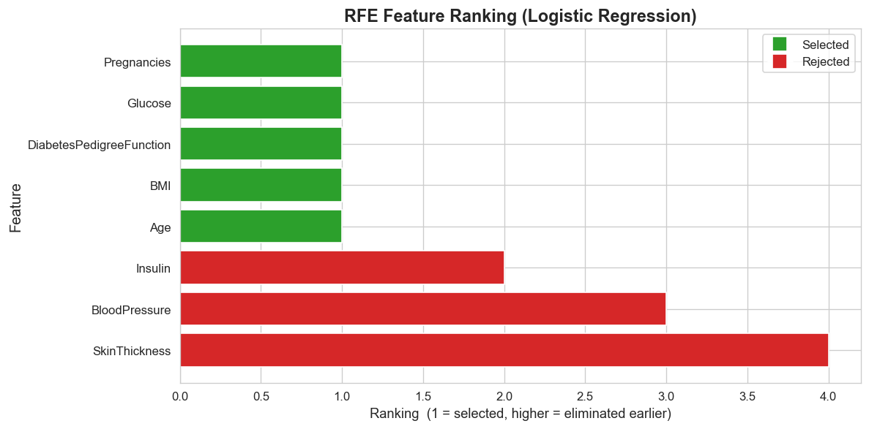
Figure 4.3.1 RFE ranking chart
The five selected RFE features were Age, BMI, DiabetesPedigreeFunction, Glucose, and Pregnancies.

4.4 Comparison of MI and RFE
Method | Selected features | Overlap
Mutual Information | DiabetesPedigreeFunction, BMI, Glucose, Insulin | DiabetesPedigreeFunction, BMI, Glucose
RFE | Age, BMI, DiabetesPedigreeFunction, Glucose, Pregnancies | DiabetesPedigreeFunction, BMI, Glucose
Both methods agreed on DiabetesPedigreeFunction, BMI, and Glucose, suggesting that these variables were consistently important. MI additionally selected Insulin, while RFE selected Age and Pregnancies, showing that the filter method emphasized individual dependency and the wrapper method emphasized contribution within Logistic Regression.

5.0 MODEL PERFORMANCE ANALYSIS

5.1 Baseline Model
The baseline Logistic Regression model used all eight standardized features with 5-fold cross-validation. It achieved Accuracy = 0.7673, Precision = 0.7059, Recall = 0.5557, and F1 = 0.6216.

5.2 After MI Feature Selection
The MI-selected model used DiabetesPedigreeFunction, BMI, Glucose, and Insulin. It achieved Accuracy = 0.7706, Precision = 0.7222, Recall = 0.5410, and F1 = 0.6180. This improved accuracy and precision compared with the baseline, although recall and F1 were slightly lower.

5.3 After RFE Feature Selection
The RFE-selected model used Age, BMI, DiabetesPedigreeFunction, Glucose, and Pregnancies. It achieved Accuracy = 0.7713, Precision = 0.7163, Recall = 0.5557, and F1 = 0.6257. This was the best overall result because it produced the highest accuracy and F1 score.

5.4 Performance Comparison
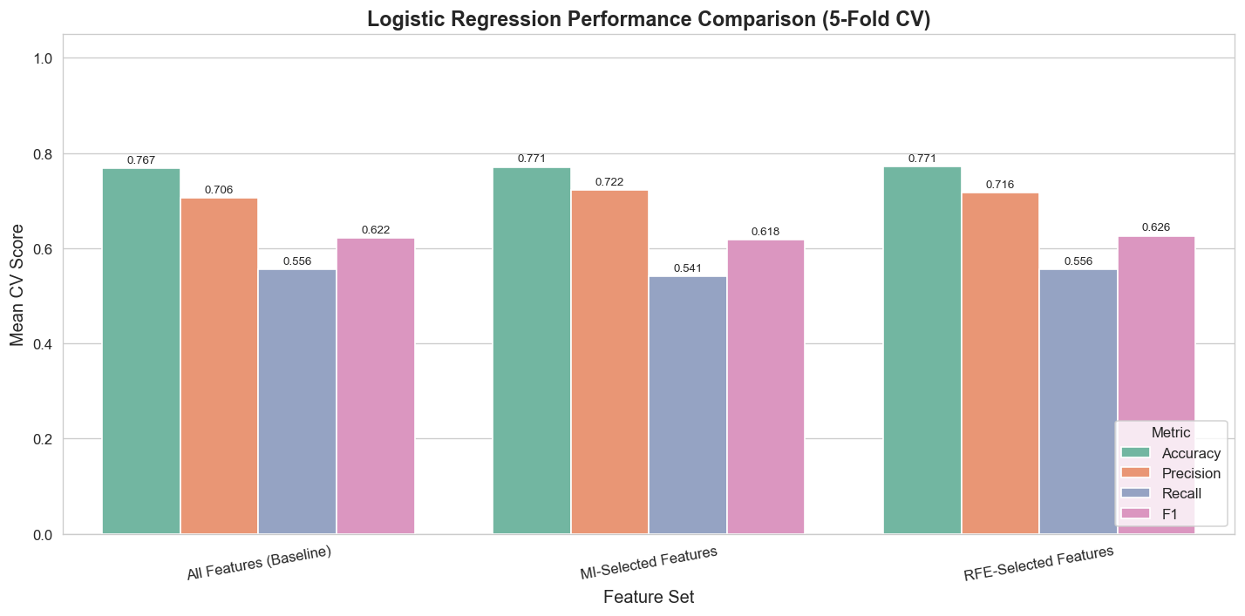
Figure 5.1 Logistic Regression performance comparison before and after feature selection
Scenario | Accuracy | Precision | Recall | F1
All features | 0.7673 | 0.7059 | 0.5557 | 0.6216
MI-selected features | 0.7706 | 0.7222 | 0.5410 | 0.6180
RFE-selected features | 0.7713 | 0.7163 | 0.5557 | 0.6257
Feature selection slightly improved performance compared with the baseline. RFE performed best overall because it achieved the highest accuracy and F1 score while keeping only five predictors. MI produced the highest precision, but its lower recall reduced its F1 score.

6.0 CONCLUSION

6.1 Summary of Findings
This study prepared two diabetes datasets through missing value treatment, dataset integration, log transformation, feature standardization, PCA analysis, and feature selection. Median imputation removed missing values caused by invalid clinical zeros, log transformation reduced skewness in insulin and diabetes pedigree function, and standardization placed all predictors on a comparable scale.
The feature selection results showed that DiabetesPedigreeFunction, BMI, and Glucose were selected by both MI and RFE. Based on the model results, RFE gave the best performance with Accuracy = 0.7713 and F1 = 0.6257, while MI gave the highest precision at 0.7222.

6.2 Limitations and Future Work
One limitation is that the PIMA dataset is limited to female patients, which may reduce generalizability to broader populations. Another limitation is that Logistic Regression is a simple linear classifier and may not capture complex nonlinear relationships in diabetes risk. Future work should compare more advanced models such as Random Forest and XGBoost, and should test other feature selection methods to verify whether the selected predictors remain stable.

REFERENCES
Ahmed, A., Aziz, S., & Qidwai, U. (2025). Machine Learning Algorithm-Based Prediction of Diabetes Among Female Population Using PIMA Dataset. Healthcare, 13(1), 37. https://doi.org/10.3390/healthcare13010037
Chang, V., Bailey, J., Xu, Q. A., & Sun, Z. (2023). Pima Indians diabetes mellitus classification based on machine learning (ML) algorithms. Neural Computing and Applications, 35(22), 16157-16173. https://doi.org/10.1007/s00521-022-07049-z
Iparraguirre-Villanueva, O., Espinola-Linares, K., Castaneda, R. O. F., & Cabanillas-Carbonell, M. (2023). Application of Machine Learning Models for Early Detection and Accurate Classification of Type 2 Diabetes. Diagnostics, 13(14), 2383. https://doi.org/10.3390/diagnostics13142383
Olisah, C. C., Smith, L., & Smith, M. (2022). Diabetes mellitus prediction and diagnosis from a data preprocessing and machine learning perspective. Computer Methods and Programs in Biomedicine, 220, 106773. https://doi.org/10.1016/j.cmpb.2022.106773
Reza, M. S., Amin, R., Yasmin, R., Kulsum, W., & Ruhi, S. (2024). Improving diabetes disease patients classification using stacking ensemble method with PIMA and local healthcare data. Heliyon, 10(2), e24536. https://doi.org/10.1016/j.heliyon.2024.e24536
Tasin, I., Nabil, T. U., Islam, S., & Khan, R. (2023). Diabetes prediction using machine learning and explainable AI techniques. Healthcare Technology Letters, 10(1-2), 1-10. https://doi.org/10.1049/htl2.12039

