完整我模型定义

{

"schema": "https://iotx-tsl.oss-ap-southeast-1.aliyuncs.com/schema.json",

"profile": {

"productKey": "a1M0PwYMMNz"

},

"services": [

{

"outputData": [],

"identifier": "set",

"inputData": [

{

"identifier": "LightSwitch",

"dataType": {

"specs": {

"0": "关闭",

"1": "开启"

},

"type": "bool"

},

"name": "主灯开关"

},

{

"identifier": "image",

"dataType": {

"specs": {

"length": "2048"

},

"type": "text"

},

"name": "图片数据"

},

{

"identifier": "musicId",

"dataType": {

"specs": {

"length": "32"

},

"type": "text"

},

"name": "音乐"

},

{

"identifier": "faceId",

"dataType": {

"specs": {

"length": "32"

},

"type": "text"

},

"name": "人脸"

},

{

"identifier": "perId",

"dataType": {

"specs": {

"length": "32"

},

"type": "text"

},

"name": "人"

},

{

"identifier": "sex",

"dataType": {

"specs": {

"min": "0",

"max": "1",

"step": "1"

},

"type": "int"

},

"name": "性别"

},

{

"identifier": "age",

"dataType": {

"specs": {

"min": "0",

"max": "100",

"step": "100"

},

"type": "int"

},

"name": "年龄"

},

{

"identifier": "curTime",

"dataType": {

"specs": {

"length": "13"

},

"type": "text"

},

"name": "当前时间"

}

],

"method": "thing.service.property.set",

"name": "set",

"required": true,

"callType": "async",

"desc": "属性设置"

},

{

"outputData": [

{

"identifier": "LightSwitch",

"dataType": {

"specs": {

"0": "关闭",

"1": "开启"

},

"type": "bool"

},

"name": "主灯开关"

},

{

"identifier": "image",

"dataType": {

"specs": {

"length": "2048"

},

"type": "text"

},

"name": "图片数据"

},

{

"identifier": "musicId",

"dataType": {

"specs": {

"length": "32"

},

"type": "text"

},

"name": "音乐"

},

{

"identifier": "faceId",

"dataType": {

"specs": {

"length": "32"

},

"type": "text"

},

"name": "人脸"

},

{

"identifier": "perId",

"dataType": {

"specs": {

"length": "32"

},

"type": "text"

},

"name": "人"

},

{

"identifier": "sex",

"dataType": {

"specs": {

"min": "0",

"max": "1",

"step": "1"

},

"type": "int"

},

"name": "性别"

},

{

"identifier": "age",

"dataType": {

"specs": {

"min": "0",

"max": "100",

"step": "100"

},

"type": "int"

},

"name": "年龄"

},

{

"identifier": "curTime",

"dataType": {

"specs": {

"length": "13"

},

"type": "text"

},

"name": "当前时间"

}

],

"identifier": "get",

"inputData": [

"LightSwitch",

"image",

"musicId",

"faceId",

"perId",

"sex",

"age",

"curTime"

],

"method": "thing.service.property.get",

"name": "get",

"required": true,

"callType": "async",

"desc": "属性获取"

}

],

"properties": [

{

"identifier": "LightSwitch",

"dataType": {

"specs": {

"0": "关闭",

"1": "开启"

},

"type": "bool"

},

"name": "主灯开关",

"accessMode": "rw",

"required": true

},

{

"identifier": "image",

"dataType": {

"specs": {

"length": "2048"

},

"type": "text"

},

"name": "图片数据",

"accessMode": "rw",

"required": true

},

{

"identifier": "musicId",

"dataType": {

"specs": {

"length": "32"

},

"type": "text"

},

"name": "音乐",

"accessMode": "rw",

"required": false

},

{

"identifier": "faceId",

"dataType": {

"specs": {

"length": "32"

},

"type": "text"

},

"name": "人脸",

"accessMode": "rw",

"required": false

},

{

"identifier": "perId",

"dataType": {

"specs": {

"length": "32"

},

"type": "text"

},

"name": "人",

"accessMode": "rw",

"required": false

},

{

"identifier": "sex",

"dataType": {

"specs": {

"min": "0",

"max": "1",

"step": "1"

},

"type": "int"

},

"name": "性别",

"accessMode": "rw",

"required": false

},

{

"identifier": "age",

"dataType": {

"specs": {

"min": "0",

"max": "100",

"step": "100"

},

"type": "int"

},

"name": "年龄",

"accessMode": "rw",

"required": false

},

{

"identifier": "curTime",

"dataType": {

"specs": {

"length": "13"

},

"type": "text"

},

"name": "当前时间",

"accessMode": "rw",

"required": false

}

],

"events": [

{

"outputData": [

{

"identifier": "LightSwitch",

"dataType": {

"specs": {

"0": "关闭",

"1": "开启"

},

"type": "bool"

},

"name": "主灯开关"

},

{

"identifier": "image",

"dataType": {

"specs": {

"length": "2048"

},

"type": "text"

},

"name": "图片数据"

},

{

"identifier": "musicId",

"dataType": {

"specs": {

"length": "32"

},

"type": "text"

},

"name": "音乐"

},

{

"identifier": "faceId",

"dataType": {

"specs": {

"length": "32"

},

"type": "text"

},

"name": "人脸"

},

{

"identifier": "perId",

"dataType": {

"specs": {

"length": "32"

},

"type": "text"

},

"name": "人"

},

{

"identifier": "sex",

"dataType": {

"specs": {

"min": "0",

"max": "1",

"step": "1"

},

"type": "int"

},

"name": "性别"

},

{

"identifier": "age",

"dataType": {

"specs": {

"min": "0",

"max": "100",

"step": "100"

},

"type": "int"

},

"name": "年龄"

},

{

"identifier": "curTime",

"dataType": {

"specs": {

"length": "13"

},

"type": "text"

},

"name": "当前时间"

}

],

"identifier": "post",

"method": "thing.event.property.post",

"name": "post",

"type": "info",

"required": true,

"desc": "属性上报"

},

{

"outputData": [

{

"identifier": "ErrorCode",

"dataType": {

"specs": {

"0": "恢复正常"

},

"type": "enum"

},

"name": "故障代码"

}

],

"identifier": "Error",

"method": "thing.event.Error.post",

"name": "故障上报",

"type": "error",

"required": true

}

]

}

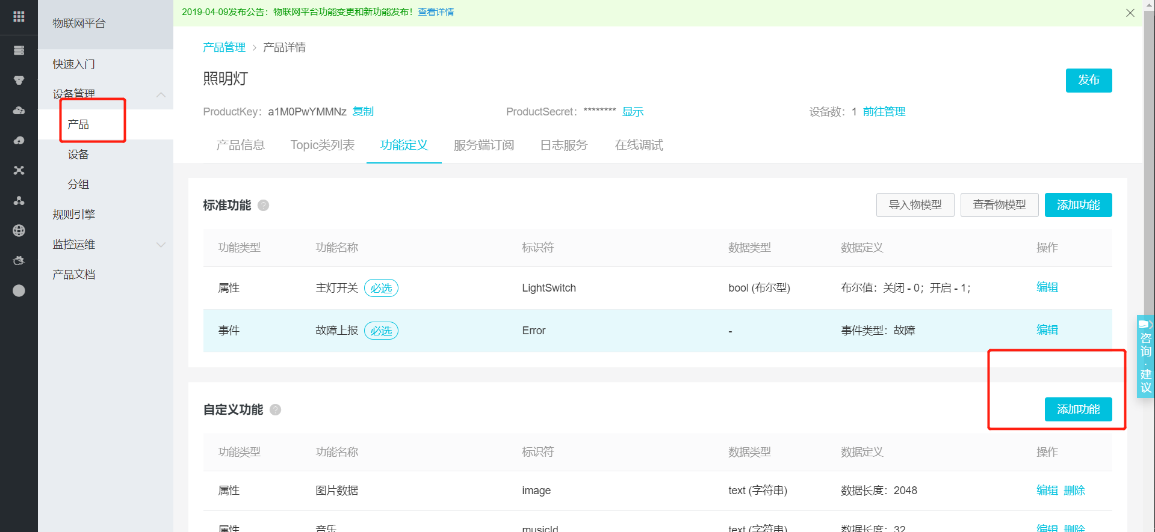

产品 自定义物模型

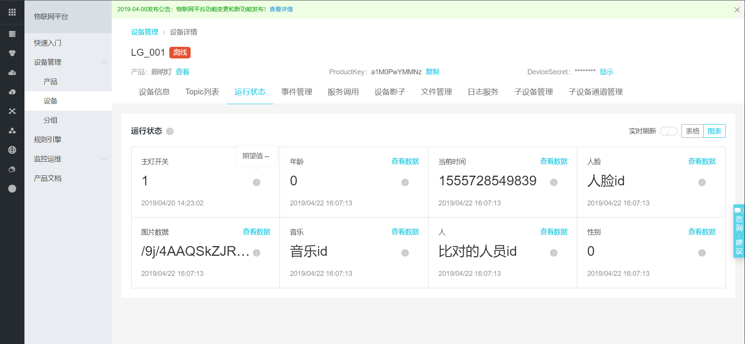

产品下的设备

TOPIC

