CONCORDIA UNIVERSITY

LAB ASSIGNMENT 1:

INVISCID FLOW FOR NACA 0012

SECTION AI-X

AHMED ZAYED,

RAYAN KANIAH,

GONZALO NORIEGA,

CHRISTIAN ROWSELL, 40092183

COLE KENNEDY, 40095681

PROF. ZIAD BOUTANIOS

FEBRUARY 16, 2022

OBJECTIVE

The objective of this lab assignment was to simulate the transonic inviscid flow around a NACA 0012 Airfoil. Since the performed simulations were ran at high Reynolds numbers and at low angles of attack, an inviscid flow assumption was used for the simulation. Therefore, the Euler equation was used for the flow calculations as the viscous terms in the Navier - Stokes equation was presumed to be minimal.

INTRODUCTION

PROCEDURE

The procedure followed during the simulation experiment can be found and referenced here: [Brian C. Vermeire’s CFD - An Open-Source Approach, Chapter 16: Inviscid NACA 0012](https://users.encs.concordia.ca/~bvermeir/books.html).

RESULTS AND DISCUSSION

1.

a)

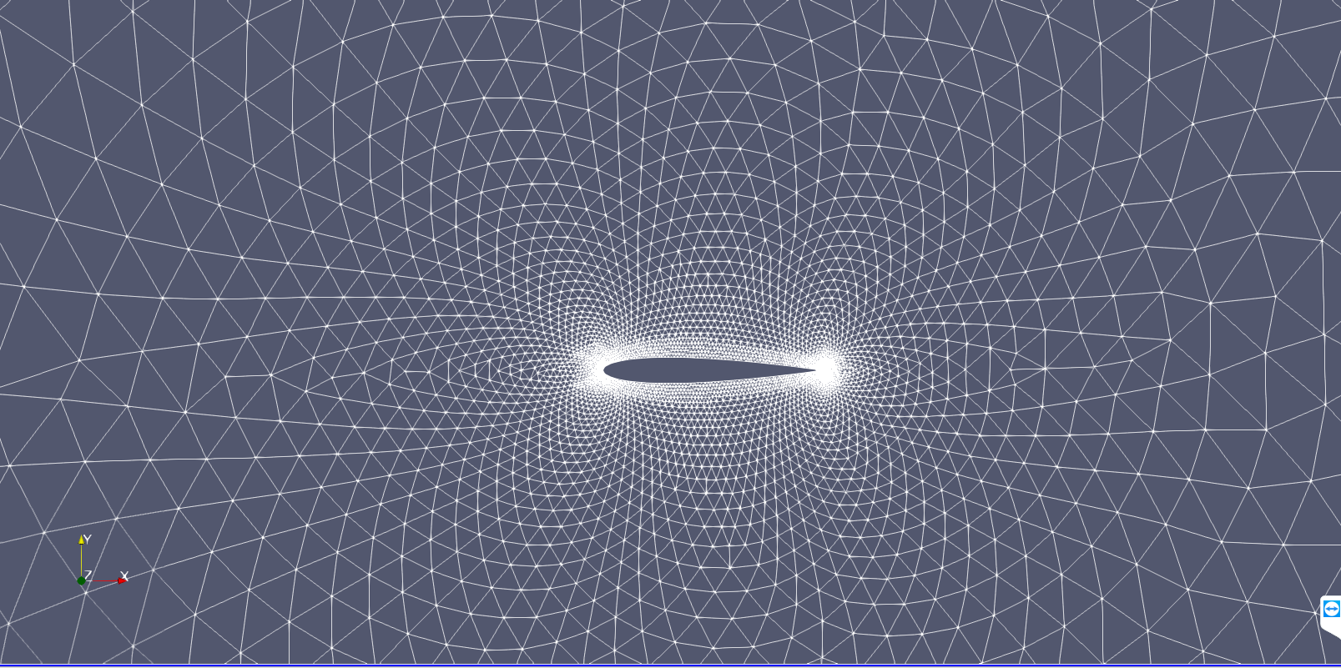

Figure 1: NACA 0012 Mesh

Referring to Figure 1, one can see the mesh used for this simulation. There are a few key things to take note of when looking at this mesh. The first being the fact that the mesh is unstructured, the second being the size of the individual elements. Looking first at the fact that the mesh is unstructured, the question comes into play: what is an unstructured mesh? An unstructured mesh simply means a mesh where the elements do not follow a regular pattern. An unstructured mesh allows for complex geometries to be better observed, however sometimes comes with the cost of increased computational cost. The next thing to discuss is the size of the individual elements. The elements are quite large far from the airfoil, and they become quite small close to the airfoil, especially around the leading and trailing edge. The reason for this is the flows at these regions are highly complex, when compared to the freestream flow further from the airfoil. Therefore, in order to save on computational cost, the mesh elements are refined near the airfoil, and coarse further from the airfoil, allowing for a higher accuracy where it counts.

b)

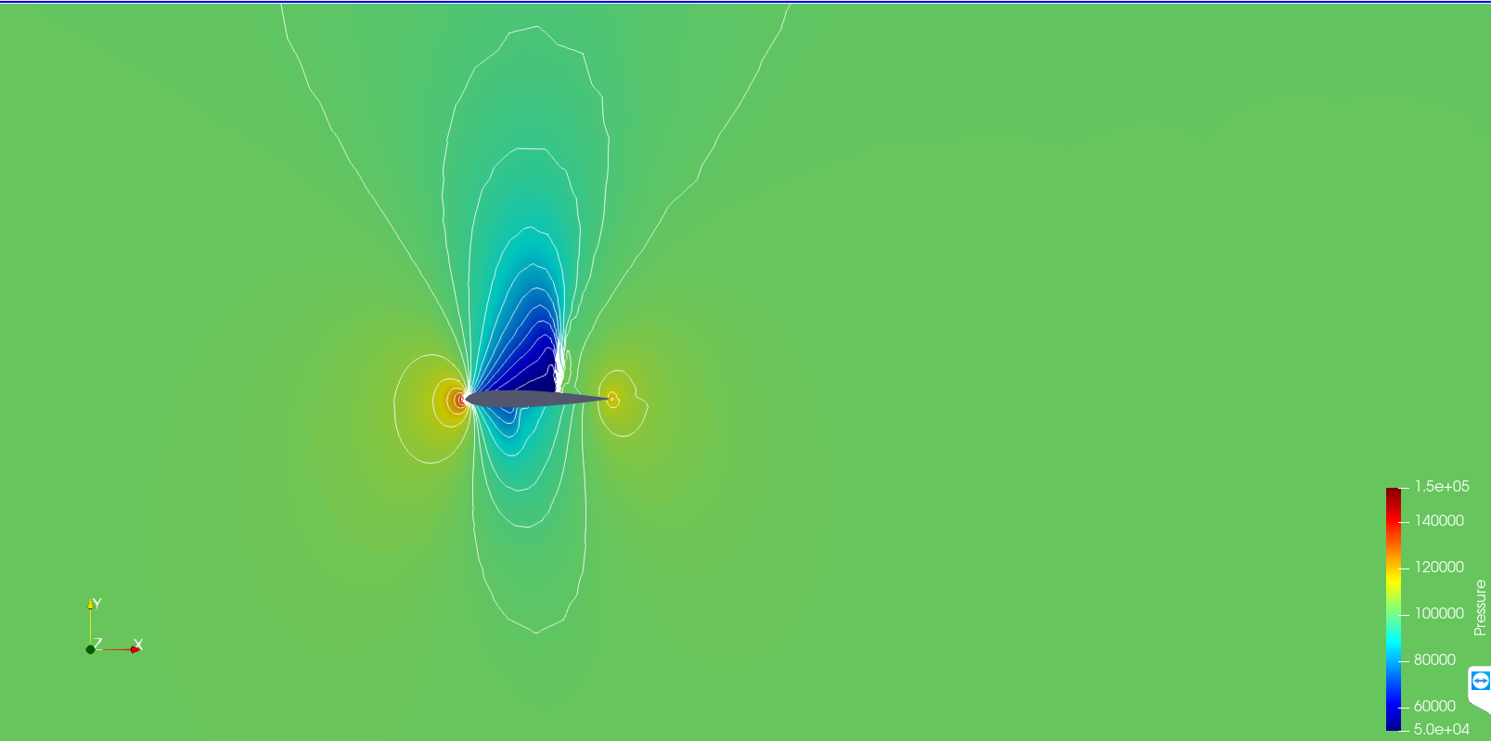

Figure 2: NACA 0012 Pressure Contour

Figure 2 shows the pressure contour around the NACA 0012 airfoil. This pressure contour is very interesting and demonstrates a lot of useful information. The main thing to be looked at is the large low-pressure zone occurring above the airfoil. This is exactly what is to be expected, as the NACA 0012 airfoil is a symmetrical airfoil. Symmetrical airfoils begin to generate lift at angles of attack above 0°. In this simulation, the angle of attack is 1.25°, indicating the generation of lift. Lift is generated by air accelerating over the upper surface of the airfoil, and decelerating along the lower surface of the airfoil. The increase in velocity above the airfoil creates a low-pressure zone, while the decrease in velocity generates a high-pressure zone. This pressure differential creates an upward force, which is by definition, lift. In the figure we are able to see this exact phenomenon. One other interesting thing to notice is the high-pressure zone at the leading and trailing edge. These two points represent stagnation points which are where the highest expected pressure will occur.

c)

Figure 3: NACA 0012 Surface Pressure Distribution

Figure 3 shows the surface pressure distribution around the NACA 0012 airfoil. This data is useful for calculating the center of pressure of the airfoil. One can see how the graph creates a closed loop. The two points (at x=0 and x=1) where the graph meets represent the leading and trailing edge of the airfoil respectively. Therefore, this graph can be divided into two separate lines representing the upper and lower surface of the airfoil. This can increase the ease of calculating the integrals to determine the center of pressure, however the data taken from Paraview has not been separated.

2.

a)

Plot of CL vs α alongside the provided theoretical data (Reference Data):

Figure 4: CL vs α alongside the provided theoretical data (Reference Data)

b)

Pressure Contours Case for 0 AOA at Mach 0.3:

Figure 5: Pressure Contours around the Airfoil @ 0 AOA

Pressure Contours Case for 8 AOA at Mach 0.3:

Figure 6: Pressure Contours around the Airfoil @ 8 AOA

Pressure Contours Case for 16 AOA at Mach 0.3:

Figure 7: Pressure Contours around the Airfoil @ 16 AOA

As expected, the pressure contour for the flow around the NACA 0012 airfoil at M = 0.3, is quite similar to the one at M = 0.8. The high-pressure regions are located at the leading and trailing edges of the airfoil. The regions of low pressure are located on the suction and pressure side of the airfoil. The pressure contour is symmetric about the camber line of the airfoil since the airfoil is symmetric and the angle of attack is 0 degrees.

The flows for 8- and 16-degrees AOA are similar for both Mach numbers. The stagnation point of the flow moves more underneath the airfoil at the leading edge and the suction side of the airfoil has a low-pressure region compared to the pressure side. The pressure contour for the 16-degree AOA flow looks similar except that the stagnation point moves slightly closer to the pressure side of the airfoil.

c)

Experimental Pressure Coefficient Vs. Theoretical (Referenced) Data Case for 0 AOA at Mach 0.3:

Figure 8: Pressure Coefficient Vs. Experimental Data for 0 AOA @ Mach 0.3

Experimental Pressure Coefficient Vs. Theoretical (Referenced) Data Case for 8 AOA at Mach 0.3:

Figure 9: Pressure Coefficient Vs. Experimental Data for 8 AOA @ Mach 0.3

Experimental Pressure Coefficient Vs. Theoretical (Referenced) Data Case for 16 AOA at Mach 0.3:

Figure 10: Pressure Coefficient Vs. Experimental Data for 16 AOA @ Mach 0.3

The experimental and theoretical results for the pressure coefficient plots are very similar with the exception of the magnitude of Cp being higher closer to the leading edge of the airfoil for the experimental results. The general shape of the curves is the same. The Cp goes to 0 towards the trailing edge and increases towards the leading edge. The pressure coefficient magnitude is higher for the negative side since the pressure is higher on the pressure side of the airfoil.

The Cp plot for the 0 AOA case is different from the rest since it is symmetric, therefore both sides overlap. The pressure coefficient in this case is also higher at the leading edge since this is the stagnation point. Furthermore, there is a slight discrepancy between the theoretical and experimental results close to the trailing edge of the airfoil. The experimental results continue to increase while the numerical results stop earlier.

3.

The main sources of error are the fact that the theoretical simulations were done under inviscid conditions, whereas in experiments, viscous effects are present and can alter the performance of the airfoil. The turbulence present in the flow changes the pressure contours which in turn changes the plot of the pressure coefficient. The accuracy of the method used for the simulation can also have an impact on the result and not provide adequate convergence.

Nonetheless, the results from the simulations agree mostly with the experimental results even with the error taken into consideration. However, for higher Reynolds number flows, different simulation methods need to be applied to maintain the accuracy of the results.