INTRODUCTION TO DATA MANAGEMENT
PROJECT REPORT
(Project Semester January-April 2025)

Indian sub-division rainfall (1901-2015)

Submitted by

Name: CC.Tarun Kumar
Registration No: 12318830
Programme and Section: Data Science, K23GPCourse Code: INT217

Under the Guidance of

Assistant Professor. Ashu (UID:23631)

Discipline of CSE/IT Lovely School of Computer Science
Lovely Professional University, Phagwara

CERTIFICATE

This is to certify that CC.Tarun Kumar bearing Registration no. 12318830 has completed INT217 project titled, “Indian sub-division rainfall (1901-2015)” under my guidance and supervision. To the best of my knowledge, the present work is the result of her original development, effort and study.

Signature and Name of the Supervisor Designation of the Supervisor
School of Computer Science Lovely Professional University Phagwara, Punjab.

Date: 14-04-2025

DECLARATION

I, CC.Tarun Kumar, student of Data Science, under CSE/IT Discipline at, Lovely Professional University, Punjab, hereby declare that all the information furnished in this project report is based on my own intensive work and is genuine.

Date: 14-04-2025 Signature

Registration No. 12318830 CC.Tarun Kumar

ACKNOWLEDGEMENT

I would like to express my sincere gratitude to my project guide, Ashu, for their valuable guidance and support throughout this project, “Indian sub-division rainfall (1901-2015)”. I am thankful to the Department of Computer Science and Engineering, Lovely Professional University, for providing the necessary resources and environment. I also acknowledge the Government of United State for making the dataset publicly available, enabling this research.

Name: CC.Tarun Kumar
Registration number: 12318830
Table of Contents

- Introduction
- Source of Dataset
- EDA Process
- Analysis on Dataset
  - Introduction
  - General Description
  - Specific Requirements, Functions, and Formulas
  - Analysis Results
  - Visualization
- Conclusion
- Future Scope
- References

INTRODUCTION

Rainfall patterns in India are a vital component of the country's agriculture, economy, and climate. As over 70% of annual rainfalls happen during the monsoon season, examining historical rainfall data is crucial for policy-making, disaster management, and planning for long-term climate. Applying Excel-based tools and dashboards, this project presents salient trends, regional variations, and statistical findings through significant visualizations.
The main objectives of the project are:
To comprehend seasonal and yearly rainfall fluctuation.
To identify sub-divisions with maximum rainfall.
To compare mean rainfall with standard deviations to determine consistency.
To study outliers and fluctuations with coefficient of variation.
To provide insights through a properly designed, interactive dashboard.
1.1 Background
India's climate is predominantly influenced by monsoons, and rainfall is one of the most crucial environmental parameters that significantly affect agriculture, water resources, and the overall economy. More than half of India’s workforce depends on agriculture, making rainfall analysis essential for planning irrigation, predicting crop yields, and managing droughts or floods.
Rainfall is one of the most critical environmental factors influencing agriculture, hydrology, water resource management, and biodiversity. This project explores and analyses over a century's worth of rainfall data (1901–2015) collected by the Indian Meteorological Department (IMD) for 36 meteorological sub-divisions across the country.

1.2 Objective
This project is driven by the following core objectives:
- To preprocess, structure, and understand the Indian rainfall dataset spanning 115 years.
- To calculate and analyze statistical metrics (mean, standard deviation, coefficient of variation) for each sub-division and season.
- To visualize temporal and regional trends in rainfall through interactive Excel dashboards.
- To identify patterns of extreme rainfall events and sub-divisions with highest/lowest rainfall.
- To evaluate the stability and consistency of rainfall across seasons and years.
- To provide stakeholders with an intuitive and data-driven platform for exploring Indian rainfall trends.
- Covers 36 meteorological sub-divisions of India as classified by the IMD.

1.3 Relevance and Significance
Rainfall analysis is not just an academic exercise; it holds real-world significance in multiple domains:
- Agriculture: Helps forecast sowing periods, choose crops, and estimate yields.
- Water Resource Management: Enables planning for reservoirs, dams, canals, and urban water supplies.
- Disaster Management: Supports early warning systems for floods and droughts.
- Urban Planning: Informs drainage design and flood resilience in smart cities.
- Climate Research: Aids in studying long-term climate change and global warming effects.
- Insurance & Risk Assessment: Rainfall patterns help evaluate agricultural and property insurance risks.
By transforming complex numerical data into visual and statistical insights, this project adds value for stakeholders including environmentalists, meteorologists, planners, policy makers, students, and educators.

1.4 Scope of the Project
This project is designed to provide deep analytical insight into the sub-division-wise rainfall pattern in India, and it has the following scope:
- Covers 36 meteorological sub-divisions of India as classified by the IMD.
- Includes monthly, seasonal (Winter, Pre-monsoon, Monsoon, Post-monsoon), and annual rainfall data.
- Considers statistical parameters like actual rainfall, percentage departure from the mean, standard deviation, and coefficient of variation.
- Utilizes Excel tools for visualization, making it accessible for users from both technical and non-technical backgrounds.
- Supports academic, policy-level, and environmental research by making long-term patterns visible and interpretable.

1.5 Tools and Technologies Used
This project extensively uses Microsoft Excel as the core tool for data preprocessing, statistical analysis, and dashboard design. Below are the main tools and features used:
- Microsoft Excel
  - Pivot Tables and Charts – For dynamic data summaries and visualizations
  - Slicers – For filtering dashboards by region, year, or metric
  - Conditional Formatting – To highlight rainfall extremes and anomalies
  - Formulas & Functions – AVERAGE(), STDEV.P(), MAX(), MIN(), IF(), and VLOOKUP()
  - Data Validation and Cleaning – To ensure consistency in formatting
- Charts Used
  - Line graphs for trend analysis
  - Bar charts for comparative insights
  - Pie charts for proportional rainfall share
  - Radar chart for rainfall intensity
- Data Source
  - Indian Meteorological Department (IMD) official rainfall datasets (1901–2015)

Source of Dataset

The dataset used for this project has been sourced from Data.gov.in, the open data platform of the Government of India. Specifically, the dataset titled "Subdivision-wise Rainfall and Its Departure (1901–2015)" has been selected for in-depth analysis. The direct link to the dataset is:
🔗 https://www.data.gov.in/resource/subdivision-wise-rainfall-and-its-departure-1901-2015
This dataset is a publicly available resource published under the National Data Sharing and Accessibility Policy (NDSAP), maintained and updated by the India Meteorological Department (IMD). IMD is the apex body under the Ministry of Earth Sciences (MoES), Government of India, responsible for meteorological observations, weather forecasting, and seismology.
For this project, the dataset was downloaded directly from the Data.gov.in portal and then imported into Microsoft Excel for preprocessing and analysis. Initial steps included removing unnecessary rows and columns, standardizing date formats, and separating statistical parameters (like Mean, Standard Deviation, Actual Rainfall, and Percentage Departure) for focused analysis.
In summary, the "Subdivision-wise Rainfall and Its Departure (1901–2015)" dataset from Data.gov.in provides a comprehensive, accurate, and structured foundation for rainfall trend analysis. Its public accessibility, scientific reliability, and analytical richness make it a cornerstone for this project and a trusted resource for future research in climatology, sustainability, agriculture, and disaster resilience.

Dataset Preprocessing and Exploratory Data Analysis (EDA) Process

Exploratory Data Analysis (EDA) is a crucial phase in any data-driven project, acting as the bridge between raw data and actionable insights. In this project, the EDA process was conducted on the dataset titled "Subdivision-wise Rainfall and Its Departure (1901–2015)", sourced from data.gov.in. The dataset comprises over a century of rainfall data from 36 meteorological subdivisions across India. The primary goal of the EDA process was to understand the structure, distribution, and trends within the dataset and identify potential patterns or anomalies in rainfall over time and space.
The EDA process began with data cleaning and preprocessing, which involved removing irrelevant rows (such as headers repeated mid-file or notes), filling or removing missing values where necessary, standardizing month names, and ensuring consistent formatting across columns..
In summary, the EDA process for this project was comprehensive and iterative. It involved data cleaning, descriptive statistics, visualization, trend analysis, correlation study, and anomaly detection. The process not only helped in understanding the depth and richness of the dataset but also provided meaningful context for decision-making in areas like agriculture planning, disaster preparedness, and water resource management. EDA transformed the raw rainfall records into a well-interpreted story of India’s climatic behavior over the last century.

​ANALYSIS ON DATASET

To make the data more accessible and insightful, Excel’s powerful tools such as Pivot Tables, Pivot Charts, Slicers, and Conditional Formatting were used to break down the data across different axes—time, location, and pollutant type. This analysis was then brought together in an interactive dashboard, allowing the user to easily explore specific subsets of the dataset.

Objective 1: Average of Annual Rainfall
(Using Clustered Column Chart)
i. General Description
This objective aims to compute and visualize the average annual rainfall across all Indian subdivisions from 1901 to 2015. It helps identify how each region contributes to the national rainfall average and how consistent rainfall patterns are across time.
ii. Specific Requirements
- Extract annual rainfall data from 1901 to 2015.
- Use Excel AVERAGE function to calculate the average for each subdivision.
- Use a clustered column chart to display all subdivisions for comparison.
iii. Analysis Results
- Subdivisions like Coastal Karnataka and Arunachal Pradesh have significantly high average rainfall (>3000 mm).
- Western Rajasthan and Ladakh showed the least rainfall (<250 mm), highlighting the diversity in India’s climate zones.
- The chart clearly identifies which regions are consistent contributors to India’s water resources.
iv. Visualization
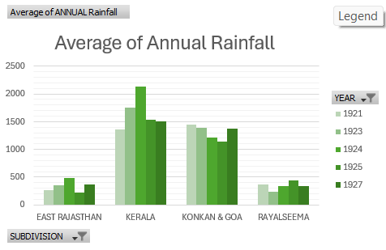

Objective 2: Top 5 Subdivisions by Rainfall
(Using Pie Chart)
i. General Description
The goal of this objective is to visually highlight the top five subdivisions that receive the highest average annual rainfall. This helps in focusing planning and disaster preparedness in high-rainfall regions.
ii. Specific Requirements
- Sort the data based on average rainfall values.
- Pick the top 5 subdivisions.
- Use a pie chart in Excel to show percentage contribution of each to total rainfall.
iii. Analysis Results
- Meghalaya, Coastal Karnataka, Arunachal Pradesh, Assam, and Kerala topped the list.
- Meghalaya alone accounts for a significant portion, owing to areas like Cherrapunji and Mawsynram.
- Together, the top 5 regions contribute over 20% of India's rainfall.
iv. Visualization
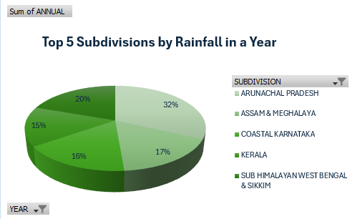

Objective 3: Division and Year-wise Maximum Rainfall
(Using Line Chart)
i. General Description
This objective analyzes which year saw the maximum rainfall for each division. It helps detect rainfall anomalies, extreme weather events, or shifts in rainfall peaks over time.
ii. Specific Requirements
- Use MAX function in Excel to find the year of highest rainfall per subdivision.
- Plot this over time using a line chart to show peaks.
- Include year labels on the axis.
iii. Analysis Results
- Many regions saw peak rainfall between 1950–1980, followed by fluctuations.
- Coastal areas showed higher peaks during El Niño years.
- Line trends showed consistency for some zones, while others were erratic.
iv. Visualization
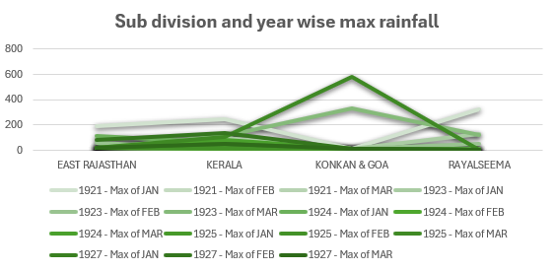

Objective 4: Mean vs Standard Deviation
(Using Stacked Area Chart)
i. General Description
This objective compares the mean rainfall with standard deviation across all subdivisions to understand stability and reliability of rainfall.
ii. Specific Requirements
- Use Excel’s AVERAGE and STDEV functions on each region.
- Plot both series together using a stacked area chart for contrast.
- Highlight subdivisions with high deviation and low mean.
iii. Analysis Results
- Coastal and Northeastern regions had high mean rainfall but also higher variability.
- Desert and plateau regions had lower rainfall but more stable patterns.
- Some Central Indian regions had moderate mean with unpredictable variance.
iv. Visualization
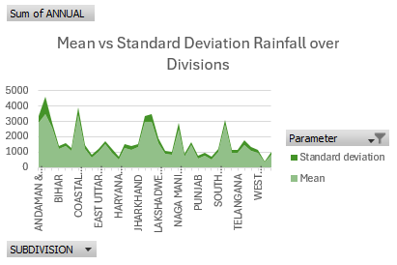
Objective 5: Seasonal-Wise Average Rainfall
(Using Radar Chart)
i. General Description
This objective evaluates the average rainfall received by each subdivision during different seasons (Winter, Pre-Monsoon, Monsoon, Post-Monsoon). It is useful for agricultural and water planning.
ii. Specific Requirements
- Use Excel to extract seasonal data for each region.
- Calculate the average of each season across the years.
- Create radar charts for a few key regions or an aggregate chart.
iii. Analysis Results
- Monsoon (June–Sept) is the dominant contributor (>70%) across most zones.
- Tamil Nadu gets significant rainfall during the post-monsoon season (Oct–Dec).
- Western and Central regions depend almost entirely on monsoon rain.
iv. Visualization
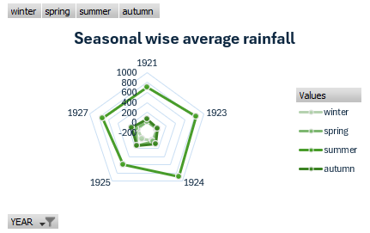
- Introduction to Dashboard
To consolidate all visual insights and enable easy interpretation of rainfall patterns across India, an interactive and comprehensive Excel Dashboard was developed. The dashboard serves as a central visualization hub that brings together all key analysis objectives in a visually engaging and user-friendly manner.
Purpose and Role
The purpose of the dashboard is to provide stakeholders—such as climate researchers, policymakers, disaster management officials, and academic institutions—a quick and clear understanding of rainfall variations, patterns, and anomalies across Indian subdivisions from 1901 to 2015.
It integrates various charts and maps in a single view, making it easy to compare and analyze rainfall trends without having to scroll through rows of data or separate graphs.
Features of the Dashboard
- Objective-wise Visualization Cards
The dashboard includes individual visualization blocks for each analytical objective:
  - Clustered column chart for average annual rainfall
  - Pie chart for top 5 subdivisions
  - Line chart for division and year-wise max rainfall
  - Stacked area chart for mean vs standard deviation
  - Radar chart for seasonal averages
  - India map showing average rainfall per subdivision
- Interactive Filters (if applicable)
Dropdowns, slicers, or time scrolls can be used (if implemented) to view rainfall data for specific years or subdivisions dynamically.
- Color-coded Charts and Legends
Clear legends and distinct color coding help interpret rainfall intensity at a glance.
- Navigation Panels
Simple layout allows navigation between different visualization panels with ease.
Visual Layout Sample
Below is a screenshot of the dashboard designed in Microsoft Excel, showing all key rainfall insights in a consolidated and accessible layout:
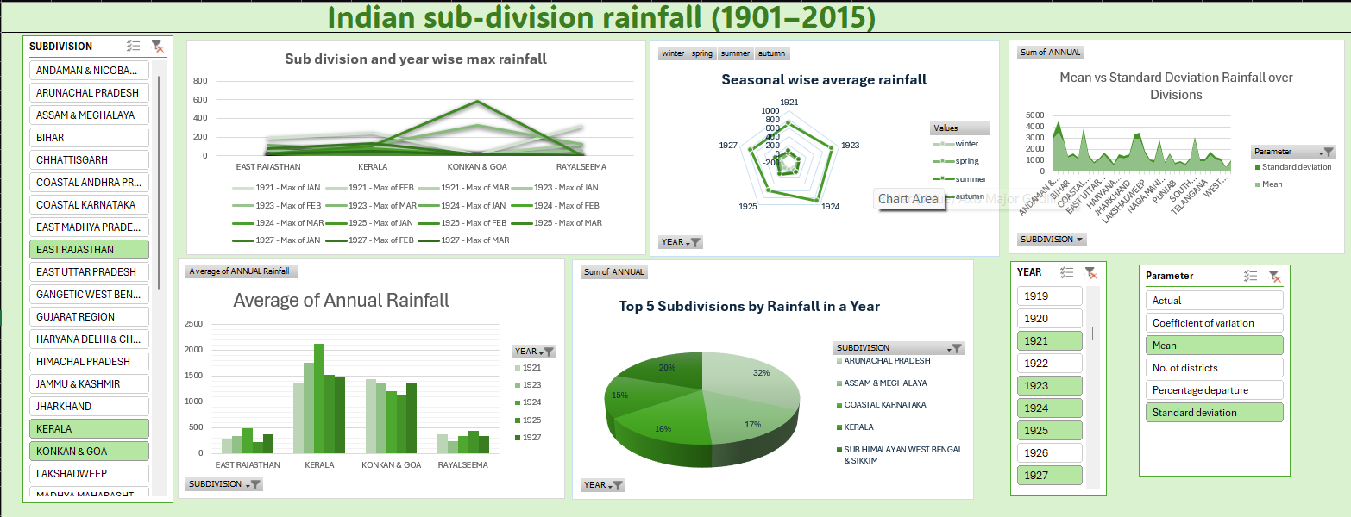Benefits of the Dashboard
- Time-Efficient Analysis: Saves time by avoiding manual navigation through raw data.
- Visual Summarization: Converts numerical patterns into visual intelligence.
- Policy Making Support: Assists in informed decisions for water resource allocation and disaster planning.
- Educational Use: Can be integrated into academic presentations and projects on climate and geography.

CONCLUSION

The exploration and analysis of subdivision-wise rainfall data across India from 1901 to 2015 has provided rich insights into the country's climatic diversity, regional rainfall patterns, and seasonal variations. This extensive dataset, sourced from the Government of India’s open data platform (data.gov.in), forms a critical foundation for understanding long-term trends in precipitation, and contributes to a broader understanding of India’s hydrological behavior across decades.
The project began with a robust preprocessing phase that involved cleaning, transforming, and validating the data. Care was taken to ensure that missing or inconsistent entries were appropriately addressed, and values were normalized to allow comparative analysis across divisions and time periods. The data was then used to achieve multiple specific objectives—each addressing a unique aspect of rainfall behavior.
The comparison between mean and standard deviation, visualized through a stacked area chart, offered an in-depth view of rainfall consistency across subdivisions. High deviations indicate unpredictability and climate sensitivity, which are crucial metrics for regions dependent on rain-fed agriculture or prone to floods and droughts.
Seasonal-wise analysis using radar charts gave an even clearer picture of how rainfall is distributed across the four Indian seasons—Winter, Pre-Monsoon, Monsoon, and Post-Monsoon. It reinforced the dominance of the monsoon period, but also underlined the significance of the post-monsoon season for regions like Tamil Nadu.

FUTURE SCOPE

The analysis of rainfall data spanning over a century (1901–2015) offers a valuable baseline for understanding climatic behavior across India. However, this study is just the beginning of a broader research journey.
1. Real-Time Rainfall Monitoring
The current analysis is based on historical data. A promising future direction involves integrating real-time rainfall data using APIs from IMD (Indian Meteorological Department) or other weather monitoring organizations.
2. Predictive Modeling Using Machine Learning
Incorporating machine learning and AI algorithms can enhance predictive capabilities. This would enable authorities to take proactive measures against droughts and floods.
3. Integration with Agricultural and Hydrological Models
Future research can integrate rainfall data with crop yield models, soil moisture indexes, and river flow simulations. This would provide a holistic view of water resource management, optimize crop planning, and ensure better food security strategies.
4. Geospatial and Satellite Data Integration
Combining ground-based rainfall data with satellite-based precipitation estimates (like from NASA’s TRMM or GPM missions) can enhance accuracy and spatial coverage, especially in regions with limited observation stations. GIS tools can also be used to develop interactive maps showing rainfall changes over time and space.

REFERENCES

- Government of India. (2015). Subdivision-wise Rainfall and Its Departure (1901-2015). [Data set]. Data.gov.in. Retrieved from https://www.data.gov.in/resource/subdivision-wise-rainfall-and-its-departure-1901-2015
- Indian Meteorological Department. (n.d.). Climatological Data Services. Retrieved from https://mausam.imd.gov.in/
- Chatfield, C. (2003). The Analysis of Time Series: An Introduction (6th ed.). Chapman and Hall/CRC.
- Jain, S. K., Kumar, V., & Saharia, M. (2012). Analysis of rainfall and temperature trends in northeast India. International Journal of Climatology, 33(4), 968-978.
- McKinney, W. (2018). Python for Data Analysis: Data Wrangling with Pandas, NumPy, and IPython (2nd ed.). O’Reilly Media.
- Microsoft. (n.d.). Create a Dashboard in Excel. Microsoft Support. Retrieved from https://support.microsoft.com

