ELEC 3300 Project Summary Sheet
This is a ONE Page Summary Sheet, Content more than 1 page will be deleted.
All the fonts used in this Sheet should be in Times New Roman at 12 points

Group Number | 11
Project Title | Music Player
Name of Student 1 | Law Chik Kwai
Name of Student 2 | Ip Ming Chiu

Please attach ONE photo of your project here
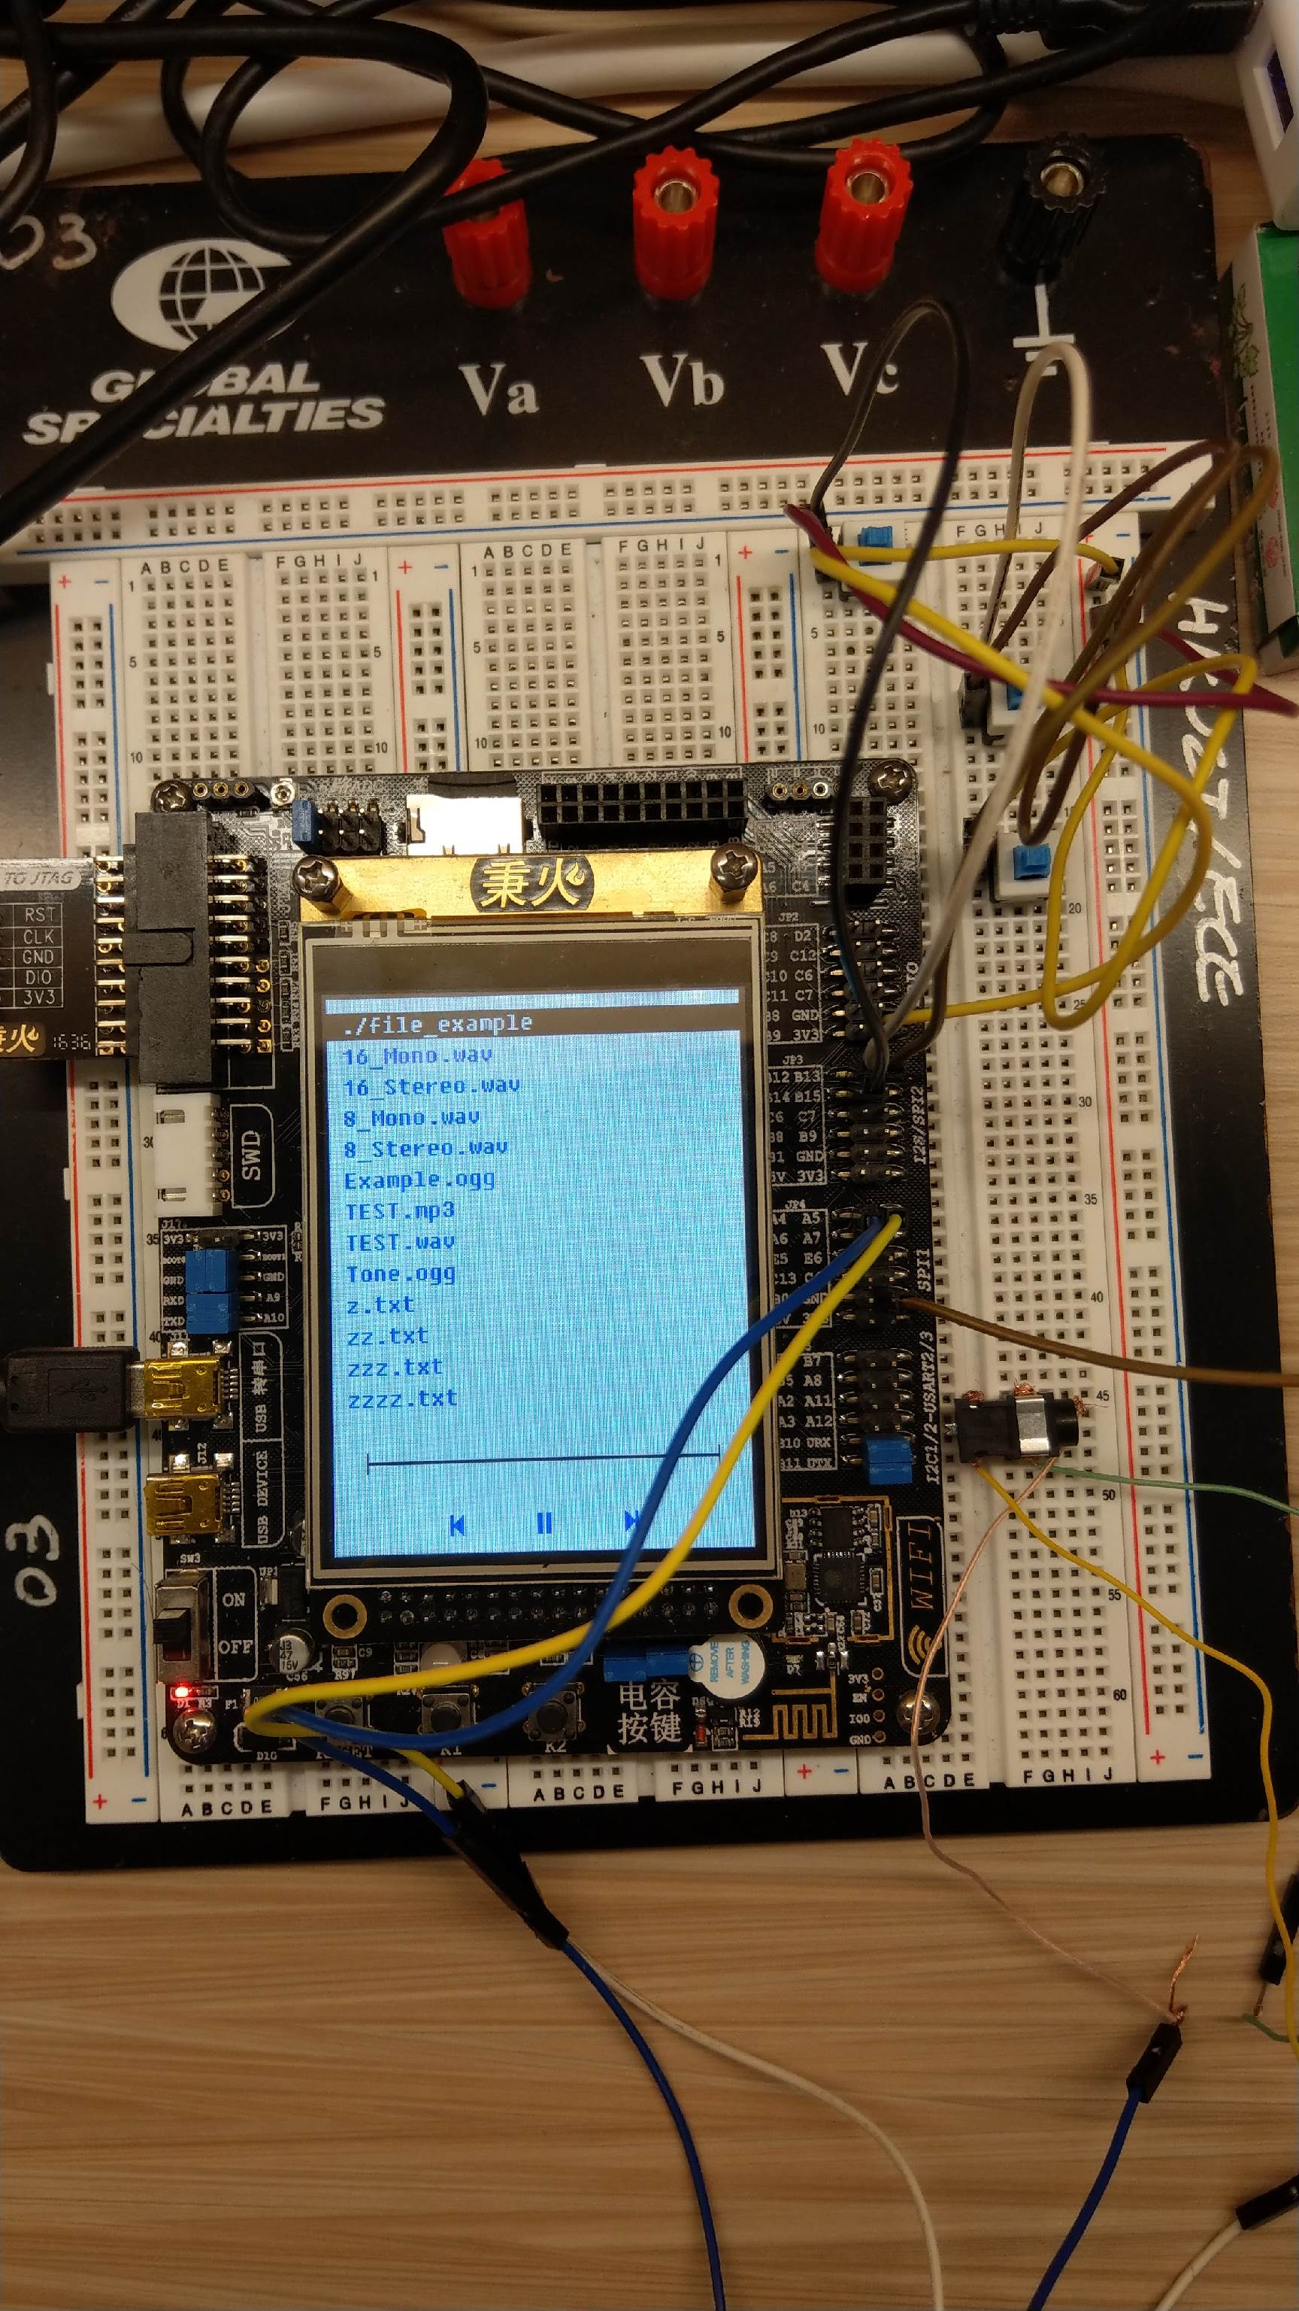

Please list the functions of your project in point form

- Read files from micro sd card
- Play .wav music files
- Navigate using buttons
- Navigate using touch screen
- Adjust volume using rheostat
- Play .ogg music files

