**Collatz Conjecture Verification Using CUDA**

Midwestern State University   
Scott Gordon, Steven Kundert

The Collatz conjecture or Ulam’s Conjecture is a famous unsolved problem from mathematics that has never been proven. The series of numbers created by the conjecture is known as the hailstone sequence. Although no proof exists most mathematicians who have examined the problem believe it is true because of the large amount of experimental evidence to support it. Using the Turing Supercomputer, we have designed 3 different types of algorithms, which perform Collatz Verification: One sequential version and two CUDA versions. During our presentation we will discuss the scope of our problem as well as delve into a discussion about our various algorithms and design choices. We will also frame a discussion on Parallelism using CUDA while we present on the results of our performance analysis. We will close with a brief Q&A session.

The code submitted, can be compiled with the following command on a compatible system: /opt/cuda-8.0/bin/nvcc TwoLoopsSequential.cu -o TwoLoops

The code can then be executed by running the command:

./TwoLoops

An output file by the name of VerifyConjecture.txt is created in the local directory.

The Following image shows a sample of our output file and is intended only for verification purposes.

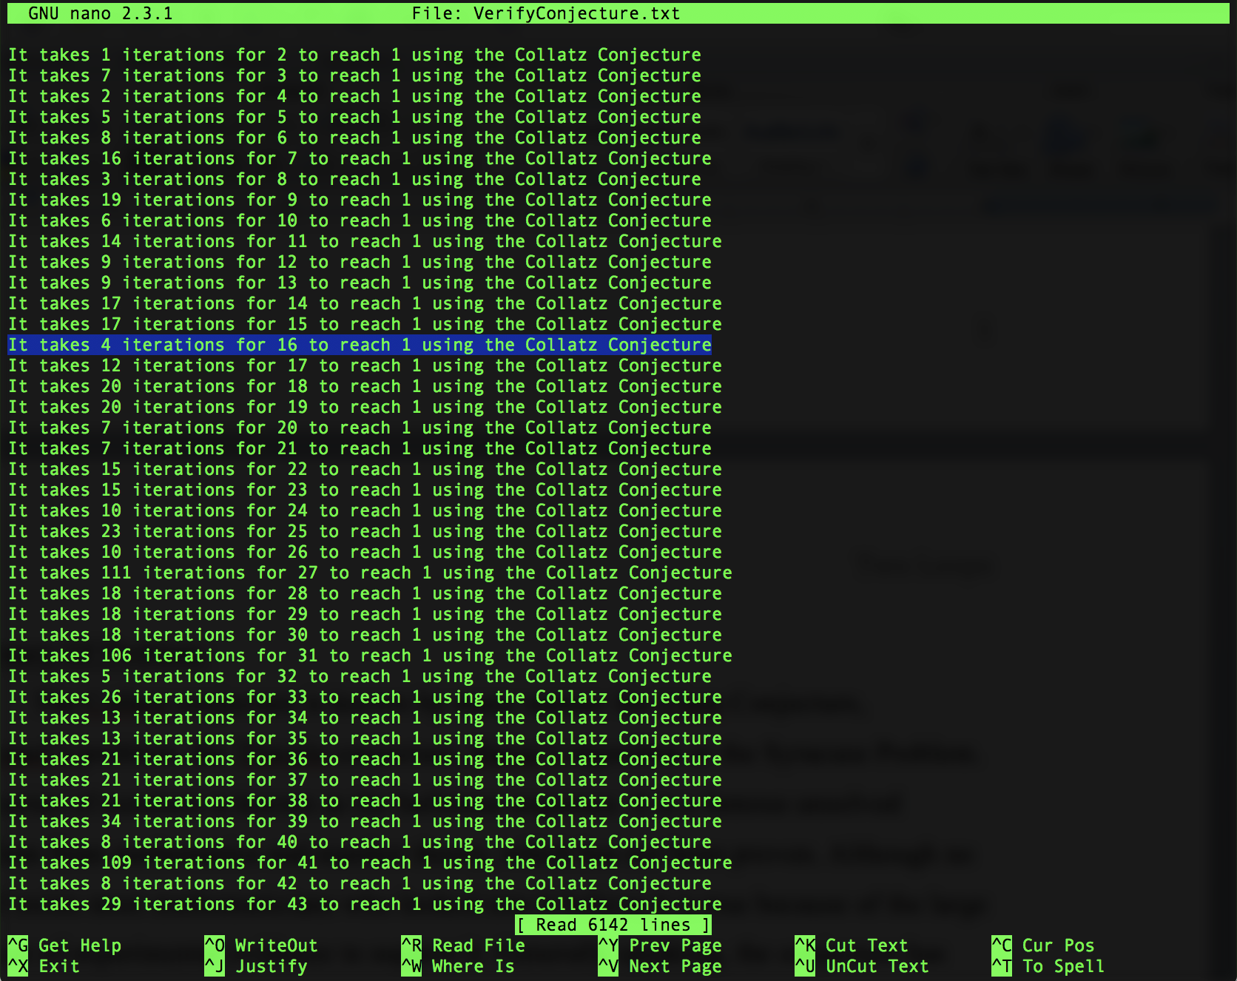

As you can see it is claimed the number 16 takes 4 iterations to reach one and 42 takes 8. Lets test that by hand: