App for scheduling stuff and rates the events according to subjective well being
- Timetable/scheduling app first
- When the event ends, prompts user to rate the event according to what they felt
- Provide recommendations for other places if the user did not like it.
Use case
- User schedules dentist appointment
- App reminds them to go
- Once they’ve gone, the app prompts the user to rate the experience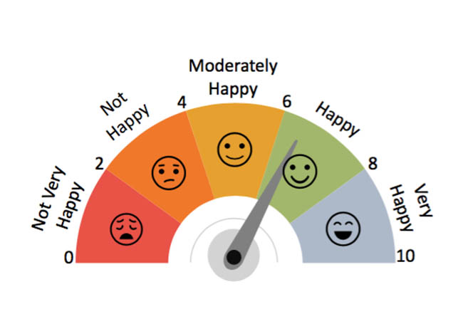
- If they felt bad about the experience, the app will recommend other similar place/events.
Things the app should do
- Give recommendations that is based on what the user’s pain points
i.e. If the user went to an event and said that he/she was unhappy after it because of traffic jams, then the app should recommend places closer to where the user lives.

App name: Libellus
App description:
App description:
Libellus is a smart scheduling app that goes beyond simple time management. It combines planning, reflection, and social sharing in one place.
- Reflect & Review: After completing scheduled tasks or events, users can record reflections or reviews to track progress and personal growth.
- Social Sharing: Users can share their achievements or experiences from their scheduled events with friends or the community, turning productivity into motivation.

UNSDGs that the app seeks to achieve:
 | 3.4 By 2030, reduce by one third premature mortality from non-communicable diseases through prevention and treatment and promote mental health and well-being
Requirements
Must haves | - Users must be able to select a date and time and enter the event title and description  - Upon completion of a scheduled event, users must be prompted to select a mood indicator from a scale of 1 to 5, with 5 being very satisfied/happy and enter a review of what they’ve done  - Users must be able to share their completed events through posts on the application, Instagram, Facebook
Should haves | - The application should have the ability to analyse the reviews of the user and recommend better options to the user if there are any. (Example, user leaves a review that the place they went to was too far, so the app would recommend something closer)  - Users should be able to tag other users on their events  - Users should be able to share their schedule with other users  - The app should automatically compile the achievements of each user every 3 months and show the summary of it to the user.  - The app should have a chatbot that helps the user to reflect (asking questions like how they felt before, in the moment, and after the moment, and what could be done as well as help them write with more clarity)
Won’t haves | - The location of where events take place will not be tracked, only the current location of the user

Modules necessary:
- Social module
  - View, edit, delete posts of users.
  - Profile management
- Scheduling module
  - Add, remove, edit items (exercise, meetings, school, sleep, work being the 5 basic tags and “others” being the 6th)
  - Share schedule with others
  - Post achievement
Monetization ideas:
- Freemium model
  - Premium features could include (I don’t know yet)
- Association with businesses
  - Run ads of businesses on the social module

