**Problem 1**

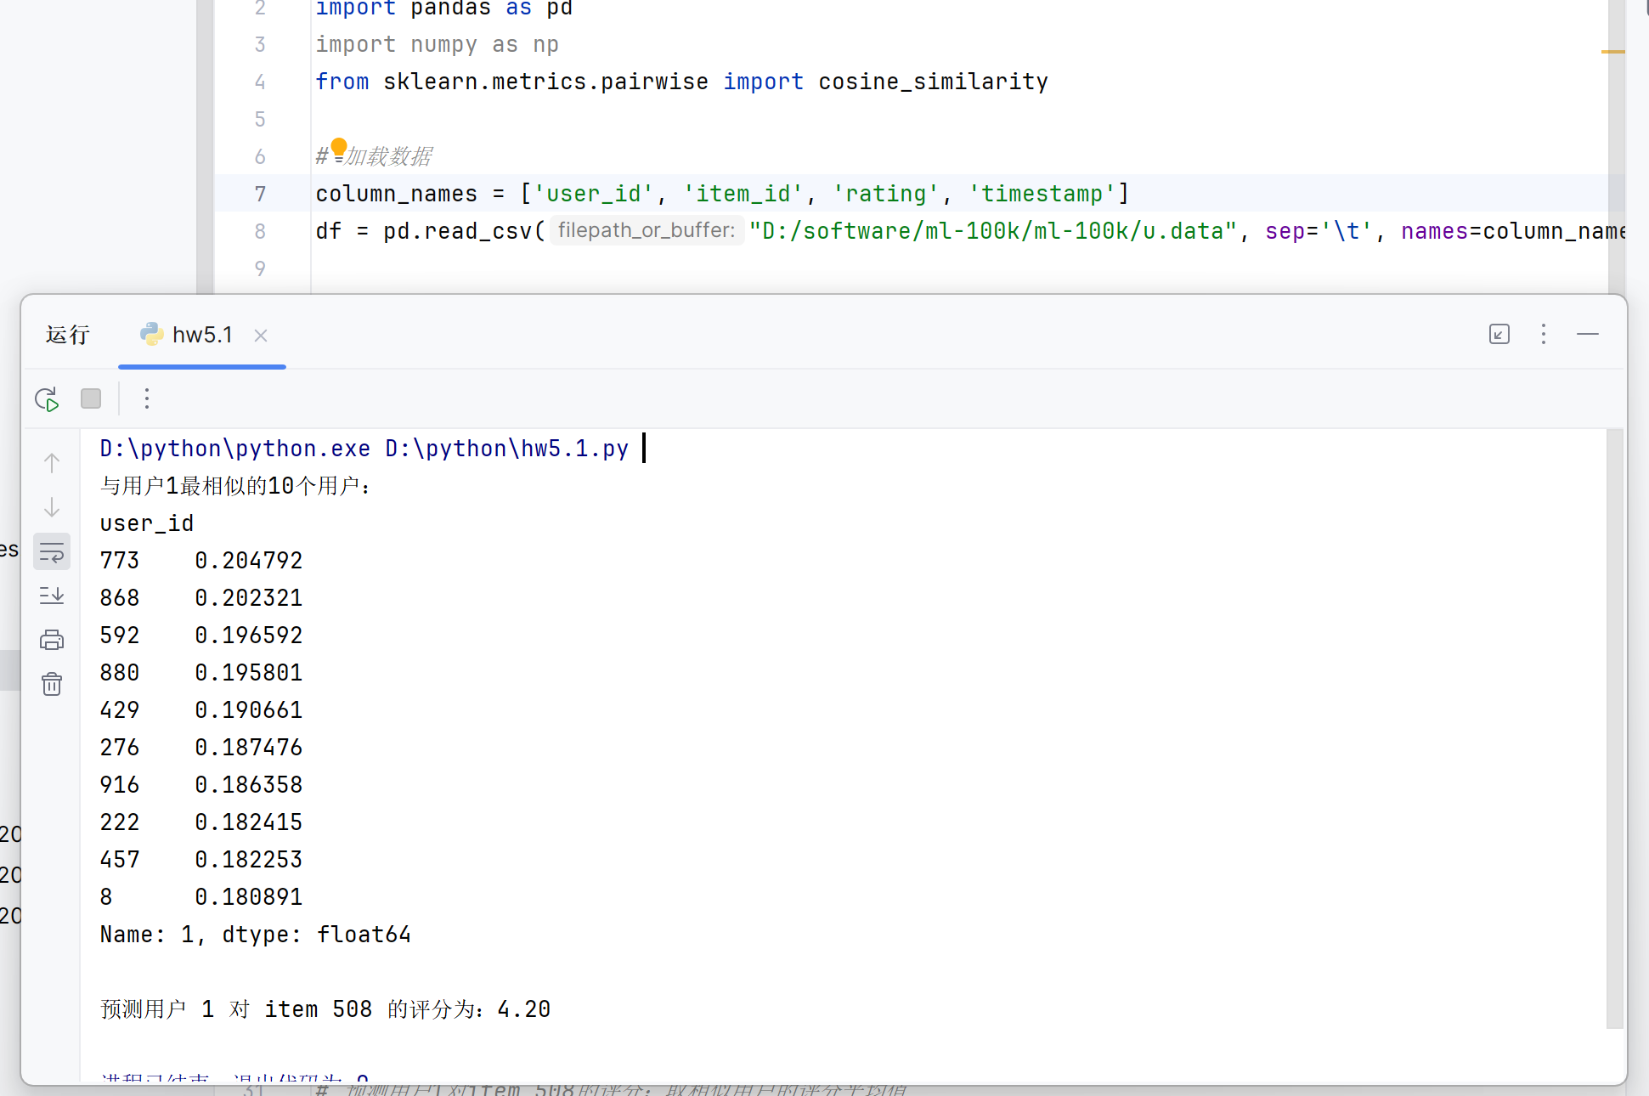

Based on the cosine similarity calculation, the top 10 users most similar to User 1 and their similarity scores are: 773 (0.204792), 868 (0.202321), 592 (0.196592), 880 (0.195801), 429 (0.190661), 276 (0.187476), 916 (0.186358), 222 (0.182415), 457 (0.182253), and 8 (0.180891). Based on the average rating of these similar users for item 508, the predicted rating of User 1 for this item is 4.20.

**Problem 2**

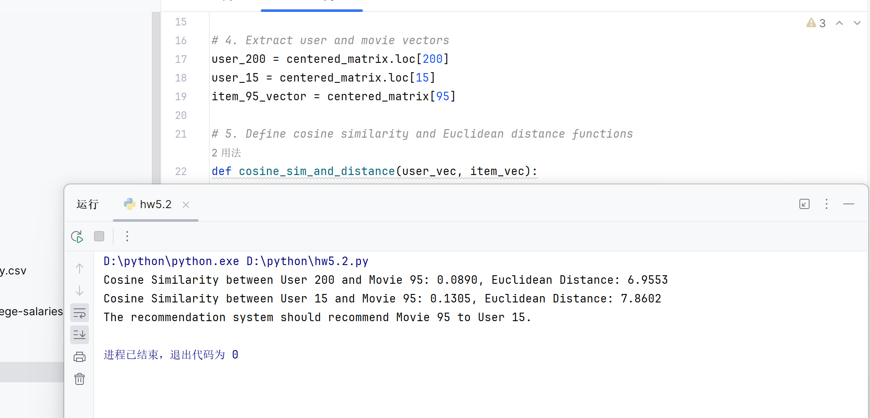

Based on the cosine similarity results (User 200: 0.0890, User 15: 0.1305), the recommendation system should recommend movie 95 to User 15, as their higher cosine similarity indicates a closer match in preferences. Although the Euclidean distance results (User 200: 6.9553, User 15: 7.8602) show a lower value for User 200, cosine similarity is a more commonly used metric in collaborative filtering recommendations for measuring similarity in interest direction.